Additional File 5: Figure S4
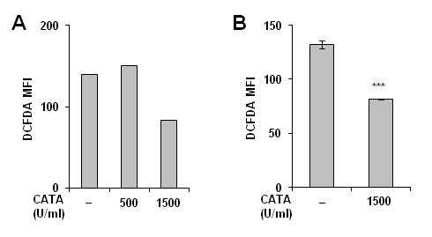
Figure S4: Effect of catalase on ROS generation in HG. a and b HepG2 cells were seeded in 12-well plates. Next day, they were pre-treated with indicated concentrations of catalase (CATA) for 3 h followed by incubation in HG medium for 3 h and cells were processed for ROS measurement by FACS. Bar graph in panel B represents mean intensity ± standard deviation; ***p<0.001

