Additional File 7: Figure S6
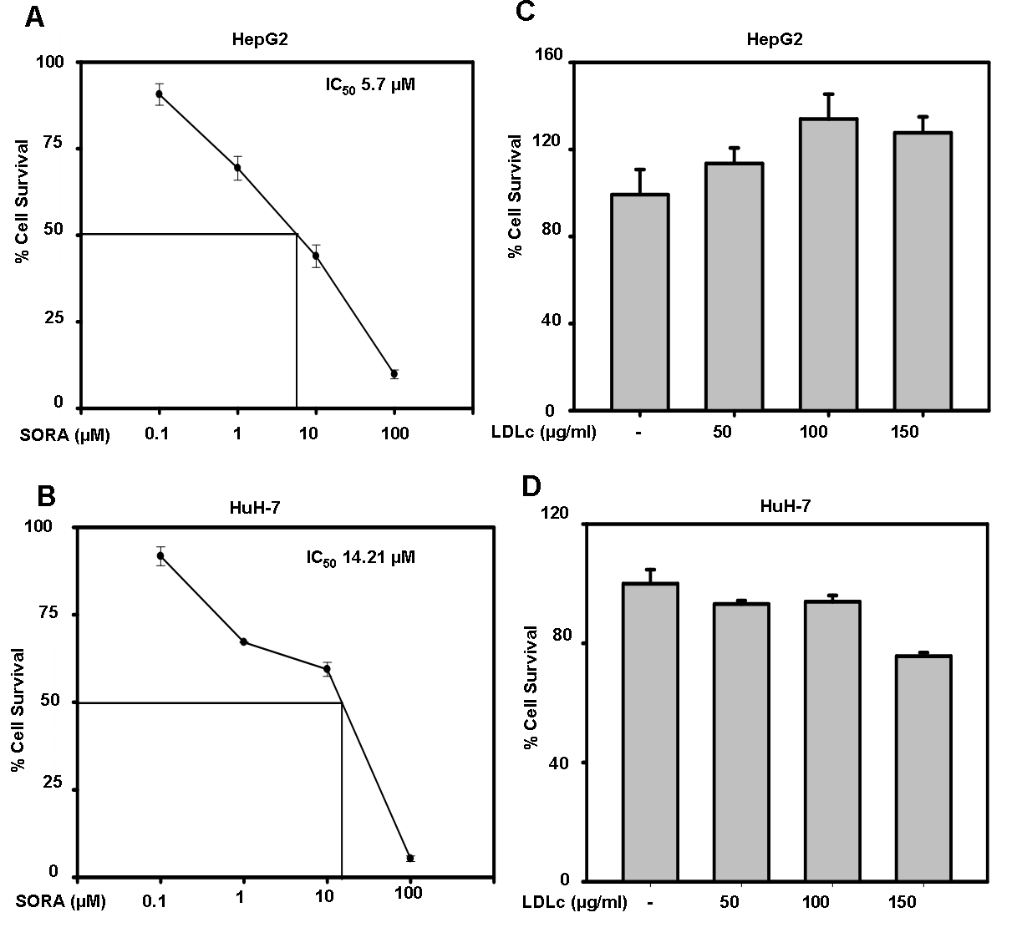
Figure S6: Screening of sorafenib and LDLc concentration. a, b HepG2 and HuH-7 cells were treated with indicated concentrations of sorafenib for 48 h, cell survival was assessed by MTT assay and IC₅₀ of sorafenib was calculated by Sigma Plot 10.0. (CA, USA). c, d HepG2 and HuH-7 cells were treated with indicated concentrations of LDLc for 72 h and cell survival was assessed by MTT assay. The results are given as means ± standard deviation.

