Additional File 8: Figure S7
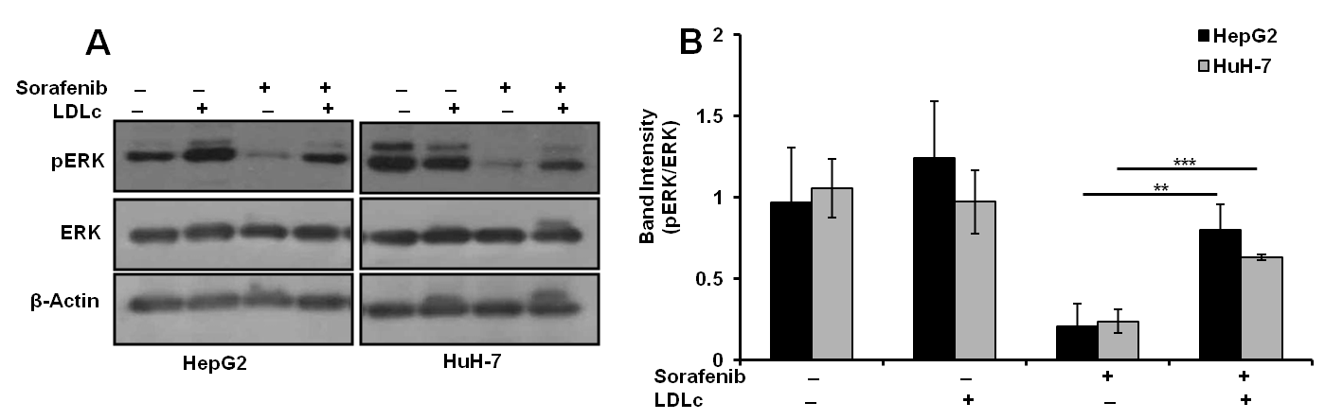
Figure S7: Effect of LDLc on sorafenib mediated signalling. a HepG2 and HuH-7 cells were seeded and allowed to adhere. Cells were cultured in DMEM containing 5% LPDS for overnight. Cells were pre-treated with LDLc (100 µg/ml) for 2 h in fresh DMEM containing 5% LPDS followed by treatment of sorafenib (5 µM) for 1 h, as indicated. Whole cell lysates were resolved on SDS-PAGE and expression of pERK, ERK and β-Actin were analyzed by Western blot. B Band intensities of pERK from three independent experiments were measured by densitometry and normalized with band intensities of ERK. The results are depicted in a bar graph as mean ± standard deviation; **p < 0.01 and ***p<0.001 denote significant differences in the groups.

