Supplementary Figure 1.
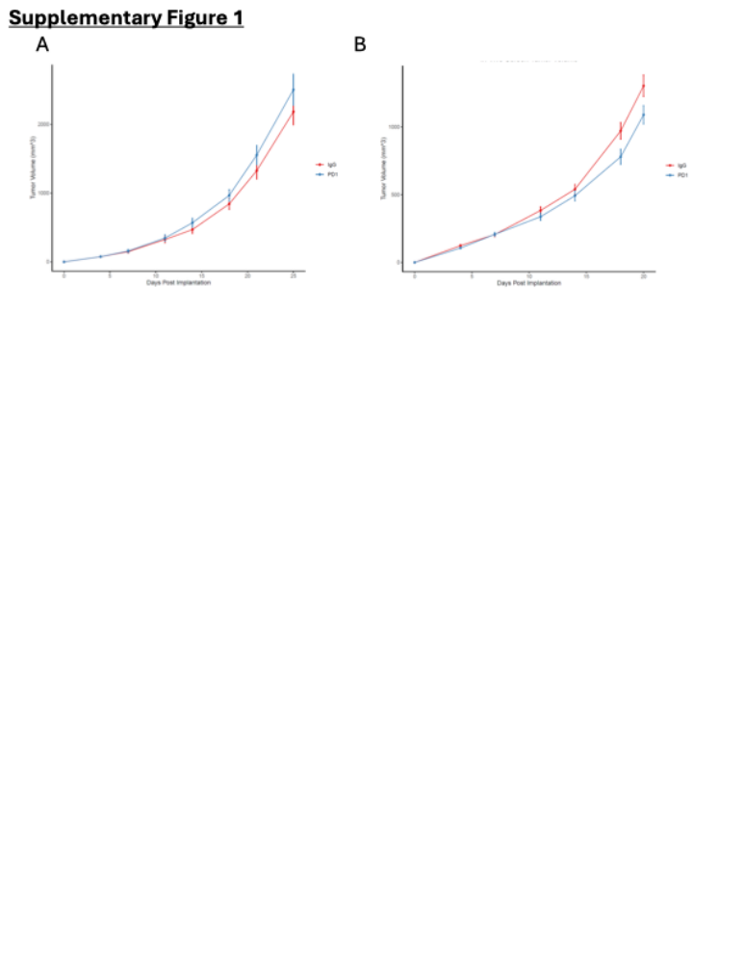
Supplementary Figure 1: In vivo growth of KP lung adenocarcinoma cells upon IgG or anti-PD1 treatments
(A) Volumes of wild-type KP tumors treated with IgG or PD1. (B) Volumes of KP tumors with metabolic gene knock-outs treated with IgG or PD1 during the primary CRISPR-based negative selection screen.

