Additional file 1: additional results and descriptive statistics

Table A1 Number of observations per period and group
 | Year 2011 |  |  |  | Year 2012
 | Men < 30 | Men ≥ 30 | Women < 30 | Women ≥ 30 | Men < 30 | Men ≥ 30 | Women < 30 | Women ≥ 30
Period I | 29,652 | 66,650 | 21,327 | 56,612 | 27,971 | 64,400 | 21,633 | 55,391
Period II | 24,958 | 59,035 | 18,087 | 49,263 | 23,455 | 57,129 | 18,297 | 47,992
Period III | 24,588 | 58,517 | 18,154 | 48,688 | 22,981 | 56,569 | 18,341 | 47,342
Period IV | 22,519 | 54,295 | 17,153 | 45,397 | 20,310 | 51,648 | 16,863 | 42,706

Table A2 Descriptive statistics, year 2012 (periods I to IV pooled)
 | Men ≥ 30 |  |  |  |  | Eligible
 | mean | min |  | max |  | mean | min |  | max
Education
Primary school | .1482202 | 0 |  | 1 |  | .1065426 | 0 |  | 1
Middle school | .4702585 | 0 |  | 1 |  | .3224575 | 0 |  | 1
Vocational diploma | .0534503 | 0 |  | 1 |  | .0549078 | 0 |  | 1
High school | .2208395 | 0 |  | 1 |  | .335775 | 0 |  | 1
Graduate | .099166 | 0 |  | 1 |  | .1755606 | 0 |  | 1
Educ. missing | .0080654 | 0 |  | 1 |  | .0047566 | 0 |  | 1
Economic activity of the firm
Agriculture | .1639506 | 0 |  | 1 |  | .1457353 | 0 |  | 1
Manufacture | .2343632 | 0 |  | 1 |  | .171082 | 0 |  | 1
Construction | .1192534 | 0 |  | 1 |  | .0273617 | 0 |  | 1
Hotel and restaurants | .1965649 | 0 |  | 1 |  | .2862817 | 0 |  | 1
Services | .2858679 | 0 |  | 1 |  | .3695394 | 0 |  | 1
Italian citizen | .6914157 | 0 |  | 1 |  | .7513722 | 0 |  | 1
Full time | .8343431 | 0 |  | 1 |  | .6281319 | 0 |  | 1
Age (years and months) | 42.79326 | 30.0 |  | 64.91666 |  | 34.17559 | 16 |  | 64.91666
Elapsed duration of job relationship  at the end of the period (years and months) | .4771345 | 0 |  | 5 |  | .4231577 | 0 |  | 5
Number of fixed term employees in the firm
One | .1883907 | 0 |  | 1 |  | .1621468 | 0 |  | 1
[2,10] | .4568132 | 0 |  | 1 |  | .3785186 | 0 |  | 1
[11,25] | .1673544 | 0 |  | 1 |  | .1759983 | 0 |  | 1
25+ | .1874418 | 0 |  | 1 |  | .2833364 | 0 |  | 1
Observations | 229,746 |  |  |  |  | 363,282

Table A3 Additional robustness checks (probability of conversion from fixed-term to permanent contract during each single period in 2012)
 | (1) | (2) | (3) | (4) | (5)
Control group: Men ≥ 30  Treatment group: all eligibles  Dependent variable: dummy for conversion | Including also non-standard fixed and temporary contracts | Excluding those in the economic sectors of Public Administration Education and Health | Excluding those with a Public Administration national contract | Excluding those with contract duration larger than 3 years | Age defined at the end of the period
Eligible | -0.0029*** | -0.0018** | -0.0015* | -0.0023*** | -0.0021***
 | (0.0006) | (0.0008) | (0.0008) | (0.0007) | (0.0007)
Period II | -0.0109*** | -0.0127*** | -0.0128*** | -0.0123*** | -0.0123***
 | (0.0007) | (0.0008) | (0.0008) | (0.0007) | (0.0007)
Period III | -0.0001 | 0.0004 | 0.0003 | 0.0001 | 0.0003
 | (0.0008) | (0.0010) | (0.0010) | (0.0009) | (0.0009)
Period IV | -0.0090*** | -0.0101*** | -0.0102*** | -0.0099*** | -0.0099***
 | (0.0007) | (0.0008) | (0.0008) | (0.0008) | (0.0008)
Eligible × Period II | 0.0018*** | 0.0011 | 0.0007 | 0.0013 | 0.0011
 | (0.0007) | (0.0009) | (0.0009) | (0.0008) | (0.0008)
Eligible × Period III | 0.0098*** | 0.0144*** | 0.0147*** | 0.0132*** | 0.0128***
 | (0.0010) | (0.0014) | (0.0013) | (0.0012) | (0.0012)
Eligible × Period IV | 0.0023*** | 0.0022** | 0.0019** | 0.0021** | 0.0020**
 | (0.0007) | (0.0010) | (0.0010) | (0.0009) | (0.0009)
Constant | 0.0155*** | 0.0184*** | 0.0183*** | 0.0177*** | 0.0177***
 | (0.0007) | (0.0007) | (0.0007) | (0.0007) | (0.0007)
Observations | 778,568 | 519,196 | 550,489 | 589,490 | 592,967
Effect / counterfactual (period III) | 0.7813 | 0.8445 | 0.8616 | 0.8530 | 0.8084
Note: * p<.10 ** p<.05 *** p<.01. Standard errors clustered for employer in brackets. See Figure 1 for the definition of periods.

Table A4 Additional robustness checks (continued; probability of conversion from fixed-term to permanent contract during each single period in 2012)
 | (1) | (2) | (3) | (4) | (5) | (6)
Control group: Men ≥ 30  Treatment group: all eligibles  Dependent variable: dummy for conversion | S.e. clustered at the economic activity (NACE Rev.2 sections, composed of 21 categories) classification | Excluding  [31/10 – 2/11] | Excluding those in “mobilità” | Only individuals aged [29, 31) | Eligible group: Men < 30; Control group: Men ≥ 35 | Panel composed of job-relationship – daily observations (see Figure A1 for description)
Eligible | -0.0021 | -0.0021*** | -0.0011 | -0.0016 | 0.0001 | -0.0001**
 | (0.0020) | (0.0007) | (0.0007) | (0.0033) | (0.0011) | (0.0001)
Period II | -0.0123*** | -0.0123*** | -0.0113*** | -0.0170*** | -0.0121*** | -0.0008***
 | (0.0031) | (0.0007) | (0.0007) | (0.0032) | (0.0008) | (0.0001)
Period III | 0.0001 | -0.0103*** | -0.0003 | -0.0023 | 0.0002 | -0.0000
 | (0.0018) | (0.0008) | (0.0009) | (0.0042) | (0.0010) | (0.0001)
Period IV | -0.0099*** | -0.0105*** | -0.0094*** | -0.0163*** | -0.0098*** | -0.0007***
 | (0.0033) | (0.0008) | (0.0008) | (0.0033) | (0.0008) | (0.0001)
Eligible × Period II | 0.0011 | 0.0011 | 0.0005 | 0.0009 | 0.0001 | 0.0000
 | (0.0016) | (0.0008) | (0.0008) | (0.0037) | (0.0013) | (0.0001)
Eligible × Period III | 0.0130*** | 0.0091*** | 0.0124*** | 0.0167*** | 0.0161*** | 0.0009***
 | (0.0039) | (0.0010) | (0.0012) | (0.0050) | (0.0020) | (0.0001)
Eligible × Period IV | 0.0020 | 0.0016* | 0.0018* | 0.0037 | 0.0009 | 0.0001*
 | (0.0016) | (0.0009) | (0.0009) | (0.0039) | (0.0014) | (0.0001)
Constant | 0.0177*** | 0.0177*** | 0.0156*** | 0.0228*** | 0.0173*** | 0.0012***
 | (0.0043) | (0.0007) | (0.0007) | (0.0028) | (0.0007) | (0.0000)
Observations | 593,028 | 590,575 | 526,396 | 35,750 | 273,857 | 8,107,907
Effect / counterfactual (period III) | 0.8284 | 1.7176 | 0.8691 | 0.8841 | 0.9188 | 0.8054
Note: * p<.10 ** p<.05 *** p<.01. Standard errors clustered for employer in brackets. See Figure 1 for the definition of periods.

Table A5 Dif-in-dif regression, only men, by different age bands around the 30 year cutoff
 | (1) | (2) | (3) | (4)
Control group: Men ≥ 30  Treatment group: Men < 30  Dependent variable: dummy for conversion | [26,34) | [27,33) | [28,32) | [29,31)
Eligible | 0.0013 | 0.0028 | 0.0003 | -0.0024
 | (0.0019) | (0.0021) | (0.0026) | (0.0039)
Period II | -0.0140*** | -0.0125*** | -0.0139*** | -0.0170***
 | (0.0015) | (0.0018) | (0.0022) | (0.0032)
Period III | -0.0008 | -0.0014 | -0.0020 | -0.0023
 | (0.0019) | (0.0022) | (0.0027) | (0.0042)
Period IV | -0.0105*** | -0.0098*** | -0.0115*** | -0.0163***
 | (0.0017) | (0.0019) | (0.0023) | (0.0033)
Eligible × Period II | -0.0001 | -0.0021 | 0.0002 | 0.0029
 | (0.0022) | (0.0025) | (0.0031) | (0.0045)
Eligible × Period III | 0.0164*** | 0.0168*** | 0.0193*** | 0.0195***
 | (0.0031) | (0.0035) | (0.0042) | (0.0063)
Eligible × Period IV | -0.0011 | -0.0033 | 0.0007 | 0.0049
 | (0.0024) | (0.0027) | (0.0033) | (0.0048)
Constant | 0.0193*** | 0.0187*** | 0.0202*** | 0.0228***
 | (0.0014) | (0.0015) | (0.0019) | (0.0028)
Observations | 78,606 | 59,128 | 39,195 | 19,392
Effect / counterfactual (period III) | 0.8260 | 0.8356 | 1.0476 | 1.0789
Note: * p<.10 ** p<.05 *** p<.01. Standard errors clustered for employer in brackets. See Figure 1 for the definition of periods.

Table A6 Replication of Table 6, but removing from the falsification those firms who converted a contract during period III
 | DEPENDENT VARIABLE
 | (1) | (2) | (3) | (4)
Control group: Men ≥ 30  Treatment group: all eligibles | Dummy for contract conversion in the initial period | Dummy for permanent employment on the 15th of the following:
Control group: Men ≥ 30  Treatment group: all eligibles | Dummy for contract conversion in the initial period | February | April | June
 | Falsification using period [17/11 - 2/12] (in 2011 or 2012)
Eligible | -0.0039*** | -0.0352*** | -0.0416*** | -0.0519***
 | (0.0008) | (0.0029) | (0.0035) | (0.0038)
Year 2012 | -0.0005 | 0.0112*** | 0.0098** | 0.0024
 | (0.0009) | (0.0037) | (0.0041) | (0.0043)
Eligible × Year 2012 | 0.0009 | -0.0064 | -0.0096** | -0.0067
 | (0.0011) | (0.0039) | (0.0042) | (0.0044)
Constant | 0.0145*** | 0.1561*** | 0.2012*** | 0.2394***
 | (0.0006) | (0.0023) | (0.0026) | (0.0029)
Observations | 218,034 | 218,034 | 218,034 | 218,034
Test for equality of interaction term with column (1) |  | 0.0542 | 0.0118 | 0.0803
 | Triple difference
Eligible | -0.0039*** | -0.0352*** | -0.0416*** | -0.0519***
 | (0.0008) | (0.0029) | (0.0035) | (0.0038)
Year 2012 | -0.0005 | 0.0112*** | 0.0098** | 0.0024
 | (0.0009) | (0.0037) | (0.0041) | (0.0043)
Eligible × Year 2012 | 0.0009 | -0.0064 | -0.0096** | -0.0067
 | (0.0011) | (0.0039) | (0.0042) | (0.0044)
Period III | 0.0042*** | 0.0140*** | 0.0092*** | 0.0031
 | (0.0009) | (0.0017) | (0.0019) | (0.0021)
Period III × Eligible | 0.0002 | -0.0016 | -0.0004 | 0.0021
 | (0.0011) | (0.0019) | (0.0021) | (0.0022)
Period III × Year 2012 | 0.0002 | -0.0076*** | -0.0082*** | -0.0066**
 | (0.0013) | (0.0022) | (0.0025) | (0.0028)
Period III × Eligible × Year 2012 | 0.0143*** | 0.0174*** | 0.0173*** | 0.0156***
 | (0.0017) | (0.0024) | (0.0026) | (0.0028)
Constant | 0.0145*** | 0.1561*** | 0.2012*** | 0.2394***
 | (0.0006) | (0.0023) | (0.0026) | (0.0029)
Observations | 502,046 | 502,046 | 502,046 | 502,046
Test for equality of triple interaction term with col (1) |  | 0.1761 | 0.2253 | 0.6516
Note: * p<.10 ** p<.05 *** p<.01. Standard errors clustered for employer in brackets.

Table A7 Regression with additional four periods of length 16 days (up to the 11th of the following January)
Control group: Men ≥ 30  Eligible group: all eligibles  Dependent variable: dummy for conversion | (1) | (2) | (1) - (2)
 | Over 2012 | Falsification over 2011 | Difference between estimates over 2012 and falsification over 2011 (triple difference)
Eligible | -0.0021*** | -0.0018** | -0.0003
 | (0.0007) | (0.0008) | (0.0011)
Period II | -0.0123*** | -0.0121*** | -0.0002
 | (0.0007) | (0.0008) | (0.0011)
Period III | 0.0001 | -0.0003 | 0.0004
 | (0.0009) | (0.0009) | (0.0013)
Period IV | -0.0099*** | -0.0097*** | -0.0002
 | (0.0008) | (0.0008) | (0.0011)
Period V | -0.0034*** | -0.0044*** | 0.0010
 | (0.0009) | (0.0009) | (0.0013)
Period VI | -0.0100*** | -0.0106*** | 0.0006
 | (0.0008) | (0.0008) | (0.0012)
Period VII | 0.0298*** | 0.0242*** | 0.0056***
 | (0.0015) | (0.0014) | (0.0019)
Period VIII | -0.0064*** | -0.0056*** | -0.0007
 | (0.0009) | (0.0009) | (0.0013)
Eligible × Period II | 0.0011 | -0.0004 | 0.0016
 | (0.0008) | (0.0009) | (0.0012)
Eligible × Period III | 0.0130*** | -0.0018* | 0.0149***
 | (0.0012) | (0.0011) | (0.0017)
Eligible × Period IV | 0.0020** | -0.0012 | 0.0031**
 | (0.0009) | (0.0009) | (0.0013)
Eligible × Period V | -0.0013 | -0.0019* | 0.0006
 | (0.0010) | (0.0010) | (0.0014)
Eligible × Period VI | -0.0009 | -0.0011 | 0.0002
 | (0.0009) | (0.0010) | (0.0013)
Eligible × Period VII | -0.0077*** | -0.0055*** | -0.0022
 | (0.0016) | (0.0017) | (0.0022)
Eligible × Period VIII | -0.0019* | -0.0027** | 0.0008
 | (0.0010) | (0.0011) | (0.0014)
Constant | 0.0177*** | 0.0184***
 | (0.0007) | (0.0007)
Observations | 1,100,752 | 1,153,206 | 2,253,958
Note: * p<.10 ** p<.05 *** p<.01. Standard errors clustered for employer in brackets. Estimates are obtained using StataTM 13. See Figure 1 for the definition of periods. Periods V to VIII are simply the following 4 periods of 16 days length, up to the 21th of the following January.

Table A8 Regression with additional four periods of length 16 days (up to the 11th of the following January). Closed sample of fixed-term contracts signed before the announcement of the policy
Control group: Men ≥ 30  Eligible group: all eligibles  Dependent variable: dummy for conversion | (1) | (2) | (1) - (2)
 | Over 2012 | Falsification over 2011 | Difference between estimates over 2012 and falsification over 2011 (triple difference)
Eligible | -0.0021*** | -0.0018** | -0.0003
 | (0.0007) | (0.0008) | (0.0011)
Period II | -0.0121*** | -0.0119*** | -0.0002
 | (0.0008) | (0.0008) | (0.0011)
Period III | 0.0022** | 0.0015 | 0.0007
 | (0.0010) | (0.0010) | (0.0014)
Period IV | -0.0085*** | -0.0083*** | -0.0002
 | (0.0008) | (0.0009) | (0.0012)
Period V | 0.0001 | -0.0011 | 0.0011
 | (0.0011) | (0.0010) | (0.0014)
Period VI | -0.0076*** | -0.0082*** | 0.0006
 | (0.0009) | (0.0009) | (0.0013)
Period VII | 0.0512*** | 0.0424*** | 0.0088***
 | (0.0020) | (0.0019) | (0.0026)
Period VIII | 0.0010 | 0.0021* | -0.0011
 | (0.0013) | (0.0013) | (0.0018)
Eligible × Period II | 0.0012 | -0.0004 | 0.0016
 | (0.0008) | (0.0009) | (0.0012)
Eligible × Period III | 0.0147*** | -0.0019 | 0.0166***
 | (0.0013) | (0.0012) | (0.0018)
Eligible × Period IV | 0.0014 | -0.0013 | 0.0028**
 | (0.0010) | (0.0010) | (0.0014)
Eligible × Period V | -0.0018 | -0.0023** | 0.0004
 | (0.0011) | (0.0012) | (0.0016)
Eligible × Period VI | -0.0015 | -0.0018 | 0.0002
 | (0.0010) | (0.0011) | (0.0015)
Eligible × Period VII | -0.0096*** | -0.0063*** | -0.0033
 | (0.0022) | (0.0023) | (0.0030)
Eligible × Period VIII | -0.0046*** | -0.0054*** | 0.0008
 | (0.0014) | (0.0014) | (0.0020)
Constant | 0.0177*** | 0.0184***
 | (0.0007) | (0.0007)
Observations | 872,947 | 926,649 | 1,799,596
Note: * p<.10 ** p<.05 *** p<.01. Standard errors clustered for employer in brackets. Estimates are obtained using StataTM 13. See Figure 1 for the definition of periods. Periods V to VIII are simply the following 4 periods of 16 days length, up to the 21th of the following January.

Figure A1 Comparison of predicted daily probability of conversion between eligible individuals and counterfactual.
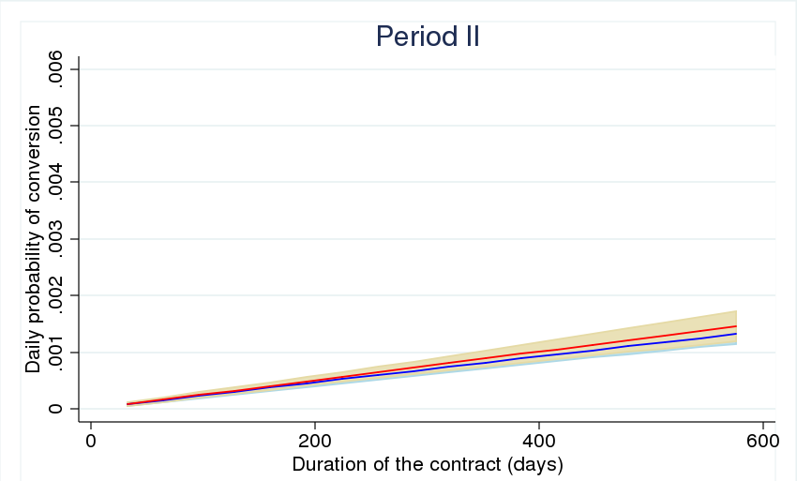
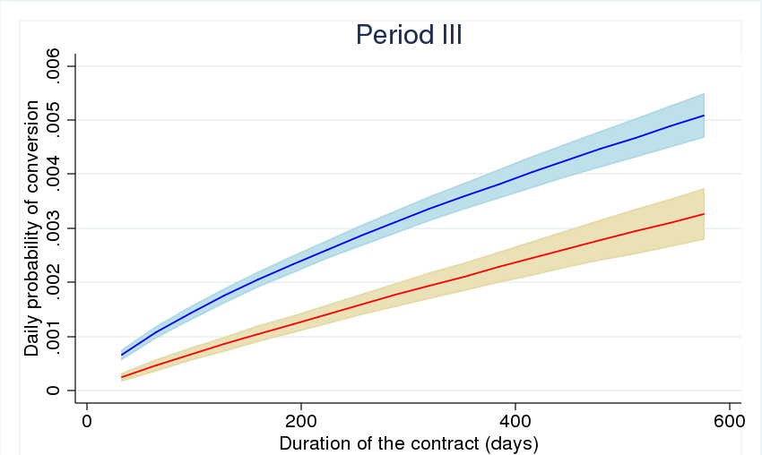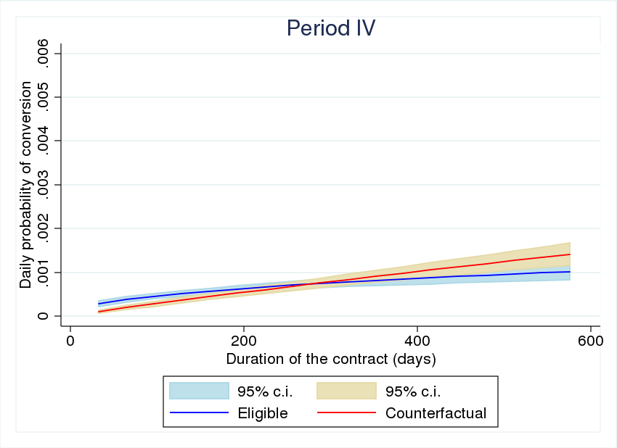
Note: Predictions are from a logit model estimated on a job-relationship – day panel:$${Pr⁡(y}_{it}=1|x_{it})=Λ\left(β_{0}+β_{E}{1\left[Eligible\right]}_{it}+{PERIOD}_{it}^{'} β_{P}+β_{D}{ln\left(duration\right)}_{it}+{1\left[Eligible\right]}_{it}×{PERIOD}_{it}^{'} δ_{P}+{β_{E×D}{1\left[Eligible\right]}_{it}×{ln\left(duration\right)}_{it}+{ln\left(duration\right)}_{it}×{PERIOD}_{it}^{'} β_{P×D}+{1\left[Eligible\right]}_{it}×{ln\left(duration\right)}_{it}×{PERIOD}_{it}^{'} δ_{P×D}+ε}_{it}\right)$$
where PERIOD is a 3×1 vector of the three periods dummy while duration refers to the elapsed duration in days. Time refers to a single day. The dependent variable is 0 for all the observations where the job-relationship is still fixed-term and 1 only for the day in which it gets converted. Predictions are obtained for the eligible group only. The counterfactual is obtained by setting the interaction equal to zero (see Puhani, 2012; Karaca-Mandic et al, 2012). The graph is produced up to the 95 percentile of the distribution of elapsed durations.

Figure A2 Comparison with the predicted daily probability of conversion between eligible and counterfactual.
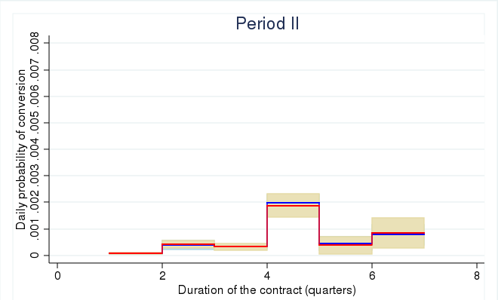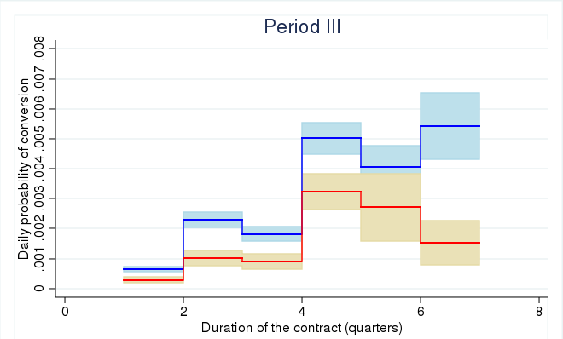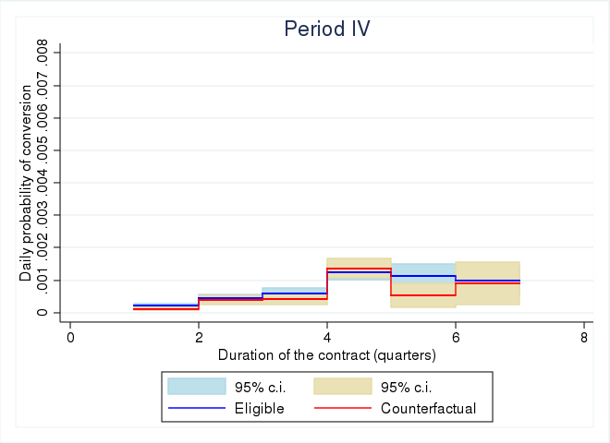
Note: Predictions are from a logit model as in figure A1, but with dummies for duration in quarters instead of log(duration) in days and a full set of interactions. The graph is produced up to the 95 percentile of the distribution of elapsed durations.

