Supplementary Table S1. The genotyping primer sequences of PRKCD and CARD9.
Gene | SNPs ID | Alleles | 2nd-PCRP | 1st-PCRP | UEP_SEQ
PRKCD | rs4687706 | G/A | ACGTTGGATGAGATTGACCAGCTCAAGCAC | ACGTTGGATGTGCTCCATGGCGTGCCTGA | TGGAGCGCAAGCACAC
PRKCD | rs3773732 | A/G | ACGTTGGATGCCTCCTCATCCACTGTAAAG | ACGTTGGATGCTTTTTGGACGTGGATGTGC | CACTGTAAAGGCCCTCGG
PRKCD | rs6797662 | C/T | ACGTTGGATGATCCTCAGAGGACAGCTCAC | ACGTTGGATGCCACCCCCTACACTGTTTC | ACAGCTCACCAAACC
PRKCD | rs6764111 | A/G | ACGTTGGATGTCAGGCCACACTCAGAGCA | ACGTTGGATGGTTTGTGGTTTTCCCTCCAG | AGCTGCTGCTCACATTT
PRKCD | rs3821689 | T/C | ACGTTGGATGTATGGTGCACATTCATGCCG | ACGTTGGATGCTTTCTCTTGCTCTCCTGCG | CTCAGCCAAGGGCAG
PRKCD | rs13084863 | C/T | ACGTTGGATGCCGCATTCATGCCTCCCAT | ACGTTGGATGATGCATTCAGCAGCCACCCT | cttcgTGCCTCCCATCTCCCA
PRKCD | rs78346230 | C/T | ACGTTGGATGATCAGCAGCCCAGAGGTAAG | ACGTTGGATGGTTTCCATTTGTCCCAGAGG | CCAGAGGTAAGGAAAGG
PRKCD | rs2306572 | A/G | ACGTTGGATGTCTCCAGGCTCCTCCTTCG | ACGTTGGATGTCTACACAAAGCCACCGTTC | GCAGGAGGAAGACTCAAG
PRKCD | rs74437127 | C/T | ACGTTGGATGAGGTAAGGTGTGATGCGTGA | ACGTTGGATGACTACGAGAACGATGACGAG | gCGGAAGCCCTCCAGGACG
PRKCD | rs45596236 | G/A | ACGTTGGATGAACCTAACCAAACCCCTCCT | ACGTTGGATGAACCTGCTAGGCTGCCTGAT | GGGGTGAGGGCACAC
CARD9 | rs4073153 | A/G | ACGTTGGATGACATGGACACGCCTCAAAAC | ACGTTGGATGATTTTAAGTGCCTTCCACTG | gTAACAGACTTCTTACACAGA
CARD9 | rs9411205 | C/T | ACGTTGGATGCACGTGTGCTGATGTATACC | ACGTTGGATGATGCATTCCTGTTCCTGCTG | ttATGTATACCAGCACAGGAG
CARD9 | rs3812555 | C/T | ACGTTGGATGAGTTGGACAAGCTTCCTGAG | ACGTTGGATGTTCTGAGCTGCAGCCAAAGG | cggtAAGGAGGAGCCGCAGAC
CARD9 | rs59902911 | C/T | ACGTTGGATGCTCTTGGGATGTTGTTGTGC | ACGTTGGATGTATCACAGGCTGAGGGTCAC | ttgaGGGAGAGCTAGGGGTTG
CARD9 | rs11145769 | G/A | ACGTTGGATGTGTGCTCCTGGACATCCTG | ACGTTGGATGACCTTCTTGTACAGCTGCGG | ggcgtACCGGCCACAAGGGCTA

Supplemental Table S2. Parameters chosen for statistical power analyses.
Parameter | Value | Note
Cases | 912 | Sample size
Controls | 878 | Sample size
Significance Level | 0.0038 | 0.05/13≈0.0038
Prevalence | 0.00001 | Cao S, et al. Br J Ophthalmol. 2016;100(3):436-442.
Disease Allele Frequency | 0.197 | Average MAF of the 13 selected SNPs
Genotype Relative Risk | 1.4 | -

Supplementary Figure S1. Statistical power achieved by the study setting versus genotypic relative risk.
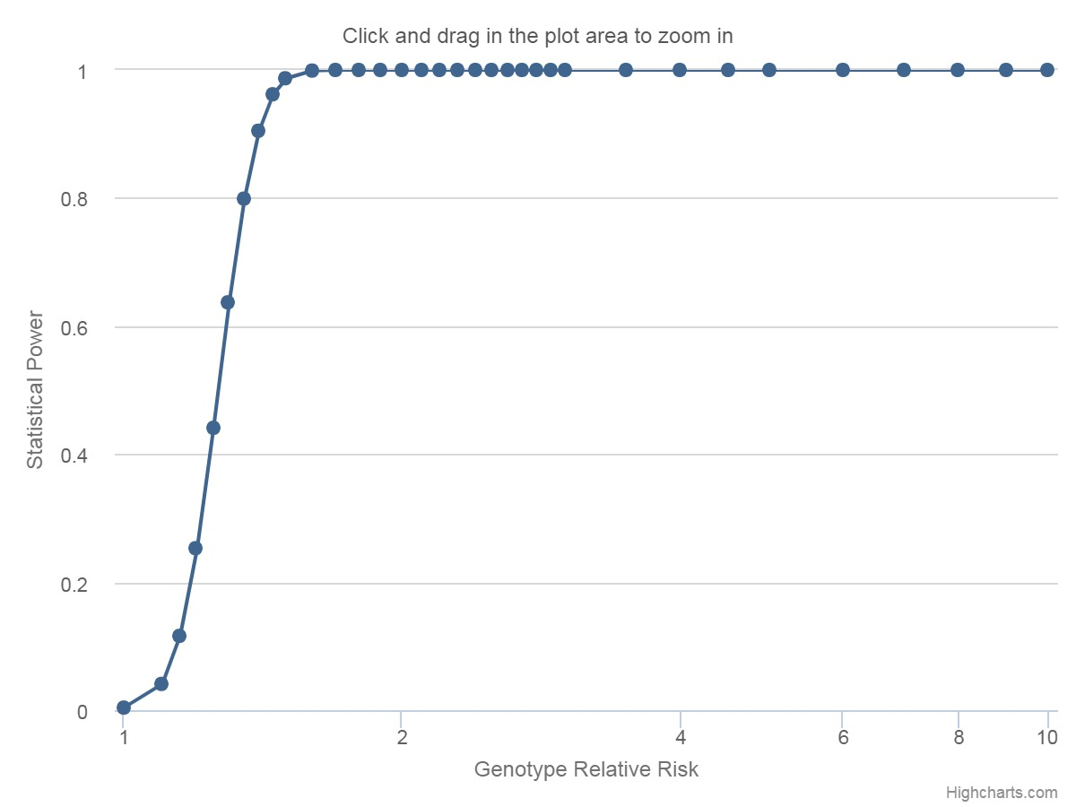
90.5%, RR=1.4
The figure was generated by GAS power calculator (version 4.2.5) http://csg.sph.umich.edu/abecasis/gas_power_calculator/index.html

Supplemental Table S3. Genetic information for the 13 tag SNPs selected for genotyping.
CHR | Position | SNP | Gene | Function | A1 | A2 | MAF | HWE | Call Rate
3 | 53190870 | rs4687706 | PRKCD | None | G | A | 0.257 | 0.07 | 98.0%
3 | 53200876 | rs3773732 | PRKCD | Intron | A | G | 0.379 | 0.43 | 93.5%
3 | 53207401 | rs6764111 | PRKCD | Intron | A | G | 0.058 | 0.54 | 99.9%
3 | 53208917 | rs3821689 | PRKCD | Intron | T | C | 0.248 | 0.10 | 97.3%
3 | 53216990 | rs78346230 | PRKCD | Intron | T | C | 0.078 | 0.62 | 99.9%
3 | 53217413 | rs2306572 | PRKCD | Intron | G | A | 0.204 | 0.14 | 99.6%
3 | 53218837 | rs74437127 | PRKCD | Intron | T | C | 0.068 | 0.06 | 99.8%
3 | 53220569 | rs45596236 | PRKCD | Intron | A | G | 0.214 | 0.53 | 99.5%
9 | 139259349 | rs4073153 | CARD9 | Intron | G | A | 0.301 | 0.17 | 94.4%
9 | 139260463 | rs9411205 | CARD9 | Intron | C | T | 0.364 | 0.11 | 98.5%
9 | 139261933 | rs3812555 | CARD9 | Intron | T | C | 0.136 | 0.23 | 92.0%
9 | 139265088 | rs59902911 | CARD9 | Synonymous | T | C | 0.078 | 0.16 | 98.0%
9 | 139265870 | rs11145769 | CARD9 | Synonymous | A | G | 0.087 | 0.27 | 99.7%
CHR:chromosome; A1: minor allele; A2: major allele; MAF: minor allele frequency; HWE: P-value for Hardy Weinberg equilibrium tests conducted in controls.

Supplementary Table S4. Genotypic and allelic distributions of tag SNPs of PRKCD and CARD9.
Gene | SNPs | Genotype  Allele | VKH n (%) | Control n (%) | P Value | Pc Value | OR (95%CI)
PRKCD | rs4687706 | AA | 502(0.562) | 468(0.548) | 0.570 | NS | 1.056(0.875-1.276)
 |  | GA | 343(0.384) | 342(0.400) | 0.472 | NS | 0.932(0.769-1.129)
 |  | GG | 49(0.055) | 44(0.052) | 0.760 | NS | 1.068(0.703-1.622)
 |  | A | 1347(0.753) | 1278(0.748) | 0.727 | NS | 1.028(0.882-1.198)
 |  | G | 441(0.247) | 430(0.252) | 0.727 | NS | 0.973(0.835-1.134)
 | rs3773732 | AA | 92(0.106) | 100(0.122) | 0.305 | NS | 0.854(0.632-1.154)
 |  | GA | 412(0.477) | 357(0.437) | 0.101 | NS | 1.174(0.969-1.423)
 |  | GG | 360(0.417) | 360(0.441) | 0.321 | NS | 0.907(0.747-1.100)
 |  | A | 596(0.345) | 557(0.341) | 0.806 | NS | 1.018(0.883-1.174)
 |  | G | 1132(0.655) | 1077(0.659) | 0.806 | NS | 0.982(0.852-1.133)
 | rs6764111 | AA | 4(0.004) | 2(0.002) | 0.687* | NS | 1.925(0.352-10.53)
 |  | GA | 50(0.055) | 64(0.073) | 0.115 | NS | 0.736(0.502-1.078)
 |  | GG | 858(0.941) | 810(0.925) | 0.173 | NS | 1.295(0.892-1.879)
 |  | A | 58(0.032) | 68(0.039) | 0.255 | NS | 0.813(0.569-1.162)
 |  | G | 1766(0.968) | 1684(0.961) | 0.255 | NS | 1.230(0.861-1.756)
 | rs3821689 | CC | 496(0.551) | 463(0.551) | 0.981 | NS | 1.002(0.830-1.211)
 |  | CT | 352(0.391) | 334(0.397) | 0.797 | NS | 0.975(0.804-1.182)
 |  | TT | 52(0.058) | 44(0.052) | 0.618 | NS | 1.111(0.735-1.679)
 |  | C | 1344(0.747) | 1260(0.749) | 0.868 | NS | 0.987(0.847-1.150)
 |  | T | 456(0.253) | 422(0.251) | 0.868 | NS | 1.013(0.869-1.181)
 | rs78346230 | CC | 733(0.804) | 721(0.822) | 0.319 | NS | 0.886(0.698-1.124)
 |  | CT | 165(0.181) | 147(0.168) | 0.458 | NS | 1.097(0.859-1.401)
 |  | TT | 14(0.015) | 9(0.010) | 0.404* | NS | 1.504(0.647-3.492)
 |  | C | 1631(0.894) | 1589(0.906) | 0.242 | NS | 0.878(0.705-1.092)
 |  | T | 193(0.106) | 165(0.094) | 0.242 | NS | 1.140(0.915-1.419)
 | rs2306572 | AA | 563(0.619) | 547(0.624) | 0.825 | NS | 0.979(0.808-1.185)
 |  | AG | 300(0.330) | 281(0.321) | 0.676 | NS | 1.043(0.856-1.272)
 |  | GG | 46(0.051) | 48(0.055) | 0.692 | NS | 0.919(0.607-1.393)
 |  | A | 1426(0.784) | 1375(0.785) | 0.975 | NS | 0.997(0.850-1.170)
 |  | G | 392(0.216) | 377(0.215) | 0.975 | NS | 1.003(0.855-1.176)
 | rs45596236 | AA | 52(0.057) | 50(0.057) | 0.996 | NS | 1.001(0.671-1.493)
 |  | AG | 320(0.352) | 304(0.348) | 0.839 | NS | 1.020(0.840-1.240)
 |  | GG | 536(0.590) | 520(0.595) | 0.841 | NS | 0.981(0.812-1.185)
 |  | A | 424(0.233) | 404(0.231) | 0.868 | NS | 1.013(0.867-1.184)
 |  | G | 1392(0.767) | 1344(0.769) | 0.868 | NS | 0.987(0.845-1.153)
CARD9 | rs4073153 | AA | 487(0.555) | 423(0.519) | 0.135 | NS | 1.157(0.956-1.401)
 |  | AG | 309(0.352) | 317(0.389) | 0.119 | NS | 0.855(0.701-1.041)
 |  | GG | 81(0.092) | 75(0.092) | 0.981 | NS | 1.004(0.722-1.396)
 |  | A | 1283(0.731) | 1163(0.713) | 0.243 | NS | 1.094(0.941-1.272)
 |  | G | 471(0.269) | 467(0.287) | 0.243 | NS | 0.914(0.786-1.063)
 | rs9411205 | CC | 117(0.130) | 119(0.138) | 0.640 | NS | 0.937(0.712-1.232)
 |  | CT | 361(0.401) | 374(0.432) | 0.183 | NS | 0.879(0.728-1.063)
 |  | TT | 422(0.469) | 372(0.430) | 0.101 | NS | 1.170(0.970-1.412)
 |  | C | 595(0.331) | 612(0.354) | 0.146 | NS | 0.902(0.785-1.037)
 |  | T | 1205(0.669) | 1118(0.646) | 0.146 | NS | 1.109(0.965-1.274)
 | rs59902911 | CC | 772(0.854) | 701(0.817) | 0.036 | NS | 1.310(1.017-1.687)
 |  | TC | 126(0.139) | 145(0.169) | 0.085 | NS | 0.796(0.614-1.032)
 |  | TT | 6(0.007) | 12(0.014) | 0.156* | NS | 0.471(0.176-1.261)
 |  | C | 1670(0.924) | 1547(0.902) | 0.020 | NS | 1.322(1.045-1.673)
 |  | T | 138(0.076) | 169(0.098) | 0.020 | NS | 0.756(0.598-0.957)
 | rs11145769 | AA | 9(0.010) | 14(0.016) | 0.297* | NS | 0.615(0.265-1.428)
 |  | GA | 139(0.153) | 166(0.190) | 0.039 | NS | 0.771(0.602-0.987)
 |  | GG | 761(0.837) | 695(0.794) | 0.019 | NS | 1.332(1.047-1.694)
 |  | A | 157(0.086) | 194(0.111) | 0.014 | NS | 0.758(0.608-0.946)
 |  | G | 1661(0.914) | 1556(0.889) | 0.014 | NS | 1.319(1.057-1.646)
VKH, VKH disease; OR, odds ratio; 95 % CI, 95 % confidence interval; NS, not significant;
Pc value, P value with Bonferroni correction; Pc value < 0.05 was regarded to have statistical significance;
* Fischer's exact test; Values with statistical significance are in boldface.

Supplementary Table S5. Full lists of eQTL and sQTL signals identified for SNP rs3812555 on CARD9.
Signals | Gene | SNP | Variant ID | P Value | NES | Tissue
eQTL | CARD9 | rs3812555 | chr9_136367481_C_T_b38 | 2.00×10⁻²⁰ | 0.2 | Whole Blood
eQTL | CARD9 | rs3812555 | chr9_136367481_C_T_b38 | 1.10×10⁻⁸ | 0.14 | Lung
eQTL | CARD9 | rs3812555 | chr9_136367481_C_T_b38 | 1.60×10⁻⁶ | -0.25 | Cells-Cultured fibroblasts
sQTL | CARD9 | rs3812555 | chr9_136367481_C_T_b38 | 6.30×10⁻²¹ | 0.54 | Whole Blood
sQTL | CARD9 | rs3812555 | chr9_136367481_C_T_b38 | 6.80×10⁻¹⁰ | 0.42 | Lung
NES, normalized effect size.

Supplementary Figures S2A,B. Linkage disequilibrium plot for PRKCD and CARD9 gene.
- The LD analysis of the examined eight tag SNPs of PRKCD were generated by SHEsis online platform. Numbers listed in each square represent the Dʹ value for pairwise analysis. (B) The LD analysis of the examined five tag SNPs of CARD9 were generated by SHEsis online platform. Numbers listed in each square represent the Dʹ value for pairwise analysis.

Supplementary Figures S3A,B. Relationship between rs3812555 and CARD9 expression.
(A) CARD9 expression in unstimulated PBMCs from healthy controls with different genotypes of rs3812555 (CC = 22, TC = 15, TT = 1). (B) CARD9 expression in LPS-stimulated PBMCs from healthy controls with different genotypes of rs3812555 (CC = 22, TC = 15, TT = 1).

Supplementary Figures S4A-D. Relationship between rs3812555 and cytokines production.
The production of IL-1β (A), IL-6 (B), IL-17 (C), and IL-23 (D) by anti-CD3/CD28-stimulated PBMCs from healthy controls with different genotypes of rs3812555 (CC = 22, TC = 15, TT = 1).

