Figure S1: Genealogical trees of to the 6 consanguineous MMA probands

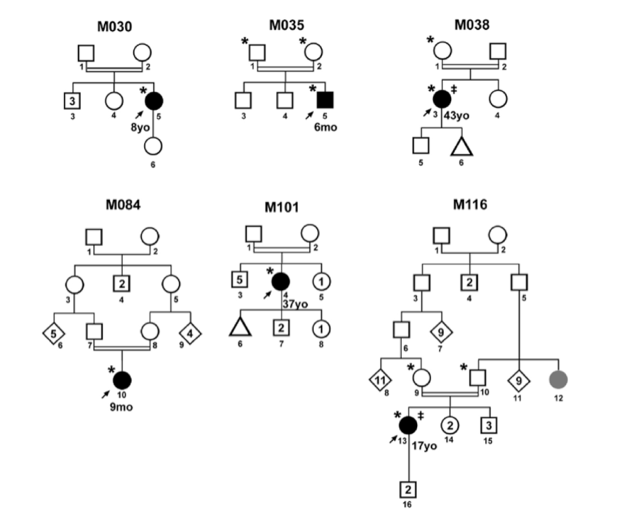
The parents of M035 and M038 probands are first cousins. The parents of M101 proband were second cousins. The parents of the M030 proband were not reported to be consanguineous but a high proportion of homozygous variants was detected in M030 exome data, and consanguinity was confirmed by loss of heterozygosity analysis.

Legend :
 proband,  WES,  male, female,  male(s) or female(s),  MMA-affected (age at first symptoms indicated under the symbol in years (yo) or months (mo)),  relative showing an early-onset (<50 years-old) but poorly documented cerebrovascular event  clinically unaffected individual  early-onset non-cerebrovascular cardiovascular disease  miscarriage

