SUPPLEMENTARY FIGURES

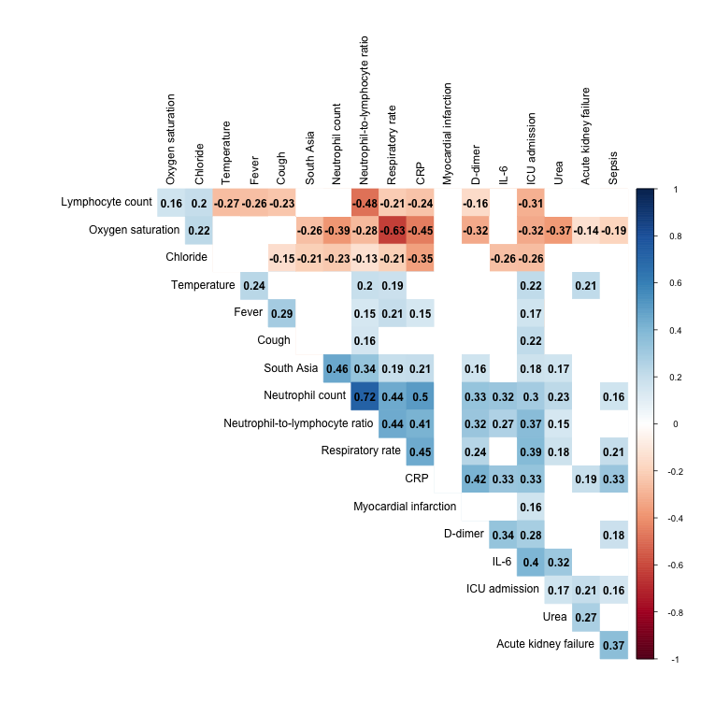
Supplementary Figure 1. Correlogram of ICU admission and the 18 clinical variables significantly associated with it. Plot only shows significant Pearson correlations (FDR < 0.05).

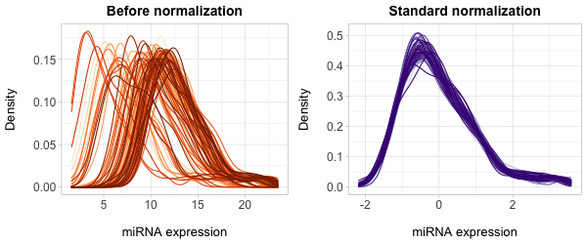
Supplementary Figure 2. Density plots of microRNA expression before and after standardization. Each line represents one of the 96 individuals in the dataset.

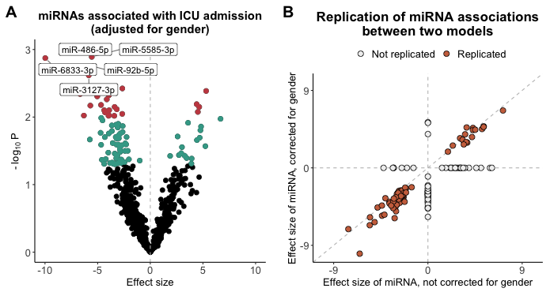
Supplementary Figure 3. (A) Volcano plot of miRNAs associated with ICU admission. Age and self-reported time from symptom onset to hospital admission were used as covariates in a logistic regression model. miRNAs significant at p < 0.05 are highlighted in blue. miRNAs significant at p < 0.01 are highlighted in red. The 5 most significant miRNAs are labeled. (B) Comparison of effect sizes of miRNA associations with ICU admission, with gender as a covariate (x-axis), and without gender as a covariate (y-axis). Age and self-reported time from symptom onset were used as covariates in both models.

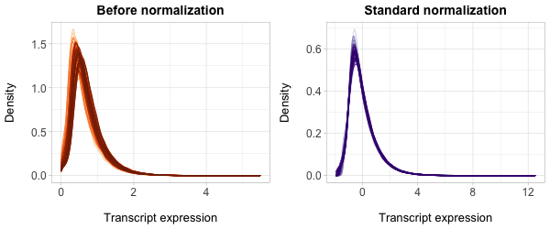
Supplementary Figure 4. Density plots of transcript expression before and after standardization. Each line represents one of 94 individuals in the dataset.

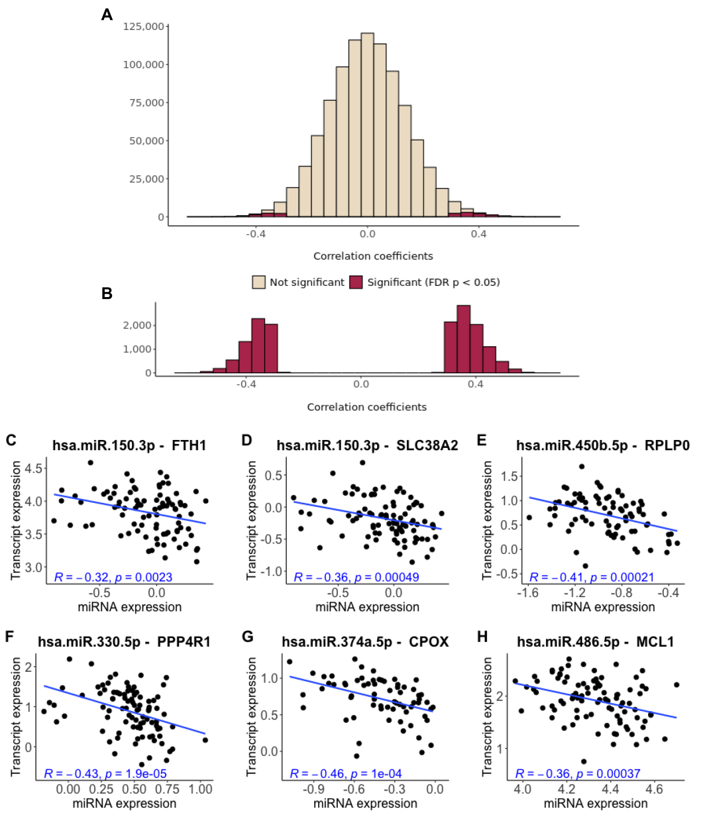Supplementary Figure 5. (A-B) Distribution of miRNA-mRNA Spearman correlation coefficients for the 21 miRNAs significantly associated with ICU admission for all correlations (A), and significant correlations (B). (C-H) Examples of highly predicted miRNA-gene target pairs whose levels were negatively correlated in our dataset. Both the miRNA expression (x-axis) and the transcript expression (y-axis) were standardized.

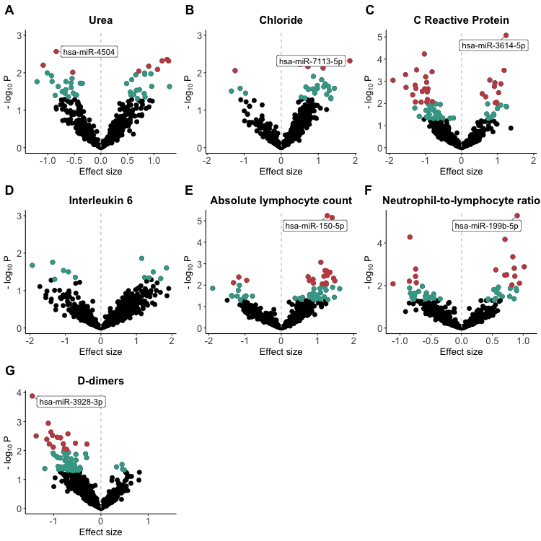
Supplementary Figure 6. Numerous miRNAs are associated with each of the 8 blood phenotypes correlated with ICU admission. Both miRNA expression and blood phenotype levels were measured from the same blood sample, collected at the time of hospital admission. miRNAs significant at p < 0.05 are highlighted in blue. miRNAs significant at p < 0.01 are highlighted in red. The top miRNA for each blood phenotype (lowest P-value, p < 0.01) is labeled. Both miRNA expression and blood phenotype levels were standardized.

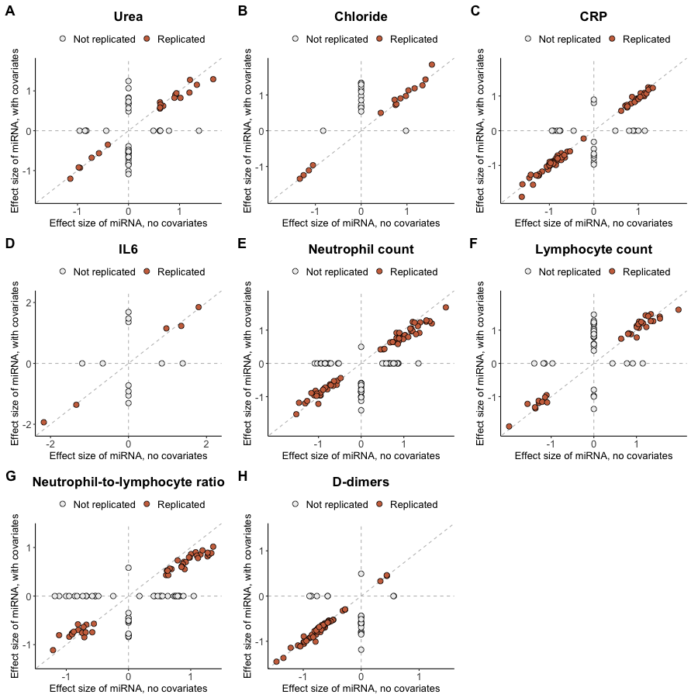
Supplementary Figure 7. Comparison of effect sizes of miRNA associations with different blood phenotypes, in unadjusted models (no covariates, x-axis) and adjusted models (age and gender as covariates, y-axis).

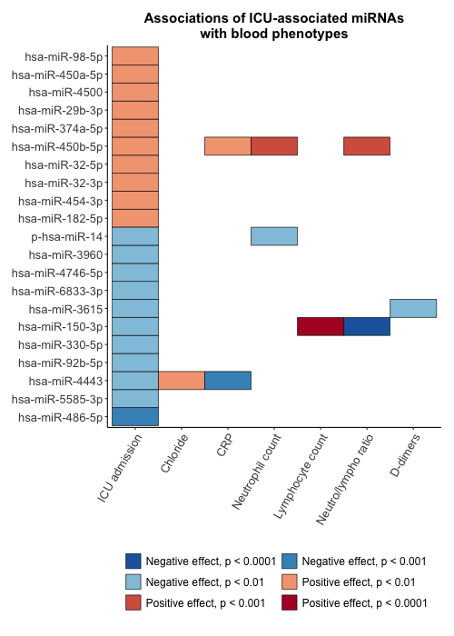
Supplementary Figure 8. Some of the miRNAs associated with ICU admission are also associated with blood phenotypes.

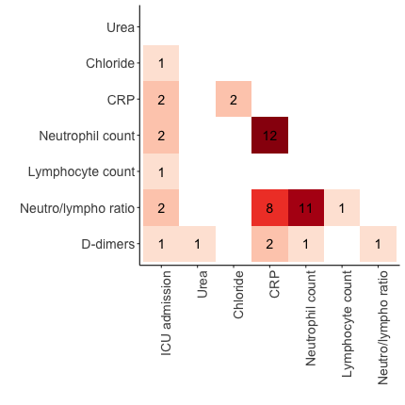
Supplementary Figure 9. Number of miRNA associations shared between pairs of blood phenotypes. Blank tile means that the two phenotypes share no significant (p < 0.01) miRNAs associations.

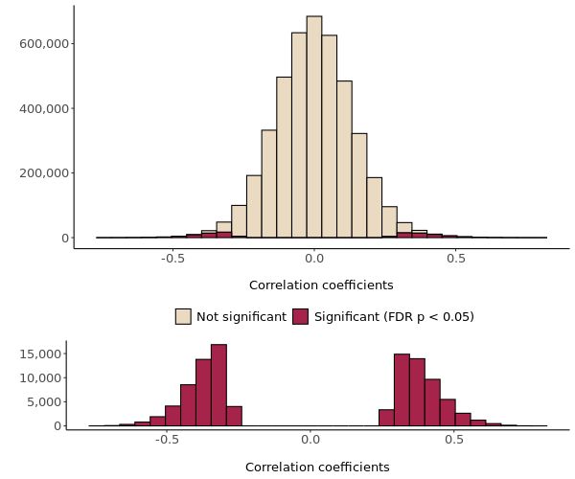
Supplementary Figure 10. (A-B) Distribution of miRNA-mRNA Spearman correlation coefficients for the 97 miRNAs significantly associated with ICU-associated blood phenotypes for all correlations (A), and significant correlations (B).

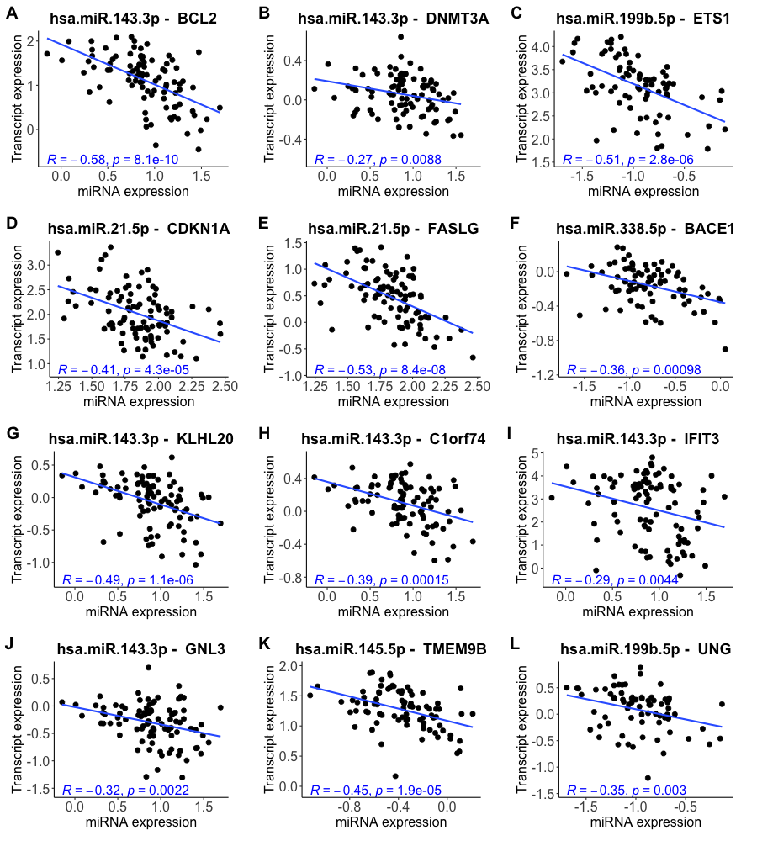
Supplementary Figure 11. Examples of miRNA-mRNA cross correlations for miRNAs associated with one of the 8 blood phenotypes. (A-F) Experimentally observed miRNA-gene target pairs that were negatively correlated in our dataset. (G-L) Highly predicted miRNA-gene target pairs that were negatively correlated in our dataset. Both the miRNA expression (x-axis) and the transcript expression (y-axis) have been standardized.

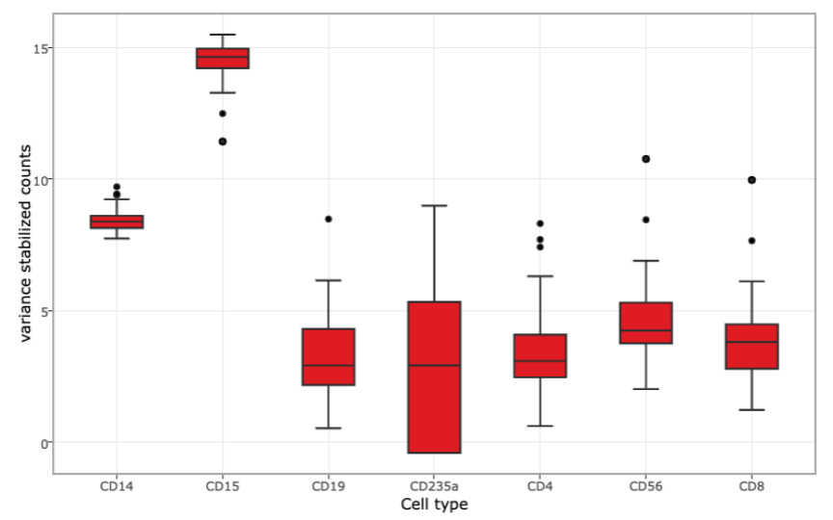
Supplementary Figure 12. Expression of hsa-miR-143-3p in different human peripheral blood types. Figure adapted from Juzenas et al. 2017, and screenshotted from http://134.245.63.235/ikmb-tools/bloodmiRs/.

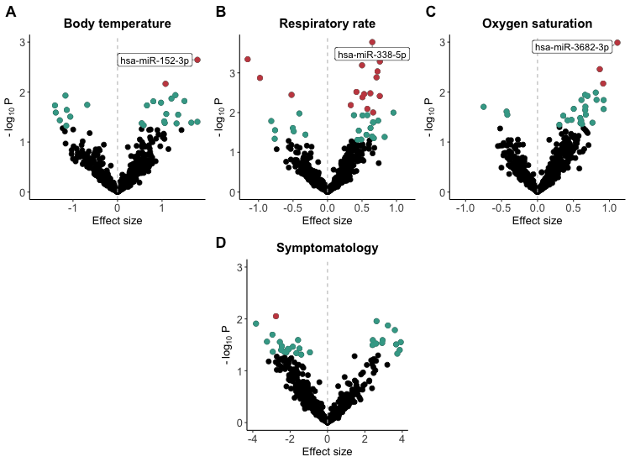
Supplementary Figure 13. Numerous miRNAs are associated with clinical and self-reported proxies of COVID-19 disease severity. (A-C) Clinical proxies of severity: temperature, respiratory rate, and oxygen saturation. (D) Being highly symptomatic is a self-reported proxy of severity; it refers to self-reporting 4 or more symptoms (out of 13) at time of hospital admission. Both miRNA expression and physical measurements were measured from the same blood sample, collected at the time of hospital admission. Both miRNA expression and physical measurements were standardized. miRNAs significant at p < 0.05 are highlighted in blue. miRNAs significant at p < 0.01 are highlighted in red. The top miRNA for each blood phenotype (lowest P-value, p < 0.01) is labeled.

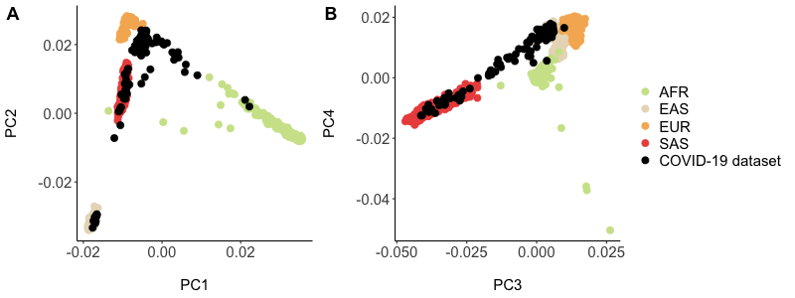
Supplementary Figure 14. Principal component analysis (PCA) of the COVID-19 dataset (this study) and four reference super-populations from the 1000 Genome Project.

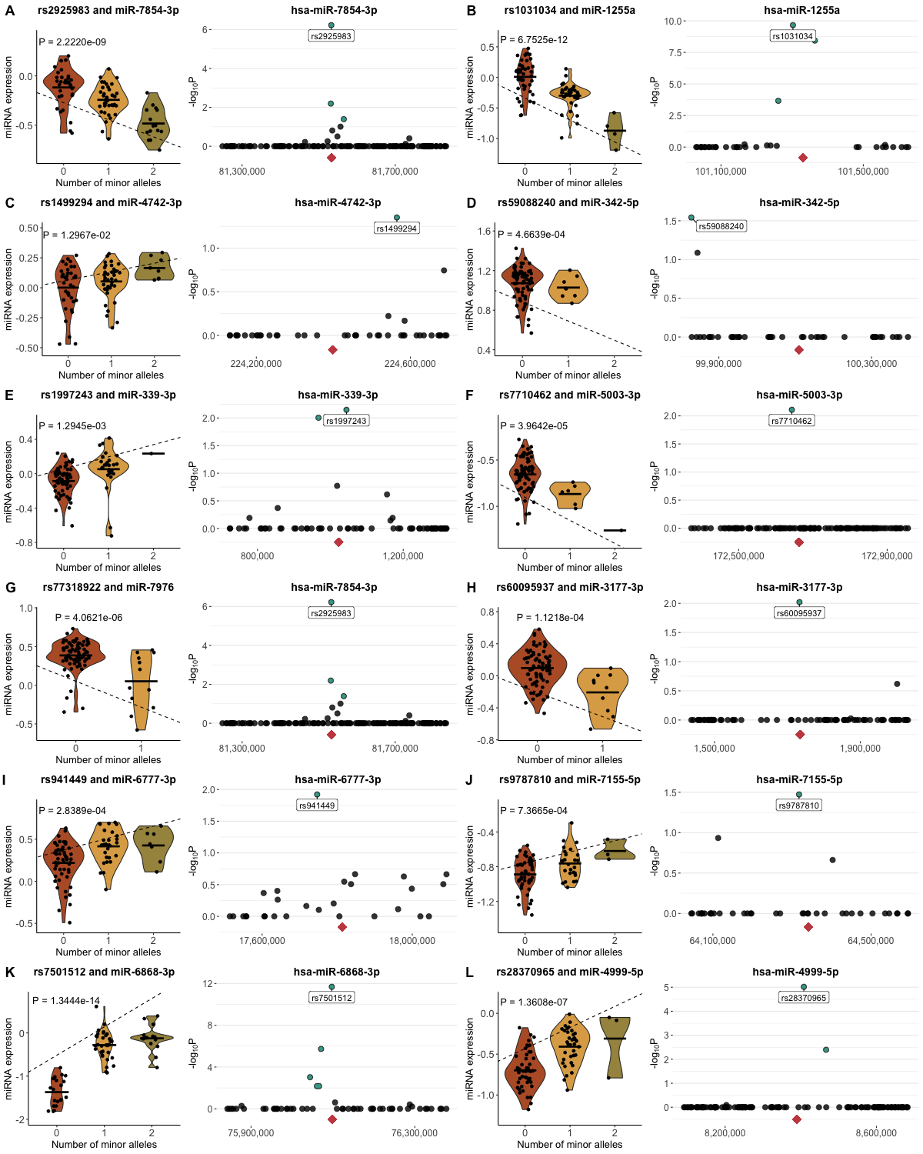
Supplementary Figure 15. Pairs of violin and fine-mapping plots for cis-eQTLs not included in Figure 3. The violin plot shows the linear relationships between the number of minor alleles and miRNA expression associated with each genotype. The dashed line corresponds to the linear regression fit, and the p-value is stated on the plot. The fine-mapping plot shows all tested SNPs for each miRNA. Points highlighted in blue show e-SNPs significant at Bonferroni P < 0.05. Labeled point shows the top e-SNP for that cis-eQTL. The pink diamond shows the genomic position of the miRNA.
SUPPLEMENTARY NOTES

- Classifications by regions

The patients in the study reported 25 different nationalities, which we had categorized into 4 large regions as follows:

Region | Nationalities
Middle East and North Africa (MENA) | Egyptian, Emirati, Iranian, Iraqi, Jordanian, Lebanese, Moroccan, Omani, Palestinian, Syrian, Tunisian, Yemeni
Africa (excluding MENA) | Comoran, Ethiopian, Sudanese, Ugandan
Southeast Asia | Bangladeshi, Filipino, Indian, Indonesian, Nepalese, Pakistani, Sri Lankan
North America and Australia | American, Australian

- List of potential COVID-19 factors

This is the full list of COVID-19 factors that were collected and tested for correlations with ICU admission:

Category | Independent variables
Demographics | - Age  - Gender  - MENA  - Southeast Asia  - Africa (excluding MENA)  - North America and Australia
Physical measurements | - BMI  - Temperature  - Oxygen saturation  - Respiratory rate  - Systolic pressure  - Diastolic pressure
Blood groups | - Blood group A  - Blood group B  - Blood group AB  - Blood group O  - Blood group - positive  - Blood group - negative
Pre-existing conditions | - Hypertension  - Diabetes  - Asthma  - Ischemic heart disease  - Cancer  - Acute kidney failure  - Chronic kidney disease  - Fungal infection  - HIV  - Sepsis  - Myocardial infarction  - Number of existing conditions
Symptoms at admission | - Fever  - Fatigue  - Headache  - Cough  - Sore throat  - Difficulty breathing  - Runny nose  - Muscle pain  - Nausea  - Loss of appetite  - Loss of sense of taste  - Loss of sense of smell  - Eye pain
Lab tests | - Urea  - Chloride  - CO2  - Potassium  - Magnesium  - Phosphorous  - Bilirubin  - C reactive protein (CRP)  - Troponin T  - Vitamin D OH  - Interleukin 6 (IL6)  - Absolute neutrophil number  - Absolute lymphocyte number  - Neutrophil-to-lymphocyte ratio  - HbA1c  - Procalcitonin  - D-dimers  - HEPB
Other | - SARS-CoV-2 viral load

- Comparison of miRNA results to other studies

- Li et al., 2021b identified 6 miRNAs that are differentially expressed between COVID-19 patients and healthy controls. Of these, 3 (50%) were associated with ICU or an ICU-associated blood phenotype in our dataset:

miRNA | Association in our dataset
miR-6501-5p | Lymphocyte count
miR-183-5p | Interleukin-6
miR-144-3p | ICU admission

- Gutmann et al., 2022 identified 69 miRNAs that were significantly differentially expressed between healthy controls and COVID-19 patients with severe disease. Of these, 31 (45%) were associated with ICU or an ICU-associated blood phenotype in our dataset.

miRNA | Association in our dataset
miR-4454 | Interleukin-6
miR-3960 | Chloride, C-reactive protein, Neutrophil count
miR-199b-5p | C-reactive protein, Neutrophil count, Neutrophil-to-lymphocyte ratio
miR-210-3p | C-reactive protein
miR-21-5p | C-reactive protein, Neutrophil count, Neutrophil-to-lymphocyte ratio
miR-22-3p | Chloride
miR-15a-5p | Chloride
miR-32-5p | C-reactive protein, Neutrophil count, D-dimers
miR-505-3p | Neutrophil count, Neutrophil-to-lymphocyte ratio
miR-199a-5p | Neutrophil count, Neutrophil-to-lymphocyte ratio
miR-324-3p | Urea
miR-425-5p | Lymphocyte count
miR-92a-3p | ICU admission
miR-93-3p | Urea, Neutrophil count
miR-181a-3p | D-dimers
miR-98-5p | Lymphocyte count
miR-26b-5p | Lymphocyte count
miR-181d-5p | C-reactive protein, Neutrophil count
miR-146b-5p | Chloride, Lymphocyte count
miR-let-7a-5p | Urea
miR-146a-5p | Lymphocyte count
miR-363-3p | Lymphocyte count
miR-10a-5p | D-dimers
miR-342-3p | C-reactive protein, Lymphocyte count, Neutrophil-to-lymphocyte ratio
miR-183-5p | Interleukin-6
miR-145-3p | C-reactive protein, Neutrophil count, Neutrophil-to-lymphocyte ratio
miR-182-5p | ICU admission
miR-let-7f-5p | Lymphocyte count
miR-4508 | C-reactive protein, Neutrophil count
miR-181a-2-3p | Chloride, Lymphocyte count
miR-150-5p | Lymphocyte count

- Farr et al., 2021 identified 42 miRNAs that were significantly differentially expressed between healthy controls and COVID-19 patients (that did not receive oxygen treatment). Of these, 15 (35.7%) were associated with ICU or an ICU-associated blood phenotype in our dataset.

miRNA | Association in our dataset
hsa-miR-99b-3p | Urea, Neutrophil count, Neutrophil-to-lymphocyte ratio
hsa-miR-1273h-3p | C-reactive protein, Neutrophil count, Neutrophil-to-lymphocyte ratio
hsa-miR-576-5p | Chloride
hsa-miR-6772-3p | C-reactive protein
hsa-miR-874-3p | Lymphocyte count
hsa-miR-92a-3p | ICU admission
hsa-miR-651-5p | C-reactive protein
hsa-miR-1468-5p | Chloride
hsa-miR-345-5p | C-reactive protein
hsa-miR-339-3p | C-reactive protein
hsa-miR-6503-3p | Interleukin-6
hsa-miR-132-3p | D-dimers
hsa-miR-877-5p | D-dimers
hsa-miR-450b-5p | C-reactive protein, Neutrophil count, Neutrophil-to-lymphocyte ratio
hsa-miR-30a-3p | Urea, D-dimers

- Fernández-Pato et al., 2022 identified 200 miRNAs that were differentially expressed between SARS-CoV-2 infected individuals and healthy controls. Of these, 55 (27.5%) were also associated with ICU or an ICU-associated blood phenotype in our dataset.

miRNA | Association in our dataset
hsa-miR-4665-5p | ICU admission
hsa-miR-331-3p | Urea, C-reactive protein
hsa-miR-4525 | Lymphocyte count
hsa-miR-6786-3p | ICU admission
hsa-miR-5010-5p | Interleukin-6
hsa-miR-6868-3p | D-dimers
hsa-miR-6804-5p | C-reactive protein
hsa-miR-6511a-3p | ICU admission
hsa-miR-3180 | Neutrophil count, D-dimers
hsa-miR-98-3p | Urea, D-dimers
hsa-miR-671-5p | C-reactive protein, Neutrophil count
hsa-miR-581 | Urea
hsa-miR-1273h-5p | D-dimers
hsa-miR-197-5p | Lymphocyte count
hsa-miR-7854-3p | D-dimers
hsa-miR-3605-5p | ICU admission
hsa-miR-5100 | Chloride, C-reactive protein
hsa-miR-3614-5p | C-reactive protein, Neutrophil-to-lymphocyte ratio
hsa-miR-27b-5p | Lymphocyte count
hsa-miR-629-5p | C-reactive protein, Neutrophil count, Neutrophil-to-lymphocyte ratio, D-dimers
hsa-miR-4443 | Chloride, C-reactive protein, Neutrophil count
hsa-miR-760 | C-reactive protein
hsa-miR-651-5p | C-reactive protein
hsa-miR-15a-5p | Chloride
hsa-miR-99b-3p | Urea, Neutrophil count, Neutrophil-to-lymphocyte ratio
hsa-miR-22-3p | Chloride
hsa-miR-125b-5p | Lymphocyte count
hsa-miR-576-3p | Urea, Neutrophil count, Neutrophil-to-lymphocyte ratio
hsa-miR-1273h-3p | C-reactive protein, Neutrophil count, Neutrophil-to-lymphocyte ratio
hsa-miR-5010-3p | D-dimers
hsa-miR-1246 | Neutrophil count, Lymphocyte count
hsa-miR-501-3p | Urea, C-reactive protein
hsa-miR-25-5p | Lymphocyte count, Lymphocyte count
hsa-miR-99b-5p | C-reactive protein, Neutrophil count, Neutrophil count, Neutrophil-to-lymphocyte ratio
hsa-miR-27b-3p | Neutrophil-to-lymphocyte ratio
hsa-miR-7-5p | Neutrophil count, Lymphocyte count, D-dimers
hsa-miR-21-5p | C-reactive protein, Neutrophil count, Neutrophil-to-lymphocyte ratio
hsa-miR-501-5p | Urea, Lymphocyte count
hsa-miR-93-3p | Urea, Neutrophil count
hsa-miR-6805-5p | C-reactive protein
hsa-miR-139-5p | Neutrophil-to-lymphocyte ratio
hsa-miR-671-3p | Urea
hsa-miR-155-5p | Neutrophil count, Lymphocyte count, D-dimers
hsa-miR-4746-5p | D-dimers
hsa-miR-30b-5p | Urea
hsa-miR-342-3p | C-reactive protein, Lymphocyte count, Neutrophil-to-lymphocyte ratio
hsa-miR-146b-5p | Chloride, Lymphocyte count
hsa-miR-7848-3p | C-reactive protein, Neutrophil count, Neutrophil-to-lymphocyte ratio
hsa-miR-132-5p | D-dimers
hsa-miR-150-3p | C-reactive protein, Neutrophil count, Lymphocyte count, Neutrophil-to-lymphocyte ratio, D-dimers
hsa-miR-342-5p | C-reactive protein, Neutrophil-to-lymphocyte ratio, D-dimers
hsa-miR-150-5p | Lymphocyte count
hsa-miR-3158-3p | D-dimers
hsa-miR-659-5p | Urea
hsa-miR-1275 | Lymphocyte count

- Chen et al., 2021 identified 32 miRNAs that were differentially expressed between SARS-CoV-2 infected individuals and healthy controls. Of these, 9 (28.1%) were also associated with ICU or an ICU-associated blood phenotype in our dataset.

miRNA | Association in our dataset
hsa-miR-3614-5p | C-reactive protein, Neutrophil-to-lymphocyte ratio
hsa-miR-652-3p | Urea
hsa-miR-192-5p | Neutrophil count, Lymphocyte count
hsa-miR-581 | Urea
hsa-miR-1291 | Neutrophil count
hsa-miR-3615 | D-dimers
hsa-miR-659-5p | Urea
hsa-miR-132-5p | D-dimers
hsa-miR-4473 | D-dimers

- Li et. al., 2021b identified 23 miRNAs that were differentially expressed between SARS-CoV-2 infected individuals and healthy controls. Of these, 8 (34.8%) were also associated with ICU or an ICU-associated blood phenotype in our dataset.

miRNA | Association in our dataset
hsa-miR-144-3p | ICU admission
hsa-miR-96-5p | C-reactive protein, Lymphocyte count
hsa-miR-183-5p | Interleukin-6
hsa-miR-21-5p | C-reactive protein, Neutrophil count, Neutrophil-to-lymphocyte ratio
hsa-miR-18a-5p | ICU admission
hsa-miR-125b-5p | Lymphocyte count
hsa-miR-6501-5p | Lymphocyte count
hsa-miR-32-5p | C-reactive protein, Neutrophil count, D-dimers

- Kim et. al., 2021 identified 5 miRNAs that were predicted to commonly bind to SARS-CoV, MERS-CoV, and SARS-CoV-2, and that showed differential expression patterns in hamster lungs before and after infection with SARS-CoV-2. Of these, 1 (20%) was also associated with ICU-associated phenotypes in our dataset.

miRNA | Association in our dataset
hsa-miR-15b-5p | Lymphocyte count, Neutrophil-to-lymphocyte ratio

- Latini et al., 2022 highlighted the functional impact of hsa-let-7b-5p on modulating ACE2 and DPP4 levels. They found that hsa-let-7b-5p was downregulated in naso-oropharyngeal swabs of COVID-19 patients compared to controls. In our dataset, we found that hsa-let-7b-5p was associated with urea levels, and hsa-let-7b-3p was associated with ICU admission.

