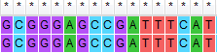
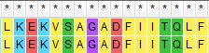
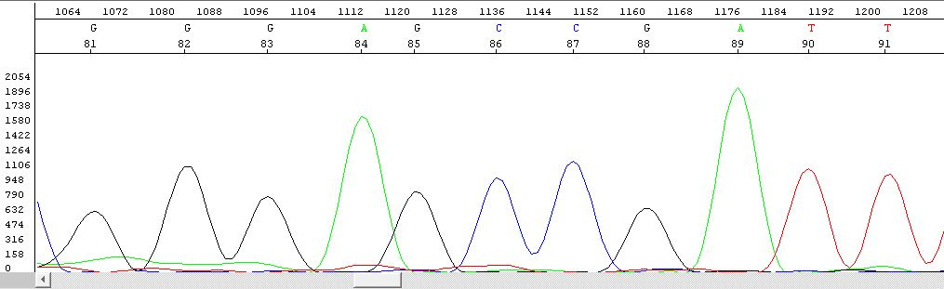
Additional File
Reference Sequence
(b)
C
No Change
(a)
Wildtype Homozygous CC
Mutant Allele Sequence
Reference Translated Sequence
Mutant Allele Translated Sequence
Figure S-1: Sanger sequencing of Wildtype homozygous genotype. (a) There was no change of nucleotide observed in wildtype homozygous, therefore no change was observed in amino acid codon (b). Whereas electropherogram analysis (c) showing one peak confirming the sample had wildtype homozygous genotype (CC).

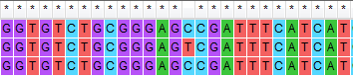
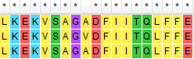
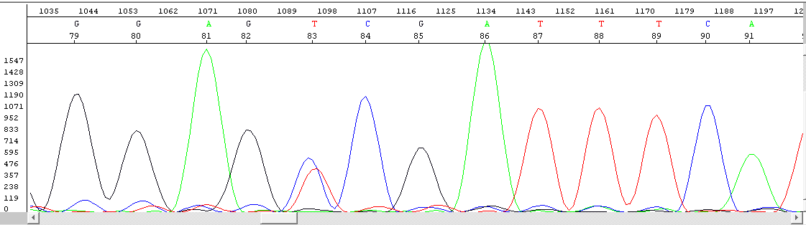
(c)
Reference Sequence
Mutant Allele Sequence
677C>T
(a)
C
T
(b)
226Ala > Val
Reference Translated Sequence
Mutant Allele Translated Sequence
Figure S-2: Sanger sequencing of heterozygous mutant genotype. (a) Nucleotide substitution observed in heterozygous mutant sample which change the coding sequence GCC to GTC causing amino acid alteration from (b) alanine to valine. Whereas electropherogram analysis (c) showing two peaks confirming the sample had heterozygous genotype (CT). No TT genotype observes in random samples.

