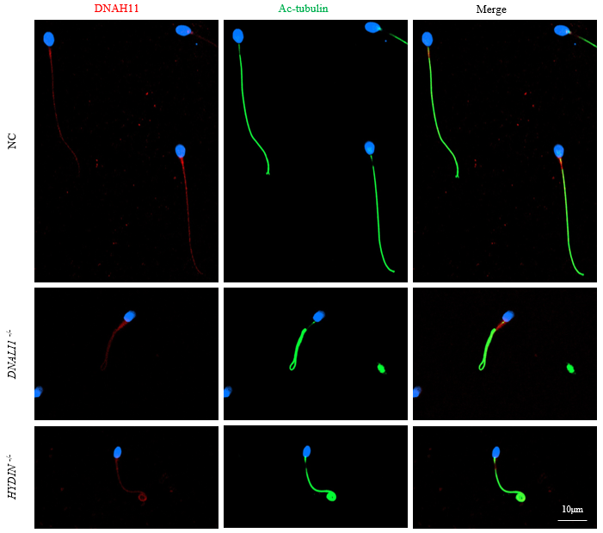

Figure S1. Immunofluorescence staining analysis of DNAH11 in sperm from normal control man, patient with DNALI1 gene pathogenic variants and patient with HYDIN gene pathogenic variants. In the fertile individual, signals of DNAH11 localized along the sperm flagella. Furthermore, the DNAH11 staining was not dramatically reduced and easily found signals in sperm of harboring DNALI1 variants and harboring HYDIN variants. Scale bar: 10μm.

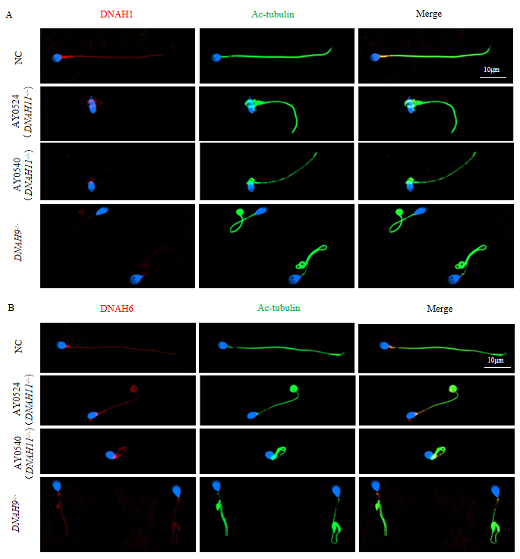
Figure S2. The distribution and expression of proteins related to inner dynein arms (IDA) in patients and control individual. IF results on the sperm of AY0524 and AY0540, patient carrying DNAH9 bi-allelic variants and normal subject using anti-DNAH1(red in A) and anti-DNAH6 (red in B). It was demonstrated that DNAH1 and DNAH6 express at full-length flagella in normal sperm. (A) There were almost no differences for DNAH1 in sperm from AY0524 and AY0540 carrying DNAH11 bi-allelic variants, as well as the subject carrying DNAH9 bi-allelic variants between normal controls. (B) Similarly, distributions of DNAH6 were comparable in sperm obtained from AY0524 and AY0540 harboring DNAH11 bi-allelic variants, and patient carrying DNAH9 bi-allelic variants which the same as in the control sperm. Anti-ac-tubulin (green) marked the sperm flagella, Hoechst (blue) marked the nucleus of spermatozoa. Scale bars: 10μm.

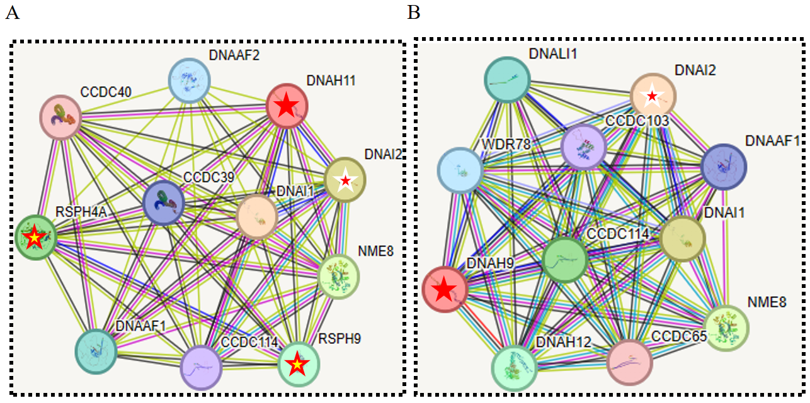
Figure S3. STRING protein-protein interaction analysis of DNAH11 and DNAH9. (A and B) Evidently, it was indicated that DNAH11 may be highly connected with DNAI2 and RSPH4A. (C) By contrast, DNAH9 could be highly associated with DNAI2, but the correlation with RSPH4A is not clear.

Table S1. Primers Used for Amplification and Verification of DNAH11 Mutations
Primer Names | Primer Sequences (5'-3') | Tm
AY0524-F | ATGAATCTGCCCGTGTTTATGG | 49℃
AY0524-R | GCCCTTGTGCACTTCTCTCATAC | 49℃
AY0540-F1 | CATGAAGCCTTTCAAAGTGAGC | 52℃
AY0540-R1 | CGGCTTCTTACAGCCAGAAGAT | 52℃
AY0540-F2 | AATACCTCCTGTGCTGGGACTG | 56℃
AY0540-R2 | CAGCCCTTTGTGGAGAACATC | 56℃
XFY03-F1 | AGGTGGGAGACTAGGGTCTG | 58℃
XFY03-R1 | CCTCTTACCTCCTGGGAAGC | 58℃
XFY03-F2 | AAGGTGTTACACACTGCCCG | 60℃
XFY03-R2 | CATCGACAAGTGAATCGAACTC | 60℃
XFY04-F1 | TCTGATGACAAAAAGATTGT | 55℃
XFY04-R1 | ATCGTCTTTTCACACTTCCCA | 55℃
XFY04-F2 | ATGAATCTGCCCGTGTTTATGG | 58℃
XFY04-R2 | GCCCTTGTGCACTTCTCTCATAC | 58℃

