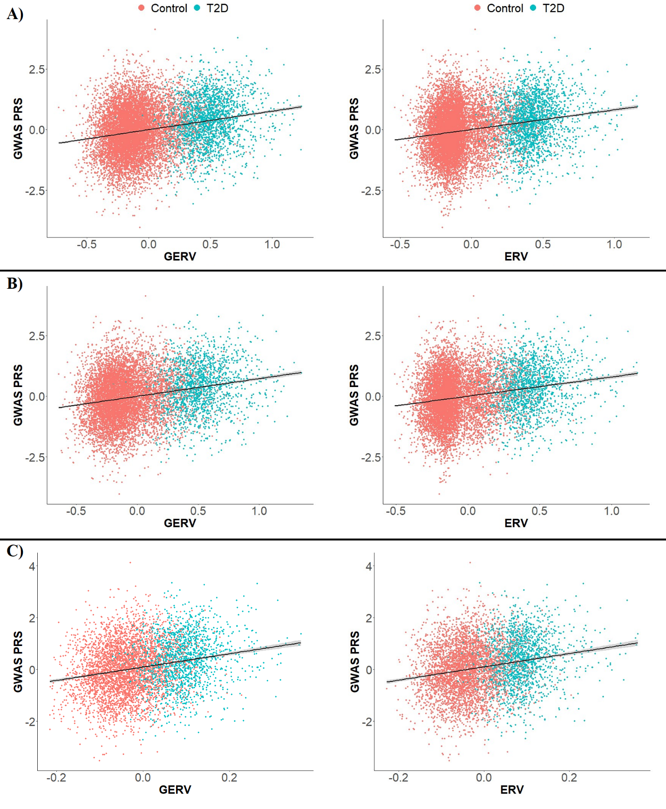
Figure S1. The scatter plots illustrate the relationship between polygenic risk scores (PRS) and genomic estimated risk values (GERV) or estimated risk values (ERV) derived from pedigree-based and SNP-based models. These plots are presented under three distinct scenarios: (A) utilizing all families, (B) considering families with at least one generation, and C) focusing on families with at least one generation that include both case and control subjects.

