Appendix

Content
Appendix 1: PRISMA checklist 3
Appendix 2. Search strategy 6
Take Pubmed for example 6
Logical relations: 5 and 1 and 2 and 3 and 4Appendix 3. Risk of Bias Assessment 6
Appendix 4: Forest plot for meta-analysis 9
4.1 Forest plot of ABCB1(rs1045642) CC vs CT/TT 9
4.2 Forest plot of GP1BA(rs6065) CC vs CT/TT 1
4.3 Forest plot of P2RY1(rs701265) AA vs AG/GG 1
4.4 Forest plot of ITGB3(rs5918) 1
4.5 Forest plot of PEAR1(rs12041331) AA vs AG/GG 2
4.6 Forest plot of PTGS1 3
4.7 Forest plot of PTGS1(rs10306114) 4
4.8 Forest plot of PTGS1(rs1236913) CC vs CT/TT 5
4.9 Forest plot of PTGS1(rs1236913) CC vs CT/TT 6
4.10 Forest plot of PTGS1(rs1330344) 6
4.11 Forest plot of PTGS1(rs3842787) 8
4.12 Forest plot of PTGS1(rs3842788) 9
4.13 Forest plot of PTGS1(rs5788) 10
4.14 Forest plot of PTGS2 (rs5277) GG vs GC/CC 11
4.15 Forest plot of PTGS2(rs689466) 12
4.16 Forest plot of ITGB3(rs2317676) AA vs AG/GG 13
4.17 Forest plot of ITGB3(rs11871251) AA vs AG/GG 14
4.18 Forest plot of P2RY1(rs1065776) CC vs CT/TT 15
4.19 Forest plot of TbXA2R(rs1131882) CC vs CT/TT 16
4.20 Forest plot of ITGA2B(rs5911) AA vs AC/CC 17
4.21 Forest plot of TbXA2R(rs4523) TT vs CT/CC 18
4.22 Forest plot of GP1BA (rs2243093) TT vs CT/CC 19
4.23 Forest plot of GP6(rs1613662) CC vs CT/TT 20
4.24 Forest plot of HMOX1(rs2071746) AA vs AT/TT 21
Appendix 5: Results of 69 gene polymorphisms 22
Appendix 6: The results of subgroup analysis 24
Appendix 7: Confunnel plots for meta-analysis 29
7.1 Confunnel plots for ITGB3(rs5918) 29
7.2 Confunnel plots for PTGS1(rs1330344) 30
7.3 Confunnel plots for PTGS1(rs3842788) 31
7.4 Confunnel plots for PTGS2(rs20417) 32

Appendix 1: PRISMA checklist
Section and Topic | Item # | Checklist item | Location where item is reported
TITLE
Title | 1 | Identify the report as a systematic review. | 1
ABSTRACT
Abstract | 2 | See the PRISMA 2020 for Abstracts checklist. | 2
INTRODUCTION
Rationale | 3 | Describe the rationale for the review in the context of existing knowledge. | 3
Objectives | 4 | Provide an explicit statement of the objective(s) or question(s) the review addresses. | 3
METHODS
Eligibility criteria | 5 | Specify the inclusion and exclusion criteria for the review and how studies were grouped for the syntheses. | 4
Information sources | 6 | Specify all databases, registers, websites, organisations, reference lists and other sources searched or consulted to identify studies. Specify the date when each source was last searched or consulted. | 4
Search strategy | 7 | Present the full search strategies for all databases, registers and websites, including any filters and limits used. | 4
Selection process | 8 | Specify the methods used to decide whether a study met the inclusion criteria of the review, including how many reviewers screened each record and each report retrieved, whether they worked independently, and if applicable, details of automation tools used in the process. | 4
Data collection process | 9 | Specify the methods used to collect data from reports, including how many reviewers collected data from each report, whether they worked independently, any processes for obtaining or confirming data from study investigators, and if applicable, details of automation tools used in the process. | 4
Data items | 10a | List and define all outcomes for which data were sought. Specify whether all results that were compatible with each outcome domain in each study were sought (e.g. for all measures, time points, analyses), and if not, the methods used to decide which results to collect. | 4
Data items | 10b | List and define all other variables for which data were sought (e.g. participant and intervention characteristics, funding sources). Describe any assumptions made about any missing or unclear information. | 4
Study risk of bias assessment | 11 | Specify the methods used to assess risk of bias in the included studies, including details of the tool(s) used, how many reviewers assessed each study and whether they worked independently, and if applicable, details of automation tools used in the process. | 4
Effect measures | 12 | Specify for each outcome the effect measure(s) (e.g. risk ratio, mean difference) used in the synthesis or presentation of results. | 4
Synthesis methods | 13a | Describe the processes used to decide which studies were eligible for each synthesis (e.g. tabulating the study intervention characteristics and comparing against the planned groups for each synthesis (item #5)). | 5
Synthesis methods | 13b | Describe any methods required to prepare the data for presentation or synthesis, such as handling of missing summary statistics, or data conversions. | 5
Synthesis methods | 13c | Describe any methods used to tabulate or visually display results of individual studies and syntheses. | 5
Synthesis methods | 13d | Describe any methods used to synthesize results and provide a rationale for the choice(s). If meta-analysis was performed, describe the model(s), method(s) to identify the presence and extent of statistical heterogeneity, and software package(s) used. | 5
Synthesis methods | 13e | Describe any methods used to explore possible causes of heterogeneity among study results (e.g. subgroup analysis, meta-regression). | 5
Synthesis methods | 13f | Describe any sensitivity analyses conducted to assess robustness of the synthesized results. | 5
Reporting bias assessment | 14 | Describe any methods used to assess risk of bias due to missing results in a synthesis (arising from reporting biases). | 5
Certainty assessment | 15 | Describe any methods used to assess certainty (or confidence) in the body of evidence for an outcome.
RESULTS
Study selection | 16a | Describe the results of the search and selection process, from the number of records identified in the search to the number of studies included in the review, ideally using a flow diagram. | 5
Study selection | 16b | Cite studies that might appear to meet the inclusion criteria, but which were excluded, and explain why they were excluded. | 5
Study characteristics | 17 | Cite each included study and present its characteristics. | 5
Risk of bias in studies | 18 | Present assessments of risk of bias for each included study. | 5
Results of individual studies | 19 | For all outcomes, present, for each study: (a) summary statistics for each group (where appropriate) and (b) an effect estimate and its precision (e.g. confidence/credible interval), ideally using structured tables or plots. | 5
Results of syntheses | 20a | For each synthesis, briefly summarise the characteristics and risk of bias among contributing studies. | 5
Results of syntheses | 20b | Present results of all statistical syntheses conducted. If meta-analysis was done, present for each the summary estimate and its precision (e.g. confidence/credible interval) and measures of statistical heterogeneity. If comparing groups, describe the direction of the effect. | 5
Results of syntheses | 20c | Present results of all investigations of possible causes of heterogeneity among study results. | 5
Results of syntheses | 20d | Present results of all sensitivity analyses conducted to assess the robustness of the synthesized results. | 5
Reporting biases | 21 | Present assessments of risk of bias due to missing results (arising from reporting biases) for each synthesis assessed. | 6
Certainty of evidence | 22 | Present assessments of certainty (or confidence) in the body of evidence for each outcome assessed.
DISCUSSION
Discussion | 23a | Provide a general interpretation of the results in the context of other evidence. | 6,7
Discussion | 23b | Discuss any limitations of the evidence included in the review. | 6,7
Discussion | 23c | Discuss any limitations of the review processes used. | 6,7
Discussion | 23d | Discuss implications of the results for practice, policy, and future research. | 6,7
OTHER INFORMATION
Registration and protocol | 24a | Provide registration information for the review, including register name and registration number, or state that the review was not registered. | 4
Registration and protocol | 24b | Indicate where the review protocol can be accessed, or state that a protocol was not prepared. | 4
Registration and protocol | 24c | Describe and explain any amendments to information provided at registration or in the protocol. | 4
Support | 25 | Describe sources of financial or non-financial support for the review, and the role of the funders or sponsors in the review. | 8
Competing interests | 26 | Declare any competing interests of review authors. | 8
Availability of data, code and other materials | 27 | Report which of the following are publicly available and where they can be found: template data collection forms; data extracted from included studies; data used for all analyses; analytic code; any other materials used in the review. | 8

Appendix 2. Search strategy

Take Pubmed for example
1 | "polymorphism, genetic"[MeSH Terms] OR "polymorphism, single nucleotide"[MeSH Terms] OR "Pharmacogenetics"[MeSH Terms] OR "Single nucleotide polymorphism"[Title/Abstract] OR "SNP"[Title/Abstract] OR "Polymorphisms"[Title/Abstract] OR "Pharmacogenetic"[Title/Abstract] OR "Pharmacogenomics"[Title/Abstract] OR "Genetic"[Title/Abstract] OR "Genomic"[Title/Abstract] OR "Genotype"[Title/Abstract] OR "Gene"[Title/Abstract] OR "polymorphisms genetic"[Title/Abstract] OR "Genetic Polymorphism"[Title/Abstract] OR "Genetic Polymorphisms"[Title/Abstract] OR "Gene Polymorphism"[Title/Abstract] OR "Gene Polymorphisms"[Title/Abstract] OR "polymorphism gene"[Title/Abstract] OR "ABCB1"[Title/Abstract] OR "FGB"[Title/Abstract] OR "GP1BA"[Title/Abstract] OR "ITGA2"[Title/Abstract] OR "ITGB3"[Title/Abstract] OR "P2RY1"[Title/Abstract] OR "P2RY12"[Title/Abstract] OR "PTGS1"[Title/Abstract] OR "PTGS2"[Title/Abstract] OR "TBXA2R"[Title/Abstract] OR "COX-1"[Title/Abstract] OR "COX-2"[Title/Abstract] OR "pla1 a2"[Title/Abstract]
2 | "Poor"[Title/Abstract] OR "low"[Title/Abstract] OR "bad"[Title/Abstract]
3 | "response"[Title/Abstract] OR "reaction"[Title/Abstract] OR "reactivity"[Title/Abstract] OR "efficacy"[Title/Abstract] OR "effect"[Title/Abstract] OR "effectiveness"[Title/Abstract] OR "responsiveness"[Title/Abstract]
4 | "aspirin"[MeSH Terms] OR "Acetylsalicylic Acid"[Title/Abstract] OR "ASA"[Title/Abstract]
5 | "Coronary Disease"[MeSH Terms] OR "Coronary Artery Disease"[MeSH Terms] OR "Myocardial Infarction"[MeSH Terms] OR "Angina Pectoris"[MeSH Terms] OR "Myocardial Ischemia"[MeSH Terms] OR "Stroke"[MeSH Terms] OR "Ischemic stroke"[MeSH Terms] OR "Coronary Heart Disease"[Title/Abstract] OR "Coronary Heart Diseases"[Title/Abstract] OR "atherosclerotic cardiovascular disease"[Title/Abstract] OR "ASCVD"[Title/Abstract] OR "coronary artery diseases"[Title/Abstract] OR "Coronary Arteriosclerosis"[Title/Abstract] OR "coronary atherosclerotic heart disease"[Title/Abstract] OR "Myocardial Infarctions"[Title/Abstract] OR "Myocardial Infarct"[Title/Abstract] OR "Myocardial Infarcts"[Title/Abstract] OR "Heart Attack"[Title/Abstract] OR "Heart Attacks"[Title/Abstract] OR "acute myocardial infarction"[Title/Abstract] OR "acute myocardial infarctions"[Title/Abstract] OR "stable angina"[Title/Abstract] OR "Chronic Stable Angina"[Title/Abstract] OR "unstable angina"[Title/Abstract] OR "Ischemic Heart Disease"[Title/Abstract] OR "Strokes"[Title/Abstract] OR "Cerebrovascular Accident"[Title/Abstract] OR "Cerebrovascular Stroke"[Title/Abstract] OR "Cerebral Stroke"[Title/Abstract] OR "Acute Cerebrovascular Accident"[Title/Abstract] OR "cerebral ischemic stroke"[Title/Abstract] OR "Ischaemic Stroke"[Title/Abstract] OR "Acute Ischemic Stroke"[Title/Abstract]

Logical relations: 5 and 1 and 2 and 3 and 4
Appendix 3. Risk of Bias Assessment
Study | Selection |  |  |  | Comparability |  | Outcome |  |  | In total
Study | 1* | 2* | 3* | 4* | 5* | 6* | 7* | 8* | 9* | In total
Abderrazek F 2009 | 1 | 1 | 1 | 1 | 1 |  | 1 | 1 | 1 | 8
Al-Azzam SI 2013 |  | 1 | 1 | 1 | 1 |  | 1 | 1 |  | 6
Cai H 2016 | 1 |  | 1 | 1 | 1 |  | 1 | 1 | 1 | 7
Cao LP 2013 | 1 | 1 | 1 | 1 | 1 | 1 | 1 | 1 | 1 | 9
Cao LP 2014 | 1 | 1 | 1 | 1 | 1 |  | 1 |  | 1 | 7
Chen JC 2016 | 1 | 1 | 1 | 1 | 1 |  | 1 | 1 | 1 | 8
Chen JJ 2019 | 1 | 1 | 1 | 1 | 1 |  | 1 | 1 | 1 | 8
Chi WZ 2013 | 1 | 1 | 1 | 1 | 1 |  | 1 |  | 1 | 7
Clappers N 2008 | 1 | 1 | 1 | 1 | 1 |  |  |  | 1 | 6
Emrah Yurek 2023 | 1 | 1 | 1 | 1 | 1 |  | 1 | 1 | 1 | 8
Fan L 2012 | 1 | 1 | 1 | 1 |  |  | 1 |  | 1 | 6
Gao F 2011 | 1 | 1 | 1 | 1 | 1 |  | 1 |  | 1 | 7
Geng L 2013 | 1 | 1 | 1 | 1 | 1 |  | 1 | 1 | 1 | 8
Guan H 2018 | 1 | 1 | 1 | 1 |  |  | 1 |  | 1 | 6
GUO S 2020 | 1 | 1 | 1 | 1 | 1 |  | 1 | 1 | 1 | 8
Guo WJ 2016 | 1 | 1 | 1 | 1 | 1 |  | 1 | 1 | 1 | 8
Huang JJ 2013 | 1 | 1 | 1 | 1 | 1 |  | 1 | 1 | 1 | 8
HQ 2016 | 1 | 1 | 1 | 1 | 1 | 1 | 1 | 1 | 1 | 9
Jastrzebska M 2019 | 1 | 1 | 1 | 1 | 1 |  | 1 |  | 1 | 7
Jefferson BK 2005 | 1 | 1 | 1 | 1 | 1 |  | 1 | 1 | 1 | 8
Kıraç D 2022 | 1 | 1 | 1 | 1 | 1 | 1 | 1 | 1 | 1 | 9
Kranzhofer R 2006 | 1 | 1 | 1 | 1 | 1 |  | 1 | 1 | 1 | 8
Lepäntalo A 2006 | 1 | 1 | 1 | 1 |  |  | 1 |  | 1 | 6
Lev EI 2007 | 1 | 1 | 1 | 1 | 1 |  | 1 |  | 1 | 7
Li CX 2011 | 1 | 1 | 1 | 1 |  |  | 1 |  | 1 | 6
Li X 2019 | 1 | 1 | 1 | 1 | 1 | 1 | 1 | 1 | 1 | 9
Li XG 2017 | 1 | 1 | 1 | 1 | 1 |  | 1 | 1 | 1 | 8
Li XL 2012 | 1 | 1 | 1 | 1 | 1 |  | 1 | 1 | 1 | 8
Liu J 2023 | 1 | 1 | 1 | 1 | 1 |  | 1 | 1 | 1 | 8
Liu QY 2023 | 1 | 1 | 1 | 1 | 1 | 1 | 1 | 1 | 1 | 9
Liu SB 2021 | 1 | 1 | 1 | 1 | 1 |  | 1 | 1 | 1 | 8
Liu Y 2021-1 | 1 | 1 | 1 | 1 | 1 | 1 | 1 | 1 | 1 | 9
Liu Y 2021-2 | 1 | 1 | 1 | 1 | 1 | 1 | 1 | 1 | 1 | 9
Mateos-Cáceres PJ 2008 | 1 | 1 | 1 | 1 | 1 |  | 1 |  | 1 | 7
Mou FQ 2013 | 1 | 1 | 1 |  | 1 |  | 1 |  | 1 | 6
Mukarram O 2016 | 1 | 1 | 1 | 1 | 1 | 1 | 1 |  | 1 | 8
Pamukcu B 2005 | 1 | 1 | 1 |  | 1 |  | 1 |  | 1 | 6
Peng LL 2014 | 1 | 1 | 1 | 1 | 1 | 1 | 1 |  | 1 | 8
Peng LL 2016 | 1 | 1 | 1 | 1 | 1 | 1 | 1 |  | 1 | 8
Sevimli S 2014 | 1 | 1 | 1 | 1 | 1 |  | 1 | 1 | 1 | 8
Su GH 2007 | 1 | 1 | 1 | 1 | 1 | 1 | 1 | 1 |  | 8
TIMUR AA 2012 | 1 | 1 | 1 | 1 |  |  | 1 |  | 1 | 6
Ulehlova J 2014 | 1 | 1 | 1 | 1 | 1 |  | 1 |  | 1 | 7
Wang BY 2012 | 1 | 1 | 1 |  | 1 |  | 1 |  | 1 | 6
Wang H 2018 | 1 | 1 | 1 | 1 | 1 | 1 | 1 |  | 1 | 8
Wang L 2015 | 1 | 1 | 1 | 1 | 1 |  | 1 | 1 | 1 | 8
Wang LQ 2022 | 1 | 1 | 1 | 1 | 1 |  | 1 | 1 | 1 | 8
Wang LL 2016 | 1 | 1 | 1 | 1 | 1 | 1 | 1 | 1 | 1 | 9
Wang LL 2021 | 1 | 1 | 1 | 1 | 1 | 1 | 1 | 1 | 1 | 9
Wang XJ 2018 | 1 | 1 | 1 | 1 | 1 | 1 | 1 | 1 | 1 | 9
Wang YH 2012 | 1 | 1 | 1 |  | 1 |  | 1 | 1 | 1 | 7
Wang YM 2012 | 1 | 1 | 1 | 1 | 1 |  | 1 | 1 | 1 | 8
Wang ZY 2016 | 1 | 1 | 1 | 1 | 1 |  | 1 | 1 | 1 | 8
Wen SY 2014 | 1 | 1 | 1 | 1 |  |  | 1 |  | 1 | 6
Wu SY 2022 | 1 | 1 | 1 | 1 | 1 |  | 1 | 1 | 1 | 8
Xu L 2021 | 1 | 1 | 1 | 1 | 1 | 1 |  | 1 | 1 | 8
Xu LX 2017 | 1 | 1 | 1 | 1 | 1 | 1 | 1 | 1 | 1 | 9
Xu HN 2021 | 1 | 1 | 1 | 1 | 1 |  | 1 | 1 | 1 | 8
Xu JJ 2016 | 1 | 1 | 1 | 1 | 1 |  | 1 | 1 | 1 | 8
Xu X 2013 | 1 | 1 | 1 | 1 | 1 |  | 1 | 1 | 1 | 8
Yang R 2009 | 1 | 1 | 1 | 1 | 1 | 1 |  | 1 | 1 | 8
Yang XF 2020 | 1 | 1 | 1 | 1 | 1 | 1 | 1 | 1 | 1 | 9
Ye P 2012 | 1 | 1 | 1 | 1 |  |  | 1 | 1 | 1 | 7
Yi X 2016 | 1 | 1 | 1 | 1 | 1 |  | 1 | 1 | 1 | 8
Yi XY 2013 | 1 | 1 | 1 | 1 | 1 |  | 1 | 1 | 1 | 8
Yi XY 2016 | 1 | 1 | 1 | 1 | 1 |  | 1 | 1 | 1 | 8
Yi XY 2017 | 1 | 1 | 1 |  | 1 |  | 1 | 1 | 1 | 7
Yu LH 2015 | 1 | 1 | 1 | 1 | 1 |  | 1 | 1 | 1 | 8
Yuan JG 2016 | 1 | 1 | 1 | 1 |  |  | 1 |  | 1 | 6
Zhang J 2009 | 1 | 1 | 1 | 1 | 1 |  | 1 | 1 | 1 | 8
Zhang SS 2015 | 1 | 1 | 1 | 1 | 1 |  | 1 | 1 | 1 | 8
Zhang R 2019 | 1 | 1 | 1 | 1 | 1 |  | 1 | 1 | 1 | 8
Zhang WT 2017 | 1 | 1 | 1 | 1 | 1 | 1 | 1 | 1 | 1 | 9
Zhang R 2019 | 1 | 1 | 1 | 1 | 1 |  | 1 | 1 | 1 | 8
Zhao Y 2011 | 1 | 1 | 1 | 1 | 1 |  |  |  | 1 | 6

Appendix 4: Forest plot for meta-analysis

4.1 Forest plot of ABCB1(rs1045642) CC vs CT/TT
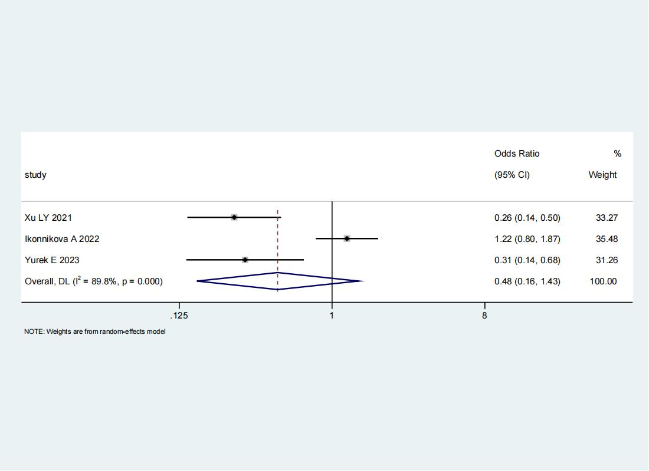

4.2 Forest plot of GP1BA(rs6065) CC vs CT/TT
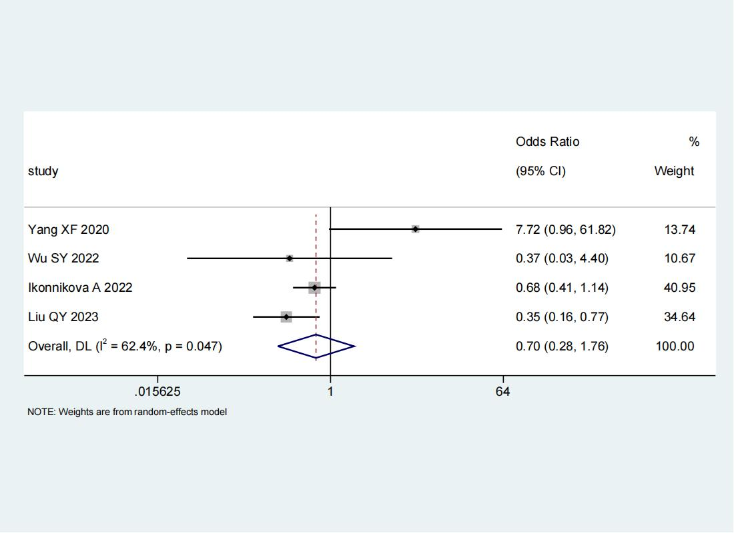

4.3 Forest plot of P2RY1(rs701265) AA vs AG/GG
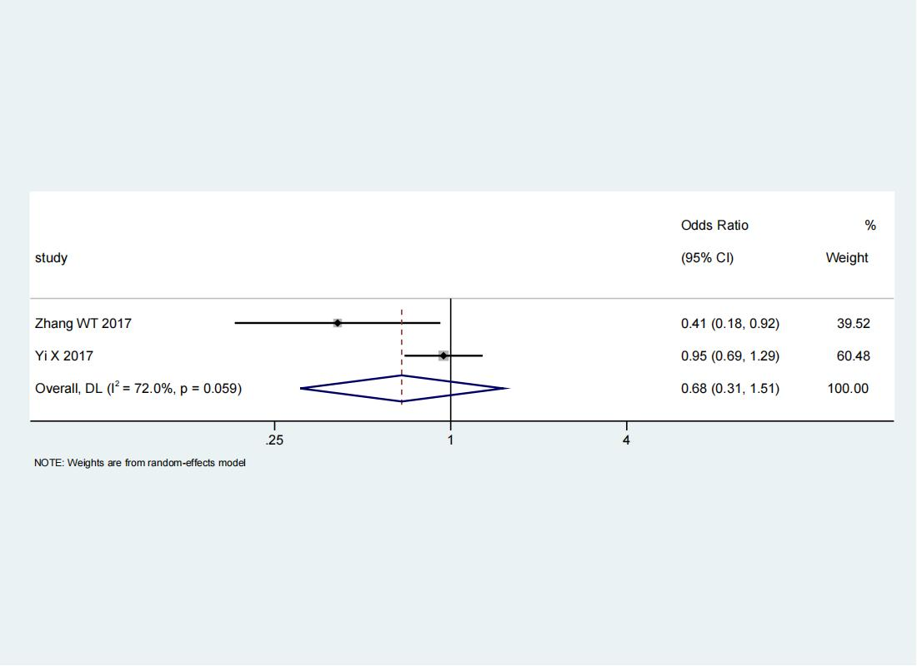

4.4 Forest plot of ITGB3(rs5918)
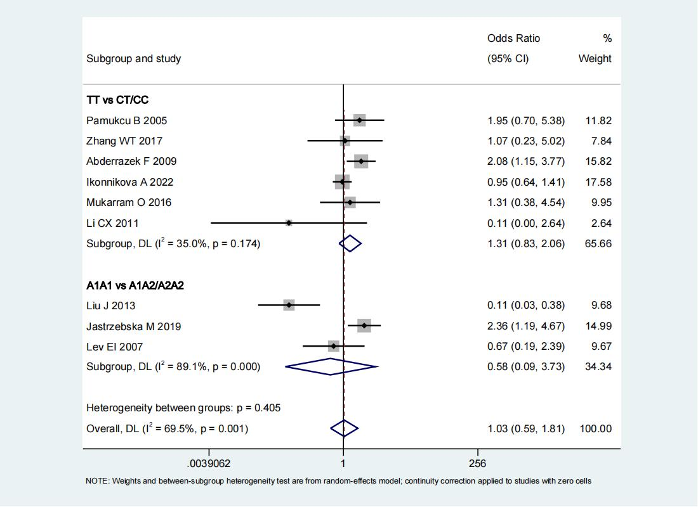

4.5 Forest plot of PEAR1(rs12041331) AA vs AG/GG

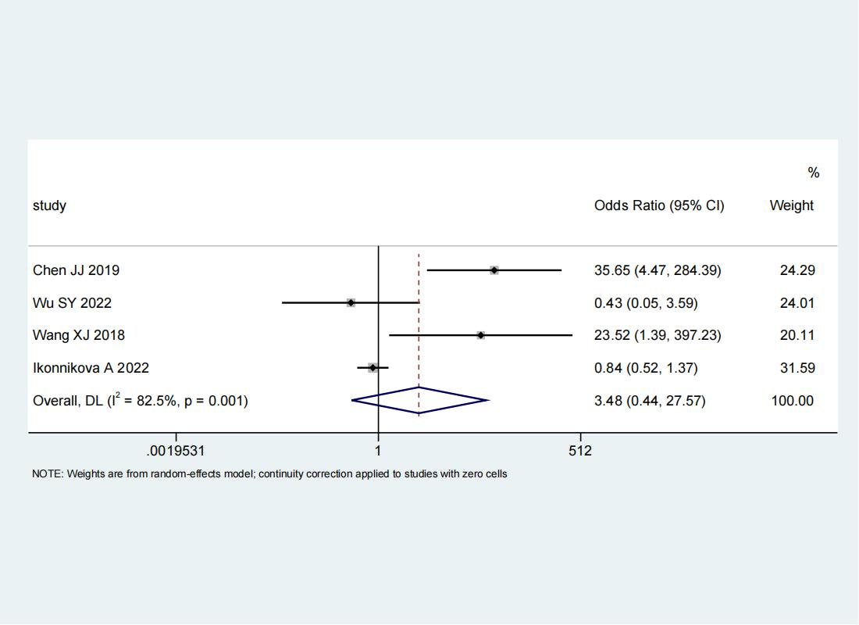

4.6 Forest plot of PTGS1
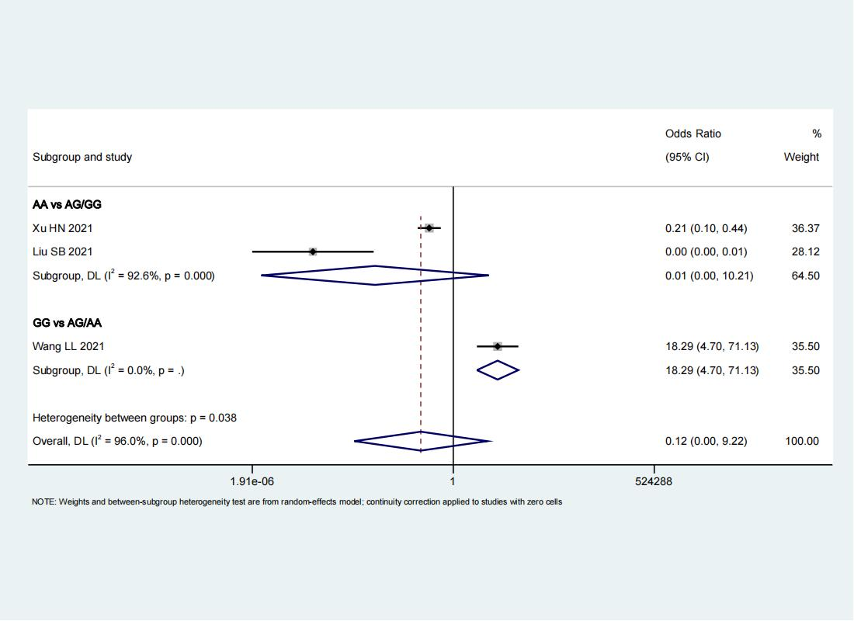

4.7 Forest plot of PTGS1(rs10306114)

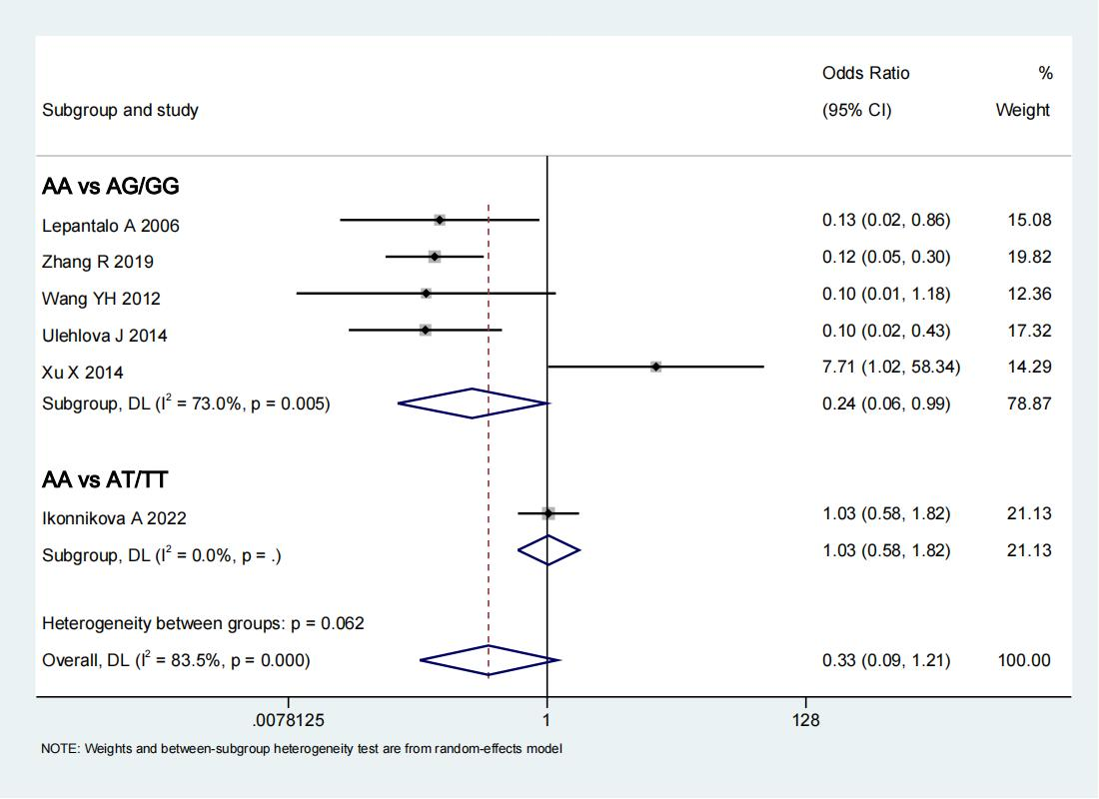

4.8 Forest plot of PTGS1(rs1236913) CC vs CT/TT
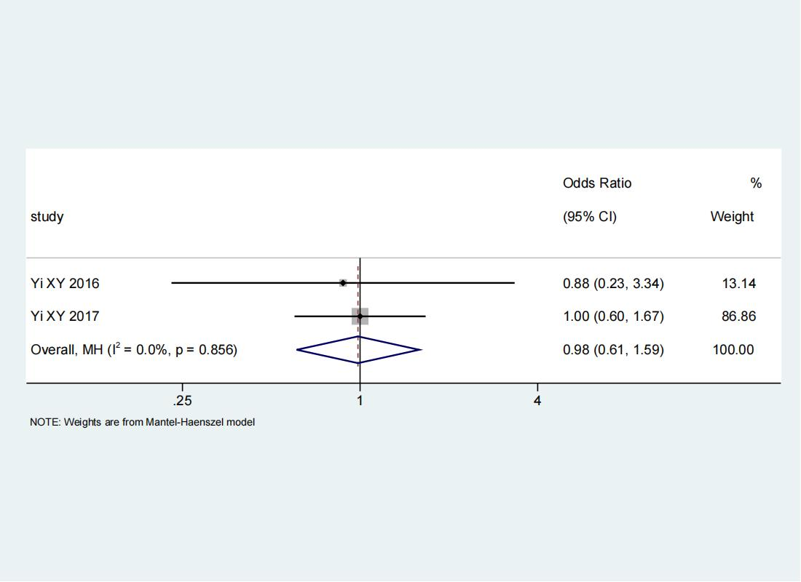

4.9 Forest plot of PTGS1(rs1236913) CC vs CT/TT

4.10 Forest plot of PTGS1(rs1330344)
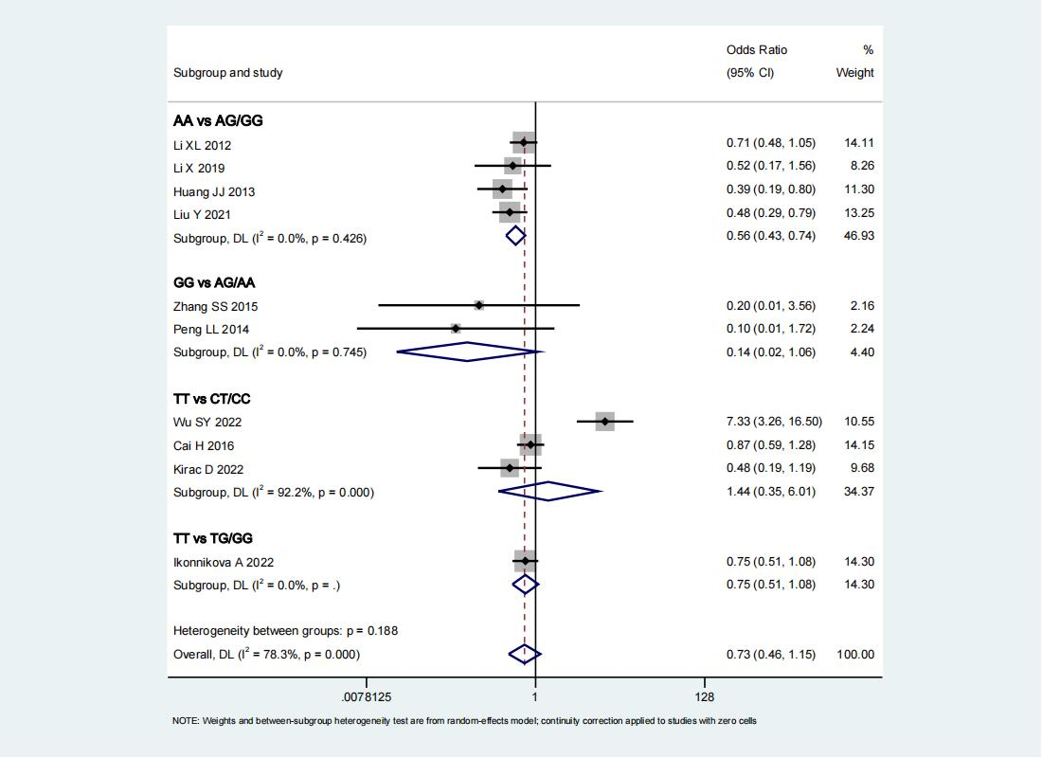

4.11 Forest plot of PTGS1(rs3842787)
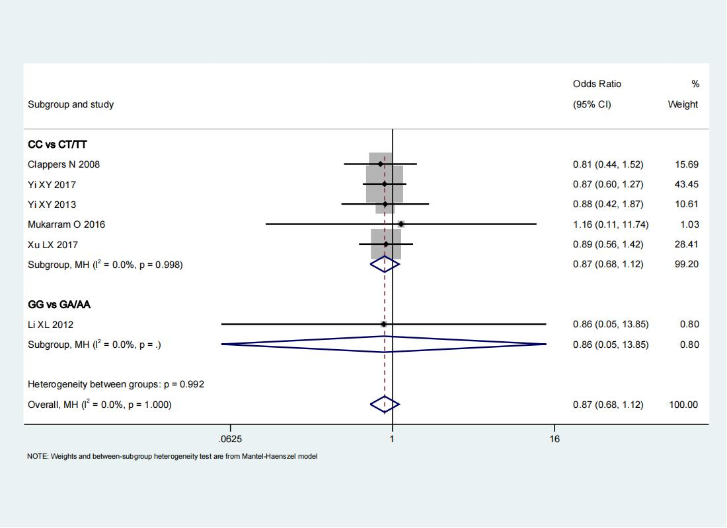

4.12 Forest plot of PTGS1(rs3842788)
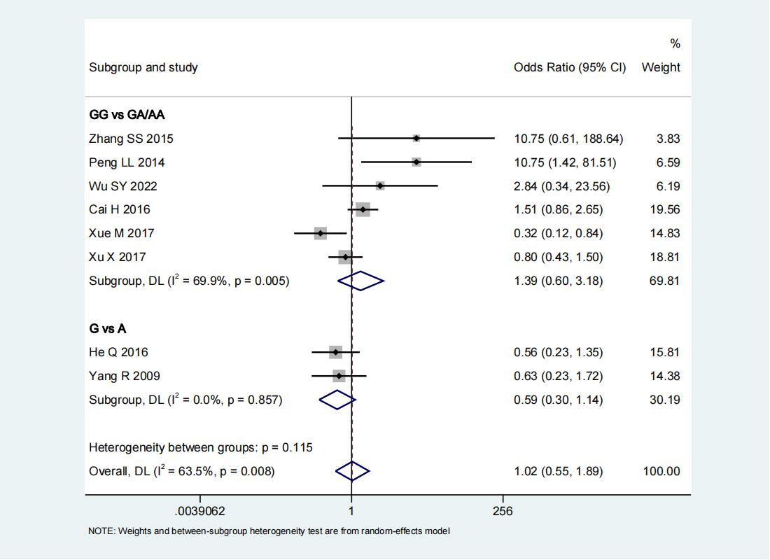

4.13 Forest plot of PTGS1(rs5788) 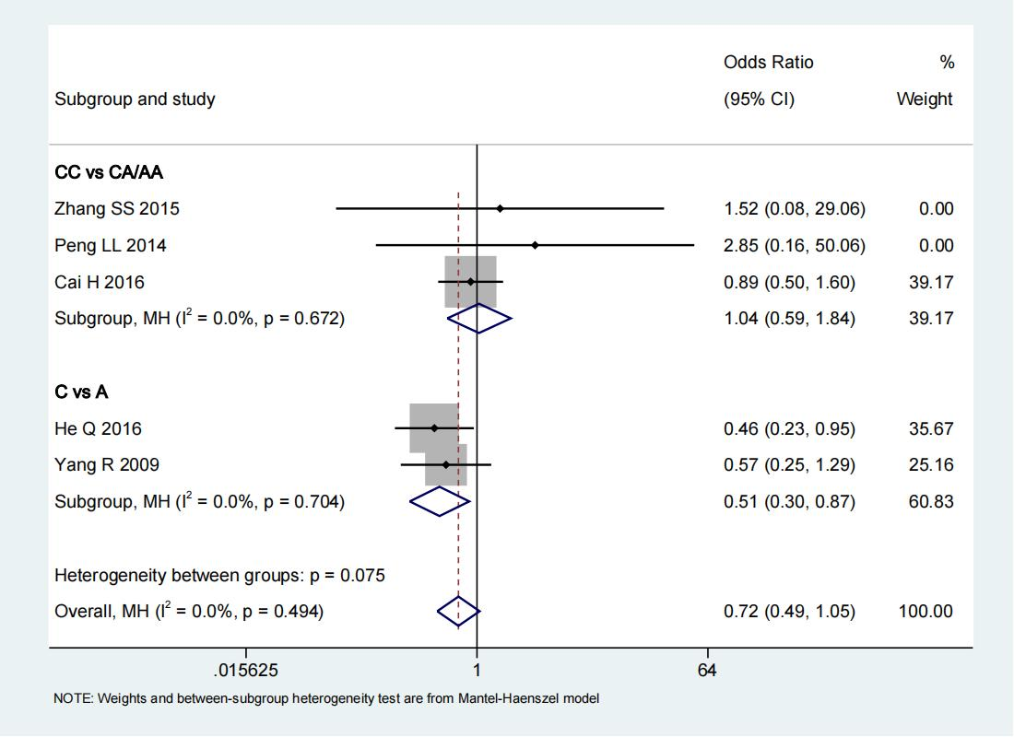

4.14 Forest plot of PTGS2 (rs5277) GG vs GC/CC

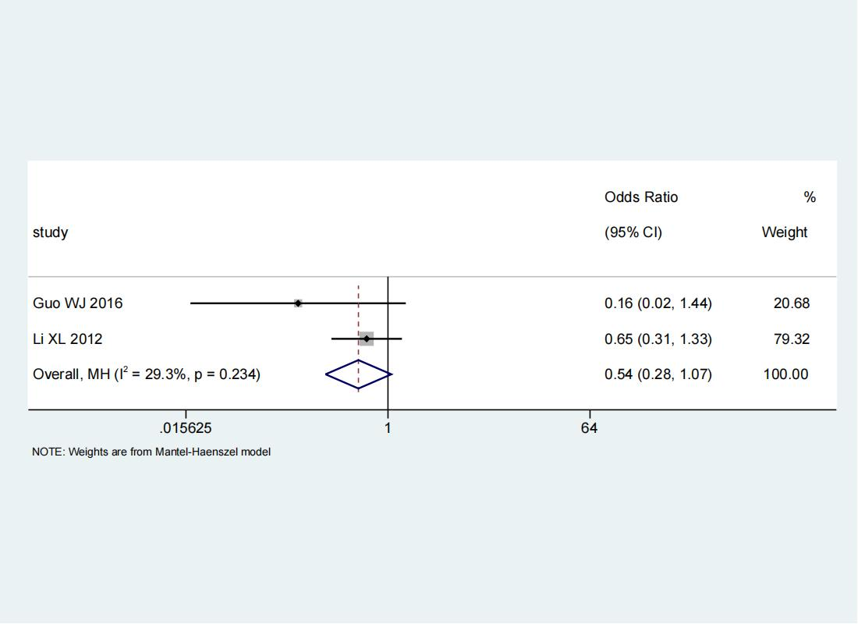

4.15 Forest plot of PTGS2(rs689466)

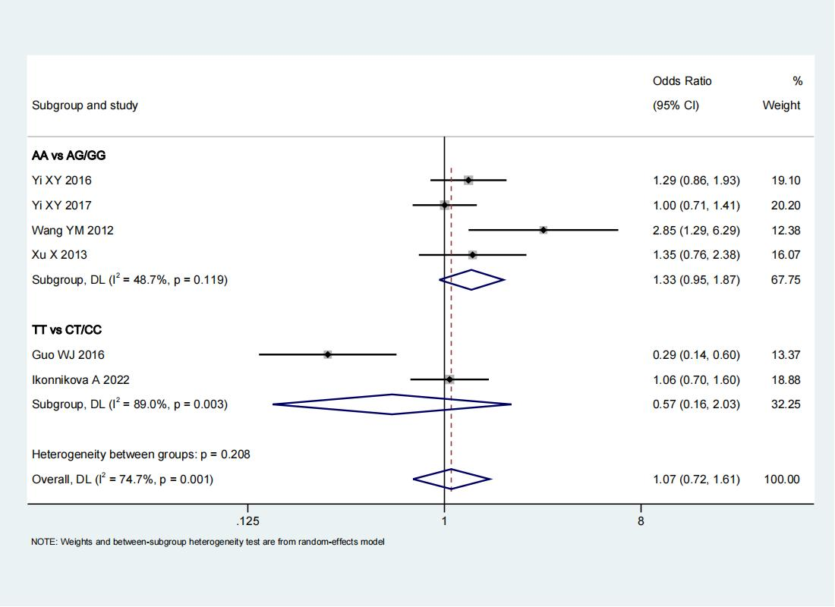

4.16 Forest plot of ITGB3(rs2317676) AA vs AG/GG
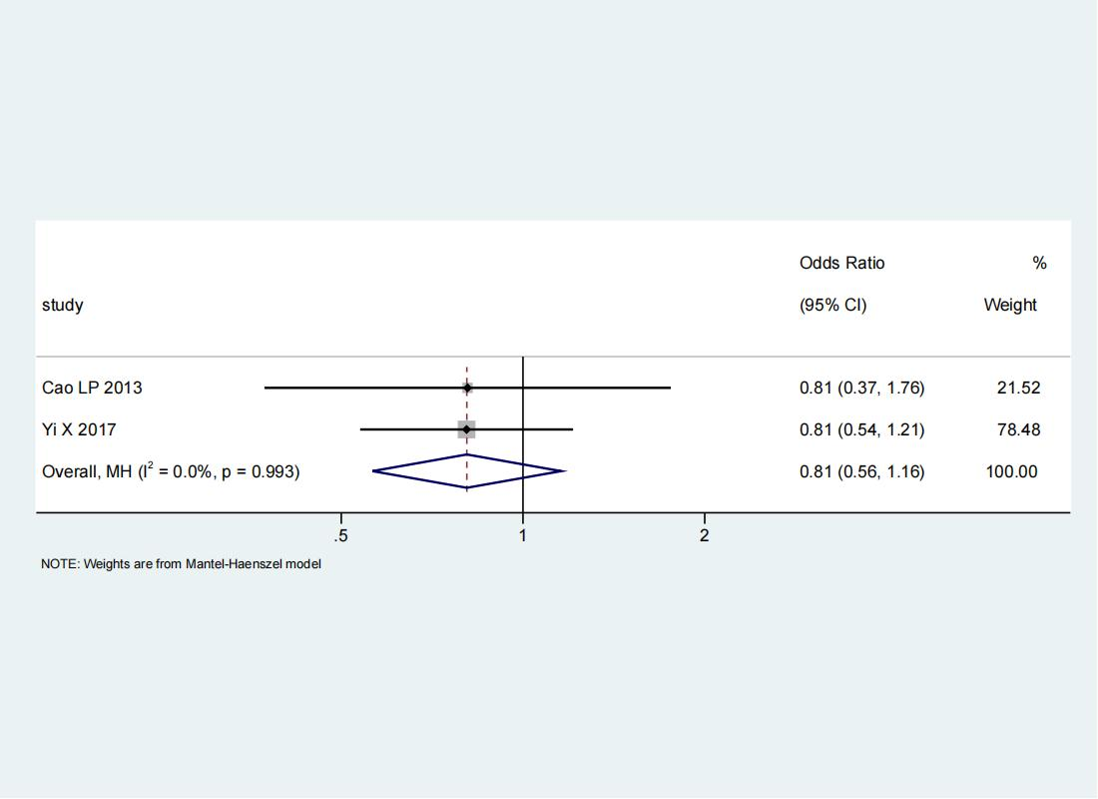

4.17 Forest plot of ITGB3(rs11871251) AA vs AG/GG

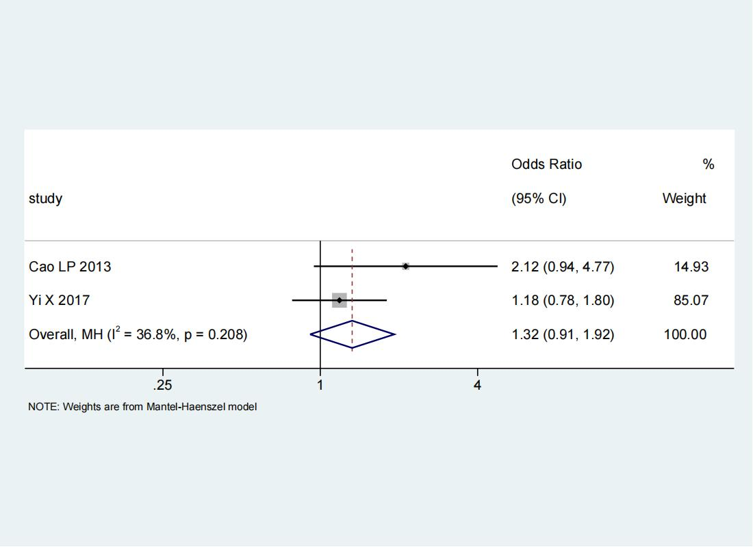

4.18 Forest plot of P2RY1(rs1065776) CC vs CT/TT

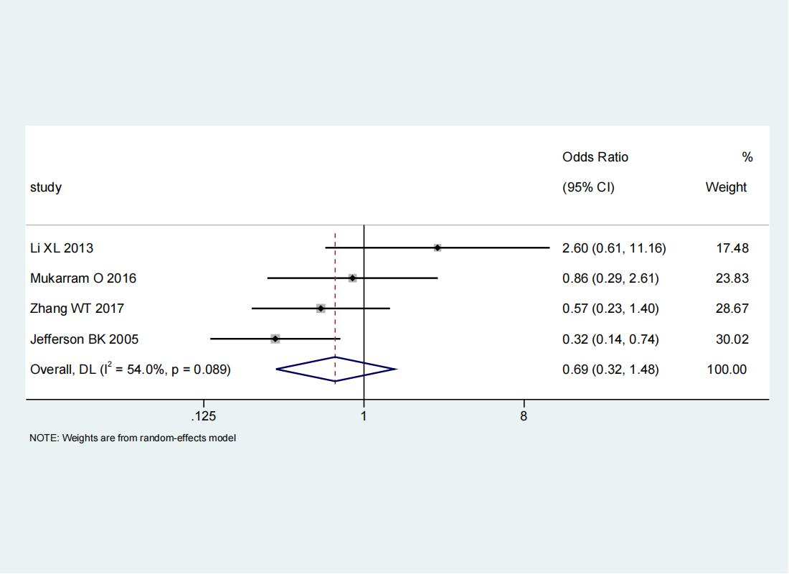

4.19 Forest plot of TbXA2R(rs1131882) CC vs CT/TT

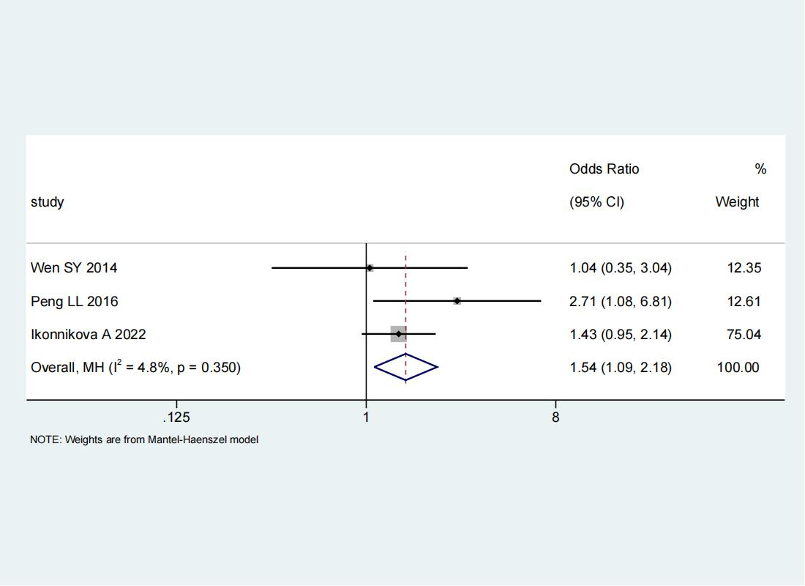

4.20 Forest plot of ITGA2B(rs5911) AA vs AC/CC
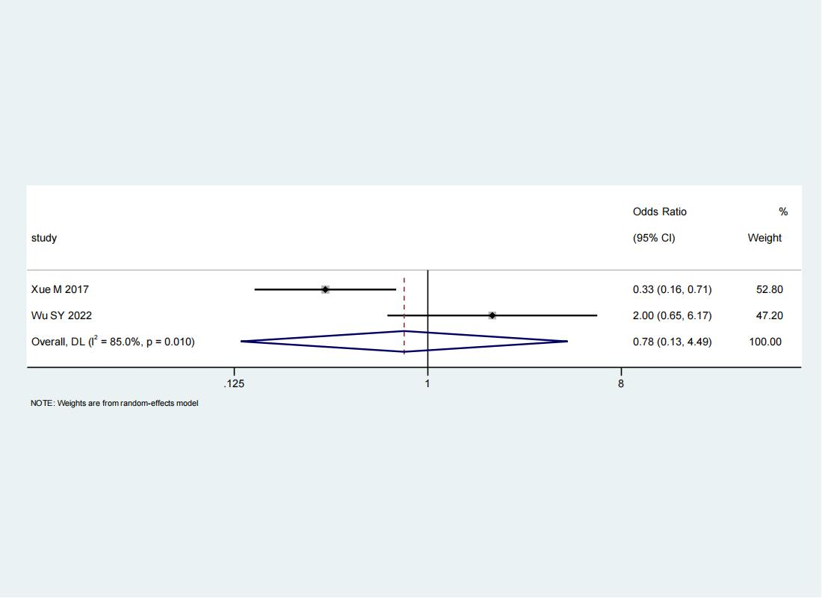

4.21 Forest plot of TbXA2R(rs4523) TT vs CT/CC

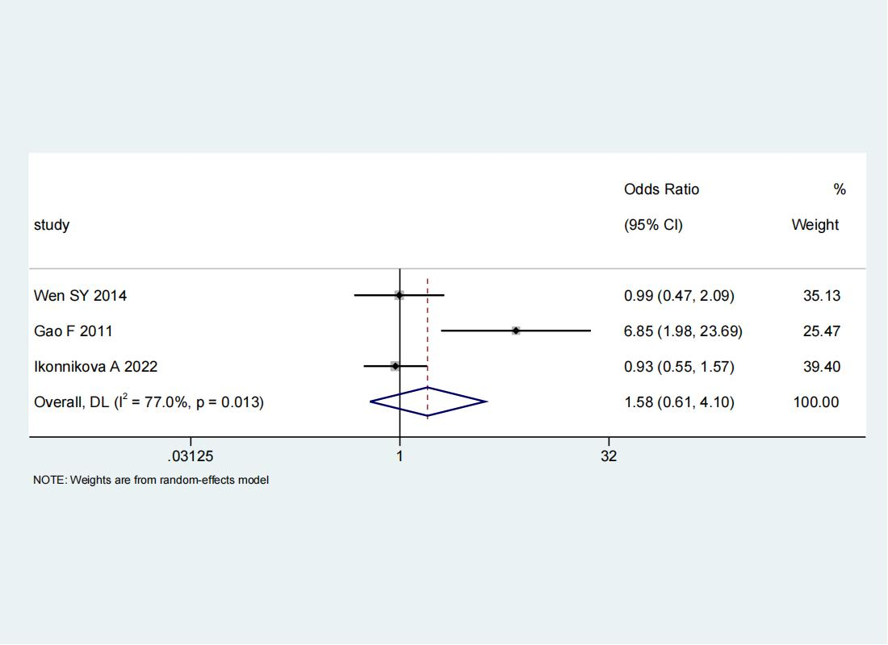

4.22 Forest plot of GP1BA (rs2243093) TT vs CT/CC
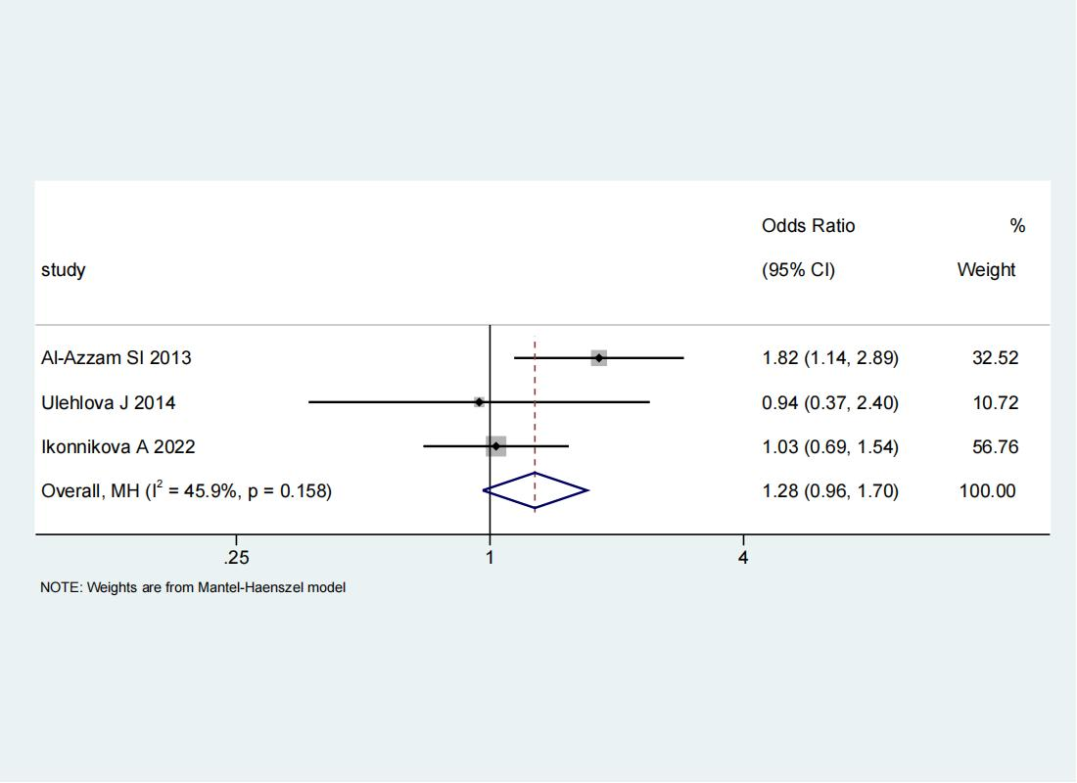

4.23 Forest plot of GP6(rs1613662) CC vs CT/TT
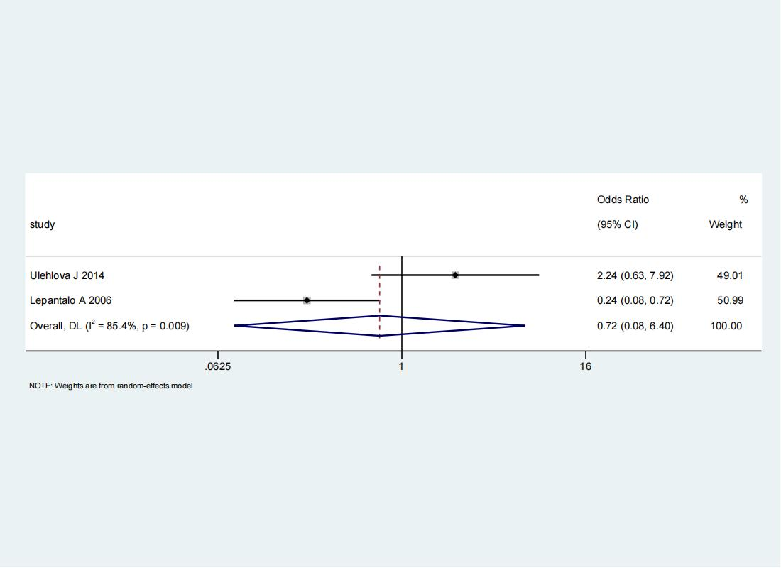

4.24 Forest plot of HMOX1(rs2071746) AA vs AT/TT
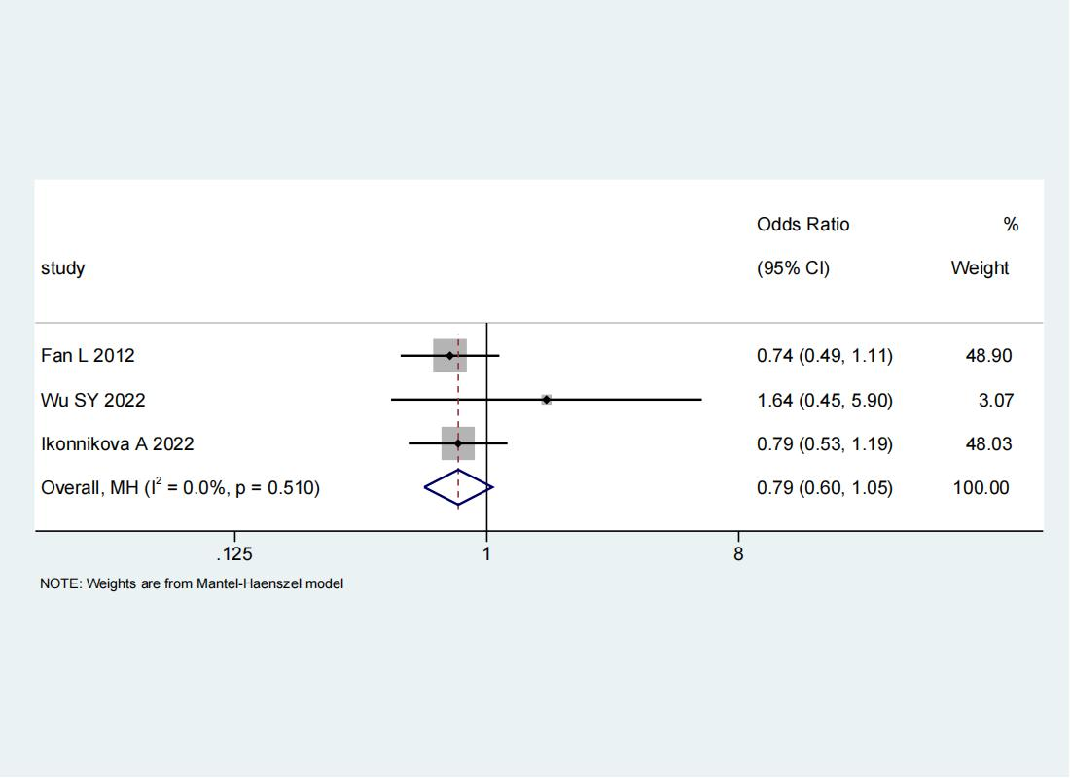

Appendix 5: Results of 69 gene polymorphisms

study | Gene polymorphisms | Genotype | AR | AR-control | AS | AS-control | OR (95% CI)
Cao LP 2014 | PTGS2(rs5275) | GG vs GA/AA | 55 | 34 | 573 | 296 | 0.84(0.53,1.31)
Chen JJ 2019 | PEAR1(rs2768759) | AA vs CA/CC | 27 | 19 | 78 | 24 | 0.44(0.21,0.92)
Gao F 2011 | GP1Bα(C1018T) | CC vs CT/TT | 23 | 0 | 237 | 0 | NA
Geng L 2013 | P2Y1(1662A>G) | GG vs GA/AA | 34 | 21 | 27 | 108 | 6.48(3.25,12.89)
Guan H 2018 | ABCB1(rs2235048) | GG vs GA/AA | 5 | 3 | 69 | 13 | 0.31(0.07,1.48)
Guan H 2018 | CYP2C19(rs4244285) | GG vs GA/AA | 3 | 5 | 72 | 10 | 0.08(0.02,0.40)
Guan H 2018 | CYP2C19(rs4986893) | GG vs GA/AA | 4 | 4 | 72 | 10 | 0.14(0.03,0.65)
Guo WJ 2016 | PTGS2(rs689465) | AA vs GG/GA | 48 | 12 | 84 | 6 | 0.29(0.10,0.81)
Ikonnikova A 2022 | ADRA2A(rs4311994) | CC vs CT/TT | 174 | 46 | 188 | 53 | 0.94(0.60,1.49)
Ikonnikova A 2022 | 9p21.3(rs10120688) | GG vs GA/AA | 68 | 152 | 65 | 176 | 0.87(0.57,1.31)
Ikonnikova A 2022 | ITGA2(rs1062535) | GG vs GA/AA | 84 | 136 | 87 | 154 | 0.93(0.63,1.37)
Ikonnikova A 2022 | PLA2G7(rs1051931) | CC vs CT/TT | 150 | 70 | 159 | 81 | 0.92(0.61,1.37)
Jefferson BK 2005 | ITGB3_3 | CC vs CT/TT | 80 | 15 | 193 | 36 | 1.14(0.57,2.26)
Jefferson BK 2005 | GPIIIa (ITGB3_2) | AA vs GG/GA | 49 | 44 | 98 | 130 | 1.48(0.91,2.40)
Jefferson BK 2005 | GPIIIa (ITGB3_4) | AA vs GG/GA | 12 | 79 | 21 | 201 | 1.45(0.68,3.10)
Jefferson BK 2005 | COX-2(PTGS2_1) | GG vs GC/CC | 63 | 23 | 147 | 57.3 | 1.06(0.60,1.87)
Jefferson BK 2005 | P2RY1_2 | AA vs GG/GA | 3 | 86 | 7 | 213 | 1.06(0.27,4.20)
Jefferson BK 2005 | COX-1(PTGS1_1) | GG vs GT/TT | 63 | 24 | 155 | 57 | 0.97(0.55,1.69)
Khudair FA 2022 | RAGE(rs2070600) | GG vs GA | 39 | 1 | 37 | 3 | 3.16(0.32,31.78)
Kranzhofer R 2006 | ITGB3(1565C>T) | PlA1/A1 vs PlA1/A2 | 10 | 4 | 26 | 15 | 1.44(0.38,5.41)
Li XL 2012 | PTGS1(rs1888943) | CC vs CT/TT | 36 | 0 | 230 | 1 | 0.48(0.02,11.89)
Li XL 2012 | PTGS1(rs5787) | GG vs GA/AA | 36 | 0 | 230 | 1 | 0.48(0.02,11.89)
Li XL 2012 | PTGS1(rs5789) | CC vs CA/AA | 36 | 0 | 230 | 0 | NA
Li XL 2013 | P2RY12(rs5853517) | H1H1 vs H1H1/H2H2 | 38 | 21 | 246 | 124 | 0.91(0.51,1.62)
Li XL 2022 | APOC1(rs429358) | TT vs TC/CC | 239 | 39 | 174 | 43 | 1.51(0.94,2.44)
Li XL 2022 | APOC1(rs7412) | CC vs CT | 215 | 57 | 206 | 20 | 0.37( 0.21,0.63)
Peng LL 2016 | ABCB1(rs1045642) | TT vs TC/CC | 2 | 31 | 59 | 191 | 0.42(0.23.0.76)
Peng LL 2016 | PEAR1(rs12041331-rs12566888) | AA vs GG/GA | 6 | 27 | 63 | 187 | 0.66(0.26,1.67)
Peng LL 2016 | PLA2G7(rs1051931-rs7756935) | AA vs GG/GA | 3 | 30 | 3 | 247 | 8.23(1.59,42.64)
Sevimli S 2014 | 455G/Ab | GG vs GA/AA | 11 | 10 | 51 | 42 | 0.91(0.35,2.34)
TimurI AA 2012 | P2RY12(rs9859538) | AA vs GG/GA | 22 | 77 | 110 | 203 | 0.53(0.31,0.89)
TimurI AA 2012 | P2RY12(rs1491974) | CC vs CT/TT | 9 | 49 | 105 | 249 | 0.44(0.21,0.92)
TimurI AA 2012 | P2RY12(rs10513398) | GG vs GA/AA | 9 | 49 | 104 | 254 | 0.45(0.21,0.95)
TimurI AA 2012 | P2RY12(rs3732765) | GG vs GA/AA | 124 | 219 | 36 | 37 | 0.58(0.35,0.97)
TimurI AA 2012 | P2RY12(rs10935841) | GG vs GA/AA | 124 | 220 | 36 | 37 | 0.58(0.35,0.96)
TimurI AA 2012 | P2RY12(rs7615865) | CC vs CT/TT | 164 | 175 | 24 | 47 | 1.84(1.07,3.14)
TimurI AA 2012 | P2RY12(rs1388623) | CC vs CA/AA | 179 | 165 | 26 | 47 | 1.96(1.16,3.31)
TimurI AA 2012 | P2RY12(rs1388622) | GG vs GA/AA | 179 | 165 | 26 | 47 | 1.96(1.16,3.31)
TimurI AA 2012 | P2RY12(rs7634096) | GG vs GA/AA | 234 | 110 | 40 | 33 | 1.76(1.05,2.93)
TimurI AA 2012 | P2RY12(rs7637803) | GG vs GA/AA | 234 | 110 | 40 | 33 | 1.76(1.05,2.93)
Wang BY 2012 | PLA | A1A1 vs AIA2/A2A2 | 240 | 10 | 182 | 0 | 0.06( 0.004,1.08)
Wang L 2022 | ApoE | ε2ε2 vs ε2ε3/ε2ε4/ε3ε4/ε3ε3/ε4ε4 | 1 | 36 | 1 | 82 | 2.28(0.14,37.43)
Wang LL 2016 | ALOX5AP(rs10507391) | TT vs TA/AA | 39 | 71 | 157 | 183 | 0.64(0.41,1.00)
Wang LL 2016 | ALOX5AP(rs4769874) | GG vs GA | 103 | 7 | 325 | 15 | 0.68(0.27,1.71)
Wang LL 2016 | ALOX5AP(rs9551963) | AA vs CA/CC | 41 | 69 | 141 | 199 | 0.84(0.54,1.31)
Wang LL 2021 | PEAR1 | GG vs GA/AA | 8 | 7 | 57 | 28 | 0.56(0.19,1.71)
Wang YM 2012 | PTGS2(rs68946) | GG vs GA/AA | 1 | 53 | 0 | 16 | 0.93(0.04, 23.81)
Wen SY 2014 | TXA2R(rs2271875) | GG vs GA/AA | 14 | 25 | 43 | 86 | 1.12(0.53,2.37)
Wen SY 2014 | TXA2R(rs768963) | TT vs TC/CC | 4 | 35 | 14 | 115 | 0.94(0.29,3.04)
Wen SY 2014 | TXA2R(G1686A) | GG vs GA/AA | 26 | 13 | 85 | 44 | 1.04(0.49,2.21)
Xu JJ 2016 | PTGS1(rs4273915) | GG vs GC/CC | 145 | 21 | 174 | 26 | 1.03(0.56,1.91)
Xu JJ 2016 | PTGS1(rs7866582) | GG vs GC/CC | 141 | 25 | 176 | 24 | 0.77(0.42,1.41)
Xu JJ 2016 | PTGS2(rs3218625) | CC vs CT/TT | 162 | 4 | 190 | 10 | 2.13(0.66,6.93)
Xu JJ 2016 | TBXA2R(rs2238630) | TT vs TC/CC | 107 | 59 | 124 | 68 | 1.00(0.64,1.54)
Xu JJ 2016 | TBXA2R(rs2238631) | CC vs CT/TT | 113 | 53 | 126 | 74 | 1.25(0.81,1.93)
Xu JJ 2016 | TBXA2R(rs2238633) | AA vs CA/CC | 55 | 111 | 55 | 145 | 1.31(0.84,2.05)
Xu JJ 2016 | TBXA2R(rs3786989) | GG vs GC/CC | 140 | 26 | 168 | 32 | 1.03(0.58,1.80)
Xu L 2021 | ABCB1(rs1128503) | CC vs CT/TT | 54 | 23 | 173 | 52 | 0.71(0.40,1.26)
Xu L 2021 | ABCB1(rs2032582) | GG vs GA/AA | 9 | 79 | 41 | 205 | 0.57(0.27,1.23)
Yi X 2017 | P2RY1(rs1371097) | CC vs CT/TT | 106 | 114 | 373 | 257 | 0.64(0.47,0.87)
Yi X 2017 | P2RY12(rs16863323) | CC vs CT/TT | 48 | 172 | 158 | 472 | 0.83(0.58,1.20)
Yi X 2017 | P2RY12(rs9859538) | GG vs GA/AA | 154 | 66 | 472 | 158 | 0.78(0.56,1.10)
Yi X 2017 | TXAS1(rs194149) | GG vs GA/AA | 75 | 145 | 190 | 440 | 1.20(0.86,1.66)
Yi X 2017 | TXAS1(rs2267679) | TT vs TC/CC | 178 | 42 | 522 | 108 | 0.88(0.59,1.30)
Yi X 2017 | TXAS1(rs41708) | GG vs GT/TT | 136 | 84 | 373 | 257 | 1.12(0.81,1.53)
Yi X 2017 | P2Y1(rs1439010) | AA vs AG/GG | 114 | 106 | 346 | 284 | 0.88(0.65,1.20)
Yu LH 2015 | ITGA2B(rs5910) | AA vs AB/BB | 39 | 113 | 107 | 143 | 0.46(0.30,0.72)
Yuan JG 2016 | DE4D(rs966221) | CC vs CT/TT | 41 | 13 | 100 | 29 | 0.92(0.43,1.93)
Yuan JG 2016 | DE4D(rs918592) | CC vs CT/TT | 3 | 51 | 13 | 368 | 1.67(0.46,6.04)

Appendix 6: The results of subgroup analysis
Gene polymorphisms | Regions | Base-pairs |  | Studies included | P value | OR (95% CI) | I2
ABCB1(rs1045642) | Asia | AR | CC | 2 | <0.001 | 0.28(0.17,0.46) | 0.00%
ABCB1(rs1045642) | Asia | AR | CT/TT
ABCB1(rs1045642) | Asia | AS | CC
ABCB1(rs1045642) | Asia | AS | CT/TT
ABCB1(rs1045642) | Europe | AR | CC | 1 | 0.35 | 1.23(0.80,1.87) | 0.00%
ABCB1(rs1045642) | Europe | AR | CT/TT
ABCB1(rs1045642) | Europe | AS | CC
ABCB1(rs1045642) | Europe | AS | CT/TT
GP1BA(rs6065) | Asia | AR | CC | 3 | 0.92 | 0.91(0.13,6.39) | 73.40%
GP1BA(rs6065) | Asia | AR | CT/TT
GP1BA(rs6065) | Asia | AS | CC
GP1BA(rs6065) | Asia | AS | CT/TT
GP1BA(rs6065) | Europe | AR | CC | 1 | 0.15 | 0.68(0.41,1.14) | 0.00%
GP1BA(rs6065) | Europe | AR | CT/TT
GP1BA(rs6065) | Europe | AS | CC
GP1BA(rs6065) | Europe | AS | CT/TT
ITGB3(rs5918) | Asia | AR | TT | 4 | 0.40 | 0.11(0.004,2.64) | 0.00%
ITGB3(rs5918) | Asia | AR | CT/CC
ITGB3(rs5918) | Asia | AS | TT
ITGB3(rs5918) | Asia | AS | CT/CC
ITGB3(rs5918) | Africa | AR | TT | 1 | 0.02 | 2.08(1.15,3.77) | 0.00%
ITGB3(rs5918) | Africa | AR | CT/CC
ITGB3(rs5918) | Africa | AS | TT
ITGB3(rs5918) | Africa | AS | CT/CC
ITGB3(rs5918) | Europe | AR | TT | 1 | 0.81 | 0.95(0.64,1.41) | 0.00%
ITGB3(rs5918) | Europe | AR | CT/CC
ITGB3(rs5918) | Europe | AS | TT
ITGB3(rs5918) | Europe | AS | CT/CC
P2RY1(rs701265) | Asia | AR | AA | 3 | 0.34 | 0.68(0.31-1.51) | 72.00%
P2RY1(rs701265) | Asia | AR | AG/GG
P2RY1(rs701265) | Asia | AS | AA
P2RY1(rs701265) | Asia | AS | AG/GG
PEAR1(rs12041331) | Asia | AR | AA | 3 | 0.20 | 6.79(0.36,128.39) | 79.30%
PEAR1(rs12041331) | Asia | AR | AG/GG
PEAR1(rs12041331) | Asia | AS | AA
PEAR1(rs12041331) | Asia | AS | AG/GG
PEAR1(rs12041331) | Europe | AR | AA | 1 | 0.49 | 0.84(0.52,1.37) | 0.00%
PEAR1(rs12041331) | Europe | AR | AG/GG
PEAR1(rs12041331) | Europe | AS | AA
PEAR1(rs12041331) | Europe | AS | AG/GG
PTGS1 | Asia | AR | GG AG/AA | 1 | <0.001 | 18.29(4.70,71.13) | 0.00%
PTGS1 | Asia | AS | GG AG/AA
PTGS1 | Asia | AR | AA | 3 | 0.18 | 0.01(0.00-10.22) | 13.60%
PTGS1 | Asia | AR | AG/GG
PTGS1 | Asia | AS | AA
PTGS1 | Asia | AS | AG/GG
PTGS1(rs10306114) | Asia | AR | AA | 3 | 0.55 | 0.44(0.03,6.32) | 85.50%
PTGS1(rs10306114) | Asia | AR | AG/GG
PTGS1(rs10306114) | Asia | AS | AA
PTGS1(rs10306114) | Asia | AS | AG/GG
PTGS1(rs10306114) | Europe | AR | AA | 2 | <0.001 | 0.11(0.04,0.35) | 0.00%
PTGS1(rs10306114) | Europe | AR | AG/GG
PTGS1(rs10306114) | Europe | AS | AA
PTGS1(rs10306114) | Europe | AS | AG/GG
PTGS1(rs1236913) | Asia | AR | CC | 2 | 0.95 | 0.98(0.61-1.59) | 0.00%
PTGS1(rs1236913) | Asia | AR | CT/TT
PTGS1(rs1236913) | Asia | AS | CC
PTGS1(rs1236913) | Asia | AS | CT/TT
PTGS1(rs1330344) | Asia | AR | AA | 4 | <0.001 | 0.56(0.43-0.74) | 0.00%
PTGS1(rs1330344) | Asia | AR | AG/GG
PTGS1(rs1330344) | Asia | AS | AA
PTGS1(rs1330344) | Asia | AS | AG/GG
PTGS1(rs1330344) | Asia | AR | GG | 2 | 0.06 | 0.14(0.01-1.06) | 0.00%
PTGS1(rs1330344) | Asia | AR | AG/AA
PTGS1(rs1330344) | Asia | AS | GG
PTGS1(rs1330344) | Asia | AS | AG/AA
PTGS1(rs1330344) | Asia | AR | TT CT/CC | 3 | 0.62 | 1.44(0.35-6.01) | 92.20%
PTGS1(rs1330344) | Asia | AS | TT CT/CC
PTGS1(rs1330344) | Europe | AR | TT TG/GG | 1 | 0.12 | 0.75(0.51-1.08) | 0.00%
PTGS1(rs1330344) | Europe | AS | TT
PTGS1(rs1330344) | Europe | AS | TG/GG
PTGS1(rs3842787) | Asia | AR | CC | 4 | 0.37 | 0.89(0.68,1.16) | 0.00%
PTGS1(rs3842787) | Asia | AR | CT/TT
PTGS1(rs3842787) | Asia | AS | CC
PTGS1(rs3842787) | Asia | AS | CT/TT
PTGS1(rs3842787) | Europe | AR | CC | 1 | 0.52 | 0.81(0.44,1.52) | 0.00%
PTGS1(rs3842787) | Europe | AR | CT/TT
PTGS1(rs3842787) | Europe | AS | CC
PTGS1(rs3842787) | Europe | AS | CT/TT
PTGS1(rs3842788) | Asia | AR | GG | 6 | 0.44 | 1.39(0.60-3.18) | 69.90%
PTGS1(rs3842788) | Asia | AR | GA/AA
PTGS1(rs3842788) | Asia | AS | GG
PTGS1(rs3842788) | Asia | AS | GA/AA
PTGS1(rs3842788) | Asia | AR | G | 2 | 0.12 | 0.59(0.31-1.14) | 0.00%
PTGS1(rs3842788) | Asia | AR | A
PTGS1(rs3842788) | Asia | AS | G
PTGS1(rs3842788) | Asia | AS | A
PTGS1(rs5788) | Asia | AR | GG | 3 | 0.9 | 1.04(0.59-1.84) | 0.00%
PTGS1(rs5788) | Asia | AR | GA/AA
PTGS1(rs5788) | Asia | AS | GG
PTGS1(rs5788) | Asia | AS | GA/AA
PTGS1(rs5788) | Asia | AR | C | 2 | 0.01 | 0.51(0.30-0.87) | 0.00%
PTGS1(rs5788) | Asia | AR | A
PTGS1(rs5788) | Asia | AS | C
PTGS1(rs5788) | Asia | AS | A
PTGS2(rs20417) | Asia | AR | GG | 17 | <0.001 | 0.58(0.44,0.76) | 55.50%
PTGS2(rs20417) | Asia | AR | GC/CC
PTGS2(rs20417) | Asia | AS | GG
PTGS2(rs20417) | Asia | AS | GC/CC
PTGS2(rs20417) | Europe | AR | GG | 1 | <0.001 | 0.97(0.65,1.44) | 0.00%
PTGS2(rs20417) | Europe | AR | GC/CC
PTGS2(rs20417) | Europe | AS | GG
PTGS2(rs20417) | Europe | AS | GC/CC
PTGS2(rs20417) | Asia | AR | G | 2 | <0.001 | 0.23(0.11-0.52) | 0.00%
PTGS2(rs20417) | Asia | AR | C
PTGS2(rs20417) | Asia | AS | G
PTGS2(rs20417) | Asia | AS | C
PTGS2(rs5277) | Asia | AR | GG | 2 | 0.08 | 0.54(0.28-1.07) | 85.40%
PTGS2(rs5277) | Asia | AR | GC/CC
PTGS2(rs5277) | Asia | AS | GG
PTGS2(rs5277) | Asia | AS | GC/CC
PTGS2(rs689466) | Asia | AR | AA | 4 | 0.1 | 1.33(0.95-1.87) | 48.70%
PTGS2(rs689466) | Asia | AR | AG/GG
PTGS2(rs689466) | Asia | AS | AA
PTGS2(rs689466) | Asia | AS | AG/GG
ITGA2(rs1126643) | Asia | AR | CC | 6 | 0.03 | 0.52(0.29-0.94) | 75.10%
ITGA2(rs1126643) | Asia | AR | TC/TC
ITGA2(rs1126643) | Asia | AS | CC
ITGA2(rs1126643) | Asia | AS | TC/TC
ITGB3(rs2317676) | Asia | AR | AA | 2 | 0.24 | 0.81(0.56-1.16) | 0.00%
ITGB3(rs2317676) | Asia | AR | AG/GG
ITGB3(rs2317676) | Asia | AS | AA
ITGB3(rs2317676) | Asia | AS | AG/GG
ITGB3(rs11871251) | Asia | AR | AA | 2 | 0.14 | 1.32(0.91-1.92) | 36.80%
ITGB3(rs11871251) | Asia | AR | AG/GG
ITGB3(rs11871251) | Asia | AS | AA
ITGB3(rs11871251) | Asia | AS | AG/GG
P2RY1(rs1065776) | Asia | AR | CC | 3 | 0.85 | 0.93(0.42,2.05) | 33.60%
P2RY1(rs1065776) | Asia | AR | TC/TC
P2RY1(rs1065776) | Asia | AS | CC
P2RY1(rs1065776) | Asia | AS | TC/TC
P2RY1(rs1065776) | American | AR | CC | 1 | 0.008 | 0.32(0.14,0.74) | 0.00%
P2RY1(rs1065776) | American | AR | TC/TC
P2RY1(rs1065776) | American | AS | CC
P2RY1(rs1065776) | American | AS | TC/TC
TbXA2R(rs1131882) | Asia | AR | CC | 2 | 0.24 | 1.75(0.69,4.47) | 43.40%
TbXA2R(rs1131882) | Asia | AR | TC/TC
TbXA2R(rs1131882) | Asia | AS | CC
TbXA2R(rs1131882) | Asia | AS | TC/TC
TbXA2R(rs1131882) | Europe | AR | CC | 1 | 0.09 | 1.43(0.95,2.14) | 0.00%
TbXA2R(rs1131882) | Europe | AR | TC/TC
TbXA2R(rs1131882) | Europe | AS | CC
TbXA2R(rs1131882) | Europe | AS | TC/TC
ITGA2B(rs5911) | Asia | AR | AA | 2 | 0.06 | 0.57(0.31-21.03) | 85.10%
ITGA2B(rs5911) | Asia | AR | AC/CC
ITGA2B(rs5911) | Asia | AS | AA
ITGA2B(rs5911) | Asia | AS | AC/CC
TbXA2R(rs4523) | Asia | AR | TT | 3 | 0.35 | 1.58(0.61-4.10) | 77.00%
TbXA2R(rs4523) | Asia | AR | CT/CC
TbXA2R(rs4523) | Asia | AS | TT
TbXA2R(rs4523) | Asia | AS | CT/CC
GP1BA(rs2243093) | Asia | AR | TT | 1 | 0.01 | 1.82(1.14,2.89) | 0.00%
GP1BA(rs2243093) | Asia | AR | CT/CC
GP1BA(rs2243093) | Asia | AS | TT
GP1BA(rs2243093) | Asia | AS | CT/CC
GP1BA(rs2243093) | Europe | AR | TT | 2 | 0.92 | 1.02(0.71,1.47) | 0.00%
GP1BA(rs2243093) | Europe | AR | CT/CC
GP1BA(rs2243093) | Europe | AS | TT
GP1BA(rs2243093) | Europe | AS | CT/CC
GP6(rs1613662) | Europe | AR | CC | 2 | 0.77 | 0.72(0.08-6.40) | 85.40%
GP6(rs1613662) | Europe | AR | CT/TT
GP6(rs1613662) | Europe | AS | CC
GP6(rs1613662) | Europe | AS | CT/TT
HMOX1(rs2071746) | Asia | AR | AA | 2 | 0.24 | 0.79(0.54,1.17) | 25.70%
HMOX1(rs2071746) | Asia | AR | AT/TT
HMOX1(rs2071746) | Asia | AS | AA
HMOX1(rs2071746) | Asia | AS | AT/TT
HMOX1(rs2071746) | Europe | AR | AA | 1 | 0.26 | 0.79(0.53,1.19) | 0.00%
HMOX1(rs2071746) | Europe | AR | AC/CC
HMOX1(rs2071746) | Europe | AS | AA
HMOX1(rs2071746) | Europe | AS | AC/CC

Appendix 7: Confunnel plots for meta-analysis

7.1 Confunnel plots for ITGB3(rs5918)
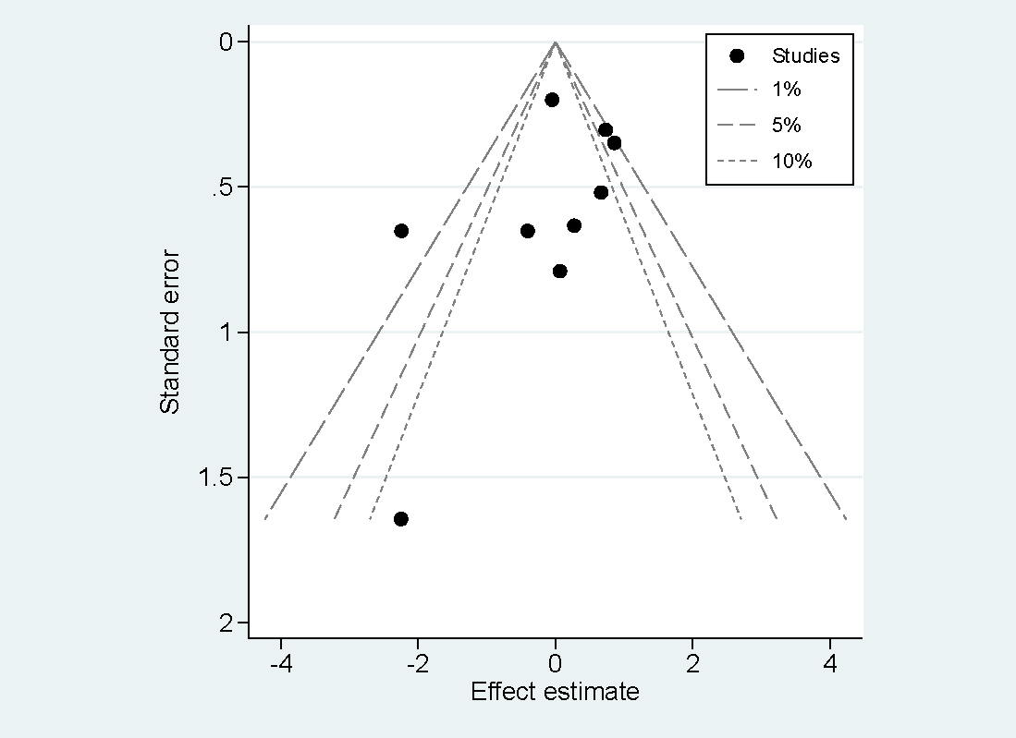

7.2 Confunnel plots for PTGS1(rs1330344)
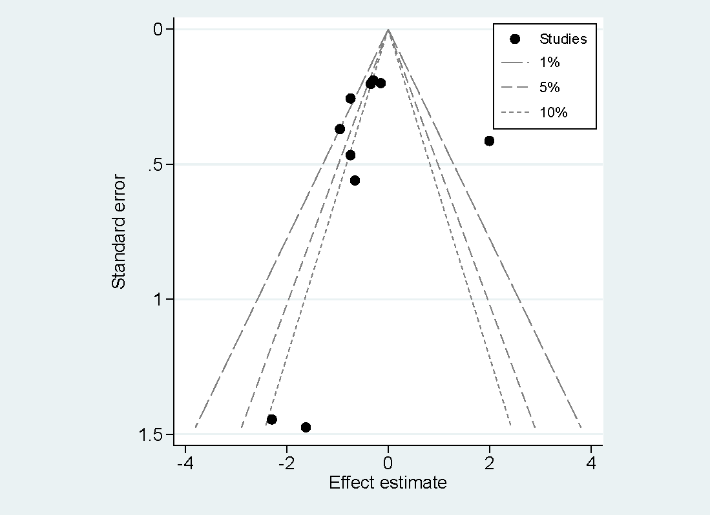

7.3 Confunnel plots for PTGS1(rs3842788)
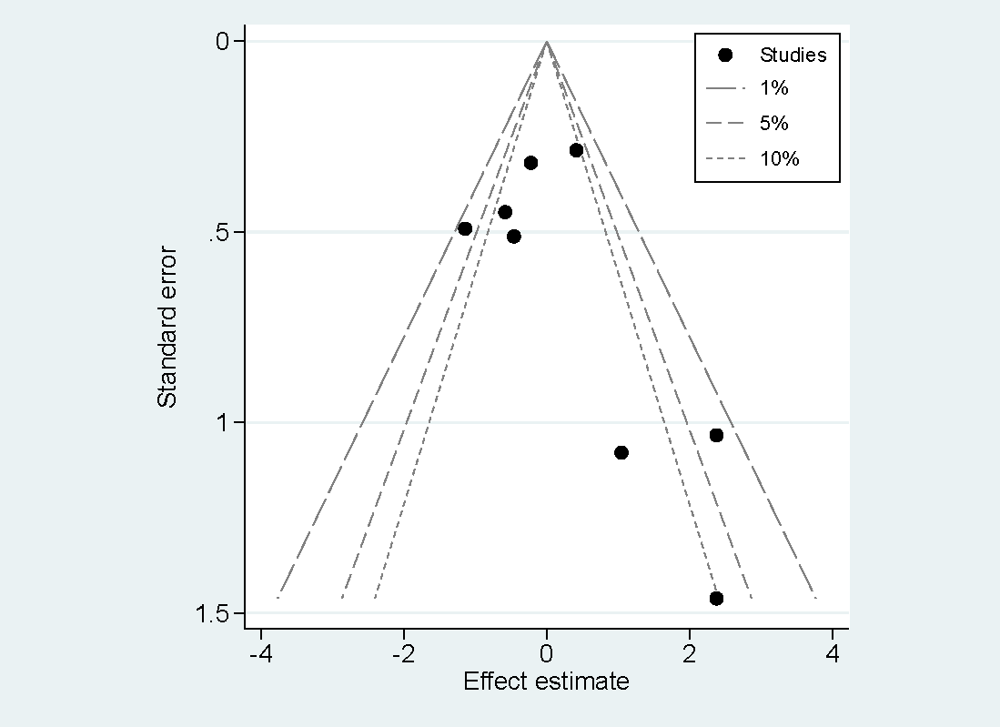

7.4 Confunnel plots for PTGS2(rs20417)


