RCM of CC and HC
Study A
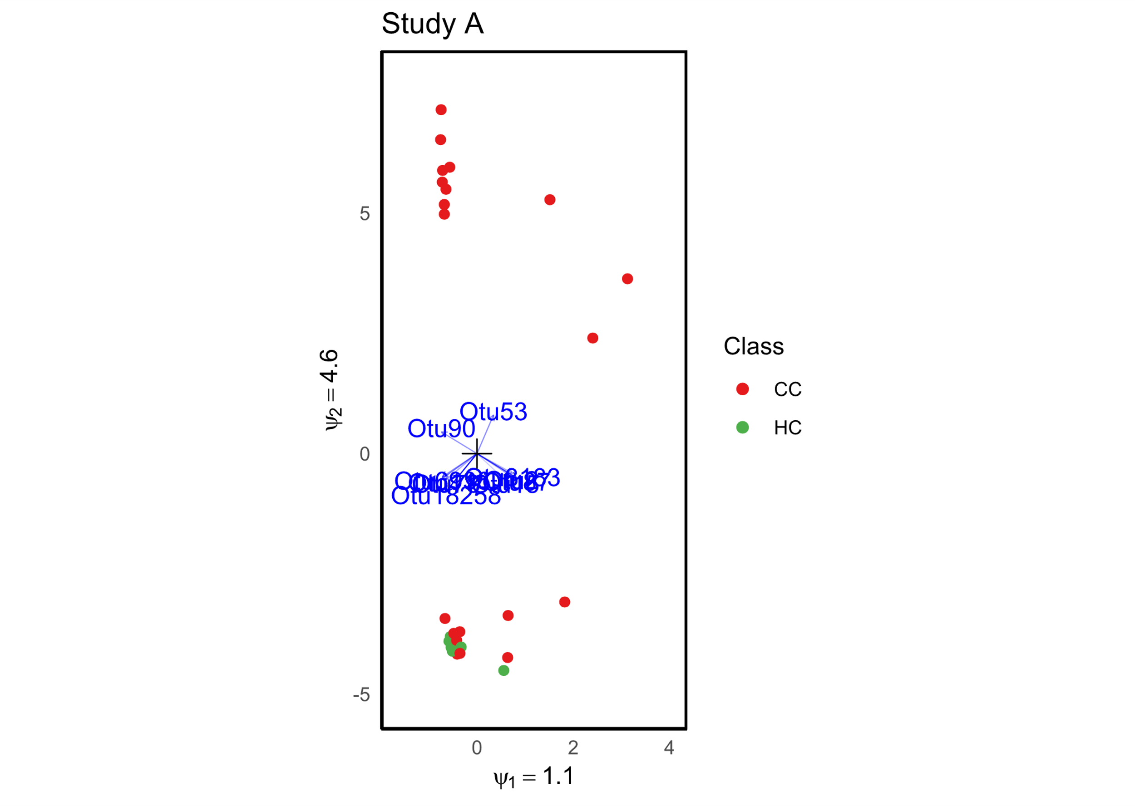
Figure 1: RCM Plot of Cervical Cancer (CC) and Healthy Control (HC) - Study A.

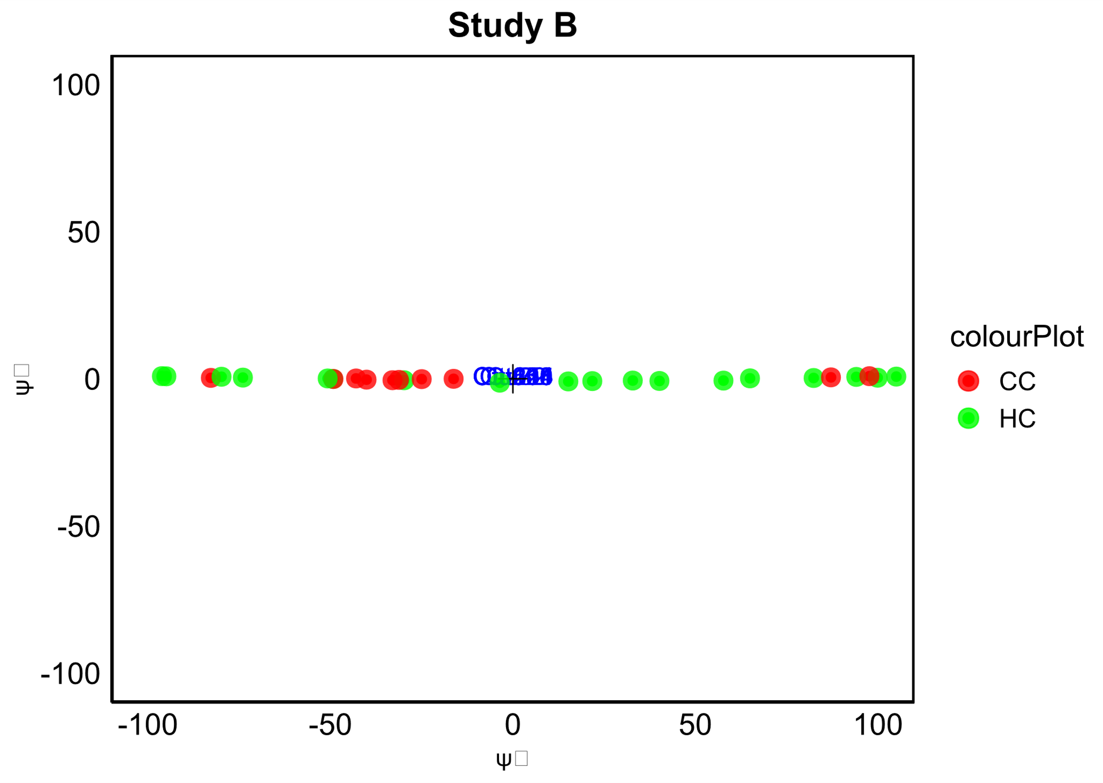
Study B
Figure 2 : RCM Plot of Cervical Cancer (CC) and Healthy Control (HC) - Study B.

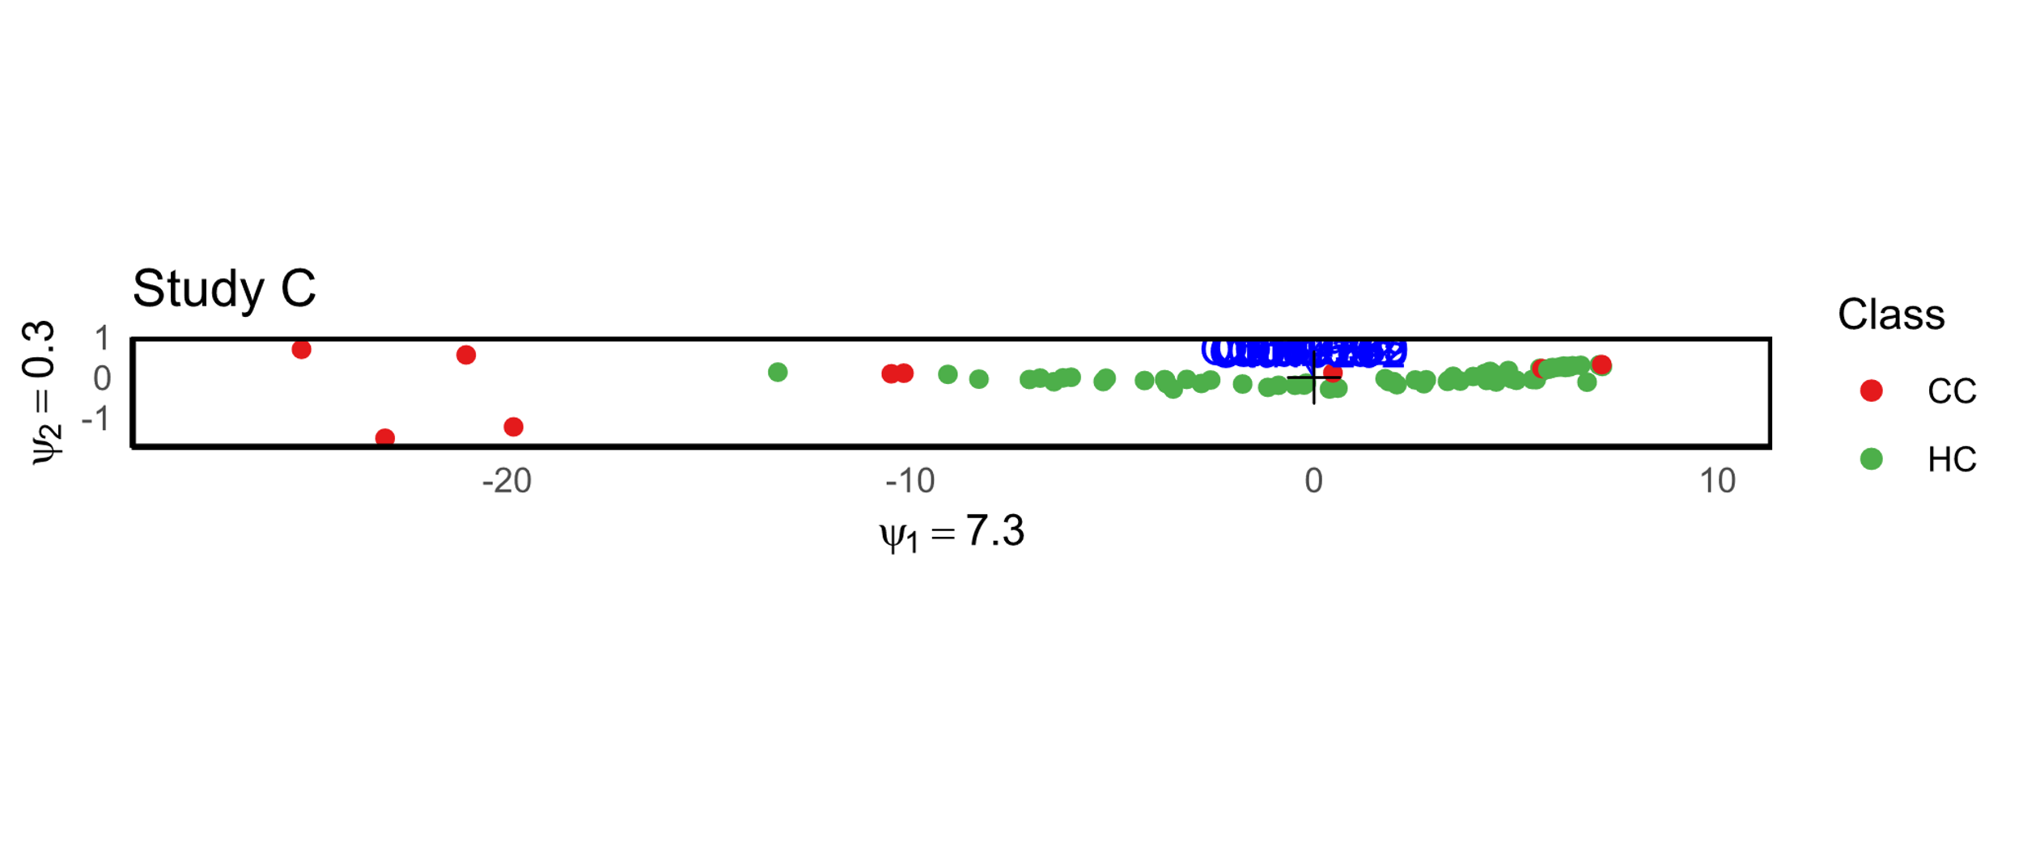
Study C
Figure 3 RCM Plot of Cervical Cancer (CC) and Healthy Control (HC) - Study C.

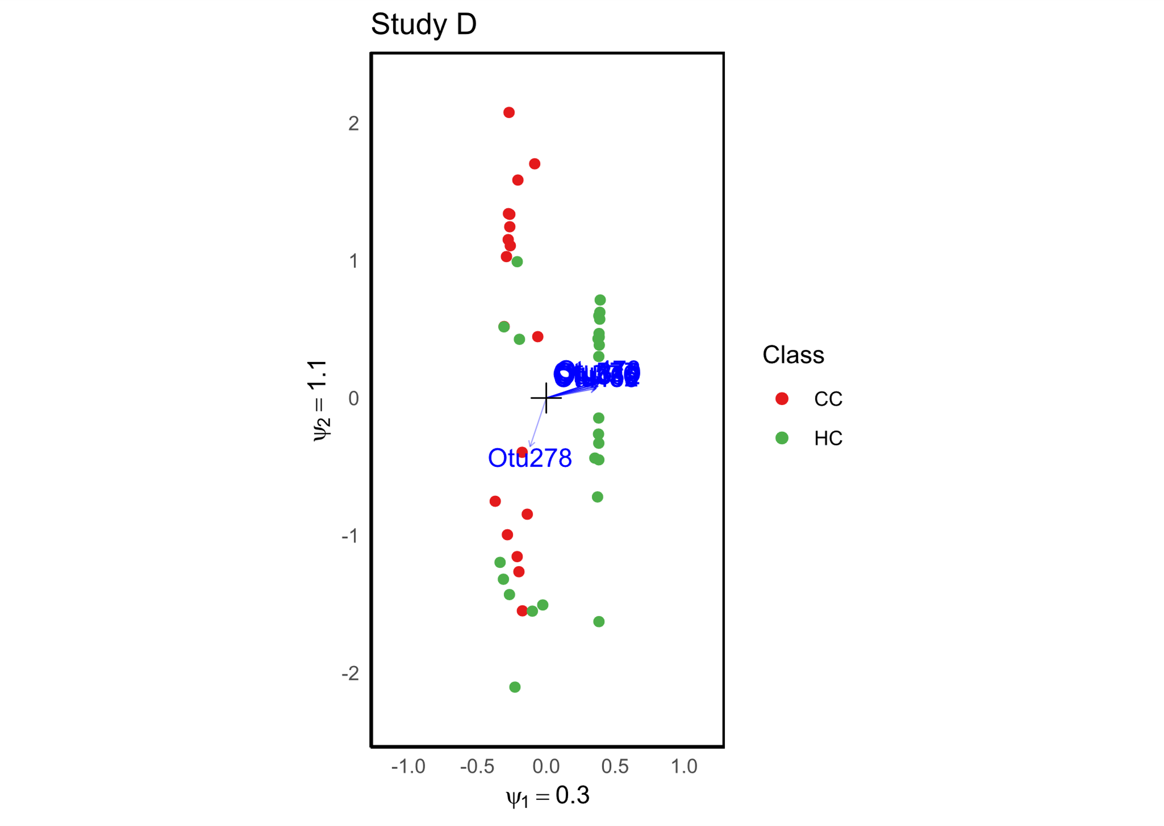
Study D
Figure 4 RCM Plot of Cervical Cancer (CC) and Healthy Control (HC) - Study D.

Study E
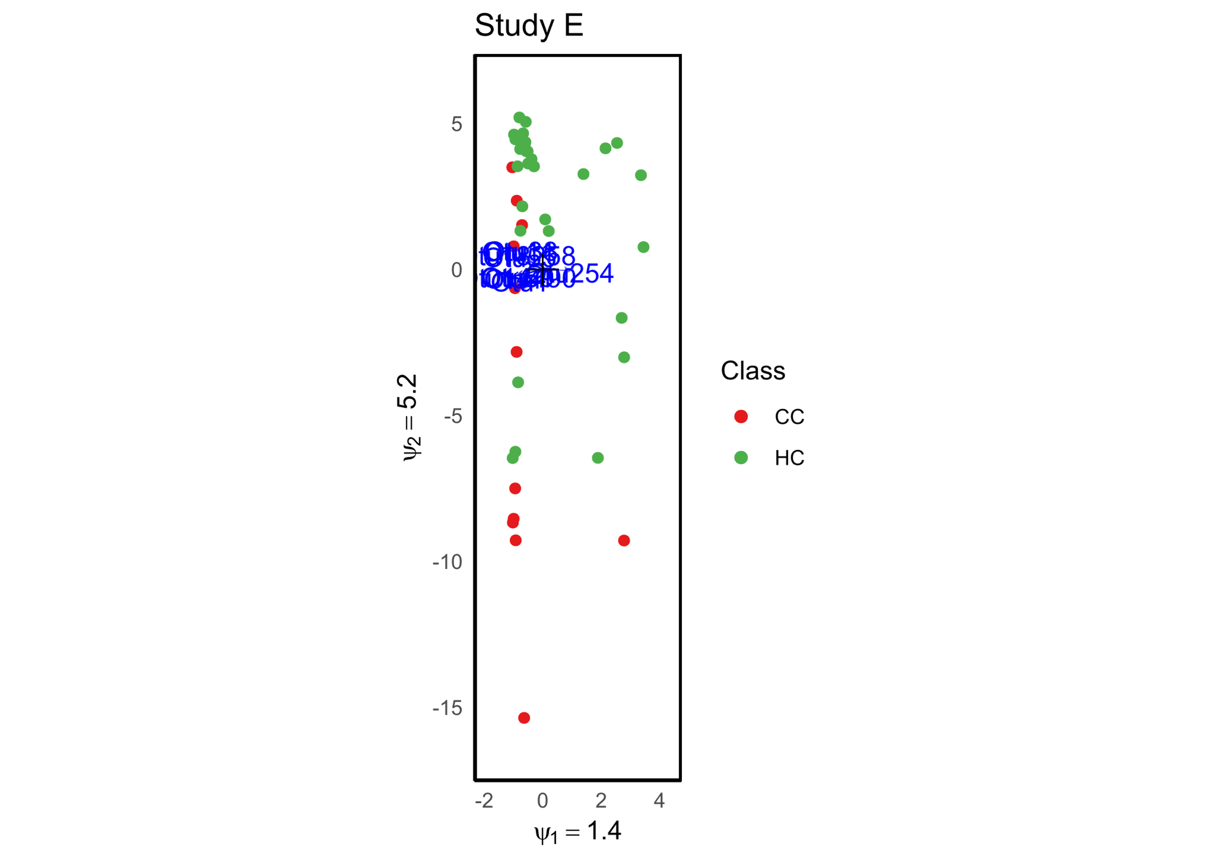
Figure 5 RCM Plot of Cervical Cancer (CC) and Healthy Control (HC) - Study E.

All studies
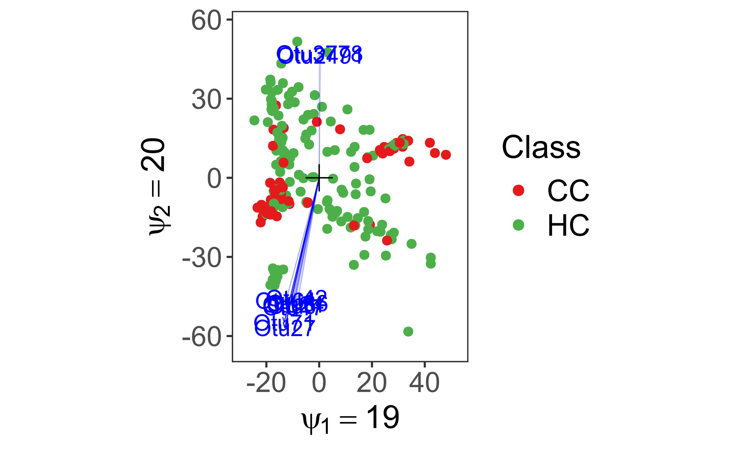
Figure 6 RCM Plot Summary Across All Studies.

Table 1 Taxonomic Levels of Bacterial Enrichment in Cervical Cancer (CC) and Healthy Control (HC) Samples. The table highlights the enriched taxa across different taxonomic levels in cervical cancer (CC) samples compared to healthy controls (HC).
Taxonomic Level | CC Enriched | HC Enriched
Phylum | Sphingobacteriaceae | NA
Class | Erysipelotrichaceae, Streptophyta and Chloroplast | NA
Order | Micrococcales, Mycobacteriales, Propionibacteriales, Bacteroidales_unclassified, Muribaculaceae, Bacteroidales, Sphingobacteriales, Bacillales, Verrucomicrobiales, Clostridiales, Peptostreptococcaceae, Clostridiales, Erysipelotrichales, Rhizobiales, Rhodobacterales, Sphingomonadales, Alcaligenaceae, Enterobacterales, Gammaproteobacteria_unclassified, Oceanospirillales, and Pseudomonadales | NA
Family | Brevibacteriaceae, Micrococcaceae, Corynebacteriaceae, Nocardiaceae, Propionibacteriaceae, Coriobacteriaceae, Bacteroidaceae, Porphyromonadaceae, Rikenellaceae, Weeksellaceae, Sphingobacteriaceae, Bacillaceae, Planococcaceae, Staphylococcaceae, Carnobacteriaceae, Streptococcaceae, Clostridiaceae, Lachnospiraceae, Peptoniphilaceae, Peptostreptococcaceae, Ruminococcaceae, Erysipelotrichaceae, Fusobacteriaceae, Brucellaceae, Phyllobacteriaceae, Rhizobiaceae, Rhodobacteraceae, Sphingomonadaceae, Enterobacteriaceae, Erwiniaceae, Halomonadaceae, Moraxellaceae, Pseudomonadaceae, and Akkermansiaceae | Ilumatobacteraceae, Geodermatophilaceae, Intrasporangiaceae, Microbacteriaceae, Micromonosporaceae, Mycobacteriaceae, Kribbellaceae, Nocardioidaceae, Pseudonocardiaceae, Streptomycetaceae, Gaiellaceae, Conexibacteraceae, Solirubrobacteraceae, Arcobacteraceae, Aggregatilineaceae, Anaerolineaceae, Sphaerobacteraceae, Deinococcaceae, Lactobacillaceae, Eubacteriaceae, Leptotrichiaceae, Gemmatimonadaceae, Isosphaeraceae, Boseaceae, Devosiaceae, Roseiarcaceae, Acetobacteraceae, Azospirillaceae, Reyranellaceae, Caballeronia, Thiobacillaceae, Azonexaceae, Polyangiaceae, Spongibacteraceae, Yersiniaceae, Steroidobacteraceae, Alcanivoracaceae, Oceanospirillaceae, Rhodanobacteraceae, Mycoplasmataceae, and Opitutaceae
Genus | Bifidobacterium, Brevibacterium, Pseudarthrobacter, Corynebacterium, Rhodococcus, Cutibacterium, Collinsella, Phocaeicola, Duncaniella, Paramuribaculum, Parabacteroides, Alistipes, Chryseobacterium, Sphingobacterium, Staphylococcus, Ligilactobacillus, Limosilactobacillus, Streptococcus, Clostridium, Anaerococcus, Fenollaria, Finegoldia, Romboutsia, Faecalibacterium, Faecalibaculum, Turicibacter, Brucella, Agrobacterium, Sphingomonas, Aquabacterium, Massilia, Halomonas, Enhydrobacter, Psychrobacter, and Akkermansia. In contrast, HC samples showed significant enrichments of Kribbella, Conexibacter, Exiguobacterium, Kurthia, Megasphaera, Sneathia, Devosiaceae, Caballeronia, and Acidibacter | Kribbella, Conexibacter, Exiguobacterium, Kurthia, Megasphaera, Sneathia, Devosiaceae, Caballeronia, and Acidibacter

