MOOSE (Meta-analyses Of Observational Studies in Epidemiology) Checklist
A reporting checklist for Authors, Editors, and Reviewers of Meta-analyses of Observational Studies. You must report the page
number in your manuscript where you consider each of the items listed in this checklist. If you have not included this information,
either revise your manuscript accordingly before submitting or note N/A.
Reporting Criteria
Reported (Yes/No)
Reported on Page No.
Reporting of Background
Problem definition
Hypothesis statement
Description of Study Outcome(s)
Type of exposure or intervention used
Type of study design used
Yes
Yes
Yes
1
1
1
1
3
3
Yes
Yes
Study population
Yes
Reporting of Search Strategy
Qualifications of searchers (eg, librarians
and investigators)
Yes
Yes
3
Search strategy, including time period
included in the synthesis and keywords
Effort to include all available studies,
including contact with authors
Databases and registries searched
Search software used, name and
version, including special features used
(eg, explosion)
3-4,supplement
Yes
Yes
3-4
4
Yes
3-4
Use of hand searching (eg, reference
lists of obtained articles)
3-4
5
Yes
Yes
List of citations located and those
excluded, including justification
Method for addressing articles
published in languages other than
English
No
Method of handling abstracts and
unpublished studies
Description of any contact with authors
Reporting of Methods
Yes
Yes
4
4
Description of relevance or
appropriateness of studies assembled for
assessing the hypothesis to be tested
Rationale for the selection and coding of
data (eg, sound clinical principles or
convenience)
Yes
Yes
3
3
Documentation of how data were
classified and coded (eg, multiple raters,
blinding, and interrater reliability)
Assessment of confounding (eg,
comparability of cases and controls in
studies where appropriate
Yes
Yes
3
3
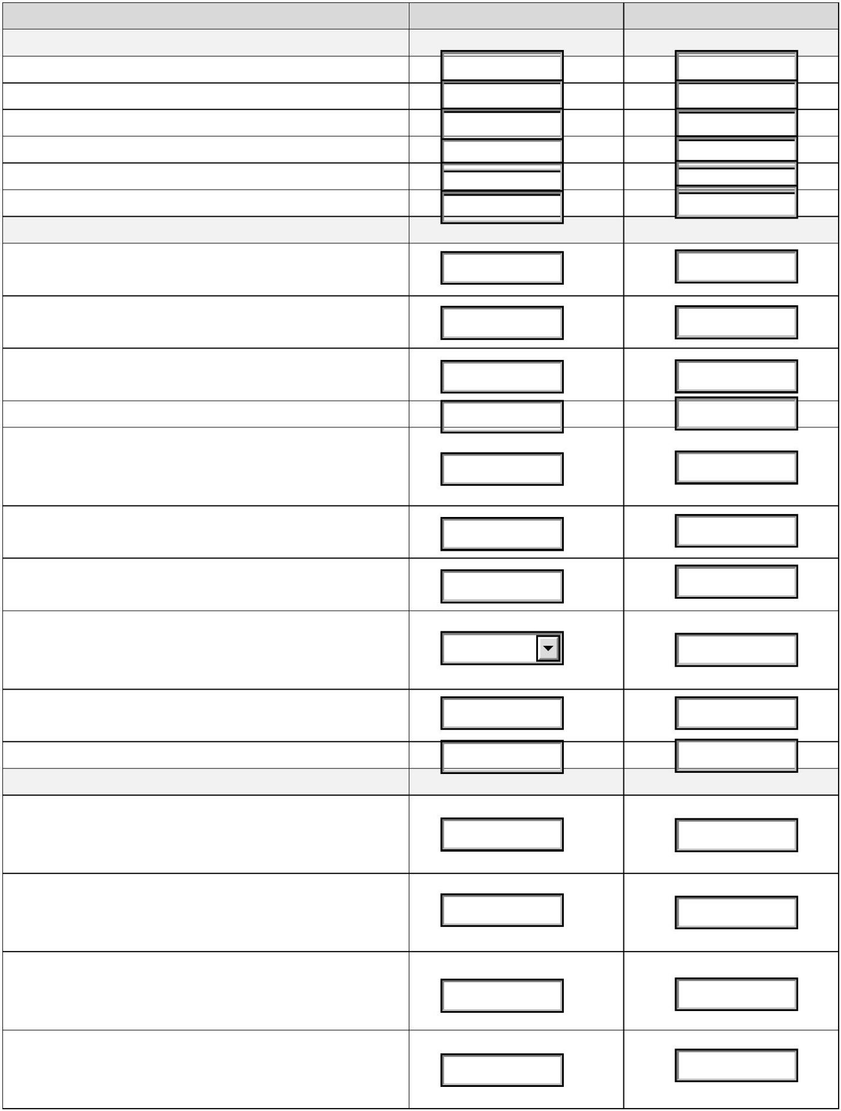

Reporting Criteria
Reported (Yes/No)
Reported on Page No.
Assessment of study quality, including
blinding of quality assessors;
stratification or regression on possible
predictors of study results
Assessment of heterogeneity
Description of statistical methods (eg,
complete description of fixed or random
effects models, justification of whether
the chosen models account for predictors
of study results, dose-response models,
or cumulative meta-analysis) in sufficient
detail to be replicated
Yes
Yes
3
3
3
Yes
Yes
Provision of appropriate tables and
graphics
3-4
Reporting of Results
Table giving descriptive information for
each study included
Results of sensitivity testing (eg,
subgroup analysis)
Indication of statistical uncertainty of
findings
Yes
Yes
Yes
table1
figure2,table2
table1
Reporting of Discussion
Quantitative assessment of bias (eg,
publication bias)
Yes
figure2
Justification for exclusion (eg, exclusion
of non–English-language citations)
Assessment of quality of included studies
Reporting of Conclusions
Yes
Yes
6
table1
Consideration of alternative explanations
for observed results
Yes
Yes
14-15
14-15
Generalization of the conclusions (ie,
appropriate for the data presented and
within the domain of the literature review)
Guidelines for future research
Disclosure of funding source
Yes
Yes
16
17
Once you have completed this checklist, please save a copy and upload it as part of your submission. DO NOT include this
checklist as part of the main manuscript document. It must be uploaded as a separate file.
