Supplementary Material

Supplementary Figure 1: (A) Schematic representation of the breakpoints and Alu sequences in introns 12 and 14 of LDLR. Exons are depicted as vertical lines, while the horizontal line represents introns. Colored triangles indicate the Alu repeats at the breakpoints, with their orientation denoted by the direction of the triangles. The Alu repeats at both sides of the deletion share high sequence similarity (84%) and are aligned in the same orientation, consistent with a mechanism of Alu-Alu recombination (B) Schematic representation of the breakpoints and AluSN repeats flanking the duplication. These repeats exhibit high homology, with 85% sequence similarity, and are also in the same orientation, supporting an Alu-Alu recombination mechanism.

Supplementary Figure 2: Pedigrees of the families with A) APOE p.Leu167del variant B) PLIN1 p.Arg93Ter variant C) CREB3L3 p.Leu461Met variant

Supplementary Figure 3: Number of significant genetic models from the PGSCatalog (www.pgscatalog.org) after applying a Benjamini-Hochberg correction. The x-axis represents the traits of the models, and the y-axis shows the number of significant models.

Table S1: List of genes participating in the cholesterol pathway used in this study (KEGG pathway: hsa048979) along with their interactors acquired from the Intact database.

Table S2: VUS and benign variants in FH genes (LDLR,APOB,PCSK9) identified in FH Cohort, along with Population-Based Frequencies from gnomAD and in-house controls.

Table S3: Variants in FH phenocopies genes (ABCG5,ABCG8,ABCA1 and LPL) identified in FH Cohort, along with Population-Based Frequencies from gnomAD and ClinVar annotation.

Supplementary references

Supplementary Figure 1

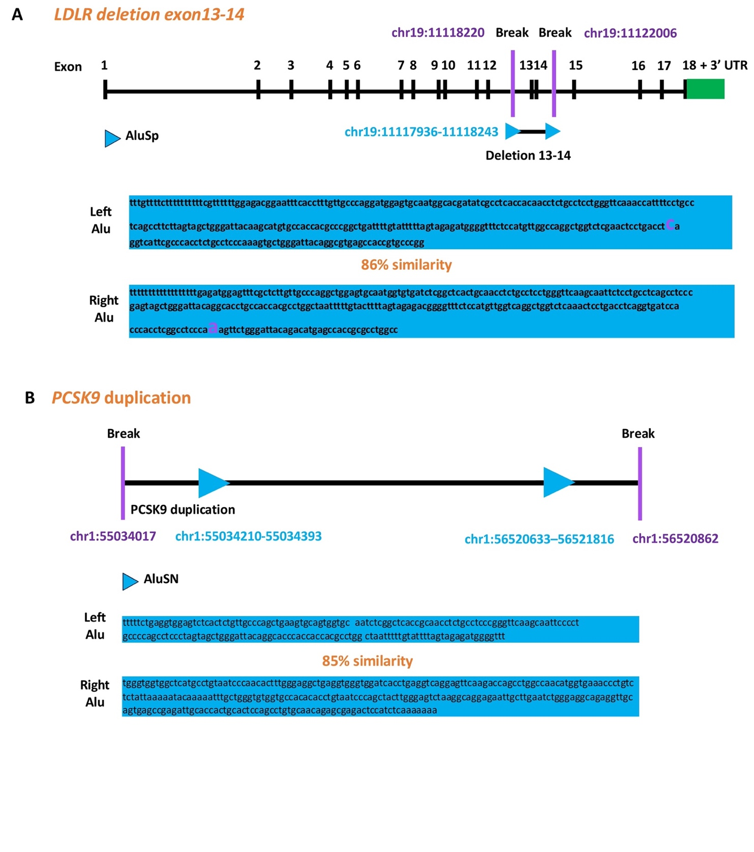

Supplementary Figure 2
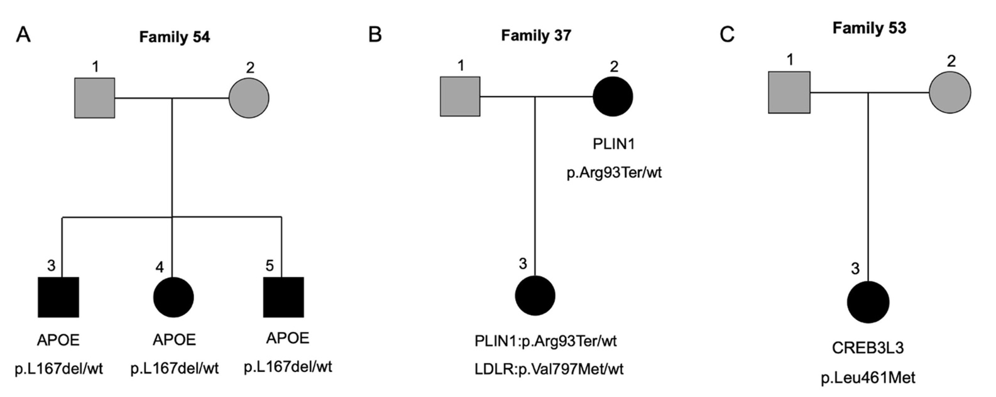

Supplementary Figure 3

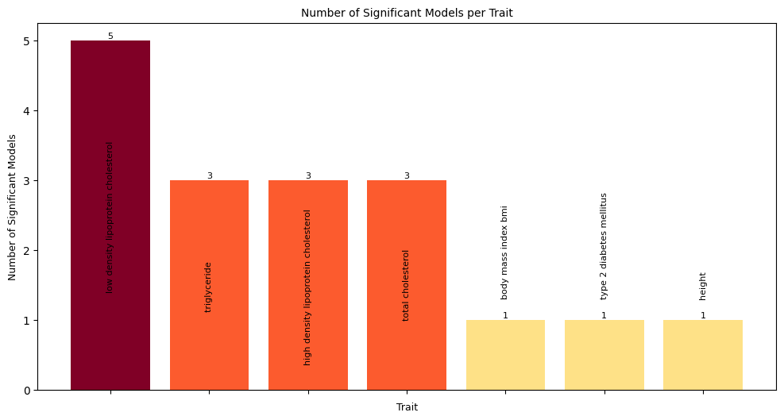

Table S1

Chromosome | Start | End | Gene | Pathway
chr9 | 104781006 | 104928155 | ABCA1 | cholesterol pathway
chr15 | 60347151 | 60397986 | ANXA2 | cholesterol pathway
chr11 | 116835751 | 116837622 | APOA1 | cholesterol pathway
chr1 | 161222292 | 161223628 | APOA2 | cholesterol pathway
chr19 | 44946051 | 44949565 | APOC2 | cholesterol pathway
chr12 | 124776856 | 124863864 | SCARB1 | cholesterol pathway
chr16 | 56961950 | 56983845 | CETP | cholesterol pathway
chr16 | 67939750 | 67944120 | LCAT | cholesterol pathway
chr8 | 19939253 | 19967259 | LPL | cholesterol pathway
chr18 | 49562057 | 49599185 | LIPG | cholesterol pathway
chr20 | 45898622 | 45912155 | PLTP | cholesterol pathway
chr15 | 58431991 | 58569844 | LIPC | cholesterol pathway
chr6 | 160531482 | 160664275 | LPA | cholesterol pathway
chr7 | 80638642 | 80679274 | CD36 | cholesterol pathway
chr3 | 172630249 | 172711067 | NCEH1 | cholesterol pathway
chr12 | 53103486 | 53124535 | SOAT2 | cholesterol pathway
chr1 | 179293797 | 179358680 | SOAT1 | cholesterol pathway
chr19 | 44914608 | 44919346 | APOC1 | cholesterol pathway
chr17 | 66212033 | 66229415 | APOH | cholesterol pathway
chr1 | 62597520 | 62606313 | ANGPTL3 | cholesterol pathway
chr19 | 8364155 | 8374370 | ANGPTL4 | cholesterol pathway
chr19 | 11239619 | 11241943 | ANGPTL8 | cholesterol pathway
chr1 | 109309575 | 109397918 | SORT1 | cholesterol pathway
chr6 | 16129086 | 16148248 | MYLIP | cholesterol pathway
chr12 | 57128483 | 57213361 | LRP1 | cholesterol pathway
chr2 | 169127109 | 169362534 | LRP2 | cholesterol pathway
chr17 | 39637144 | 39664201 | STARD3 | cholesterol pathway
chr5 | 133971871 | 134004975 | VDAC1 | cholesterol pathway
chr10 | 75210796 | 75231448 | VDAC2 | cholesterol pathway
chr8 | 42391880 | 42405937 | VDAC3 | cholesterol pathway
chr22 | 43151559 | 43163242 | TSPO | cholesterol pathway
chr2 | 218782147 | 218815293 | CYP27A1 | cholesterol pathway
chr18 | 9914016 | 9960021 | VAPA | cholesterol pathway
chr20 | 58389229 | 58451101 | VAPB | cholesterol pathway
chr18 | 23531442 | 23586506 | NPC1 | cholesterol pathway
chr11 | 3087107 | 3165310 | OSBPL5 | cholesterol pathway
chr14 | 74479940 | 74493305 | NPC2 | cholesterol pathway
chr8 | 38142700 | 38150952 | STAR | cholesterol pathway
chr14 | 24305187 | 24307977 | CIDEB | cholesterol pathway
chr8 | 58490178 | 58500163 | CYP7A1 | cholesterol pathway
chr2 | 168920781 | 169031324 | ABCB11 | cholesterol pathway
chr11 | 116829907 | 116833072 | APOC3 | cholesterol pathway
chr11 | 116820700 | 116823304 | APOA4 | cholesterol pathway
chr2 | 43812472 | 43838839 | ABCG5 | cholesterol pathway
chr2 | 43838971 | 43882988 | ABCG8 | cholesterol pathway
chr10 | 89213572 | 89251775 | LIPA | cholesterol pathway
chr4 | 3503612 | 3532422 | LRPAP1 | cholesterol pathway
chr19 | 44946051 | 44949565 | APOC2 | interactor
chr14 | 74479940 | 74493305 | NPC2 | interactor
chr18 | 23531442 | 23586506 | NPC1 | interactor
chr1 | 179293797 | 179358680 | SOAT1 | interactor
chr1 | 109309575 | 109397918 | SORT1 | interactor
chr21 | 25880550 | 26170770 | APP | interactor
chr10 | 52765380 | 52772784 | MBL2 | interactor
chr5 | 75377775 | 75511629 | CERT1 | interactor
chr1 | 159587826 | 159588865 | APCS | interactor
chr15 | 74782080 | 74803197 | CSK | interactor
chr20 | 41137543 | 41177626 | PLCG1 | interactor
chr22 | 30240453 | 30246759 | LIF | interactor
chr11 | 119185475 | 119190213 | NHERF4 | interactor
chr12 | 14612632 | 14696599 | GUCY2C | interactor
chr17 | 58301231 | 58328795 | TSPOAP1 | interactor
chr1 | 145670985 | 145707368 | PDZK1 | interactor
chr5 | 157477304 | 157575775 | ADAM19 | interactor
chr11 | 116789367 | 116791879 | APOA5 | interactor
chr5 | 38474668 | 38556646 | LIFR | interactor
chr3 | 124761948 | 124887365 | ITGB5 | interactor
chr11 | 1752755 | 1763927 | CTSD | interactor
chr5 | 55935095 | 55994963 | IL6ST | interactor
chr8 | 143213218 | 143217170 | GPIHBP1 | interactor
chr15 | 39581079 | 39599466 | THBS1 | interactor
chr1 | 115285917 | 115338249 | NGF | interactor
chr1 | 156860865 | 156881850 | NTRK1 | interactor
chr16 | 30896614 | 30903547 | CTF1 | interactor
chr11 | 58622665 | 58625733 | CNTF | interactor
chr10 | 106573663 | 107164706 | SORCS1 | interactor
chr8 | 132866958 | 133134899 | TG | interactor
chr16 | 23463542 | 23510494 | GGA2 | interactor
chr6 | 160702244 | 160754097 | PLG | interactor
chr22 | 30262829 | 30266851 | OSM | interactor
chr12 | 85874295 | 85882992 | NTS | interactor
chr2 | 215360865 | 215436068 | FN1 | interactor
chr22 | 19846146 | 19854874 | RTL10 | interactor
chr4 | 76158737 | 76213824 | SCARB2 | interactor
chrX | 101397803 | 101407925 | GLA | interactor
chr18 | 24162052 | 24397824 | OSBPL1A | interactor
chr9 | 134880810 | 134887523 | FCN2 | interactor
chr17 | 44345302 | 44353106 | GRN | interactor
chr9 | 87497867 | 87708634 | DAPK1 | interactor
chr22 | 37608834 | 37633564 | GGA1 | interactor
chr15 | 87859751 | 88256739 | NTRK3 | interactor
chr10 | 32900318 | 32958230 | ITGB1 | interactor
chr11 | 6395125 | 6419094 | APBB1 | interactor
chr10 | 97737128 | 97760895 | ZFYVE27 | interactor
chr16 | 72054505 | 72061055 | HP | interactor
chr8 | 11842524 | 11868087 | CTSB | interactor
chr11 | 27654893 | 27700455 | BDNF | interactor
chr7 | 22727200 | 22731998 | IL6 | interactor
chr20 | 45469753 | 45481532 | WFDC2 | interactor
chr16 | 2026902 | 2039026 | NHERF2 | interactor
chr9 | 84669729 | 85027054 | NTRK2 | interactor
chr6 | 33572552 | 33580276 | BAK1 | interactor

Table S2

CLASS | GENE (TRANSCRIPT) | HGVS (LOVD ID) | CARRIERS FH COHORT  (n=300) | CARRIERS CONTROLS  (n=741) | GnomAD exomes Freq
VUS | LDLR (NM_000527.5) | c.631C>T,  p.His211Tyr  (LDLR_000711) | 1 het | 3 het | 0.00000274
VUS | LDLR (NM_000527.5) | c.82G>A,  p.Glu28Lys  (LDLR_002047) | 5 het | 5 het | 0.0000616
VUS | LDLR (NM_000527.5) | c.2312-12T>G | 1 het |  | -
VUS | LDLR (NM_000527.5) | c.190+12T>A | 1 het |  | -
VUS | LDLR (NM_000527.5) | c.313+5G>A | 1 het |  | -
VUS | APOB  (NM_000384.3) | c.1331C>T,  p.Ala444Val | 1 het |  | 0.00000958
VUS | APOB  (NM_000384.3) | c.11569G>A,  p.Val3857Met  (APOB_000543) | 1 het |  | 0.0000581
VUS | APOB  (NM_000384.3) | c.2143G>A,  p.Val715Ile | 1 het |  | 0.00000205
VUS | APOB  (NM_000384.3) | c.7331G>A,  p.Arg2444Cys  (APOB_000339) | 1 het |  | 0.0000212
VUS | APOB  (NM_000384.3) | c.12511G>A,  p.Val4171Met | 1 het |  | 0.00000616
VUS | APOB  (NM_000384.3) | c.9462A>T,  p.Glu3154Asp | 1 het |  | -
VUS | APOB  (NM_000384.3) | c.11337T>G,  p.Phe3779Leu | 1 het |  | -
VUS | APOB  (NM_000384.3) | c.1554G>C,  p.Lys518Asn | 1 het | 1 het] | 0.00000547
VUS | APOB  (NM_000384.3) | c.1039C>A,  p.Leu347Ile | 1 het |  | 6.84E-07
VUS | APOB  (NM_000384.3) | c.5066G>A,  p.Arg1689His  (APOB_000144) | 1 het |  | 0.00174
VUS | APOB  (NM_000384.3) | c.10726C>T,  p.Leu3576Phe | 1 het |  | 0.0000041
VUS | APOB  (NM_000384.3) | c.3427C>T,  p.Pro1143Ser  (APOB_000400) | 1 het |  | 0.00245
VUS | APOB  (NM_000384.3) | c.721A>T,  p.Ser241Cys | 1 het |  | 0.00000616
VUS | APOE  (NM_000041.2) | c.262G>C,  p.Glu88Gln | 1 het |  | 0.00000274
 | PCSK9 (NM_174936.4) | c.385G>A,  p.Asp129Asn  (PCSK9_000248) | 1 het |  | 0.00000821
 | PCSK9 (NM_174936.4) | c.839T>C,  p.Val280Ala  (PCSK9_000287) | 1 het |  | 0.00000137
 | PCSK9 (NM_174936.4) | c.109G>A,  p.Asp37Asn | 1 het |  | -
 | PCSK9 (NM_174936.4) | c.60_65dupGCTGCT,  p.L22_L23dup  (PCSK9_000229) | 1 het | 2 het | 0.00327
BENIGN | LDLR (NM_000527.5) | c.829G>A,  p.Glu277Lys  (LDLR_001845) | 7 het | 2 het | 0.000457
BENIGN | APOB  (NM_000384.3) | c.61_66dupCTGCTG,  p.Leu21_Leu22dup  (APOB_000794) | 20 het | 60 het and 2 hom | 0.000621
BENIGN | APOB  (NM_000384.3) | c.3337G>C,  p.Asp1113His  (APOB_000404) | 5 het | 6 het | 0.00847
BENIGN | APOB  (NM_000384.3) | c.12794T>C,  p.Val4265Ala  (APOB_000222) | 7 het | 2 het | 0.00893
BENIGN | APOB  (NM_000384.3) | c.3383G>A,  p.Arg1128His  (APOB_000685) | 2 het | 2 het | 0.00463
BENIGN | APOB  (NM_000384.3) | c.12382G>A,  p.Val4128Met  (APOB_000228) | 1 het | 6 het | 0.00722
BENIGN | APOB  (NM_000384.3) | c.12940A>G  p.Ile4314Val  (APOB_000220) | 1 hom | 4 het | 0.00788
BENIGN | APOB  (NM_000384.3) | c.2981C>T,  p.Pro994Leu  (APOB_000717) | 1 het and 1 hom |  | 0.00106
BENIGN | APOB  (NM_000384.3) | c.9835A>G,  p.Ser3279Gly  (p.S3279G) | 1 het | 4 het | 0.00325
BENIGN | PCSK9 (NM_174936.4) | c.63_65delGCT  p.Leu23del  (PCSK9_000230) | 1 het |  | 0.000228

Table S3

GENE (TRANSCRIPT) | HGVS (LOVD ID) | CARRIERS FH COHORT  (n=300) | AF gnomAD | ClinVar
ABCG5  (NM_022436.2) | c.1864A>G,  p.Met622Val  (ABCG5_000004) | 3 het | 0.00606 | Benign/Likely benign
ABCG5  (NM_022436.2) | c.901T>C,  p.Tyr301His | 3 het | 0.00000274 | Uncertain significance
ABCG5  (NM_022436.2) | c.731T>C,  p.Ile244Thr  (ABCG5_000094) | 1 het | 0.0000315 | Uncertain significance
ABCG5  (NM_022436.2) | c.293C>G,  p.Ala98Gly  (ABCG5_000043) | 5 het | 0.00214 | Conflicting classifications of pathogenicity
ABCG5  (NM_022436.2) | c.1570G>A,  p.Val524Ile  (ABCG5_000009) | 2 het | 0.0000691 | Uncertain significance
ABCG5  (NM_022436.2) | c.1466C>T,  p.Thr489Met  (ABCG5_000129) | 1 het | 0.0000417 | not reported
ABCG5  (NM_022436.2) | c.1337G>A,  p.Arg446Gln  ABCG5(NM_022436.3) | 1 het | 0.0000164 | Conflicting classifications of pathogenicity
ABCG5  (NM_022436.2) | c.1320T>A,  p.Asn440Lys | 2 het | 0.0000129 | Uncertain significance
ABCG5  (NM_022436.2) | c.1163C>T,  p.Thr388Met | 1 het | 0.000163 | Conflicting classifications of pathogenicity
ABCG5  (NM_022436.2) | c.314G>T,  p.Arg105Leu | 1 het | - | not reported
ABCG5  (NM_022436.2) | c.139G>T,  p.Val47Phe | 1 het | 0.0003213 | benign
ABCG5  (NM_022436.2) | c.80G>C,  p.Gly27Ala  (ABCG5_000050) | 1 het | 0.003959 | Conflicting classifications of pathogenicity
ABCG5  (NM_022436.2) | c.28G>A,  p.Gly10Arg | 1 het | 0.00001642 | Uncertain significance
ABCG8  (NM_022437.2) | c.1201A>T,  p.Thr401Ser  (ABCG8_000122) | 4 het | 0.0021 | Conflicting classifications of pathogenicity
ABCG8  (NM_022437.2) | c.1228G>A,  p.Asp410Asn | 1 het | 0.0000129 | not reported
ABCG8  (NM_022437.2) | c.255G>T  p.Glu85Asp | 1 het | 0.0000157 | Uncertain significance
ABCG8  (NM_022437.2) | c.598T>C,  p.Cys200Arg | 1 het | 0.00000342 | not reported
ABCG8  (NM_022437.2) | c.787C>T,  p.Arg263Trp | 1 het | 0.00000889 | Uncertain significance
ABCG8  (NM_022437.2) | c.1073A>G,  p.Asp358Gly | 1 het | 0.00000342 | Uncertain significance
ABCG8  (NM_022437.2) | c.1226A>G, p.Asn409Ser  (ABCG8_000128) | 3 het | 0.0000705 | Conflicting classifications of pathogenicity
ABCG8  (NM_022437.2) | c.1486A>G,  p.Lys496Glu | 2 het | 0.0000411 | Uncertain significance
LPL  (NM_000237.2) | c.430-6C>T  (LPL_000041) | 27 het and 1 hom | - | Benign/Likely benign
LPL  (NM_000237.2) | c.1279G>A,  p.Ala427Thr | 2 het | 0.00138 | Benign/Likely benign
ABCA1  (NM_005502.3) | c.6588G>C,  p.Gln2196His  (ABCA1_000056) | 1 het | 0.000183 | not reported
ABCA1  (NM_005502.3) | c.6279G>C,  p.Glu2093Asp | 1 het | 0.00000137 | not reported
ABCA1  (NM_005502.3) | c.3544G>A,  p.Ala1182Thr | 1 het | 0.000882 | Conflicting classifications of pathogenicity
ABCA1  (NM_005502.3) | c.1196T>C,  p.Val399Ala  (ABCA1_000031) | 3 het | 0.00462 | Conflicting classifications of pathogenicity
ABCA1  (NM_005502.3) | c.688C>T,  p.Arg230Cys  (ABCA1_000429) | 46 het and 1 hom | 0.00269 | Benign
ABCA1  (NM_005502.3) | c.5039G>A,  p.Arg1680Gln  (ABCA1_000023) | 1 het | 0.00054 | Conflicting classifications of pathogenicity
ABCA1  (NM_005502.3) | c.2311G>C,  p.Val771Leu  (ABCA1_000361) | 1 het | 0.000183 | not reported
ABCA1  (NM_005502.3) | c.1276T>C,  p.Phe426Leu  (ABCA1_000030) | 2 het | 0.0000424 | uncertain-significance
ABCA1  (NM_005502.3) | c.520A>G,  p.Arg174Gly | 2 het | 0.00000274 | not reported
ABCA1  (NM_005502.3) | c.254C>T,  p.Pro85Leu  (ABCA1_000041) | 1 het | 0.00135 | Conflicting classifications of pathogenicity
ABCA1  (NM_005502.3) | c.4222C>T  p.Leu1408Phe | 1 het | 0.0000779 | Benign/Likely benign
LIPA  (NM_001127605.1) | c.761A>T,  p.Lys254Met | 1 het | 0.00000205 | Uncertain significance
LIPA  (NM_001127605.1) | c.380G>A  p.Arg127Gln  (LIPA_000015) | 1 het | 0.0000793 | Uncertain significance

Supplementary references

[1] H. Hh, B. Ms, and G. Jl, “Molecular genetics of the LDL receptor gene in familial hypercholesterolemia,” Human mutation, vol. 1, no. 6, 1992, doi: 10.1002/humu.1380010602.
[2] A. Cenarro et al., “Identification of recurrent and novel mutations in the LDL receptor gene in Spanish patients with familial hypercholesterolemia. Mutations in brief no. 135. Online,” Hum Mutat, vol. 11, no. 5, p. 413, 1998, doi: 10.1002/(SICI)1098-1004(1998)11:5<413::AID-HUMU16>3.0.CO;2-I.
[3] L. Robles-Osorio et al., “Genetic heterogeneity of autosomal dominant hypercholesterolemia in Mexico,” Arch Med Res, vol. 37, no. 1, pp. 102–108, Jan. 2006, doi: 10.1016/j.arcmed.2005.04.018.
[4] J. C. Webb, X. M. Sun, D. D. Patel, S. N. McCarthy, B. L. Knight, and A. K. Soutar, “Characterization of two new point mutations in the low density lipoprotein receptor genes of an English patient with homozygous familial hypercholesterolemia,” J Lipid Res, vol. 33, no. 5, pp. 689–698, May 1992.
[5] R. M. Sánchez-Hernández et al., “The island of Gran Canaria: A genetic isolate for familial hypercholesterolemia,” Journal of Clinical Lipidology, vol. 13, no. 4, pp. 618–626, Jul. 2019, doi: 10.1016/j.jacl.2019.04.099.
[6] N. Loux et al., “Screening for new mutations in the LDL receptor gene in seven French familial hypercholesterolemia families by the single strand conformation polymorphism method,” Hum Mutat, vol. 1, no. 4, pp. 325–332, 1992, doi: 10.1002/humu.1380010411.
[7] J. Geisel, J. Gielen, K. Oette, W. Herrmann, and K. Wielckens, “Mutation analysis of exon 3 of the LDL receptor gene in patients with severe hypercholesterolemia,” Clin Chem Lab Med, vol. 36, no. 5, pp. 279–282, May 1998, doi: 10.1515/CCLM.1998.047.
[8] A. Al-Khateeb et al., “Analysis of sequence variations in low-density lipoprotein receptor gene among Malaysian patients with familial hypercholesterolemia,” BMC Med Genet, vol. 12, p. 40, Mar. 2011, doi: 10.1186/1471-2350-12-40.
[9] G. V. Z. Dedoussis et al., “Molecular characterization of familial hypercholesterolemia in German and Greek patients,” Hum. Mutat., vol. 23, no. 3, pp. 285–286, Mar. 2004, doi: 10.1002/humu.9218.
[10] K. H. Y. Wong et al., “Three patients with homozygous familial hypercholesterolemia: Genomic sequencing and kindred analysis,” Molec Gen &amp; Gen Med, vol. 7, no. 12, p. e1007, Dec. 2019, doi: 10.1002/mgg3.1007.
[11] D. C. Rubinsztein, I. Jialal, E. Leitersdorf, G. A. Coetzee, and D. R. van der Westhuyzen, “Identification of two new LDL-receptor mutations causing homozygous familial hypercholesterolemia in a South African of Indian origin,” Biochim Biophys Acta, vol. 1182, no. 1, pp. 75–82, Aug. 1993, doi: 10.1016/0925-4439(93)90156-u.
[12] A. B. García-García et al., “Molecular genetics of familial hypercholesterolemia in Spain: Ten novel LDLR mutations and population analysis,” Hum Mutat, vol. 18, no. 5, pp. 458–459, Nov. 2001, doi: 10.1002/humu.1218.
[13] H. K. Jensen, L. G. Jensen, H. Meinertz, P. S. Hansen, N. Gregersen, and O. Faergeman, “Spectrum of LDL receptor gene mutations in Denmark: implications for molecular diagnostic strategy in heterozygous familial hypercholesterolemia,” Atherosclerosis, vol. 146, no. 2, pp. 337–344, Oct. 1999, doi: 10.1016/s0021-9150(99)00158-6.
[14] S. Bertolini et al., “Spectrum of mutations and phenotypic expression in patients with autosomal dominant hypercholesterolemia identified in Italy,” Atherosclerosis, vol. 227, no. 2, pp. 342–348, Apr. 2013, doi: 10.1016/j.atherosclerosis.2013.01.007.
[15] D. G. Shin et al., “Clinical features of familial hypercholesterolemia in Korea: Predictors of pathogenic mutations and coronary artery disease - A study supported by the Korean Society of Lipidology and Atherosclerosis,” Atherosclerosis, vol. 243, no. 1, pp. 53–58, Nov. 2015, doi: 10.1016/j.atherosclerosis.2015.08.033.
[16] G. Vaca et al., “Mutational analysis of the LDL receptor and APOB genes in Mexican individuals with autosomal dominant hypercholesterolemia,” Atherosclerosis, vol. 218, no. 2, pp. 391–396, Oct. 2011, doi: 10.1016/j.atherosclerosis.2011.06.006.
[17] T. Maruyama et al., “Common mutations in the low-density-lipoprotein-receptor gene causing familial hypercholesterolemia in the Japanese population,” Arterioscler Thromb Vasc Biol, vol. 15, no. 10, pp. 1713–1718, Oct. 1995, doi: 10.1161/01.atv.15.10.1713.
[18] A. Benito-Vicente, K. B. Uribe, S. Jebari, U. Galicia-Garcia, H. Ostolaza, and C. Martin, “Validation of LDLr Activity as a Tool to Improve Genetic Diagnosis of Familial Hypercholesterolemia: A Retrospective on Functional Characterization of LDLr Variants,” Int J Mol Sci, vol. 19, no. 6, p. 1676, Jun. 2018, doi: 10.3390/ijms19061676.
[19] J.-H. Chang et al., “Identification and characterization of LDL receptor gene mutations in hyperlipidemic Chinese,” J Lipid Res, vol. 44, no. 10, pp. 1850–1858, Oct. 2003, doi: 10.1194/jlr.M200470-JLR200.
[20] M. C. Vohl, S. Mooriani, and A. L. Torres, “Rapid detection of three point mutations in the LDL receptor gene causing familial hypercholesterolemia among French Canadians,” American Journal of Human Genetics, vol. 55, no. Suppl.3, Art. no. CONF-941009-, Sep. 1994, Accessed: Aug. 09, 2024. [Online]. Available: https://www.osti.gov/biblio/134351
[21] M. Bourbon, A. C. Alves, A. M. Medeiros, S. Silva, and A. K. Soutar, “Familial hypercholesterolaemia in Portugal,” Atherosclerosis, vol. 196, no. 2, pp. 633–642, Feb. 2008, doi: 10.1016/j.atherosclerosis.2007.07.019.
[22] A. Guerin, I. Iatan, I. Ruel, L. F. Ngufor, and J. Genest, “Genetic testing for familial hypercholesterolemia in Quebec, Canada: a single-centre retrospective cohort study,” CMAJ Open, vol. 11, no. 4, pp. E754–E764, 2023, doi: 10.9778/cmajo.20220108.
[23] R. Thiart et al., “Mutation analysis in a small cohort of New Zealand patients originating from the United Kingdom demonstrates genetic heterogeneity in familial hypercholesterolemia,” Mol Cell Probes, vol. 14, no. 5, pp. 299–304, Oct. 2000, doi: 10.1006/mcpr.2000.0318.
[24] S. W. Fouchier, J. C. Defesche, M. W. Umans-Eckenhausen, and J. P. Kastelein, “The molecular basis of familial hypercholesterolemia in The Netherlands,” Hum Genet, vol. 109, no. 6, pp. 602–615, Dec. 2001, doi: 10.1007/s00439-001-0628-8.
[25] P. Mozas et al., “Molecular characterization of familial hypercholesterolemia in Spain: Identification of 39 novel and 77 recurrent mutations in LDLR: MUTATIONS IN BRIEF,” Hum. Mutat., vol. 24, no. 2, pp. 187–187, Aug. 2004, doi: 10.1002/humu.9264.
[26] A. Reshef et al., “Molecular genetics of familial hypercholesterolemia in Israel,” Hum Genet, vol. 98, no. 5, pp. 581–586, Nov. 1996, doi: 10.1007/s004390050263.
[27] O. Guardamagna et al., “The Type of LDLR Gene Mutation Predicts Cardiovascular Risk in Children with Familial Hypercholesterolemia,” The Journal of Pediatrics, vol. 155, no. 2, pp. 199-204.e2, Aug. 2009, doi: 10.1016/j.jpeds.2009.02.022.
[28] T. D. J. Hernández Flores et al., “Screening of LDLR and APOB gene mutations in Mexican patients with homozygous familial hypercholesterolemia,” Journal of Clinical Lipidology, vol. 12, no. 3, pp. 693–701, May 2018, doi: 10.1016/j.jacl.2018.02.015.
[29] A. D. Laurie, R. S. Scott, and P. M. George, “Genetic screening of patients with familial hypercholesterolaemia (FH): a New Zealand perspective,” Atherosclerosis Supplements, vol. 5, no. 5, pp. 13–15, Dec. 2004, doi: 10.1016/j.atherosclerosissup.2004.09.001.
[30] U. Galicia-Garcia et al., “Mutation type classification and pathogenicity assignment of sixteen missense variants located in the EGF-precursor homology domain of the LDLR,” Sci Rep, vol. 10, p. 1727, Feb. 2020, doi: 10.1038/s41598-020-58734-9.
[31] L. Rieck et al., “Mutation spectrum and polygenic score in German patients with familial hypercholesterolemia,” Clin Genet, vol. 98, no. 5, pp. 457–467, Nov. 2020, doi: 10.1111/cge.13826.
[32] N. M. Suárez et al., “Age, Origin and Functional Study of the Prevalent LDLR Mutation Causing Familial Hypercholesterolaemia in Gran Canaria,” Int J Mol Sci, vol. 24, no. 14, p. 11319, Jul. 2023, doi: 10.3390/ijms241411319.
[33] R. M. Sánchez-Hernández et al., “Familial hypercholesterolemia in Gran Canaria: Founder mutation effect and high frequency of diabetes,” Clin Investig Arterioscler, vol. 33, no. 5, pp. 247–253, Sep. 2021, doi: 10.1016/j.artere.2021.08.003.
[34] C. F. Bunn, C. J. Lintott, R. S. Scott, and P. M. George, “Comparison of SSCP and DHPLC for the detection of LDLR mutations in a New Zealand cohort,” Hum Mutat, vol. 19, no. 3, p. 311, Mar. 2002, doi: 10.1002/humu.9021.
[35] T. P. Leren et al., “Application of molecular genetics for diagnosing familial hypercholesterolemia in Norway: results from a family-based screening program,” Semin Vasc Med, vol. 4, no. 1, pp. 75–85, Feb. 2004, doi: 10.1055/s-2004-822989.
[36] A. Taylor et al., “Multiplex ARMS analysis to detect 13 common mutations in familial hypercholesterolaemia,” Clinical Genetics, vol. 71, no. 6, pp. 561–568, Jun. 2007, doi: 10.1111/j.1399-0004.2007.00807.x.
[37] E. Leitersdorf, D. R. Van der Westhuyzen, G. A. Coetzee, and H. H. Hobbs, “Two common low density lipoprotein receptor gene mutations cause familial hypercholesterolemia in Afrikaners.,” J Clin Invest, vol. 84, no. 3, pp. 954–961, Sep. 1989.
[38] N. Setia et al., “Genetic analysis of familial hypercholesterolemia in Asian Indians: A single-center study,” J Clin Lipidol, vol. 14, no. 1, pp. 35–45, 2020, doi: 10.1016/j.jacl.2019.12.010.
[39] H. K. Jensen et al., “Two mutations in the same low-density lipoprotein receptor allele act in synergy to reduce receptor function in heterozygous familial hypercholesterolemia,” Hum Mutat, vol. 9, no. 5, pp. 437–444, 1997, doi: 10.1002/(SICI)1098-1004(1997)9:5<437::AID-HUMU10>3.0.CO;2-3.
[40] M. Ebhardt et al., “Mutation analysis in 46 German families with familial hypercholesterolemia: identification of 8 new mutations. Mutations in brief no. 226. Online,” Hum Mutat, vol. 13, no. 3, p. 257, 1999, doi: 10.1002/(SICI)1098-1004(1999)13:3<257::AID-HUMU15>3.0.CO;2-A.
[41] F. Tricot-Guerber, B. Saint-Jore, K. Valenti, T. Foulon, M. Bost, and A. J. Hadjian, “Identification of a mutation, N543H, in exon 11 of the low-density lipoprotein receptor gene in a French family with familial hypercholesterolemia,” Hum Mutat, vol. 6, no. 1, pp. 87–88, 1995, doi: 10.1002/humu.1380060117.
[42] I. N. Day et al., “Spectrum of LDL receptor gene mutations in heterozygous familial hypercholesterolemia,” Hum Mutat, vol. 10, no. 2, pp. 116–127, 1997, doi: 10.1002/(SICI)1098-1004(1997)10:2<116::AID-HUMU4>3.0.CO;2-I.
[43] R. Alonso et al., “Genetic diagnosis of familial hypercholesterolemia using a DNA-array based platform,” Clin Biochem, vol. 42, no. 9, pp. 899–903, Jun. 2009, doi: 10.1016/j.clinbiochem.2009.01.017.
[44] L. Tichý, T. Freiberger, P. Zapletalová, V. Soška, B. Ravčuková, and L. Fajkusová, “The molecular basis of familial hypercholesterolemia in the Czech Republic: spectrum of LDLR mutations and genotype-phenotype correlations,” Atherosclerosis, vol. 223, no. 2, pp. 401–408, Aug. 2012, doi: 10.1016/j.atherosclerosis.2012.05.014.
[45] K.-R. Chiou and M.-J. Charng, “Detection of mutations and large rearrangements of the low-density lipoprotein receptor gene in Taiwanese patients with familial hypercholesterolemia,” Am J Cardiol, vol. 105, no. 12, pp. 1752–1758, Jun. 2010, doi: 10.1016/j.amjcard.2010.01.356.
[46] K. E. Heath, S. E. Humphries, H. Middleton-Price, and M. Boxer, “A molecular genetic service for diagnosing individuals with familial hypercholesterolaemia (FH) in the United Kingdom,” Eur J Hum Genet, vol. 9, no. 4, pp. 244–252, Apr. 2001, doi: 10.1038/sj.ejhg.5200633.
[47] M. S. Figueiredo, J. E. Dos Santos, F. L. Alberto, and M. A. Zago, “High frequency of the Lebanese allele of the LDLr gene among Brazilian patients with familial hypercholesterolaemia,” J Med Genet, vol. 29, no. 11, pp. 813–815, Nov. 1992, doi: 10.1136/jmg.29.11.813.
[48] T. P. Leren and M. P. Bogsrud, “Molecular genetic testing for autosomal dominant hypercholesterolemia in 29,449 Norwegian index patients and 14,230 relatives during the years 1993-2020,” Atherosclerosis, vol. 322, pp. 61–66, Apr. 2021, doi: 10.1016/j.atherosclerosis.2021.02.022.
[49] N. Jalkh, C. Mehawej, and E. Chouery, “Actionable Exomic Secondary Findings in 280 Lebanese Participants,” Front Genet, vol. 11, p. 208, 2020, doi: 10.3389/fgene.2020.00208.
[50] M. Abifadel and C. Boileau, “Genetic and molecular architecture of familial hypercholesterolemia,” J Intern Med, vol. 293, no. 2, pp. 144–165, Feb. 2023, doi: 10.1111/joim.13577.
[51] R. D. Santos et al., “Clinical and molecular aspects of familial hypercholesterolemia in Ibero-American countries,” J Clin Lipidol, vol. 11, no. 1, pp. 160–166, 2017, doi: 10.1016/j.jacl.2016.11.004.
[52] V. G. Bañares et al., “Preliminary spectrum of genetic variants in familial hypercholesterolemia in Argentina,” Journal of Clinical Lipidology, vol. 11, no. 2, pp. 524–531, Mar. 2017, doi: 10.1016/j.jacl.2017.02.007.
[53] A. Etxebarria, A. Benito-Vicente, A. C. Alves, H. Ostolaza, M. Bourbon, and C. Martin, “Advantages and versatility of fluorescence-based methodology to characterize the functionality of LDLR and class mutation assignment,” PLoS One, vol. 9, no. 11, p. e112677, 2014, doi: 10.1371/journal.pone.0112677.
[54] M. Marduel et al., “Molecular Spectrum of Autosomal Dominant Hypercholesterolemia in France,” Hum Mutat, vol. 31, no. 11, pp. E1811–E1824, Nov. 2010, doi: 10.1002/humu.21348.
[55] S. L. T. Pek et al., “Spectrum of mutations in index patients with familial hypercholesterolemia in Singapore: Single center study,” Atherosclerosis, vol. 269, pp. 106–116, Feb. 2018, doi: 10.1016/j.atherosclerosis.2017.12.028.
[56] Y. T. Mak et al., “Mutations in the low-density lipoprotein receptor gene in Chinese familial hypercholesterolemia patients,” Arterioscler Thromb Vasc Biol, vol. 18, no. 10, pp. 1600–1605, Oct. 1998, doi: 10.1161/01.atv.18.10.1600.
[57] S. Amsellem et al., “Intronic mutations outside of Alu-repeat-rich domains of the LDL receptor gene are a cause of familial hypercholesterolemia,” Hum Genet, vol. 111, no. 6, pp. 501–510, Dec. 2002, doi: 10.1007/s00439-002-0813-4.
[58] E. Pereira et al., “Recurrent and novel LDL receptor gene mutations causing heterozygous familial hypercholesterolemia in La Habana,” Hum Genet, vol. 96, no. 3, pp. 319–322, Sep. 1995, doi: 10.1007/BF00210415.
[59] M. Chmara et al., “Molecular characterization of Polish patients with familial hypercholesterolemia: novel and recurrent LDLR mutations,” J Appl Genet, vol. 51, no. 1, pp. 95–106, 2010, doi: 10.1007/BF03195716.
[60] M. Am, A. Ac, F. V, B. M, and undefined, “Update of the Portuguese Familial Hypercholesterolaemia Study. - Abstract - Europe PMC”, Accessed: Feb. 05, 2025. [Online]. Available: https://europepmc.org/article/med/20828696
[61] I. De Castro-Orós et al., “Functional analysis of LDLR promoter and 5’ UTR mutations in subjects with clinical diagnosis of familial hypercholesterolemia,” Hum Mutat, vol. 32, no. 8, pp. 868–872, Aug. 2011, doi: 10.1002/humu.21520.
[62] M. Bourbon, M. A. Duarte, A. C. Alves, A. M. Medeiros, L. Marques, and A. K. Soutar, “Genetic diagnosis of familial hypercholesterolaemia: the importance of functional analysis of potential splice-site mutations,” J Med Genet, vol. 46, no. 5, pp. 352–357, May 2009, doi: 10.1136/jmg.2007.057000.
[63] H. Yan, J.-H. Qiu, Y.-N. Ma, Y. Xiao, and J.-B. Du, “Next-generation sequencing verified by multiplex ligation-dependent probe amplification to detect a new copy number variations in a child with heterozygous familial hypercholesterolemia,” Chinese Medical Journal, vol. 134, no. 7, p. 840, Apr. 2021, doi: 10.1097/CM9.0000000000001224.
[64] S. Bertolini et al., “Analysis of LDL receptor gene mutations in Italian patients with homozygous familial hypercholesterolemia,” Arterioscler Thromb Vasc Biol, vol. 19, no. 2, pp. 408–418, Feb. 1999, doi: 10.1161/01.atv.19.2.408.
[65] K. E. Liyanage, A. J. Hooper, J. C. Defesche, J. R. Burnett, and F. M. Van Bockxmeer, “High-resolution melting analysis for detection of familial ligand-defective apolipoprotein B-100 mutations,” Ann Clin Biochem, vol. 45, no. 2, pp. 170–176, Mar. 2008, doi: 10.1258/acb.2007.007077.
[66] Z. Awan et al., “APOE p.Leu167del mutation in familial hypercholesterolemia,” Atherosclerosis, vol. 231, no. 2, pp. 218–222, Dec. 2013, doi: 10.1016/j.atherosclerosis.2013.09.007.
[67] A. Cenarro et al., “The p.Leu167del Mutation in APOE Gene Causes Autosomal Dominant Hypercholesterolemia by Down-regulation of LDL Receptor Expression in Hepatocytes,” J Clin Endocrinol Metab, vol. 101, no. 5, pp. 2113–2121, May 2016, doi: 10.1210/jc.2015-3874.
[68] A. Meshkov et al., “The LDLR, APOB, and PCSK9 Variants of Index Patients with Familial Hypercholesterolemia in Russia,” Genes (Basel), vol. 12, no. 1, p. 66, Jan. 2021, doi: 10.3390/genes12010066.
[69] M. A. Iacocca et al., “Whole-Gene Duplication of PCSK9 as a Novel Genetic Mechanism for Severe Familial Hypercholesterolemia,” Canadian Journal of Cardiology, vol. 34, no. 10, pp. 1316–1324, Oct. 2018, doi: 10.1016/j.cjca.2018.07.479.
[70] S. Canizales-Quinteros et al., “A novel ARH splice site mutation in a Mexican kindred with autosomal recessive hypercholesterolemia,” Hum Genet, vol. 116, no. 1–2, pp. 114–120, Jan. 2005, doi: 10.1007/s00439-004-1192-9.

