SUPPLEMENTARY INFORMATION

Expanding the phenotype associated with biallelic SCNM1 variants
Asier Iturrate, Frédéric Tran-Mau Them, Alain Verloes, Antoine Pouzet, Deepthi de Silva, Laurence Perrin-Sabourin, Ingrid M Wentzensen, Kennedi Jones, Jariya Upadia, Ebtesam Abdalla, Christel Thauvin-Robinet, Victor L Ruiz-Perez, Ange-Line Bruel

TABLE OF CONTENTS
- Supplementary Materials and Methods
- Supplementary Figures
- Supplementary Tables

I. Supplementary Materials and Methods
Human subjects and ethical considerations
Clinical assessments were conducted in multiple centers by geneticists or pediatricians. The reports from various examinations were compiled and summarized in Table 1. For certain examinations or tests (brain MRI/scans, neonatal assessments), the information is not available or not detailed due to geographical and/or cultural difficulties that have limited access of these families to healthcare services. Consent for genetic testing, research analysis and data publication, including clinical images, was obtained from the affected individual, a parent or a guardian.
Exome sequencing
Libraries of genomic DNA from blood samples were prepared using the Agilent SureSelect Human all Exon v5 (Agilent, Santa Clara, CA) for patient P3 and Twist Human Core Exome kit (Twist Biosciences, San Francisco, CA) for individuals of family I (P1, P2 and parents) and patient P4. They were sequenced on a HiSeq 4000 for patient P3 and NovaSeq 6000 instrument (Illumina, San Diego, CA) for other individuals according to the manufacturer’s recommendations for paired-end 151-bp reads. Variants were identified using a computational platform of the FHU Translad, hosted by the University of Burgundy Computing Cluster (CCuB). Raw data quality was evaluated by FastQC software (v0.11.4). Reads were aligned to the GRCh37/hg19 human genome reference sequence using the Burrows-Wheeler Aligner (v0.7.15). Aligned read data underwent the following steps: (a) duplicate paired-end reads were marked by Picard software (v2.4.1), and (b) base quality score recalibration was done by the Genome Analysis Toolkit (GATK v3.8) Base Recalibrator. Variant calling was performed using GATK Haplotype Caller and Single Nucleotide Variants with a quality score >30 and an alignment quality score >20 were annotated with SNPEff (v4.3). Rare variants were identified by focusing on nonsynonymous changes present at a frequency less than 1% in the gnomAD database.
In the case of family IV (P5 and his parents), genomic DNA from blood samples was used to capture the exonic regions and flanking splice junctions of the genome using the Twist Bioscience Exome 2.0 (Twist Bioscience). Massively parallel (NextGen) sequencing was done on an Illumina system with 150-bp paired-end reads. Reads were aligned to human genome build GRCh37/UCSC hg19 and analyzed for sequence variants using a custom-developed analysis tool. Reported variants were confirmed, if necessary, by an appropriate orthogonal method in the proband and in selected relatives. Additional sequencing technology and variant interpretation protocol has been previously described [1]. The general assertion criteria for variant classification are publicly available on the GeneDx ClinVar submission page (http://www.ncbi.nlm.nih.gov/clinvar/submitters/26957/).
Cell culture
Dermal fibroblasts from patient P2 were generated from a skin biopsy and cultured in fibroblast culture medium containing DMEM supplemented with 10 % fetal bovine serum (FBS) and an antibiotic-antimycotic solution (100 units/mL penicillin, 100 mg/mL streptomycin and 0.25 mg/mL amphotericin B; Gibco, ThermoFisher Scientific, Waltham, MA, USA) in a humidified atmosphere at 37 ºC/5% CO₂. Commercial normal human neonatal dermal fibroblasts (CC-2509 neonatal; Lonza, Basel, Switzerland) and fibroblasts from an unrelated age- and sex-matched healthy donor were used as controls (C1 and C2, respectively). SCNM1 null fibroblasts (SCNM1^{-/-}) used in phenotypic rescue experiments were described earlier. These cells are homozygous for the NM_024041.4:c.187del; p.(Arg63Valfs*33) variant and were characterized with complete absence of wild-type SCNM1 protein [2]. Fibroblast cultures with less than 10 passages were used in all experimental procedures.
Lentiviral transductions
The wild-type SCNM1 cDNA (NM_024041.4) was amplified from a previously described plasmid (pBABE-SCNM1 [2]) with Platinum Superfi II Polymerase (ThermoFisher Scientific, USA) and primers listed in Supplementary Table S2; and subsequently cloned into the pLJM1 lentiviral transfer vector (#91980; Addgene, Watertown, MA, USA). The NM_024041.4:c.203A>G ; p.(His68Arg) variant was introduced through site directed mutagenesis using as template the wild-type pLJM1-SCNM1 plasmid. DNA sequences from both wild-type and His68Arg lentiviral transfer vectors were verified by Sanger sequencing. To generate the lentiviral particles, 2 x 10⁶ HEK293T were seeded in P100 plates with DMEM + 10 % FBS + antibiotic-antimycotic solution. Next day, the cells were transfected with 2 µg pLJM1 vector (empty, or carrying the wild-type or His68Arg version of SCNM1) + 1.8 µg pCMV-dR8.91 packaging plasmid + 0.2 µg pCMV-VSV-G envelope plasmid using Lipofectamine 2000 (ThermoFisher Scientific) according to the instructions provided by the manufacturer. Approximately 16 h later, culture media were refreshed, and 48 h post-transfection, lentiviral supernatants were collected and filtered through 0.45 µm filters. Recipient fibroblasts were seeded at 8 x 10⁵ cells / P100 density and one day later were transduced by adding a mix containing 1 mL of viral supernatant and 9 mL of fibroblasts culture medium containing polybrene (8 µg/mL final concentration). Media containing lentiviral particles were removed 24 h after infections, and cells were left to recover for one day before undergoing puromycin selection (72 h with puromycin at 2 µg/mL). Experimental procedures with transduced fibroblasts were performed as described below. For each biological replicate, viral supernatants obtained from independent transfections of HEK293T cells were used to transduce different fibroblast cultures.
RT-qPCR
Fibroblasts were seeded in P60 plates (3 x 10⁵ cells / P60) and 48 h later, total RNA was extracted using the Speedtools Total RNA extraction kit from Biotools (Biotools, B&M Labs, Madrid, Spain) following the manufacturer’s instructions. Reverse transcription was carried out with the High-capacity reverse-transcription kit (ThermoFisher Scientific), random primers and 250 ng of total RNA. Quantification of transcripts was performed with TaqMan real-time PCR gene expression assays (ThermoFisher Scientific) for SCNM1 (Hs00276716_m1), TMEM107 (Hs00766060_m1), CIBAR1 (Hs01584032_g1), DERL2 (Hs00959155_m1) and ZC3H8 (Hs01056139_m1). Endogenous housekeeping controls included GAPDH (Hs99999905_m1) and GUSB (Hs99999908_m1). In the case of C17orf75, mRNA quantification was achieved using Power Syber Green PCR Master Mix (ThermoFisher Scientific). Primers for amplification of C17orf75 and endogenous controls (GAPDH and GUSB) are indicated in Supplementary Table S2. Reactions were run in triplicates using a QS7 Flex Real-Time PCR system (ThermoFisher Scientific) with a final volume of 10 µL and 2.5 ng of cDNA as template (assuming 1:1 RNA to cDNA conversion). Relative mRNA expression levels were obtained with the 2^{-ΔΔCt} method. The geometric mean of GAPDH and GUSB was used for ΔCt calculation. In the case of experiments involving P2 fibroblasts, the mean of the ΔCt values from control samples (C1 and C2) was used as calibrator to calculate the ΔΔCt in each independent experiment. In the phenotypic rescue experiments, the mean ΔCt value from three independent experiments of a control sample (C2 transduced with the empty vector [C2-pLJM1]) served as reference to calculate the ΔΔCt.
Immunoblotting
Fibroblasts were seeded in P100 dishes (1 x 10⁶ cells / P100) and 48 h later harvested and lysed in RIPA buffer (150 mM NaCl, 50 mM Tris-HCl, 2 mM EDTA, 0.5% sodium deoxicolate, 0.1% SDS, 1% NP-40) supplemented with a protease inhibitor cocktail (P8340; Sigma-Aldrich, St Louis, MO, USA), phosphatase inhibitors (P0044 and P5726, Sigma-Aldrich) and PMSF 1 mM. Protein quantification was performed with the BCA colorimetric assay (ThermoFisher Scientific). Samples were prepared in Laemmli buffer containing 20 mM DTT and denatured at 95 ºC for 5 minutes, except those used for DERL2 analysis, which were incubated at 37 ºC for 30 min. Proteins were loaded onto SDS-PAGE gels for electrophoretic separation and transferred to nitrocellulose membranes (Cytiva Amersham, Buckinghanshire, UK) for Western Blot analysis. Primary antibodies against the following proteins were used: SCNM1 (1:500, Santa Cruz Biotechnology, Inc. Heidelberg, Germany, sc-376328), DERL2 (1:500; Santa Cruz Biotechnology, sc-398573), CIBAR1 (1:2,000; Proteintech Germany, Planegg-Martinsried, Germany, 24803-1-AP), ZC3H8 (1:2,000; Proteintech, 26152-1-AP) and C17orf75 (1:250, Santa Cruz Biotechnology, sc-81862). α-Tubulin (1:240,000; Sigma, T9026) and vinculin (1:40,000, Santa Cruz Biotechnology, sc-73614) were used as loading controls. HRP-conjugated secondary antibodies (Jackson ImmunoResearch, West Grove, PA) were diluted at 1:10,000. Immunoblot membranes were developed with enhanced chemiluminescence (ECL) reagent (Cytiva Amersham) followed by exposure to Agfa X-ray films. ImageJ Fiji software was used for densitometry. For this analysis, the protein of interest / loading control ratio was calculated for each fibroblast line, and these data were then normalized against the mean value of control samples (C1 and C2) in each experiment.
Immunofluorescence and primary cilia analysis
Primary fibroblasts were seeded on coverslips in 24-multiwell plates (1 x 10⁵ cells per well) and 24 h later, they were switched to low-serum medium (DMEM + 0.5 % FBS + antibiotic-antimycotic solution) to induce ciliation. Next day, cells were fixed using 4 % PFA/PBS for 10 min at room temperature and permeabilized with 0.1 % Triton X-100/PBS for 15 min. An additional step of fixation using chilled methanol for 5 min in ice was performed in those samples stained with γ-tubulin. Coverslips were incubated in blocking solution (0.05 % TritonX-100/PBS + 4 % Goat Serum + 1 % BSA) for 45 min before adding a mix of primary antibodies for overnight incubation at 4 ºC. Primary antibodies included: acetylated tubulin (1:5,000; Sigma, T7451) and pericentrin (1:500; Abcam, Cambridge, UK; ab28144) or γ-tubulin (1:2,000; Sigma, T5326). Following two washes with PBS and one with 0.05 % Tween20/PBS (PBS-T), fluorescent secondary antibodies (ThermoFisher Scientific) diluted in blocking solution at 1:1,000 were added for 1 hour at room temperature. DAPI was used for nuclei staining (1:2,000 in PBS; ThermoFisher Scientific) and coverslips were mounted on microscope glass slides with Prolong Diamond (ThermoFisher Scientific). Images from experiments involving P2 fibroblasts were acquired with a spectral LSM710 confocal microscope (Zeiss, Oberkochen, Germany) and processed using ImageJ Fiji software. Primary cilia length measurements were performed using the CiliaQ ImageJ plugin [3]. For phenotypic rescue experiments involving lentiviral transduced cells, images were acquired with a Nikon 90i microscope (Nikon Instruments Europe, Amsterdam, Netherlands), and cilia lengths were manually measured using the NIS-Elements Software (Nikon). In all assays, the percentage of ciliated cells was calculated as the number of cilia labeled with acetylated tubulin with respect to nuclei stained with DAPI.
Statistical analysis
All experiments were performed on three independent cultures of each fibroblast line. Statistical analysis was performed using Graphpad Prism 10 (Graphpad, San Diego, CA). The normality of the data was assessed through D’Agostino & Pearson test, Anderson-Darling test, Shapiro-Wilk test, Kolmogorov-Smirnov test and/or skewness and kurtosis scores. For data following a normal distribution, one-way ANOVA with Šidák multiple comparisons test was used to assess differences between the means of control fibroblasts (C1 and C2) and fibroblasts from P2. In phenotypic rescue experiments, differences with respect to SCNM1^{-/-} fibroblasts transduced with the empty vector (SCNM1^{-/-}-pLJM1) were assessed using one-way ANOVA with Dunnett’s multiple comparisons test. When normality was not assumed, non-parametric Kruskal-Wallis test was applied, followed by Dunn’s multiple comparisons test.

II. Supplementary Figures

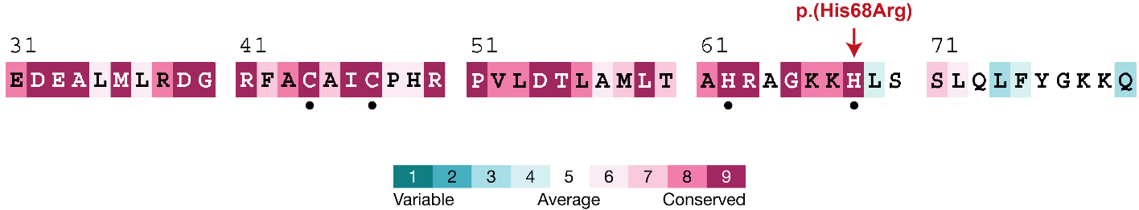

Figure S1. Evolutionary conservation of the His68 residue of SCNM1.
Amino acid sequence of the SCNM1 C2H2-ZF domain and adjacent residues showing conservation scores obtained with the ConSurf Server (https://consurf.tau.ac.il/consurf_index.php). Homolog search was performed using the human SCNM1 protein (UniprotID: Q9BWG6) as query against the NCBI non-redundant database (NR). Conservation scores were calculated from 453 unique sequences, including query. Cysteines and histidines (including His68) of the C2H2-ZF domain are marked with a black dot.

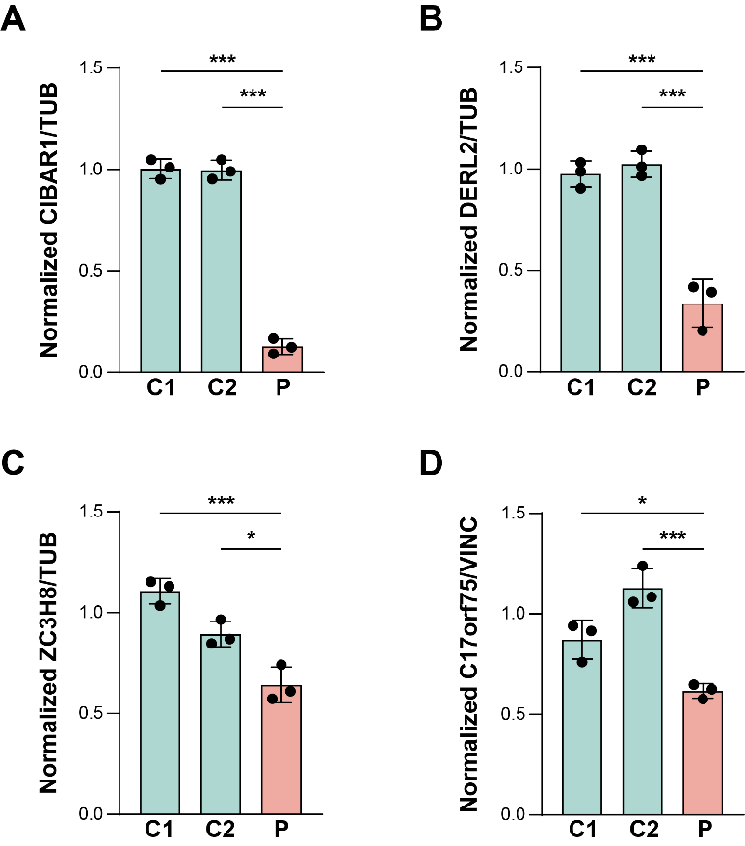

Figure S2. Quantification of the protein levels of SCNM1-target genes.
(A-D) Densitometric quantification of CIBAR1 (A), DERL2 (B), ZC3H8 (C) and C17orf75 (D) protein levels in fibroblasts from P2 (P) and controls (C1 and C2) calculated from the Western Blots indicated in Figure 2D. The levels of the protein of interest were corrected by the levels of a loading control (Tubulin (TUB) in A-C; and Vinculin (VINC) in D) and these data were normalized against the mean value of control samples C1 and C2. Graphs are expressed as mean ± SD (n=3). Differences between control (C1 and C2) and P samples were analyzed by One-way ANOVA with Šídák’s multiple comparisons test. *p<0.05, **p<0.01, ***p<0.001.

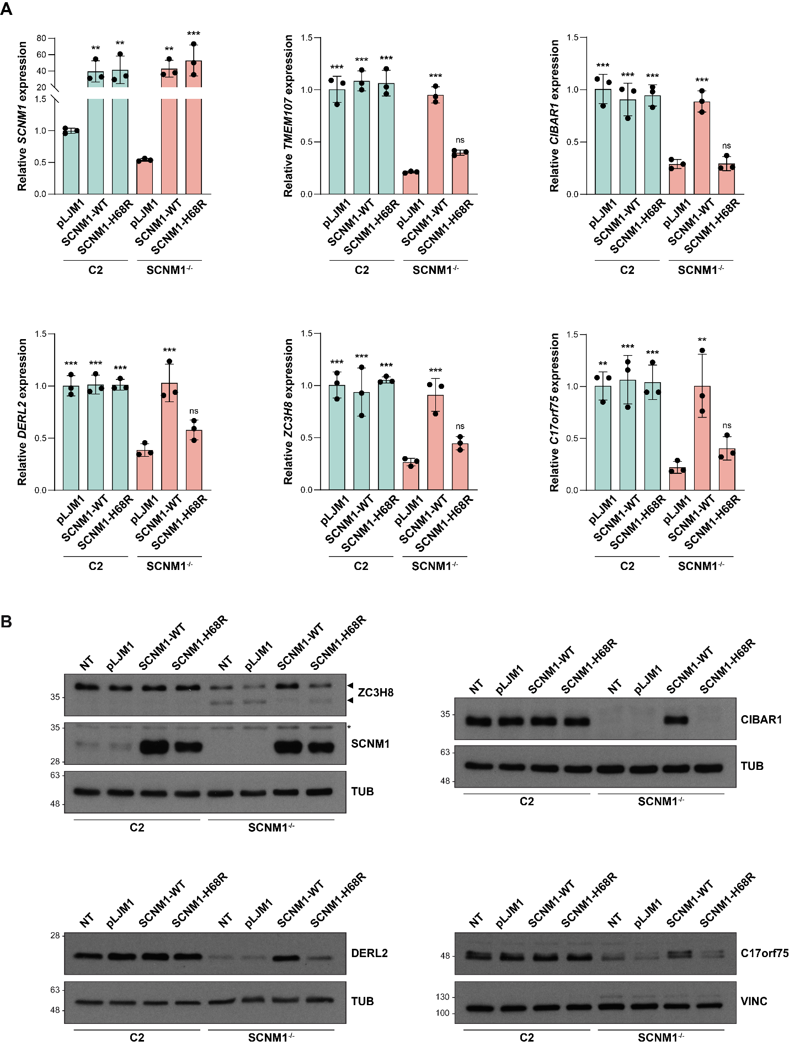
Figure S3. The p.His68Arg variant is unable to restore the expression levels of SCNM1-target U12-intron–containing genes in SCNM1^{-/-} cells.
(A) Relative mRNA quantification of SCNM1, TMEM107, CIBAR1, DERL2, ZC3H8 and C17orf75 by RT-qPCR in control (C2) and SCNM1 null (SCNM1^{-/-}) fibroblasts transduced with either the wild-type version of SCNM1 (SCNM1-WT), the His68Arg version (SCNM1-H68R) or the empty vector (pLJM1). Gene expression was normalized against the geometric mean of GAPDH and GUSB mRNA levels. The ΔCt mean value of control fibroblasts transduced with the empty vector (C2-pLJM1) was used as calibrator to calculate ΔΔCt. Graphs are expressed as mean ± SD (n=3). One-way ANOVA with Dunnett’s multiple comparisons test relative to the SCNM1^{-/-}-pLJM1 sample. p>0.05: not significant (ns), *p<0.05, **p<0.01, ***p<0.001.
(B) Representative immunoblots of SCNM1, ZC3H8, CIBAR1, DERL2 and C17orf75 in the same cultures as indicated in (A). Non-transduced fibroblasts were also included in these experiments (NT). Loading controls: tubulin (TUB) and vinculin (VINC). n=3. Asterisk: non-specific band. For ZC3H8, the top arrowhead indicates the full-length protein and the lower arrowhead a shorter protein variant previously shown to be generated by an alternative splicing event induced by SCNM1 deficiency [2].

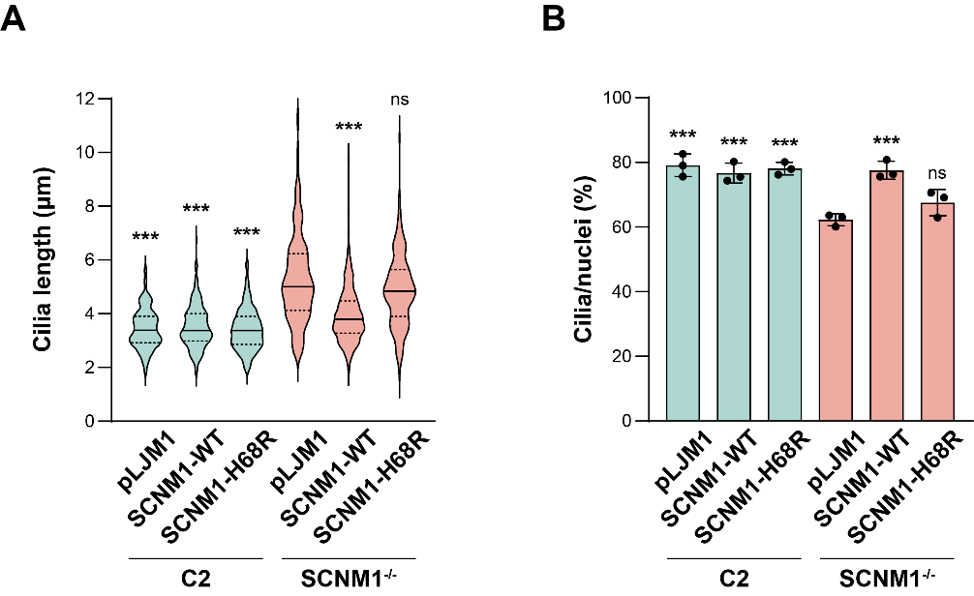

Figure S4. Primary cilia defects of SCNM1^{-/-} cells are not rescued by the p.His68Arg version of SCNM1.
(A) Cilia length measurements in control (C2) and SCNM1 null (SCNM1^{-/-}) fibroblasts transduced with either the wild-type (SCNM1-WT), or the His68Arg (SCNM1-H68R) version of SCNM1, or the empty vector (pLJM1). At least 180 cilia from 3 independent biological replicates were measured in each sample. Median (solid line) and quartiles (dotted lines) are represented in violin plots. Differences related to the SCNM1^{-/-}-pLJM1 sample were analyzed by Kruskal-Wallis test with Dunn’s multiple comparisons test. p>0.05: not significant (ns), ***p<0.001.
(B) Percentage of ciliated cells (cilia/nuclei) in the in the same cultures as indicated in (A). At least 280 cells from 3 independent biological replicates were analyzed in each sample. Graphs are expressed as mean ± SD (n=3). One-way ANOVA with Dunnett’s multiple comparisons test relative to the SCNM1^{-/-}-pLJM1 sample. p>0.05: not significant (ns), ***p<0.001.

III. Supplementary Tables
Table S1. Clinical features of OFD patients with SCNM1 variants.
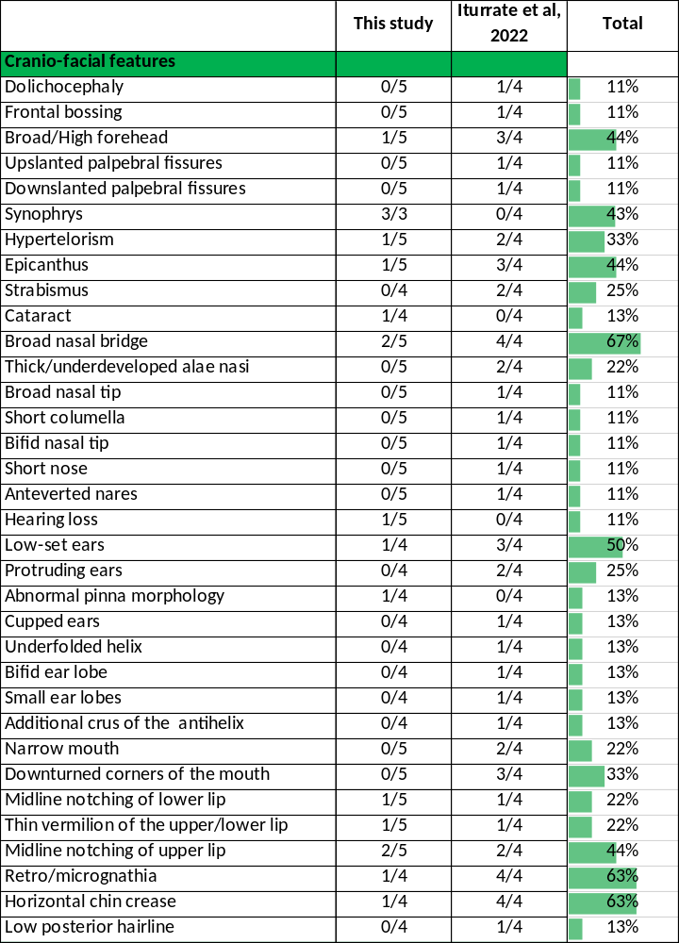

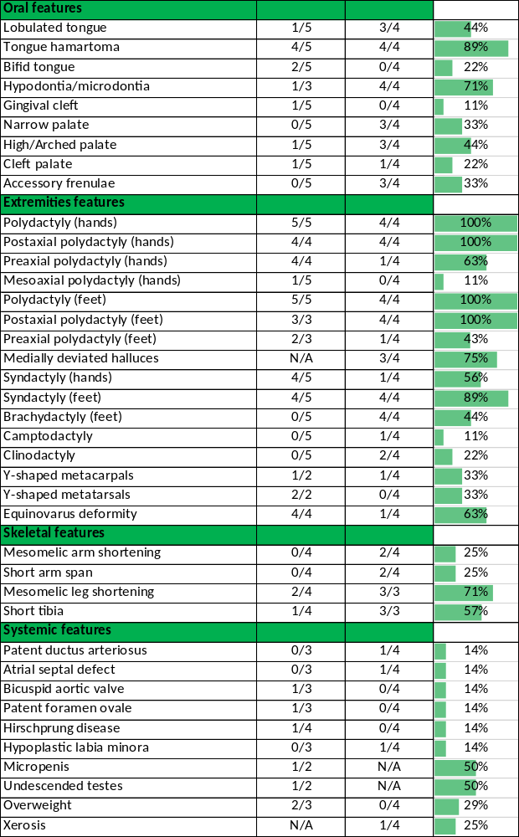
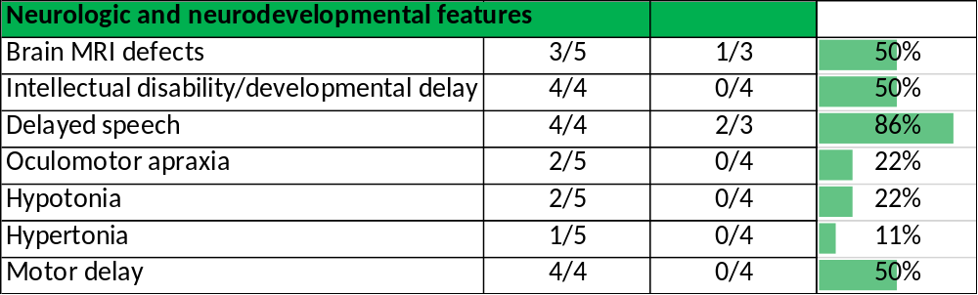

Table S2. Primers used in this work.
Primer | Sequence (5’ – 3’) | Use
C17orf75-Fw | GGACTTGAGCTTTTCAGGCTTG | RT-qPCR
C17orf75-Rv | CCCTTTGGATTGGGCATACAAC | RT-qPCR
GAPDH-Fw | TGCACCACCAACTGCTTAGC | RT-qPCR
GAPDH-Rv | GGCATGGACTGTGGTCATGAG | RT-qPCR
GUSB-Fw | CACCAGGGACCATCCAATACC | RT-qPCR
GUSB-Rv | GCAGTCCAGCGTAGTTGAAAAA | RT-qPCR
SCNM1-cDNA-Fw | TTTGCTAGCGTCGTGATGTCTTTCAAGAGG | pLJM1-SCNM1 cloning
SCNM1-cDNA-Rv | TTTGAATTCGTATCAGTCCAAGGGGAGATC | pLJM1-SCNM1 cloning
SCNM1-His68Arg-Fw | TGCAGGCAAGAAACGTCTGTCCAGCTTGC | Site-directed mutagenesis
SCNM1-His68Arg-Rv | GCAAGCTGGACAGACGTTTCTTGCCTGCA | Site-directed mutagenesis

IV. Supplementary References
- Retterer K, Juusola J, Cho MT, Vitazka P, Millan F, Gibellini F, et al. Clinical application of whole-exome sequencing across clinical indications. Genet Med. 2016;18(7):696–704.

- Iturrate A, Rivera-Barahona A, Flores CL, Otaify GA, Elhossini R, Perez-Sanz ML, et al. Mutations in SCNM1 cause orofaciodigital syndrome due to minor intron splicing defects affecting primary cilia. Am J Hum Genet. 2022;109(10):1828–49.

- Hansen JN, Rassmann S, Stüven B, Jurisch-Yaksi N, Wachten D. CiliaQ: a simple, open-source software for automated quantification of ciliary morphology and fluorescence in 2D, 3D, and 4D images. Eur Phys J E Soft Matter. 2021;44(2):18.

