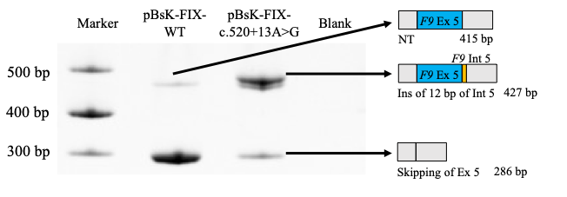
Figure S1. Features of the pBSK-FIX exon 5 contexts and FIX mRNA splicing patterns.
(A) Analysis of pBSK-FIX exon 5 spliced transcripts. pBSK-FIX exon 5 normal and c.520+13A>G variant minigenes were transfected in HEK293T cells. The splicing pattern was evaluated by RT-PCR and amplified products were resolved on a 10% PAGE gel. M is the molecular 1 Kb marker.

Figure S2. Co-transfection analysis of pBSKFIX-opT-WT and c.520+13A>G reporters with wild-type U1 snRNA.
Representative RT-PCR analysis showing the effect of wild-type U1 snRNA overexpression on FIX pre-mRNA splicing. Four transfection conditions were tested in HEK293 cells: (1) pBSK FIX-opt WT, (2) pBSK FIX-opt WT + pU1 WT, (3) pBSK FIX-opt c.520+13A>G, and (4) pBSK FIX-opt c.520+13A>G + pU1 WT. M, marker.

Table S1. Patient information with the F9 c.520+13A>G variant.
FIX: C (%) | FIX: Ag (%) | Severity | Country | Reference
/ | / | Moderate | Italy | PMID: 15921378
/ | / | / | United Kingdom | PMID: 8091381
20 | / | Mild | United Kingdom | PMID: 8091381
4 | / | Moderate | United Kingdom | PMID: 8091381
6 | / | Mild | United Kingdom | PMID: 8091381
11 | 4 | Mild | United Kingdom | PMID: 8091381
3 | / | Moderate | United Kingdom | PMID: 8091381
5 | / | Moderate | United Kingdom | PMID: 8091381
2 | 6 | Moderate | United Kingdom | PMID: 8091381
3 | 6 | Moderate | United Kingdom | PMID: 8038695
8 | / | Mild | New Zealand | PMID: 27213901
8 | / | Mild | New Zealand | PMID: 27213901
5 | 5 | Moderate | Canada | PMID: 1740319
9 | / | Mild | USA | PMID: 2198809
9 | / | Mild | USA | PMID: 2198809
3 | / | Moderate | USA | PMID: 10647899
3 to 15 | / | Mild | USA | PMID: 10647899
3 | / | Moderate | USA | PMID: 10647899
2 | / | Moderate | USA | PMID: 10647899
2 | / | Moderate | USA | PMID: 10647899
1 to 13 | / | Mild | USA | PMID: 10647899
<1 | / | Severe | USA | PMID: 11013449
4.8 | / | Moderate | Colombia | PMID: 32155688
4.4 | / | Moderate | Colombia | PMID: 32155688
4.8 | / | Moderate | Colombia | PMID: 32155688
8.4 | / | Mild | Colombia | PMID: 32155688
8.5 | / | Mild | Colombia | PMID: 32155688
7.9 | / | Mild | Colombia | PMID: 32155688
5.9 | / | Mild | Colombia | PMID: 32155688
/ | / | / | Centre B37 | /
<1 | 10 | Severe | Centre B31 | /
6 | / | Mild | Centre B31 | /
6 | / | Mild | Centre B31 | /
/ | / | / | Centre B31 | /
/ | / | / | Centre B31 | /
5 | 6 | Moderate | Centre B31 | /
9 | / | Mild | Centre B31 | /
8 | / | Mild | Centre B31 | /
9 | / | Mild | Centre B31 | /
12 | 4 | Mild | Centre B31 | /
/ | / | / | Centre B31 | /
5 | / | Moderate | Centre B31 | /

