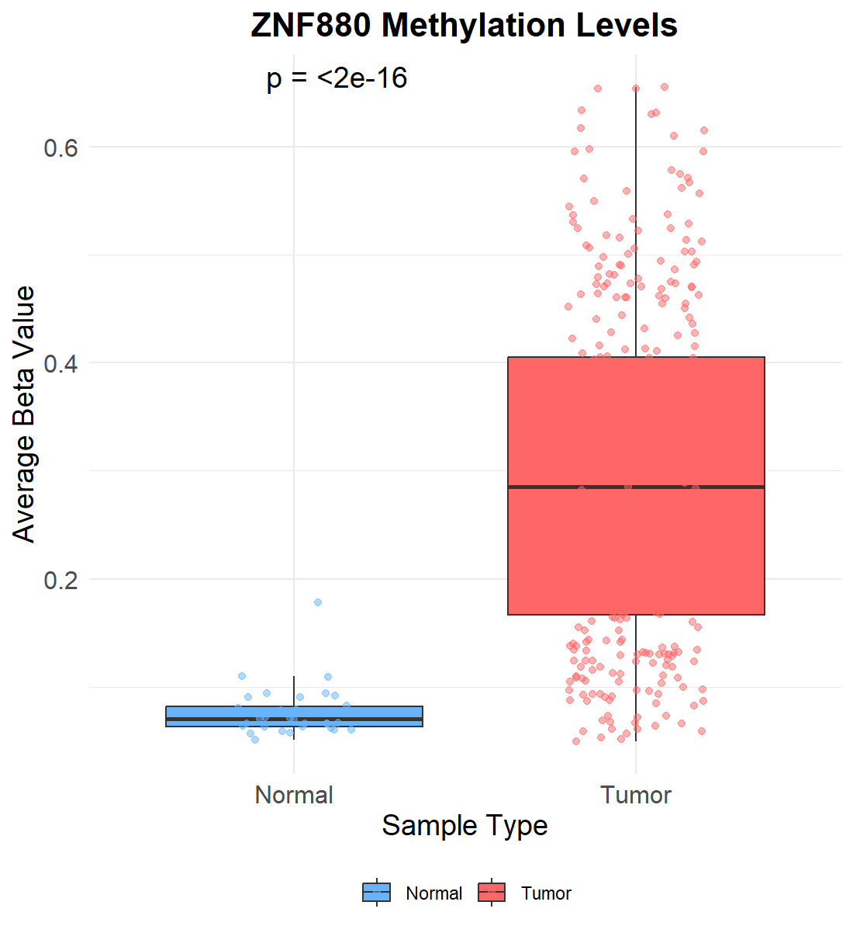

Supplementary Figure 1: Average methylation of ZNF880 in the TCGA-OSCC cohort

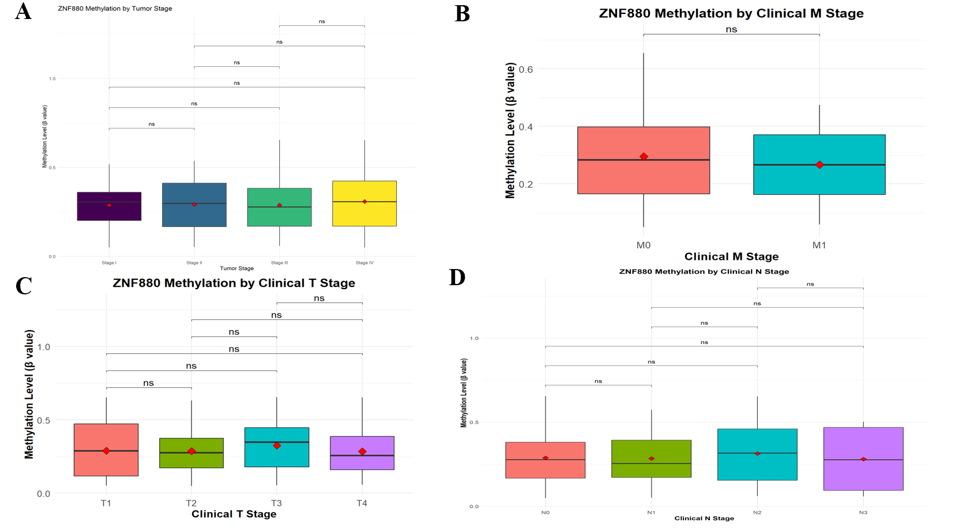
Supplementary Figure 2: Correlation between the average methylation of ZNF880 and different stages in the TCGA-OSCC cohort. (A) Correlation with tumor stage, (B) Correlation with M stage, (C) Correlation with T stage, (D) Correlation with N stage
Supplementary Figure 3: Kaplan–Meier analysis of ZNF880 methylation in the OSCC cohort from TCGA.(A) Progression-free survival (PFS) Kaplan-Meier survival curve (B)Disease-specific survival (DSS) Kaplan-Meier survival curve

Supplementary Figure 5: Cox regression analysis. Univariate and multivariate Cox regression (A and B) based on TCGA clinical data.***P < .001, **P < .01 and *P < .05.

