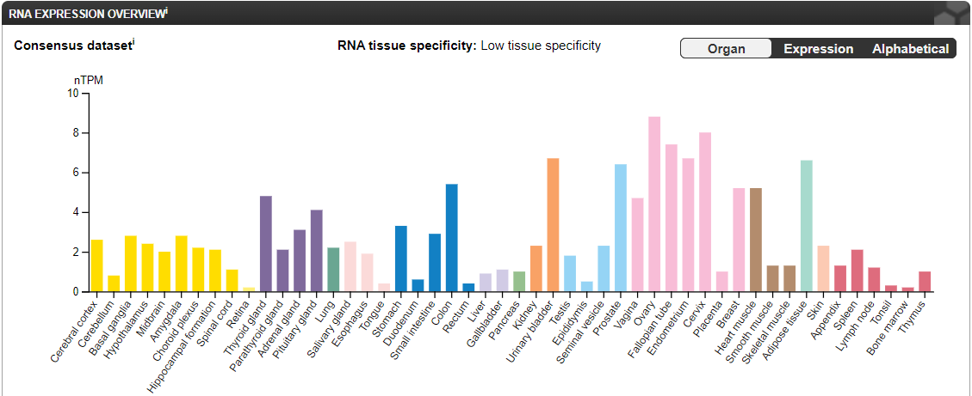
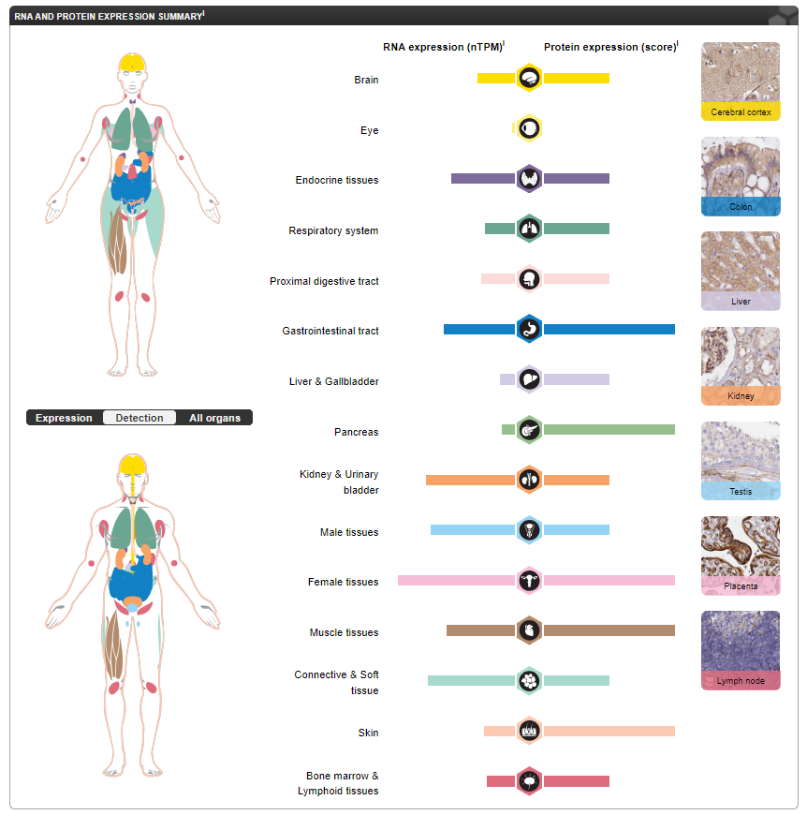
(A)
(B)

Supplementary Figure 1: Analysis of KIF7 gene expression across several organs and tissues. (A) the RNA-seq data obtained by combining the HPA and GTEx transcriptomics datasets, and (B) the RNA and protein expression data obtained from the Human Protein Atlas.

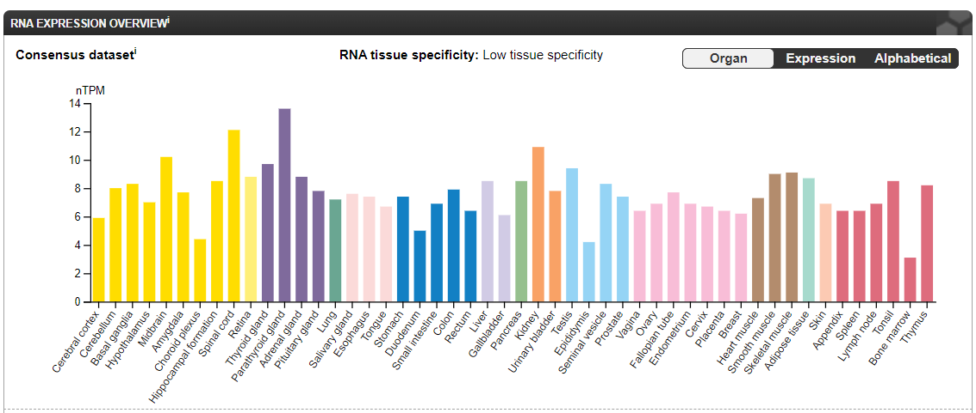
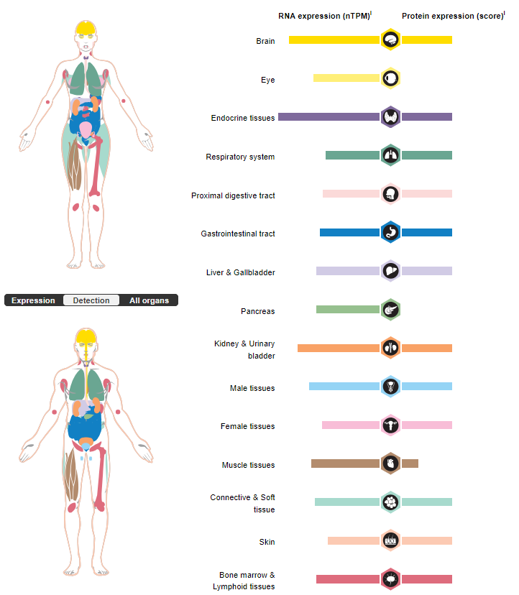
(A)
(B)

Supplementary Figure 2: Analysis of CEP104 gene expression across several organs and tissues. (A) the RNA-seq data obtained by combining the HPA and GTEx transcriptomics datasets, and (B) the RNA and protein expression data obtained from the Human Protein Atlas.

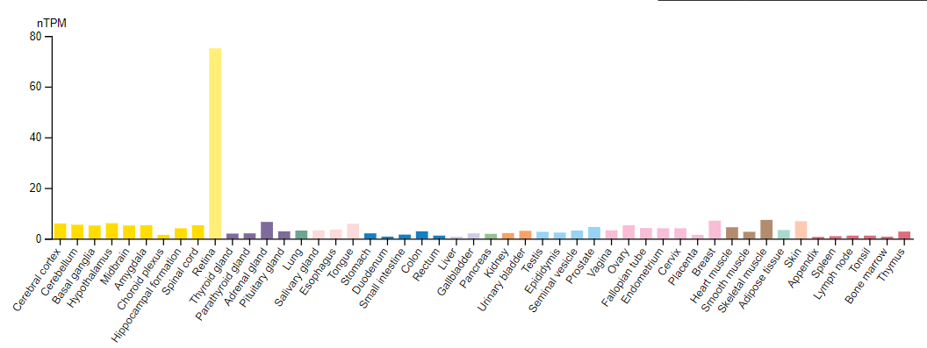
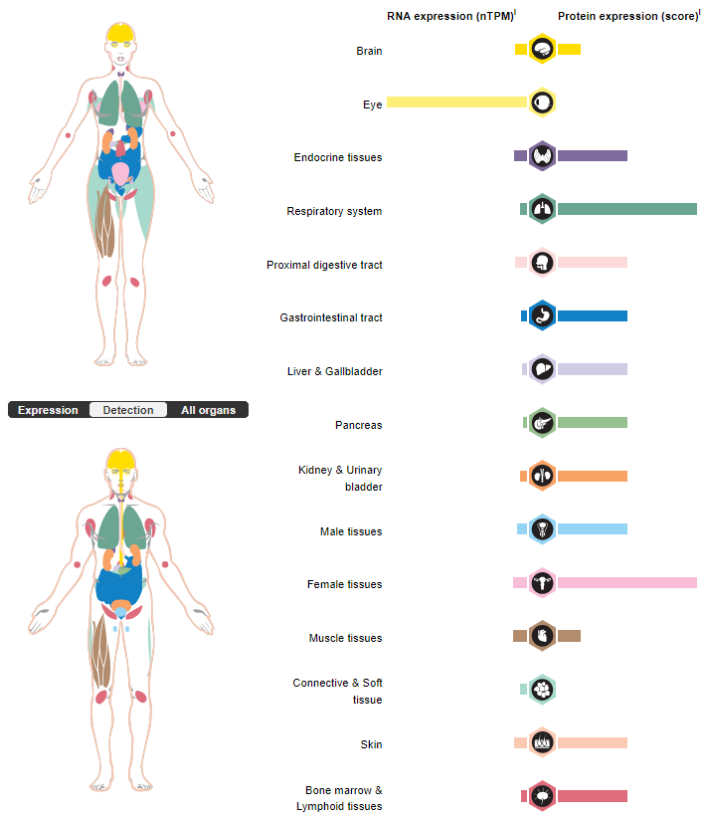
(A)
(B)

Supplementary Figure 3: Analysis of TMEM237 gene expression across several organs and tissues. (A) the RNA-seq data obtained by combining the HPA and GTEx transcriptomics datasets, and (B) the RNA and protein expression data obtained from the Human Protein Atlas

