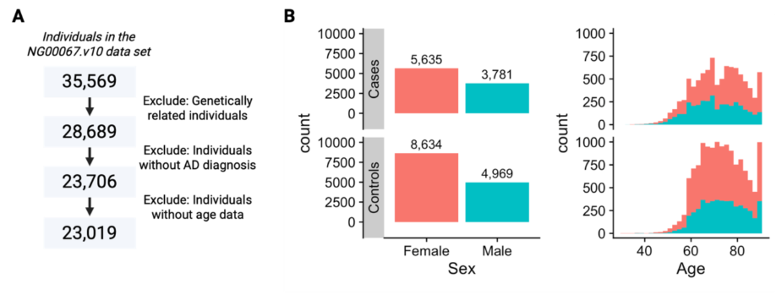
Supplemental Fig. 1. A) Samples removed at each step of the pre-processing. B) Demographics of the final data set.
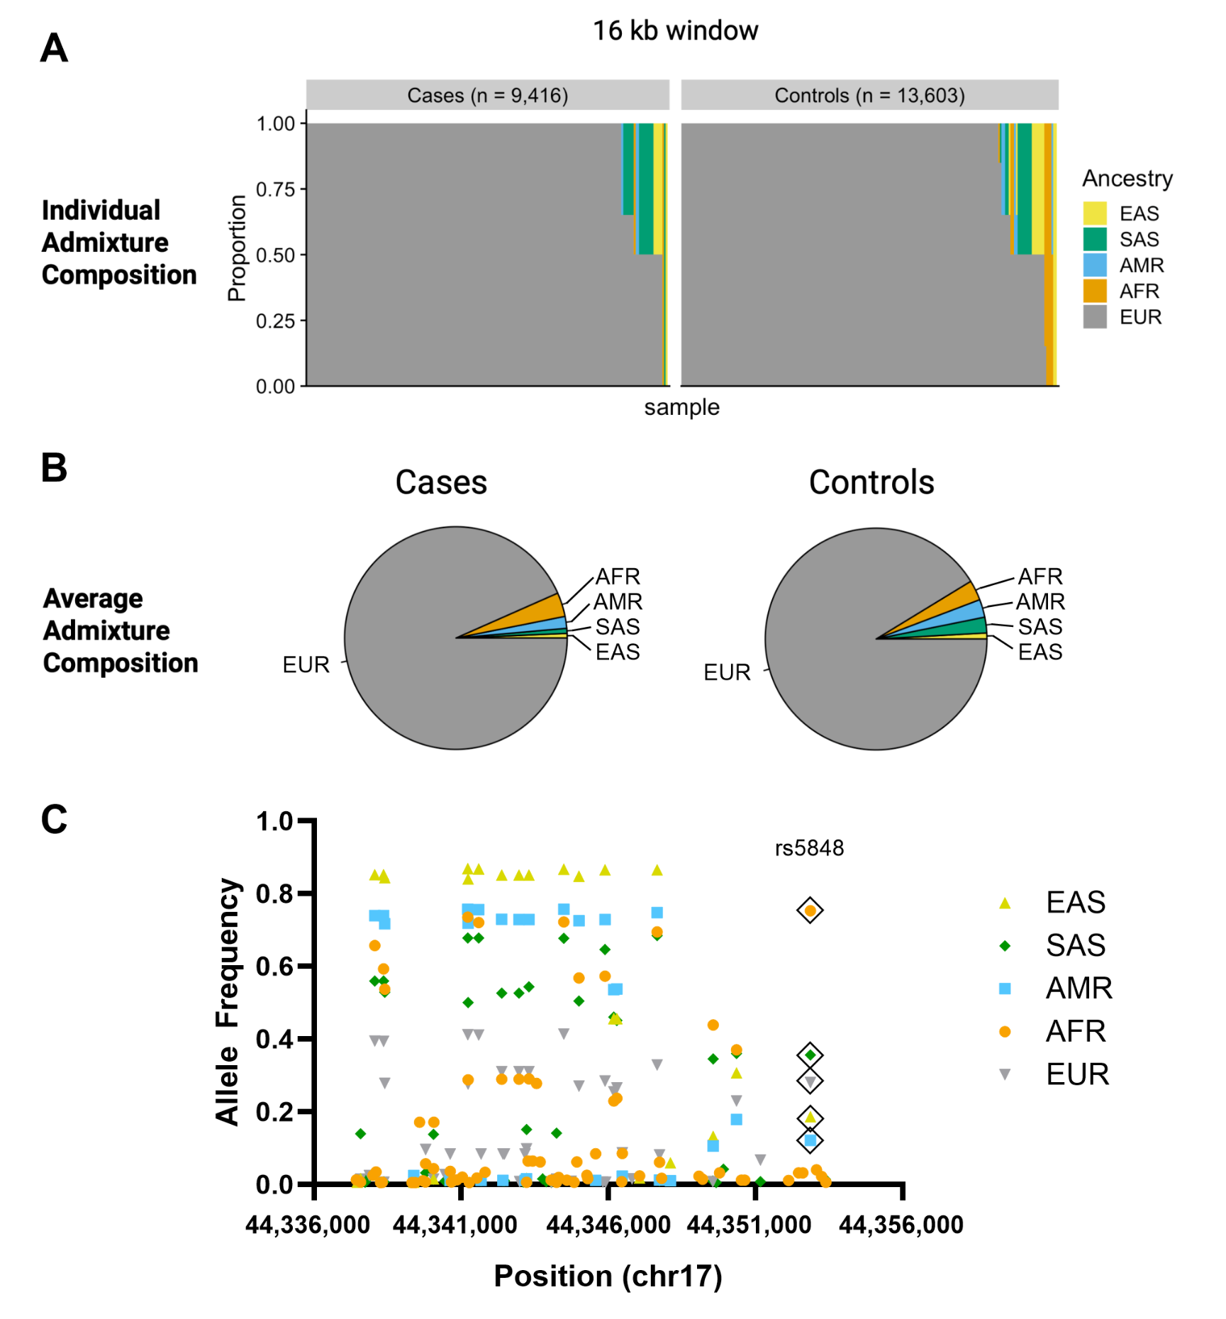
Supplemental Fig. 2: Admixture and common variant allele frequencies by genetic ancestry in the GRN 16kb cis-regulatory region. A) Local ancestry was inferred in each genetic variant within the GRN 16kb cis-regulatory region. The admixture composition of the region was calculated per individual as the proportion of alleles most similar to each reference population divided by the total number of alleles in the 16kb window. B) Average admixture composition across individuals in the cases and control groups, determined as the average of the proportions depicted in A. C) Allele frequencies are shown for all ancestry-specific common variants (MAF > 0.005 in a given ancestry group) in the GRN 16kb cis-regulatory region, chr17:44,337,379 − 44,353,435 (GRCh38/hg38). This is a graphical representation of the data presented in Supplemental Information 9. Symbol colour and shape reflect genetic ancestry. chr17 = chromosome 17, EAS = East Asian, SAS = South Asian, AMR = Admixed American, AFR = African, EUR = European.
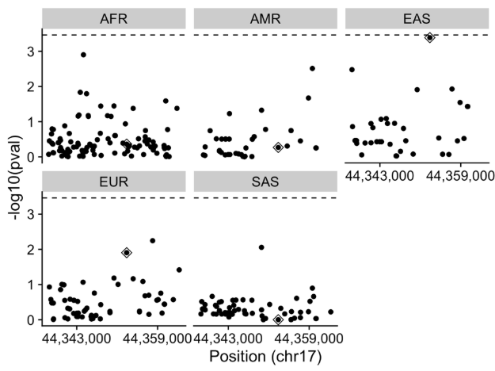
Supplemental Fig. 3. No significant associations between genetic variants and AD were detected in the sensitivity analysis. We tested ancestry-specific association of variants with MAF > 0.005 in a given ancestry and AD using Tractor. We analyzed the GRN 16kb regulatory region and an additional 10kb in the 3’ end (chr17:44,337,379 − 44,363,435 GRCh38/hg38). The horizontal dashed line reflects the p adjusted significance threshold (3.45*10⁻ ⁴ after Bonferroni correction) for the 145 SNPs tested. EAS = East Asian, SAS = South Asian, AMR = Admixed American, AFR = African, EUR = European. Data points surrounded by a diamond shape highlight the rs5848 SNP.

