Supplemental Table S2. List of the candidate compounds for diabetic retinopathy.
Name | Score | Description | Chemical Formula | Structure | Vina score | Cavity volume (Å³)
Actarit | -99.89 | Interleukin receptor agonist | C₁₀H₁₁NO₃ | 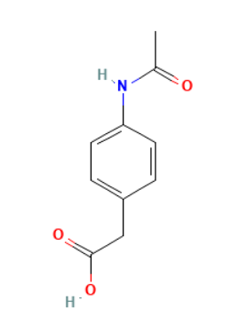 | -7.2 | 3624
Tyrphostin-AG-1295 | -99.89 | PDGFR receptor inhibitor | C₁₆H₁₄N₂ | 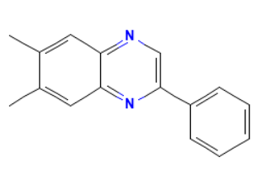 | -8.7 | 3624
Naftopidil | -99.86 | Adrenergic receptor antagonist | C₂₄H₂₈N₂O₃ | 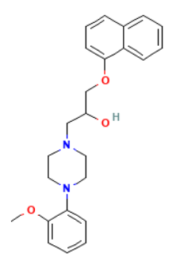 | -7.8 | 6458
BMS-191011 | -99.82 | Potassium channel activator | C₁₆H₁₀ClF₃N₂O₃ | 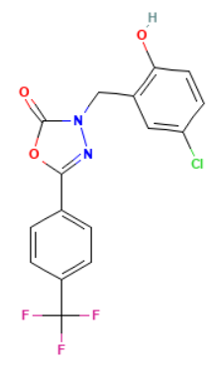 | -8.0 | 3624
AC-55649 | -99.79 | Retinoid receptor agonist | C₂₁H₂₆O₂ | 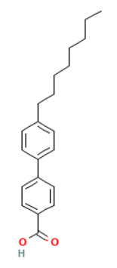 | -7.6 | 3624
Zileuton | -99.79 | Leukotriene inhibitor | C₁₁H₁₂N₂O₂S | 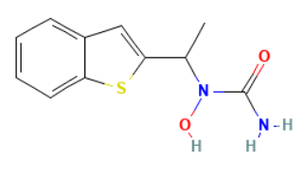 | -6.2 | 6458
VU-0400193-3 | -99.79 | Glutamate receptor modulator | C₂₁H₂₀ClN₃O₃ | 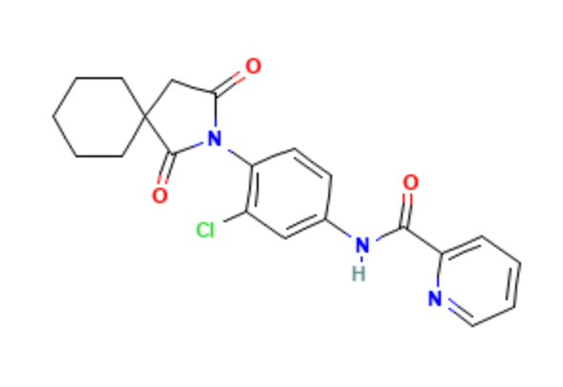 | -9.4 | 3624
Griseofulvin | -99.75 | Tubulin inhibitor | C₁₇H₁₇ClO₆ | 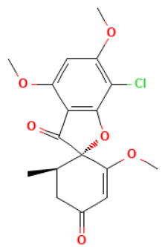 | -7.6 | 6458
SJ-172550 | -99.75 | MDM inhibitor | C₂₂H₂₁ClN₂O₅ | 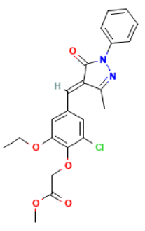 | -7.9 | 6458
Fluoropyruvate | -99.72 | Pyruvate dehydrogenase kinase inhibitor | C₃H₃FO₃ | 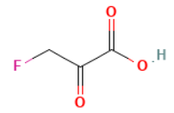 | -4.3 | 3624
TG100-115 | -99.72 | PI3Kγ inhibitors | C₁₈H₁₄N₆O₂ | 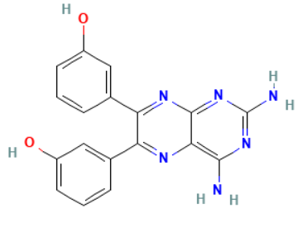 | -8.4 | 6458
Loreclezole | -99.61 | GABA receptor agonist | C₁₀H₆Cl₃N₃ | 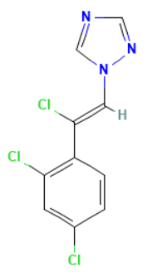 | -5.5 | 6458
* Chemical formulas and structures are sourced from the PubChem database.

