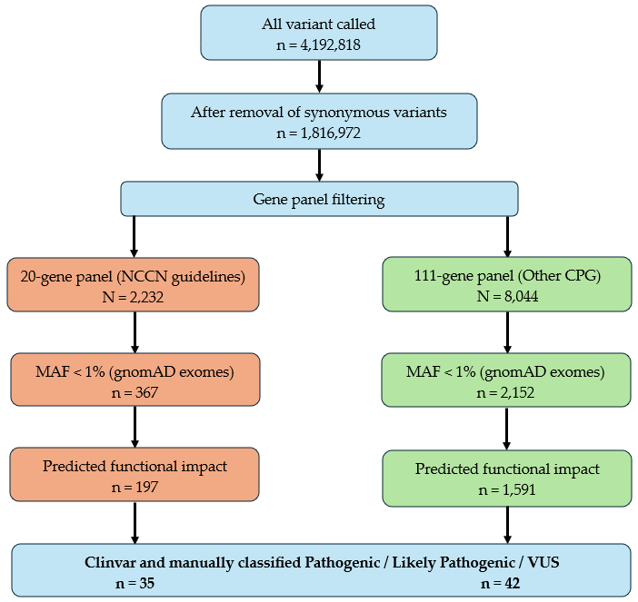

Supplementary Figure 1 | Overview of the variant filtering workflow applied to whole-exome sequencing data. Numbers indicate aggregated variants retained across all samples at each filtering step. Variants were sequentially filtered based on gene panel inclusion, allele frequency (gnomAD exomes), predicted functional impact, and clinical classification. CPG: cancer predisposition genes.

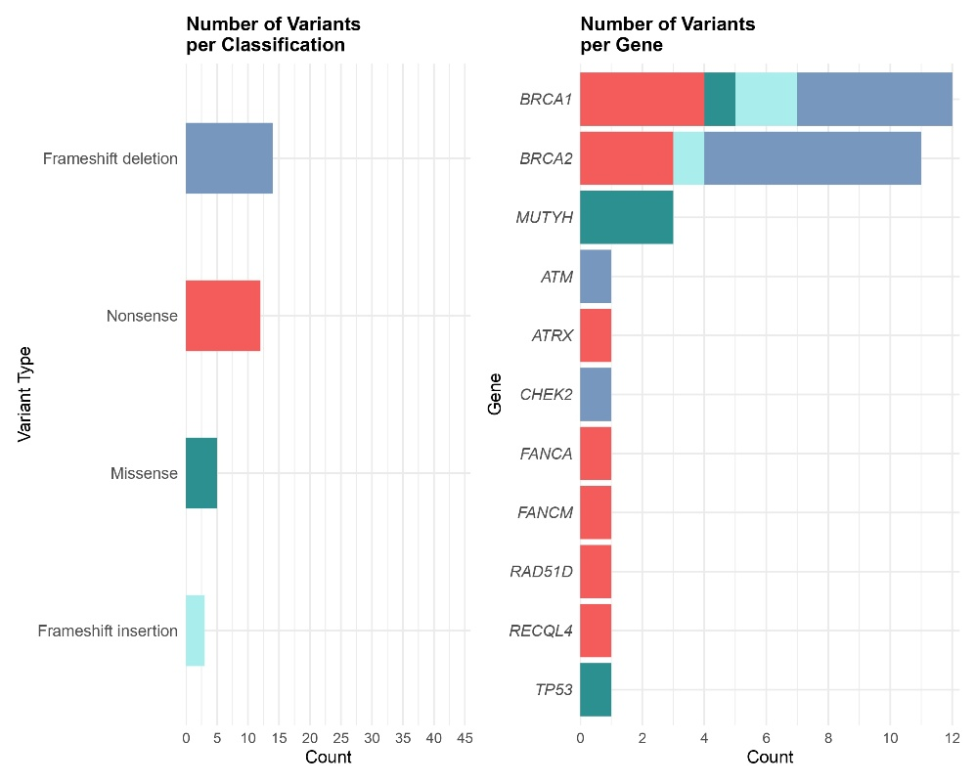
A

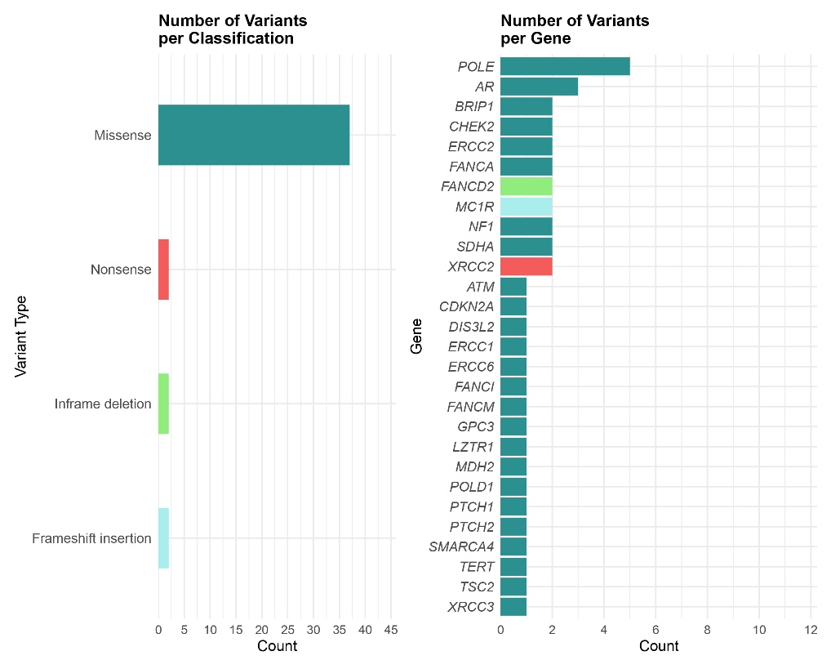
B

Supplementary Figure 2 | Distribution of retained variants by functional class and gene. (A) Distribution of pathogenic and likely pathogenic variants by variant type (left) and by gene (right). (B) Distribution of variant of uncertain significance (VUS) by variant type (left) and by gene (right).

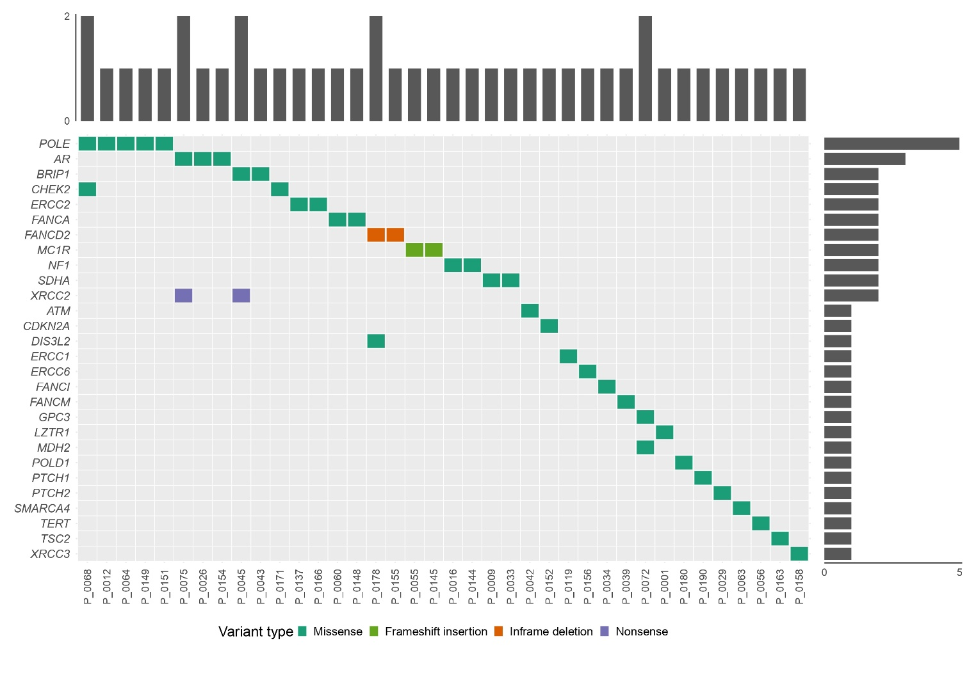

Supplementary Figure 3 | Distribution of variants of uncertain significance (VUS) across cancer predisposition genes. Oncoplot summarizing VUS identifies in this study. Genes are ordered by decreasing frequency of variants. Columns represent individual patients, and colors indicate variant types. Upper bars denote the number of variants per patient, and side bars indicate the number of variants per gene.

Supplementary Table 1 | Genes included in the germline analysis.
NCCN BC predisposition genes  (n=20) | Other cancer-related predisposition genes  (n=111)
TP53, PTEN, ATM, BARD1, BRCA1, BRCA2, BRIP1, CDH1, CDKN2A, CHEK2, NF1, PALB2, RAD51C, RAD51D, STK11, MSH2, MLH1, MSH6, PMS2, EPCAM | AIP, AKT1, ALK, APC, AR, ATRX, AXIN2, BAP1, BLM, BMPR1A, CDC73, CDK4, CDKN1B, CTNNA1, DDB2, DICER1, DIS3L2, DLST, EGLN1, EGLN2, ERCC1, ERCC2, ERCC3, ERCC4, ERCC5, ERCC6, FAN1, FANCA, FANCB, FANCC, FANCD2, FANCE, FANCF, FANCG, FANCI, FANCL, FANCM, FH, FLCN, GALNT12, GCM2, GPC3, GPR101, GREM1, HNF1A, HNF1B, HOXB13, KIF1B, KIT, LZTR1, MAD2L2, MAX, MC1R, MDH2, MEN1, MET, MITF, MLH3, MNX1, MRE11, MSH3, MSR1, MUTYH, NBN, NF2, NFIX, NSD1, NTHL1, PDGFRA, PHOX2B, POLD1, POLE, POLH, POT1, PRKAR1A, PTCH1, PTCH2, RAD50, RAD51, RB1, RECQL, RECQL4, RET, RNF43, RPS20, SCG5, SDHA, SDHAF2, SDHB, SDHC, SDHD, SLC25A11, SLX4, SMAD4, SMARCA4, SMARCB1, SMARCE1, SUFU, TERT, TGFBR2, TMEM127, TSC1, TSC2, UBE2T, VHL, WRN, WT1, XPA, XPC, XRCC2, XRCC3
BC: Breast cancer

Supplementary Table 2. Germline variant of uncertain significance identified in the study group

Patient ID | Gene | Transcript (MANE) | cDNA change (HGVS) | Protein change (HGVS) | Variant type | RS ID
P_0064 | POLE | NM_006231.4 | c.3857G>A | p.Arg1286His | Missense | rs771823596
P_0068
P_0149
P_0151
P_0012 | POLE | NM_006231.4 | c.2375A>G | p.Lys792Arg | Missense | rs2042772263
P_0026 | AR | NM_000044.6 | c.1040T>G | p.Leu347Arg | Missense | rs746981310
P_0075
P_0154
P_0043 | BRIP1 | NM_032043.3 | c.2386C>G | p.Leu796Val | Missense | rs1057521362
P_0045 | BRIP1 | NM_032043.3 | c.3412G>C | p.Asp1138His | Missense | -
P_0068 | CHEK2 | NM_007194.4 | c.1582G>A | p.Glu528Lys | Missense | rs138040612
P_0171 | CHEK2 | NM_007194.4 | c.952G>A | p.Arg318Cys | Missense | rs148053495
P_0137 | ERCC2 | NM_000400.4 | c.402C>G | p.Cys134Trp | Missense | rs767543274
P_0166 | ERCC2 | NM_000400.4 | c.1133G>A | p.Arg378His | Missense | rs200043231
P_0060 | FANCA | NM_000135.4 | c.2639G>A | p.Arg880Gln | Missense | rs372254398
P_0148
P_0155 | FANCD2 | NM_001018115.3 | c.2865_2867del | p.Glu956del | Inframe Del | rs1693630743
P_0178
P_0055 | MC1R | NM_002386.4 | c.85upA | p.Asn29fs | Frameshift Ins | rs796296176
P_0145
P_0016 | NF1 | NM_001042492.3 | c.2297T>C | p.Ile766Thr | Missense | rs863224657
P_0144 | NF1 | NM_001042492.3 | c.2681T>G | p.Phe894Cys | Missense | rs1282493551
P_0009 | SDHA | NM_004168.4 | c.899T>C | p.Ile300Cys | Missense | rs878854637
P_0033 | SDHA | NM_004168.4 | c.644A>G | p.Tyr215Cys | Missense | rs781660628
P_0045 | XRCC2 | NM_005431.2 | c.794T>A | p.Leu265Ter | Nonsense | rs771671971
P_0075
P_0043 | ATM | NM_000051.4 | c.5178T>G | p.Cys1726Trp | Missense | rs1446243372
P_0152 | CDKN2A | NM_000077.5 | c.104G>A | p.Gly104Ala | Missense | rs746834149
P_0178 | DIS3L2 | NM_152383.5 | c.2138G>A | p.Arg713His | Missense | rs780396185
P_0119 | ERCC1 | NM_001983.4 | c.619C>T | p.Arg207Trp | Missense | rs764503289
P_0156 | ERCC6 | NM_000124.4 | c.4445G>T | p.Gly1482Val | Missense | rs574307052
P_0034 | FANCI | NM_001113378.2 | c.2879G>A | p.Arg960Gln | Missense | rs151267266
P_0039 | FANCM | NM_020937.4 | c.1192C>T | p.Arg398Trp | Missense | rs752364451
P_0072 | GPC3 | NM_004484.4 | c.458C>T | p.Ser153Phe | Missense | rs1310073855
P_0001 | LZTR1 | NM_006767.4 | c.2374T>C | p.Cys792Arg | Missense | rs2518626095
P_0072 | MDH2 | NM_005918.4 | c.196G>A | p.Ala66Thr | Missense | rs141539461
P_0180 | POLD1 | NM_002691.4 | c.922G>A | p.Ala308Thr | Missense | rs2122258884
P_0190 | PTCH1 | NM_000264.5 | c.2518C>T | p.Leu840Phe | Missense | rs2117948928
P_0037 | PTCH2 | NM_003738.5 | c.1243C>T | p.Arg415Trp | Missense | rs143737414
P_0063 | SMARCA4 | NM_003072.5 | c.926G>T | p.Gly309Val | Missense | rs762999710
P_0056 | TERT | NM_198253.3 | c.1141C>T | p.Arg381Cys | Missense | -
P_0143 | TSC2 | NM_000548.5 | c.2996G>T | p.Ser999Ile | Missense | rs149808366
P_0158 | XRCC3 | NM_005432.4 | c.556G>A | p.Asp186Asn | Missense | rs753182555

