Table S1 Genetic testing results of four patients with biallelic IARS variants.
 |  | Variant type | gnomAD  (AC|Hom) | ExAC | 1000 genome | SIFT | Polyphen2 | MutationTaster | CADD | ACMG
Patient 1 | Y148C | Missense | 7|0 | 1.64e-05 | 0 | D | D | D | 28.7 | VUS
Patient 1 | R444X | Stopgain | 5|0 | 8.23e-06 | 0 | NA | NA | A | 41 | P
Patient 2 | P437L | Missense | 0|0 | 0 | 0 | D | D | D | 32 | LP
Patient 2 | H499Qfs*5 | Frameshift | 0|0 | 0 | 0 | NA | NA | NA | NA | P
Patient 3 | R81G | Splice acceptor | 0|0 | 0 | 0 | D | D | D | 26.1 | P
Patient 3 | R519H | Missense | 3|0 | 1.64e-05 | 0 | D | D | D | 25.4 | VUS
Patient 4 | Y148C | Missense | 7|0 | 1.64e-05 | 0 | D | D | D | 28.7 | VUS
Patient 4 | V321Vfs*42 | Frameshift | 0|0 | 0 | 0 | D | D | D | NA | P
NA: not applicable.

Table S2 Clinical manifestations of four patients with biallelic IARS variants.
Proband | P 1 | P 2 | P 3 | P4
Gestational age(week) | 35⁺⁴ | 38⁺² | 37 | 31
Birth weight(g) | 2200 | 2150 | 2550 | 1700
Height(cm) | 47.3 | 45 | 47.9 | 38
Sex | Male | Male | Female | Male
Pregnancy related findings | - | Oligohydramnios | - | -
Respiratory phenotype
Cough | + | + | + | +
Wheezing | + | + | + | +
Oxygen support | + | + | + | +
Clubbing | + | NA | + | +
Pulmonary alveolar proteinosis | + | + | + | -
Recurrent pneumonia | + | + | + | +
Lung function abnormality | Obstructive ventilation dysfunction | NA | Mixed ventilation dysfunction | -
Developmental phenotype
IUGR | + | + | - | +
Developmental delay | + | + | - | +
Exercise intolerance | + | NA | + | +
Neurological phenotype
Encephalomalacia | - | + | - | +
Low muscle strength | + | + | - | -
Intellectual disability | + | NA | - | -
Gastrointestinal phenotypes
Gastric volvulus | + | - | - | -
Gastroesophageal reflux | + | - | - | -
Diarrhea | - | + | + | +
Feeding Difficulties (tube/parenteral) | + | + | - | -
Liver phenotype
Neonatal hyperbilirubinemia | + | + | - | +
Abnormal liver function | + | + | + | -
Hepatosplenomegaly | + | + | + | -
Skin sclera yellow | - | + | - | -
Cholestasis | + | + | - | -
Fatty liver | + | + | + | -
Liver iron deposition | - | + | - | -
Blood phenotypes
Neonatal ABO hemolysis | + | - | - | -
Anemia | + | + | - | +
Hypoproteinemia | + | + | + | -
Thrombocytosis | + | - | - | -
Eosinophilia | - | + | - | -
Coagulopathy | + | + | - | -
Other phenotypes
Urological Anomalies | + | + | - | -
Hypoglycemia | + | - | - | -
Iron metabolism disorder | - | + | - | -
Hyperlipidemia | - | + | - | +
Hypoadrenocorticism | - | + | - | -
IUGR: intrauterine growth retardation; NA: not available.

Figure S1 Protein structural modeling with AlphaFold for variants in IARS gene of four patients and molecular dynamics (MD) simulations of Arg444Ter.
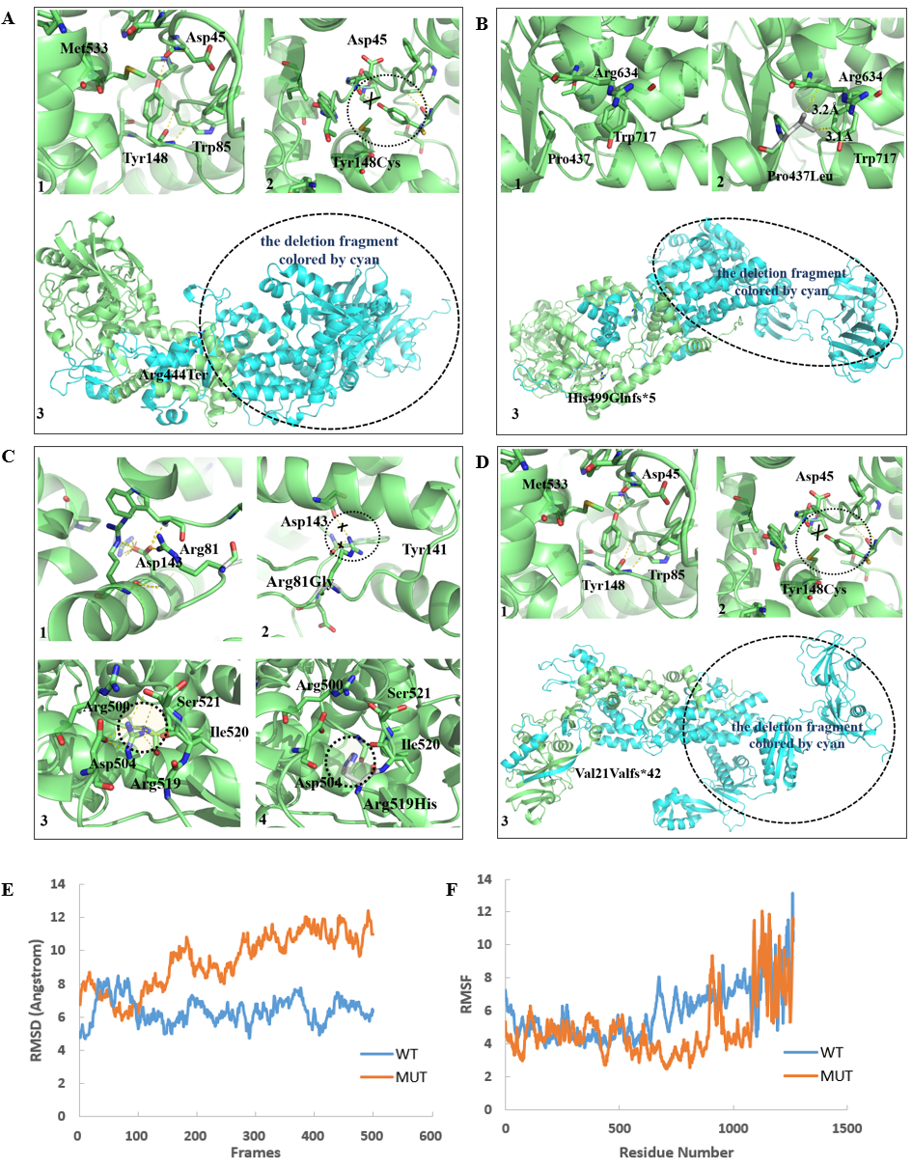
A. A representative IARS structure predicted by AlphaFoldDB P41252 (1). A representative IARS (which predicted by AlphaFoldDB P41252) depicted the positions of the mutated residues on the Tyr148Cys (Y148C). Overlapping between the wildtype and mutant, residues are labeled by number mapping the mutation. The hydrogen-bond interaction was shown as a yellow dotted line in picture (2). The whole secondary structure was shown in picture with the deletion fragment colored by cyan. The mutant of Arg444Ter (R444X) made the C-terminal deletion in IARS (3).
B. A representative IARS (which predicted by AlphaFoldDB P41252) depicting the positions of the mutated residues on the Pro437Leu (P437L) (1). Residues were labeled by number mapping the mutation. The distance of atoms was shown as a yellow dotted line in picture (2). The mutant of His499Glnfs*5 (H499Qfs*5) made the C-terminal deletion (colored by cyan) in picture (3).
C. The interaction of the side chian of Arg81/Arg81Gly were predicted by pymol shown in picture. A representative IARS (which predicted by AlphaFoldDB P41252) depicted the positions of the mutated residues on the Arg81Gly (R81G) (2). Residues are labeled by number mapping the mutation. The interaction of the side chain of Arg519/Arg519His were predicted by pymol shown in pictures. The hydrogen-bond interaction was shown as a yellow dotted line in picture (4).
D. A representative IARS structure predicted by AlphaFoldDB P41252 (1). A representative IARS (which predicted by AlphaFoldDB P41252) depicted the positions of the mutated residues on the Tyr148Cys (Y148C). Overlapping between the wildtype and mutant, residues are labeled by number mapping the mutation. The hydrogen-bond interaction was shown as a yellow dotted line in picture (2). The mutant of Val321Valfs*42 made the C-terminal deletion (colored by cyan) in IARS protein were shown by secondary structure (light green) (3).
E-F. Root mean square deviation (RMSD) and root mean square fluctuations (RMSF) plots of 100 ns molecular dynamics (MD) simulations of WT and Mutant (Arg444Ter) IARS. Higher RMSD indicates larger structural fluctuation of the whole protein during the simulation. Higher RMSF indicates larger flexibility of the residues.

Figure S2 Bone mineral density testing of Patient 1.
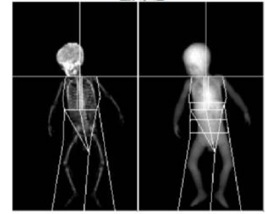
Z-score values of bone mineral density in Patient 1 is -2.88.

Figure S3 HE staining of smear of BALF from Patient 1 and Patient 3.
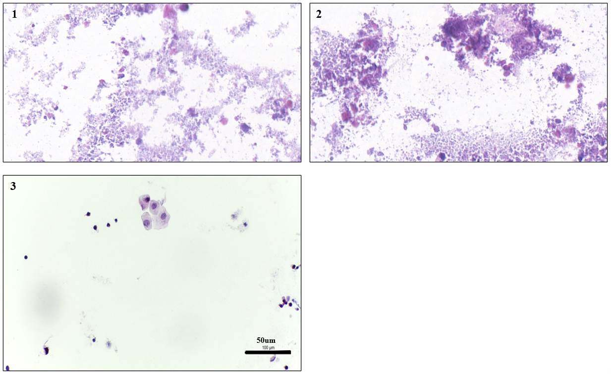
HE staining of smear of BALF from Patient 1(1), Patient 3(2) and general pneumonia control (3). Scale bar=50um, 400X.

Figure S4 Schematic and cell marker genes of scRNA-seq.
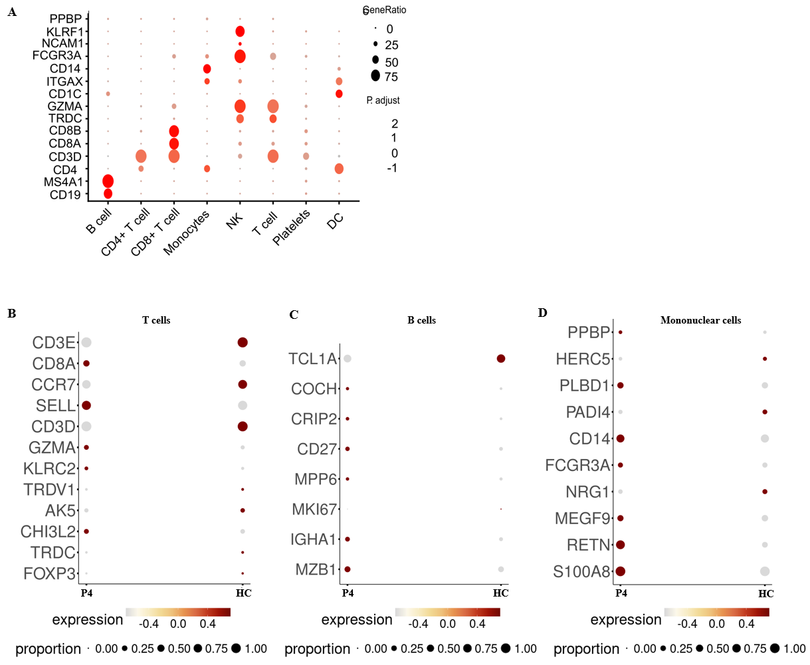
(A) Dot plots depicting the expression distribution of chosen cell marker genes within the 8 clusters. The rows represent selected marker genes while the columns represent clusters. (B) Dot plots showing the expression distribution of T cells marker genes between Patient 4 and health control. (C) Dot plots showing the expression distribution of B cells marker genes between Patient 4 and health control. (D) Dot plots showing the expression distribution of monocyte cells marker genes between Patient 4 and health control. The rows represent selected marker genes while the columns represent clusters.

Figure S5 Radiographic imaging was partial improvement by comparison of routine chest CT before and after each whole-lung lavage therapy of Patient 1.
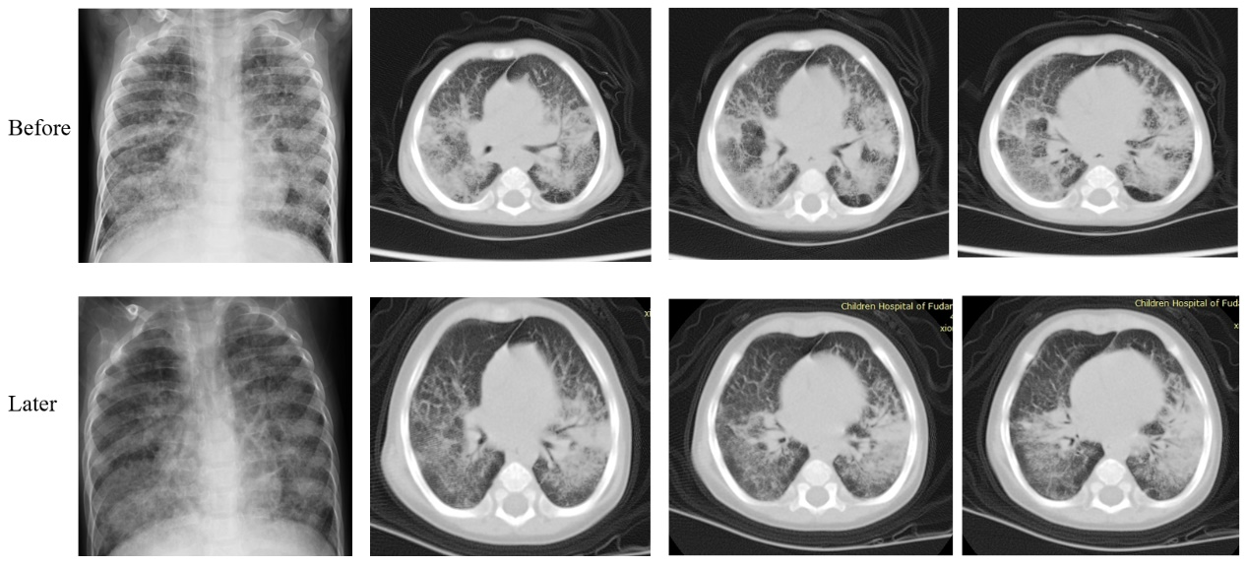

Materials and Methods
Exome sequencing and data analysis
- WES data processing pipeline:
Raw Data QC: Raw fastq files were first assessed using FastQC (v0.11.9) to evaluate base quality scores, GC content, and adapter contamination.
Preprocessing: Adapter sequences and low-quality bases (Q<20) were trimmed using Trimmomatic (v0.36). Clean reads were then aligned to the human reference genome (GRCh38) using BWA-MEM (v0.7.17).
Post-alignment Processing: Duplicate reads were marked and removed using Picard tools MarkDuplicates (v2.21.6). Subsequently, Base Quality Score Recalibration (BQSR) was performed using GATK (v4.1.8.0) to correct systematic errors in base quality scores.
Variant Calling: Variants were called using GATK HaplotypeCaller.
Following the GATK Best Practices for small sample cohorts or targeted analysis, we applied standard hard-filtering thresholds recommended by the GATK developers. For SNVs, the criteria were: QD < 2.0, FS > 60.0, MQ < 40.0, SOR > 3.0, MQRankSum < -12.5, ReadPosRankSum < -8.0. For Indels, the criteria were: QD < 2.0, FS > 200.0, ReadPosRankSum < -20.0. Additionally, we required a minimum depth (DP) ≥ 30.

- Germline SNV/Indel Variant Filtration Pipeline
  - Dataset Preparation
Curate population frequency (1000 Genomes, ExAC, gnomAD, in-house database), pathogenicity evidence (HGMD, ClinVar, OMIM), and predictive scores (CADD, SPIDEX) databases.
  - Variant Preprocessing
Left-align indels, standardize nomenclature, and validate key metrics (read depth, allele balance, quality score, genotype).
  - Valid Analysis Region (VAR) Filtering
Retain variants in RefSeq exons (±15 bp), high-impact regions (CADD > 20, SPIDEX |Z| > 1.96), and pathogenic loci (HGMD pathogenic variants, non-benign ClinVar entries); exclude non-VAR variants.
  - Frequency Filtering
Annotate variants against public and local frequency databases; filter common variants using tiered thresholds (≤1000 samples: MAF > 7.5%; >1000 samples: MAF > 2%).
  - Functional Annotation
Annotate variant function, amino acid changes, and pathogenicity predictions via ANNOVAR/VEP, integrating Swiss-Prot, HGMD, and OMIM data.
  - Prioritization
Rank remaining candidates by pathogenicity scores, functional impact, population rarity, and phenotypic relevance (e.g., via PhenoPro).^{[1]}

Bronchoalveolar lavage fluid (BALF) samples collection
Strict quantitative control was implemented during BALF sample collection and processing. Whole lung lavage was performed in all patients at a standardized volume of 10 ml/kg of body weight. The total recovered BALF was fully mixed and equally divided into four aliquots. One aliquot was centrifuged for cytospin preparation and morphological staining. For control subjects, since BALF usually contains very few cells, all available cells from the control patients were used for smear staining to maximize the evaluable cellular material and ensure comparability between patient and control groups.

Reference
1. Wang, X., et al., An Integrated Pipeline for Trio-Rapid Genome Sequencing in Critically Ill Infants. Curr Protoc, 2023. 3(3): p. e706.

