Figure S1. Top 20 DMPs distinguishing Exertional Heat Stroke (EHS) from Exertional Heat Exhaustion (EHE).
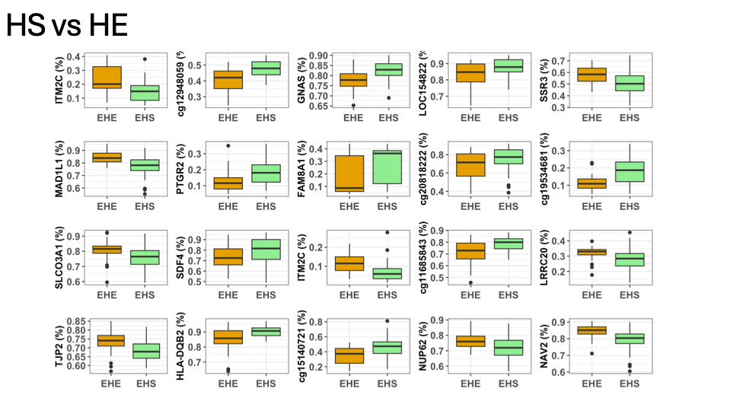
Figure S2. Top 20 DMPs distinguishing Exertional Heat Injury (EHI) from Exertional Heat Exhaustion (EHE).
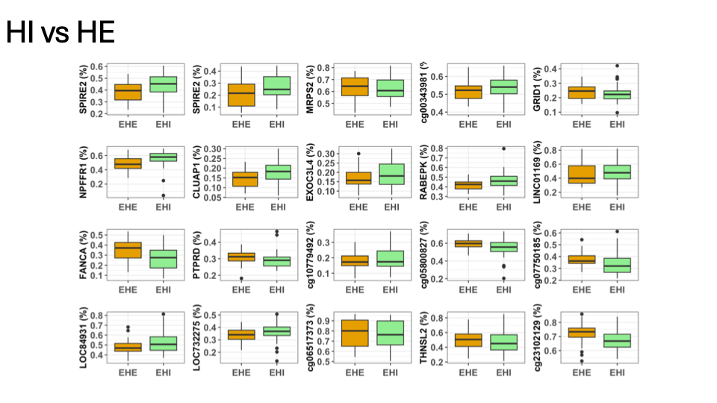
Figure S3. Top 20 DMPs distinguishing Exertional Heat Stroke (EHS) from Exertional Heat Injury (EHI).
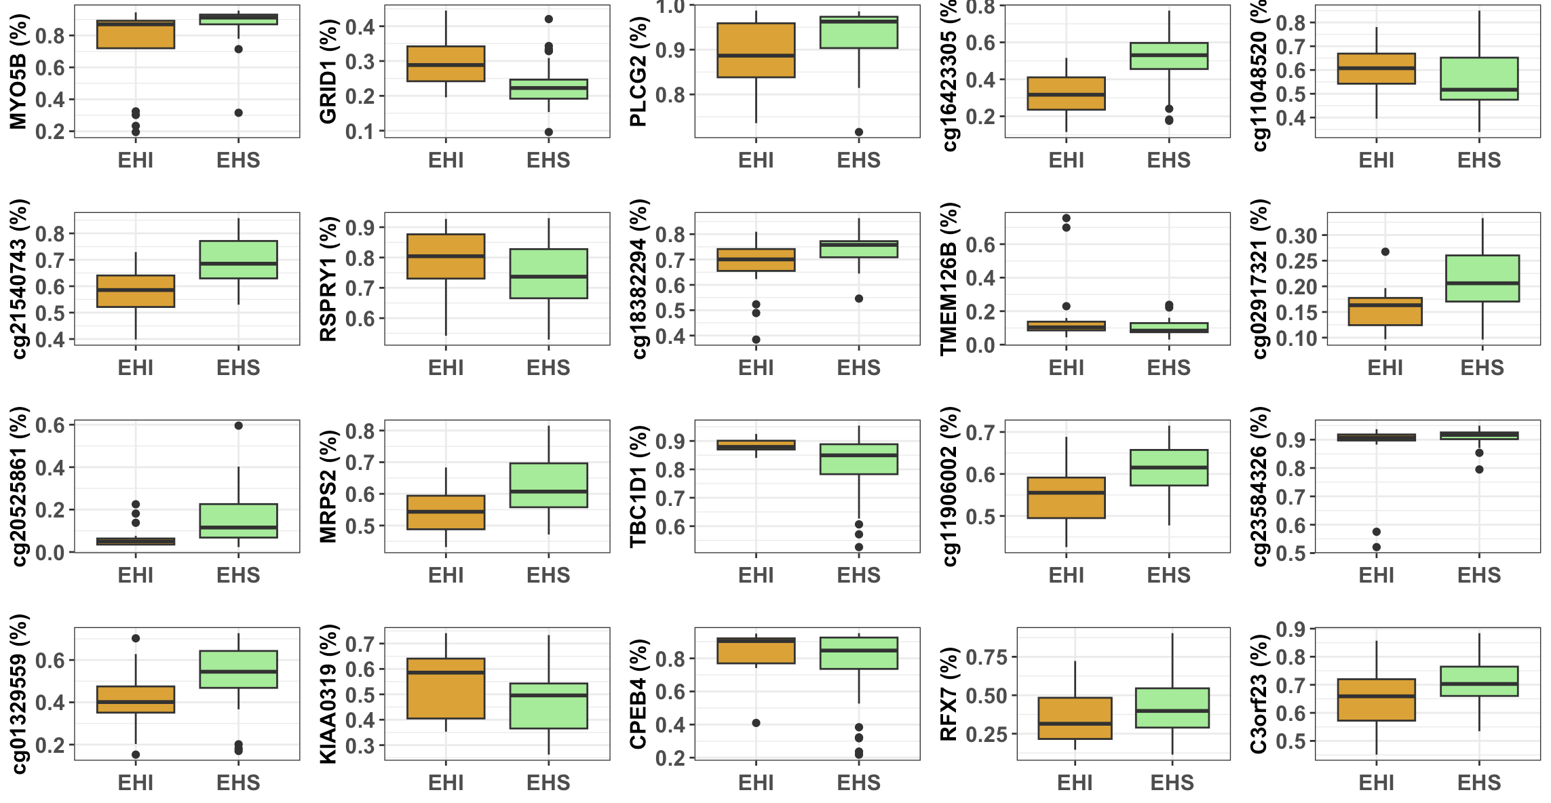
Table S1. DNA Methylation-Estimated Blood Profiling at Baseline (Time = 1)
Genomic Feature | EHS vs. EHE (N = 2,258) | EHI vs. EHE (N = 628) | EHS vs. EHI (N = 424)
Body | 836 (37.0%) | 242 (38.5%) | 144 (34.0%)
IGR | 643 (28.5%) | 217 (34.6%) | 151 (35.6%)
TSS1500 | 305 (13.5%) | 72 (11.5%) | 55 (13.0%)
5'UTR | 218 (9.7%) | 37 (5.9%) | 38 (9.0%)
TSS200 | 148 (6.6%) | 37 (5.9%) | 16 (3.8%)
1stExon | 52 (2.3%) | 9 (1.4%) | 11 (2.6%)
3'UTR | 50 (2.2%) | 11 (1.8%) | 9 (2.1%)
ExonBnd | 6 (0.3%) | 3 (0.5%) | - (0.0%)

Table S2. Longitudinal Cell Profiling Across Time Bins Cell Profiling.
Cell Type | T1 (N = 118) | T2 (N = 46) | T3 (N = 59) | T4 (N = 46)
Neutrophils (Neu) | 66.32% ± 11.77% | 59.61% ± 8.23% | 59.30% ± 10.09% | 59.06% ± 8.78%
Monocytes (Mono) | 9.43% ± 2.69% | 10.31% ± 2.48% | 9.97% ± 2.68% | 10.38% ± 2.25%
CD8 + T Cells (CD8T) | 9.37% ± 4.70% | 11.58% ± 3.80% | 12.29% ± 4.13% | 11.30% ± 4.24%
CD4 + T Cells (CD4T) | 7.48% ± 4.70% | 10.96% ± 3.87% | 10.52% ± 3.94% | 9.71% ± 3.81%
B Cells (Bcell) | 6.05% ± 3.22% | 7.73% ± 3.28% | 8.55% ± 3.32% | 8.79% ± 3.58%
NK Cells (NK) | 4.15% ± 4.40% | 2.84% ± 2.68% | 2.81% ± 2.48% | 4.32% ± 3.20%

Table S3. Exertional Heat Stroke Longitudinal Cohort Cell Profiling (N = 186 samples)
Cell Type | T1 (N = 53) | T2 (N = 37) | T3 (N = 53) | T4 (N = 43)
Neutrophils (Neu) | 66.46% ± 13.20% | 59.84% ± 8.90% | 59.46% ± 10.36% | 60.09% ± 8.10%
Monocytes (Mono) | 8.68% ± 2.62% | 10.47% ± 2.50% | 9.80% ± 2.66% | 10.24% ± 2.26%
CD8 + T Cells (CD8T) | 9.47% ± 5.74% | 11.40% ± 3.86% | 12.35% ± 4.35% | 10.78% ± 3.87%
CD4 + T Cells (CD4T) | 6.71% ± 5.07% | 11.21% ± 4.12% | 10.44% ± 3.88% | 9.58% ± 3.90%
B Cells (Bcell) | 6.40% ± 3.46% | 7.82% ± 3.45% | 8.83% ± 3.37% | 8.68% ± 3.66%

Table S4. Exertional Heat Injury Longitudinal Cohort Cell Profiling (N = 38 samples)
Cell Type | T1 (N = 23) | T2 (N = 6) | T3 (N = 6) | T4 (N = 3)
Neutrophils (Neu) | 69.82% ± 10.12% | 58.91% ± 5.52% | 57.87% ± 7.86% | 44.36% ± 3.10%
Monocytes (Mono) | 9.62% ± 2.42% | 10.29% ± 2.72% | 11.51% ± 2.55% | 12.36% ± 0.24%
CD8 + T Cells (CD8T) | 8.48% ± 3.36% | 11.96% ± 4.36% | 11.72% ± 0.87% | 18.74% ± 0.69%
CD4 + T Cells (CD4T) | 6.42% ± 4.11% | 9.96% ± 3.14% | 11.28% ± 4.74% | 11.57% ± 0.90%
B Cells (Bcell) | 4.99% ± 2.15% | 7.19% ± 3.17% | 6.10% ± 1.30% | 10.41% ± 1.28%
NK Cells (NK) | 3.56% ± 2.23% | 4.90% ± 2.14% | 4.71% ± 2.28% | 7.26% ± 1.38%

Table S5. Genomic Feature Descriptive Analysis.
Genomic Feature | EHS vs. EHE (N = 2,258) | EHI vs. EHE (N = 628) | EHS vs. EHI (N = 424)
Body | 836 (37.0%) | 242 (38.5%) | 144 (34.0%)
IGR | 643 (28.5%) | 217 (34.6%) | 151 (35.6%)
TSS1500 | 305 (13.5%) | 72 (11.5%) | 55 (13.0%)
5'UTR | 218 (9.7%) | 37 (5.9%) | 38 (9.0%)
TSS200 | 148 (6.6%) | 37 (5.9%) | 16 (3.8%)
1stExon | 52 (2.3%) | 9 (1.4%) | 11 (2.6%)
3'UTR | 50 (2.2%) | 11 (1.8%) | 9 (2.1%)
ExonBnd | 6 (0.3%) | 3 (0.5%) | 0 (0.0%)

