Additional file 4:
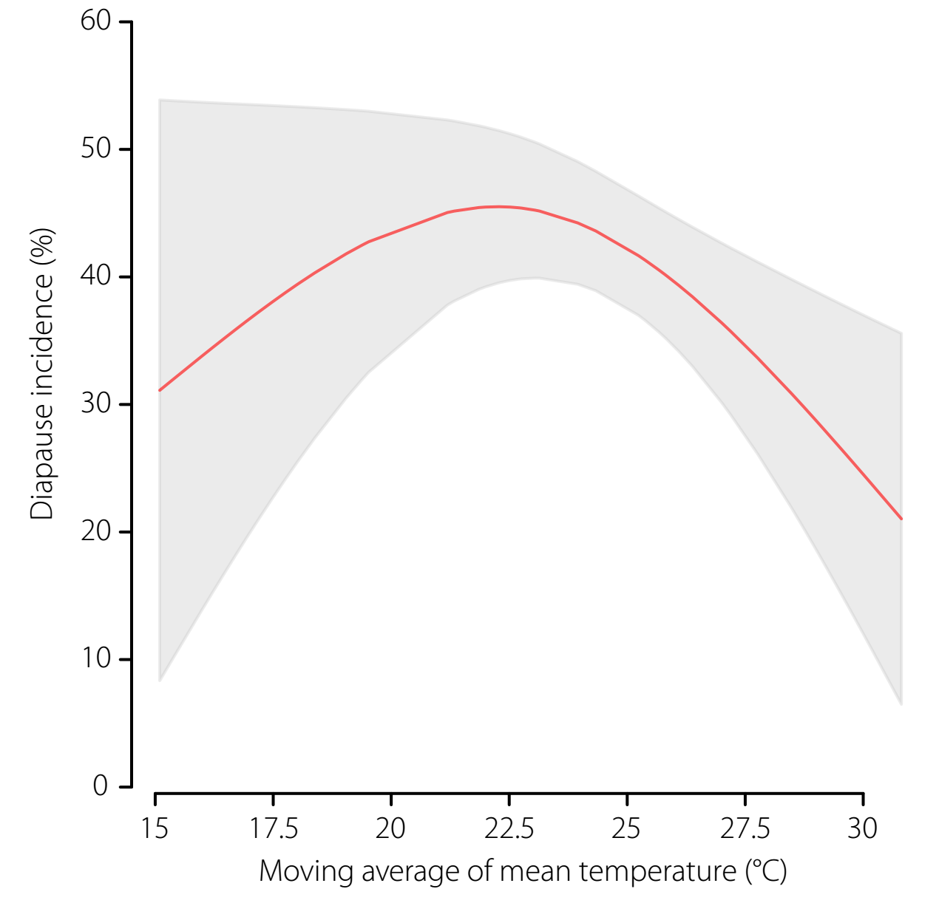
Figure S2. The predicted diapause incidence along a moving average of mean temperature over a lag of 0-2 weeks. The red line represents the predicted diapause incidence, and the shaded area is the corresponding 95% confidence interval of the predicted diapause incidence. The predicted diapause incidence was estimated for week_{2017,43}, given the same day length as that observed in the week and the previous 2 weeks.

