Changes in the epidemiology of hepatitis A in three socio-economic regions of China, 1990‒2017

Technical appendix

Three regions in China
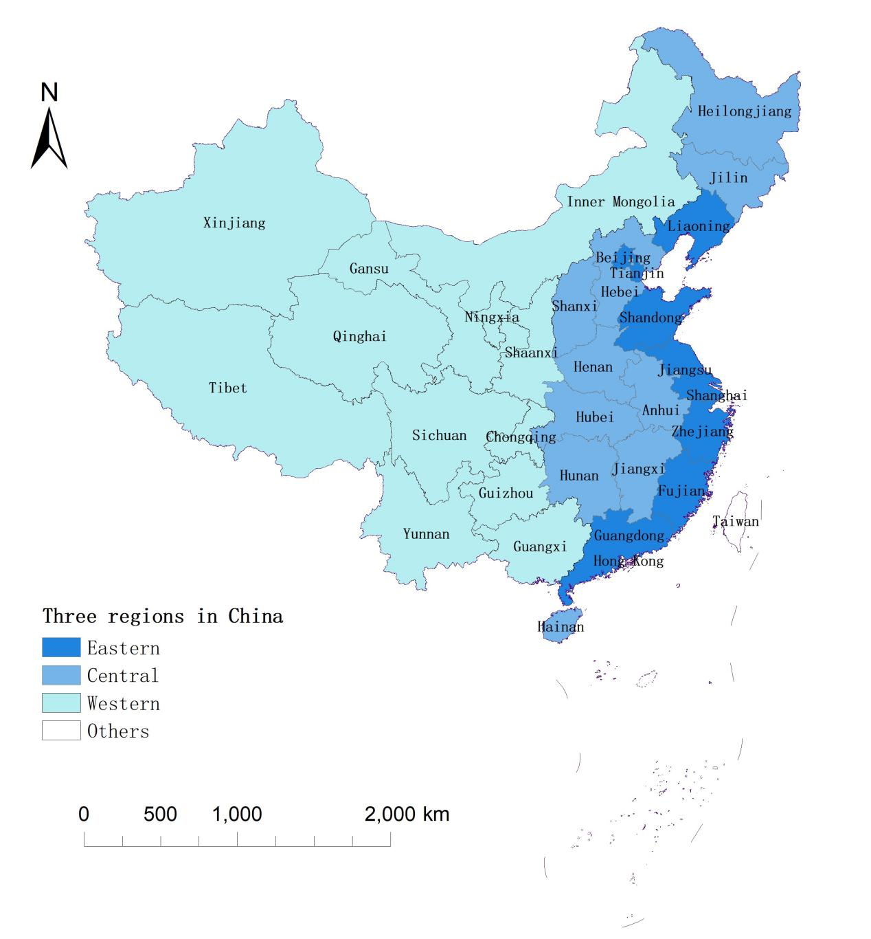
Technical appendix fig1. Three regions were divided, with Eastern region including 9 higher developed provinces of Beijing, Tianjin, Liaoning, Shandong, Jiangsu, Shanghai, Zhejiang, Fujian and Guangdong, Central region including 10 provinces of Heilongjiang, Jilin, Hebei, Henan, Shanxi, Hubei, Hunan, Jiangxi, Anhui and Hainan, Western region including 12 lower developed provinces of Inner Mongolia, Guangxi, Chongqing, Sichuan, Guizhou, Yunnan, Tibet, Shaanxi, Gansu, Qinghai, Ningxia and Xinjiang. Data of HepA incidence was not available in Hongkong SAR, Macau SAR and Taiwan province.

