ADDITIONAL FILE
Description of village health volunteers (VHV)
The MHAA is a local nongovernmental organization (NGO) that implements malaria control activities, with funding support from various sources. A sub-office was opened by the MHAA and was occupied by three assigned health assistants and five field supervisors. The staff is paid a monthly salary directly from the central office of Yangon, Myanmar and is monitored by higher-level staff. A VHV was assigned to each village by the MHAA without overlapping other partners, including the respective township’s VBDC team. In addition to the VHVs’ activities, routine health education sessions were in place in each village, organized by the MHAA’s field staff using pamphlets and posters.
The MHAA trained VHVs during a 5-day recruitment training session and 3 to 4 days of yearly refresher training and organized routine supportive supervision. With guidance from the NMCP, the volunteers were remunerated with a standardized incentive scheme of 50,000 MMK (35 USD) per quarter, and other occasional in-kind distributions. Moreover, full supplies for malaria diagnosis and treatment were ensured and refilled when necessary to avoid potential stock-outs. The training-aid materials, checklists, case report forms (CRFs) , and other formats were adopted and reproduced from the NMCP’s standard materials and guidelines.

ADDITIONAL FIGURES
Additional Figure S1: Example of simple latrine-type toilet
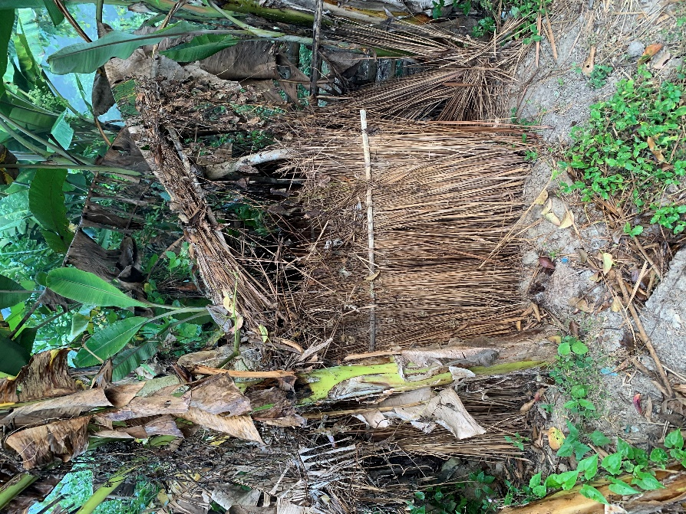
Additional Figure S2: Example of a hut
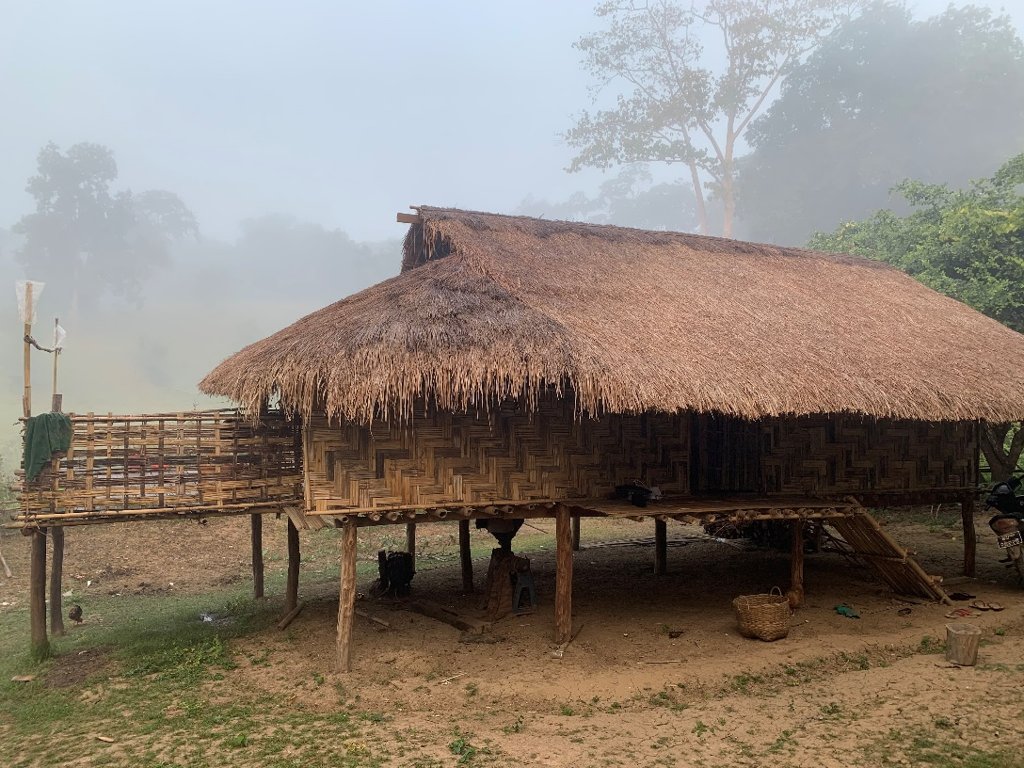

Additional Figure S3A: Example of a house that is not considered as hut
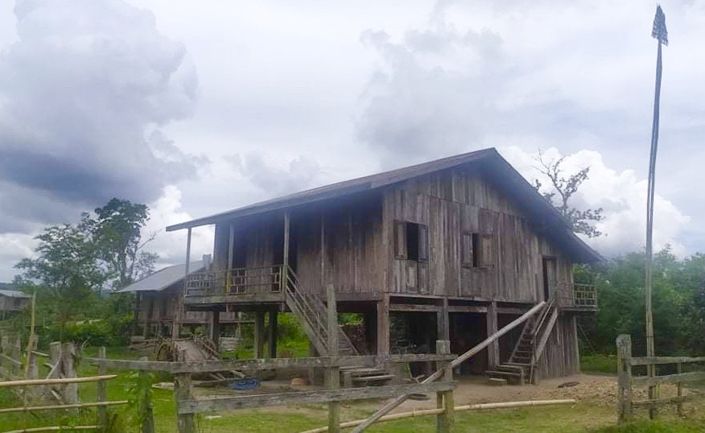
Additional Figure S3B: Example of a house that is not considered as hut
