Additional information: Figure
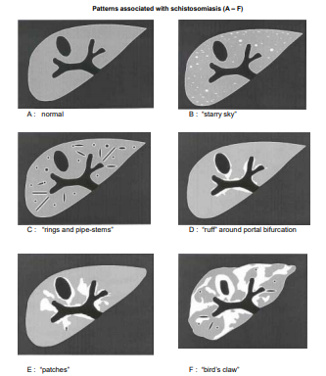
Figure S1: Liver image patterns associated with schistosomiasis, by [15].

