Additional files

Table S1: Full searching strategy by databases

Medline searching strategy*
1 | (“Lost to follow-up” or “LTFU” or discontinuation or attrition or retention or defaulting or “discontinuation rate” or “attrition rate” or “retention rate” or defaulting rate”).tw.
2 | (Predictors or factors or determinants).tw.
3 | (“Antiretroviral therap*” “ART” or “Highly active antiretroviral therap*” or “HAART” or “Human Immuno deficiency virus” or “HIV” or “AIDS”) ).tw.
4 | (“Sub-Saharan Africa” or Africa).tw.
5 | 1 and 2 and 3 and 4;
*MeSH terms to be added during searching
PubMed searching strategy*
1 | (“lost to follow up” OR “ltfu” OR discontinuation OR retention OR attrition OR adherence OR retention OR attrition OR compliance OR “ltfu” OR discontinuation OR defaulting OR ((“loss to follow-up”) OR (“loss to follow up”) OR (“lost to follow-up”) OR (“lost to follow up”) OR (“loss-to-follow-up”) OR (“lost-to-follow-up”) OR (“loss to retention”) OR (“lost to retention”) OR (“treatment initiation”) OR (“retention”) OR (“retain*”) OR (“attrition”)) OR ((“adher*”) OR (“complian*”) OR (“comply”) OR (“complied”) OR (“noncomplian*”) OR (“non-complian*”) OR (“non-adher*”) OR (“nonadher”)))
2 | (Predictors OR Factors OR Determinants)
3 | (“Antiretroviral therapy” OR “art” OR “haart” OR “Highly active antiretroviral therapy” OR “human Immuno deficiency virus” OR “hiv” OR “aids”)  (“hiv” OR “art” OR “triple therapy” OR “haart” OR “aids” OR "HIV Infections"[Mesh] OR "HIV" [MeSH] OR “human immunodeficiency virus”[tiab] OR “human immuno deficiency virus”[tiab] OR “human immune deficiency virus”[tiab] OR “human immunedeficiency virus”[tiab] OR “aids”[tiab] OR “acquired immunodeficiency syndrome”[tiab] OR “acquired immunodeficiency syndromes”[tiab] OR “acquired immuno deficiency syndrome”[tiab] OR “acquired immuno deficiency syndromes”[tiab] OR “acquired immune deficiency syndrome”[tiab] OR “acquired immune deficiency syndromes”[tiab] OR “acquired immunedeficiency syndrome”[tiab] OR “acquired immunedeficiency syndromes”[tiab]
4 | (Africa OR “Sub Saharan Africa”)
5 | (1 AND 2 AND 3AND 4) NOT Medline[sb])” LIMITED to English, adult, time(2002-2019), AIDS
* MeSH terms to be added during searching
Web of Science searching strategy
1 | TS= (“Lost to follow-up” or “LTFU” or discontinuation or attrition or retention or defaulting or “discontinuation rate” or “attrition rate” or “retention rate” or “defaulting rate”)
2 | TS= (Predictors or factors or determinants)
3 | TS= (“Anti-retroviral therap*” “ART” or “Highly active antiretroviral therap*” or “HAART” or “Human Immuno deficiency virus” or “HIV” or “AIDS”)
4 | TS= (“Sub-Saharan Africa” or Africa)
5 | 1 AND 2 AND 3 AND 4; Limited to language (English), age (adult), time(2002-2019), subject (AIDS)

Scopus searching strategy
1 | ALL (“lost to follow up” OR “LTFU” OR discontinuation OR attrition OR retention OR defaulting OR “discontinuation rate” OR “attrition rate” OR “retention rate” OR “defaulting rate”)
2 | ALL (predictors OR factors OR determinants)
3 | ALL (“Ant-retroviral therap*” OR “ART” OR “HAART” OR “Highly active antiretroviral therap*” OR “human Immuno deficiency virus” OR “HIV” OR “AIDS”)” LIMITED to English
4 | ALL(Africa OR “Sub-Saharan Africa”)
5 | 1 AND 2 AND 3 AND 4; Limited to language (English), age (adult), time(2002-2019), subject (AIDS)

CINAHL Searching strategy*
S1 | Lost to follow-up” or “LTFU” or discontinuation or attrition or retention or defaulting or “discontinuation rate” or “attrition rate” or “retention rate” or “defaulting rate”
S2 | Predictors or factors or determinants
S3 | “Anti-retroviral therap*” “ART” or “Highly active antiretroviral therap*” or “HAART” or “Human Immuno deficiency virus” or “HIV” or “AIDS”)
S4 | “Sub-Saharan Africa” or Africa
S5 | S1 AND S2 AND S3 AND S4; Limited to language (English), age (adult), time(2002-2019), subject (AIDS)
*MH words to be added during searching

S1 doc: JBI Critical Appraisal instruments

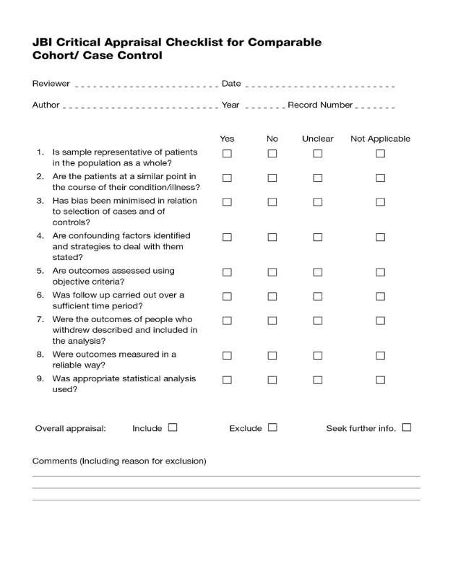

S2 doc: JBI Data extraction instruments
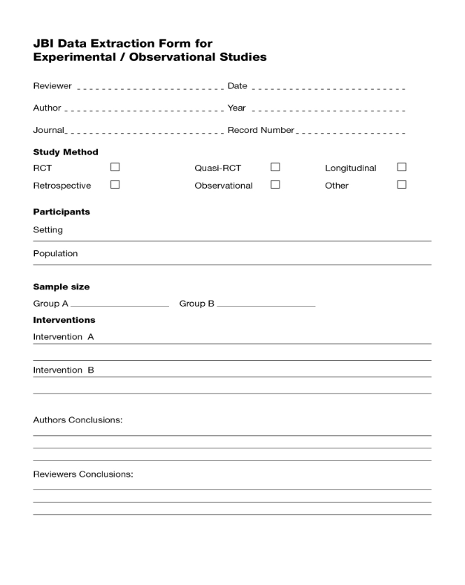
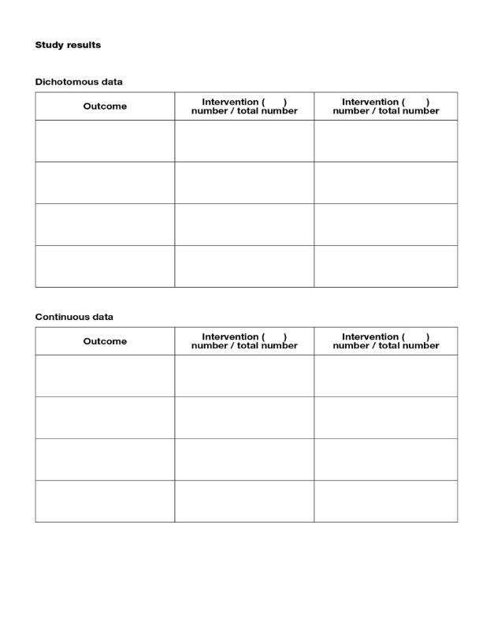

S3 doc: PRISMA Checklist of items to include when reporting a systematic review or meta-analysis [Adapted from Preferred reporting items for systematic review and meta-analysis protocols (PRISMA-P) 2015 statement by Moher D et al, 2015]
Section/topic | # | Checklist item | Information reported
Section/topic | # | Checklist item | Yes | No | Page number(s)
ADMINISTRATIVE INFORMATION
Title
Identification | 1a | Identify the report as a protocol of a systematic review | √ |  | 5
Update | 1b | If the protocol is for an update of a previous systematic review, identify as such |  | √
Registration | 2 | If registered, provide the name of the registry (e.g., PROSPERO) and registration number in the Abstract | √ |  | CRD42018114418
Authors
Contact | 3a | Provide name, institutional affiliation, and e-mail address of all protocol authors; provide physical mailing address of corresponding author | √ |  | 1
Contributions | 3b | Describe contributions of protocol authors and identify the guarantor of the review | √ |  | 29
Amendments | 4 | If the protocol represents an amendment of a previously completed or published protocol, identify as such and list changes; otherwise, state plan for documenting important protocol amendments | √
Support
Sources | 5a | Indicate sources of financial or other support for the review | √ |  | 29
Sponsor | 5b | Provide name for the review funder and/or sponsor |  |  | 29
Role of sponsor/funder | 5c | Describe roles of funder(s), sponsor(s), and/or institution(s), if any, in developing the protocol |  |  | 29
ABSTRACT Structured summary | 6 | Provide a structured summary: background, objectives, methods, results, conclusions and implications of key findings | √ |  | 2-3
INTRODUCTION
Rationale | 8 | Describe the rationale for the review in the context of what is already known | √ |  | 3-5
Objectives | 8 | Provide an explicit statement of the question(s) the review will address with reference to participants, interventions, comparators, and outcomes (PICO) | √ |  | 4-5
METHODS
Eligibility criteria | 9 | Specify the study characteristics (e.g., PICO, study design, setting, time frame) and report characteristics (e.g., years considered, language, publication status) to be used as criteria for eligibility for the review | √ |  | 5
Information sources | 10 | Describe all intended information sources (e.g., electronic databases, contact with study authors, trial registers, or other grey literature sources) with planned dates of coverage | √ |  | 6
Search strategy | 11 | Present draft of search strategy to be used for at least one electronic database, including planned limits, such that it could be repeated | √ |  | 6-7
STUDY RECORDS
Data management | 12a | Describe the mechanism(s) that will be used to manage records and data throughout the review | √ |  | 6-7
Selection process | 12b | State the process that will be used for selecting studies (e.g., two independent reviewers) through each phase of the review (i.e., screening, eligibility, and inclusion in meta-analysis) | √ |  | 6-7
Data collection process | 12c | Describe planned method of extracting data from reports (e.g., piloting forms, done independently, in duplicate), any processes for obtaining and confirming data from investigators | √ |  | 7
Data items | 13 | List and define all variables for which data will be sought (e.g., PICO items, funding sources), any pre-planned data assumptions and simplifications | √ |  | 5-7
Outcomes and prioritization | 14 | List and define all outcomes for which data will be sought, including prioritization of main and additional outcomes, with rationale | √ |  | 5
Risk of bias in individual studies | 15 | Describe anticipated methods for assessing risk of bias of individual studies, including whether this will be done at the outcome or study level, or both; state how this information will be used in data synthesis | √ |  | 9
DATA
Synthesis | 16a | Describe criteria under which study data will be quantitatively synthesized | √ |  | 9
Synthesis | 16b | If data are appropriate for quantitative synthesis, describe planned summary measures, methods of handling data, and methods of combining data from studies, including any planned exploration of consistency (e.g., I ², Kendall’s tau) | √ |  | 9
Synthesis | 16c | Describe any proposed additional analyses (e.g., sensitivity or subgroup analyses, meta-regression) | √ |  | 9
Synthesis | 16d | If quantitative synthesis is not appropriate, describe the type of summary planned | √ |  | 9
Meta-bias(es) | 17 | Specify any planned assessment of meta-bias(es) (e.g., publication bias across studies, selective reporting within studies) | √ |  | 9
Confidence in cumulative evidence | 18 | Describe how the strength of the body of evidence will be assessed (e.g., GRADE) | √ |  | 9
RESULTS
Study selection | 19 | Give numbers of studies screened, assessed for eligibility, and included in the review, with reasons for exclusions at each stage, ideally with a flow diagram. | √ |  | 6-7
Study characteristics | 20 | For each study, present characteristics for which data were extracted (e.g., study size, PICOS, follow-up period) and provide the citations. | √ |  | 8-10
Risk of bias within studies | 21 | Present data on risk of bias of each study and, if available, any outcome level assessment (see item 12). | √ |  | 10
Results of individual studies | 22 | For all outcomes considered (benefits or harms), present, for each study: (a) simple summary data for each intervention group (b) effect estimates and confidence intervals, ideally with a forest plot. | √ |  | 13-16
Synthesis of results | 23 | Present results of each meta-analysis done, including confidence intervals and measures of consistency. | √ |  | 13-25
Risk of bias across studies | 24 | Present results of any assessment of risk of bias across studies (see Item 15). | √ |  | Supportive doc table 2
Additional analysis | 25 | Give results of additional analyses, if done (e.g., sensitivity or subgroup analyses, meta-regression [see Item 16]). |  | √
DISCUSSION
Summary of evidence | 26 | Summarize the main findings including the strength of evidence for each main outcome; consider their relevance to key groups (e.g., healthcare providers, users, and policy makers). | √ |  | 15-18
Limitations | 27 | Discuss limitations at study and outcome level (e.g., risk of bias), and at review-level (e.g., incomplete retrieval of identified research, reporting bias). | √ |  | 17-18
Conclusions | 28 | Provide a general interpretation of the results in the context of other evidence, and implications for future research. | √ |  | 18
FUNDING
Funding | 29 | Describe sources of funding for the systematic review and other support (e.g., supply of data); role of funders for the systematic review. | √ |  | 19

Table S2: Characteristics of included articles (n=30)
Author | Year | Sample size (n) | Study design | Outcome of interest | Measurement | Setting | Summary
Ahonkhai et al.[38] | 2012 | 11,397 | Retrospective cohort | LTFU | Missing all follow-up visits in the first 12 months on ART. | South Africa | Enrolment in later calendar year (2008 Vs 2004) (AOR 0.49, 95%CI 0.39–0.62) and being female (AOR 0.82; 95%CI 0.73–0.91) had lower risk of LTFU
Akilimali et al. [39] | 2017 | 844 | Retrospective Cohort | LTFU | Stop attending ART clinic for more than 3 months and had not yet been classified as dead' or `transferred-out' | Goma, Democratic Republic of Congo | Patients who did not disclosed their HIV status (AHR 2.28, 95% CI 1.46±2.29), rural residents (AHR 1.97, 95% CI 1.02±3.77), and being more educated (AHR 1.60, 95% CI 1.02±2.53) were at higher risk of being lost from treatment.
Asefa et al.[25] | 2013 | 236 | Case control | Defaulting | HIV positive patient who had been enrolled on ART treatment and who failed to return for two or months | Western Ethiopia, Ethiopia | Rural residence (AOR=4.1; 95%CI 1.86 to 9.42), no income (AOR=13.9; 95%CI 4.23 to 45.99), having psychiatric illness (AOR=4.7; 95%CI 1.65 to 13.35), having discordant partner (AOR=5.1; 95%CI 1.59 to 16.63), having partner with unknown HIV status (AOR=2.8; 95% CI 1.23 to 6.50) and having a concern for stigma (AOR=8.3; 95% CI 2.88 to 23.83) were predictors for exit from treatment
Assemie et al.[40] | 2018 | 602 | Retrospective Cohort | LTFU | Patients not taking ART refill for a period of 3 months or longer from the last attendance for refill and not yet classified as ‘died’ or ‘transferred-out’ | Northwest Ethiopia,  Ethiopia | Being young (15–28 years, AHR = 0.44; 95% CI 0.24–0.83), advanced WHO clinical stage (stage IV, AHR = 2.09; 95% CI 1.02–3.13); and receiving isoniazid preventive therapy (AHR = 0.11; 95% CI 0.06–0.18) were independent significant predictors of lost to follow up
Berheto et al. [22] | 2014 | 2133 | Retrospective cohort | LTFU | Not taking ART refill for a period of three months or longer from the last attendance and not yet classified as ‘dead’ or ‘transferred-out’ | Mizan, Southwest Ethiopia | Patients with regimen substitution (AHR=5.2, 95% CI: 3.6-7.3), non-isoniazid (INH) prophylaxis (AHR=3.7, 95% CI: 2.3-6.2), adolescent (HR=2.1, 95% CI: 1.3-3.4), and had a baseline CD4 count < 200 cells/mm3 (AHR=1.7, 95% CIs: 1.3-2.2) were at higher risk of LTFU. WHO clinical stage 3 (AHR=0.6, 95% CIs: 0.4-0.9) and 4 (AHR=0.8, 95% CI: 0.6-1.0) patients at entry were less likely to be LTFU than clinical stage 1 patients.
Bucciardini et al.[10] | 2015 | 563 | Prospective  Cohort | LTFU | Patients who lost scheduled visit to the same ART clinic more than three months after the last visit.  Or  Patients known to have discontinued ART for any reasons | Tigray, Northern Ethiopia | Low level Health Facility (AHR 2.99, 95% CI: 2.77–3.23), Active TB (HR 1.72, 95% CI: 1.23–2.41) and male gender (AHR 1.64, 95% CI: 1.10–2.56) were the predictors of attrition.
Deribe et al. [60] | 2008 | 1270 | Case control study | Defaulting | An individual who had been on ART treatment and who had not been seen for the last 2 months | Jimma, Ethiopia | Taking hard drugs (cocaine, cannabis and IV drugs) (AOR = 0.02, 95%CI: 0.003±0.17), excessive alcohol consumption (AOR = 6, 95%CI: 3.3±11.1), being bedridden (AOR = 5.7, 95% CI: 1.6±20.2), rural residence (AOR = 2.2, 95%CI: 1.4±3.5) and having sero-discordant (AOR = 3.5, 95%CI: 1.1±11.1) or unknown HIV status partner (AOR = 1.7, 95%CI: 1.02 = 2.9) were associated with ART defaulting.
Dessalegn et al.[5] | 2015 | 727 | Case control | LTFU | Patients who had missed two or more clinical appointments since the last scheduled visit | Wukro, Northern Ethiopia | Presence of bereavement concern (AOR=0.1, 95%CI: 0.01-0.3), not being provided with Isoniazid prophylaxis (AOR=3.04, 95%CI: 1.3-7.3), and presence of side effects (AOR=12.3, 95%CI: 4.9-31.4) were found determinants of lost to follow up
Djarma et al. [41] | 2014 | 509 | Retrospective cohort | LTFU | A time delay of 3 months  since the last scheduled visit. | N’Djamen, Chad | Stable free access to HAART (72.5 vs. 10%; p,0.001) was associated with decreasing lost from care. On the contrary, living outside the town (24.2% vs 9.2%; p¼0.001) was associated with increasing risk of LTFU
Eguzo et al. [42] | 2015 | 1256 | Retrospective Cohort | LTFU | A patient who missed an appointment for more than 6 months after the last visit | Aba­Nigeria, Nigeria | Early calendar year enrollment (2008 Vs 2010-2013) (HR 3.1, 95% CI 1.16–8.17; P = 0.02) and ((2009 Vs 2010-2013) (AHR 2.69 95% CI 1.05–6.88, P = 0.04)) were more likely to be LTFU
Fatti et al. [43] | 2010 | 29203 | Retrospective cohort | LTFU | Absence from the clinic for three or more months after the last missed appointment date and not known to have died or transferred treatment program or place. | South Africa | Being male (AHR 1.20 95% CI 1.09–1.33 P 0.001) and enrolled in later years (AHR 6.18, 95% CI: 4.30–8.89; P< 0.001) had elevated risks of LTFU. On the other hand, Older age was inversely related to the risk of LTFU (AHR 0.89 95% CI 0.84–0.94, P <0.001)
Gesesew et al. [44] | 2017 | 4900 | Retrospective Cohort | LTFU | Patients who failed to pick up their medications for at least 3 months but had not yet been classified as dead or transferred out | Jimma, Southwest Ethiopia | Being female (AOR = 2.1, 95%CI: 1.7±2.8), developing immunological failure (AOR = 2.3, 1.9±8.2), having tuberculosis co-infection (AOR=1.5, 1.1±2.1) and having no history of HIV testing (AOR = 1.8, 1.4±2.9) were more likely to discontinue care.
Gezae et al. [45] | 2019 | 305 | Retrospective Cohort | LTFU | Patients who failed to collect ART drugs for at least three consecutive months and not recorded as dead, alive, transfer, drop out or stop | Mekelle, Ethiopia | Low Hemoglobin level (≤ 11.0 g/dl, AHR = 2.660; 95%CI: 1.459–4.848), and any history of OI/s (AHR = 3.795; 95%CI: 1.165–12.364) were associated with LTFU. Whereas, adverse drug events (AHR = 0.451; 95%CI: 0.216–0.941), TB treatment completion (AHR = 0.121; 95% CI: 0.057–0.254), and being on Isoniazid Preventive Therapy (IPT) (AHR = 0.085; 95%CI: 0.012–0.628) had protective effect against LTFU.
Ibiloye et al. [46] | 2018 | 710 | Retrospective cohort | LTFU | Missing treatment for more than 2 months since the last appointment. | Nasarawa state, Nigeria. | Patients having no formal education (AHR 1.8; 95% CI 1.3–2.6, P= 0.001) and unemployed (AHR 1.8; 95% CI 1.2–2.6, p= 0.001) were more likely to get lost from the care
Kaplan et al. [48] | 2017 | 39,884 | Retrospective Cohort | Disengagement | A patient stopping accessing care in an ART clinic for >6 months after his or her last visit date. | Cape Town, South Africa | Recent lower CD4 count(CD4 200±350 HR 2.03; 95% CI 1.91±2.15; CD4 50±200 HR 3.07; 95% CI 2.84±3.31; CD4 <50 HR 3.34; 95% CI 2.92±3.83, all relative to CD4 > 350), use of d4T (stavudine) at last visit (AHR 1.72; 95% CI 1.57±1.89), and initiating ART during pregnancy (AHR 1.58; 95% CI 1.47±1.69) were determinants of lost from care.
Katz et al. [47] | 2017 | 4025 | Retrospective Cohort | LTFU | Break off from treatment within the first 4 months on ART | Cape Town, South Africa | Linking to ART in later calendar year (AOR= 1.30, 95% CI 1.09±1.55), lower CD4 count at ART initiation (< 200; AOR = 1.34, 95% CI 1.06±1.67).
Kiguba et al. [61] | 2007 | 686 | Cross sectional | Discontinuation | Simultaneous stopping of all antiretrovirals for at least 1 month | Kampala, Uganda. | HAART experience before starting the current regimen (AOR = 3.70, 95% CI: 2.13 to 6.25), use of alternative medicines (AOR = 2.18, 95% CI: 1.06 to 4.47), history of hospitalization (AOR = 2.36, 95% CI: 1.32 to 4.20), and 1 year or less on ART (OR = 11.11, 95% CI: 5.00 to 25.00) were the determinants of discontinuation.
Mberi et al. [20] | 2015 | 595 | Retrospective cohort | LTFU | A patient who had been failed to return to the health facility for more than six months since their last expected date of return | South Africa | Having no regular partner (AHR: 2.9, 95 % CI:1.19-6.97, p = 0.019), owning private business (AHR: 13.9, 95 % CI:2.81 - 69.06, p = 0.001), higher baseline CD4 count (AHR: 3.8, 95 % CI: 1.85-7.85, p < 0.001), virologic failure in the last visit (AHR: 3.6, 95 % CI:1.98 - 6.52, p < 0.001) and a last known advanced WHO treatment stage (AHR: 2.0, 95 % CI:1.22-3.27, p = 0.006) had a higher risk of LTFU. Patients with a history of ART adverse event had a lower risk (AHR: 0.6, 95 % CI: 0.38 - 0.99, p = 0.044) of becoming LTFU than those who had not.
Megerso et al. [59] | 2016 | 1248 | Case–control study | LTFU | Individual patients who were registered as LTFU during the 12 months prior to the survey | Oromia, Ethiopia | Age 15–24 years (AOR 19.82, 95% CI: 6.80, 57.73); day laborers (AOR, 5.36; 95% CI: 3.23, 8.89), rural residents (AOR, 2.35; 95% CI: 1.45, 3.89), World Health Organization clinical stage 4 (AOR, 2.29; 95% CI: 1.45, 3.62), baseline CD4 count <350 cells/mL (AOR, 2.06; 95% CI: 1.36, 3.13), and suboptimal adherence to ART (AOR, 7.42; 95% CI: 1.87, 29.41), were factors which increased the risk of loss to follow-up in ART.
Mekonnen et al. [50] | 2019 | 569 | Retrospective cohort | LTFU | Missing from the clinic for at least three months after the last missed appointment but not transferred out from the facility to another facility or died. | Gondor, North West Ethiopia | Being underweight (AHR, 1.52, 95% CI 1.01–2.28), unemployed (AHR, 2.22, 95% CI 1.2–4.11), substance abuser (AHR, 1.84 95% CI 1.19–2.86), having sub-optimal adherence (AHR 6.33, 95% CI (3.90–10.26)), not received isoniazid prophylaxis (AHR 2.47, 95% CI (1.36–4.48)), ambulatory functional status (AHR 1.94, 95% CI (1.23–3.06)), opportunistic infections (AHR, 1.74 95% CI 1.11–2.72), lower CD4 count (AHR 0.58, 95% CI (0.38–0.88)) were found to be significant predictors of lost to follow up from ART service
Melaku et al. [13] | 2015 | 53,300 | Retrospective longitudinal | LTFU | Failure to visit ART clinic for more than 6 months and was not recorded as dead or transferred | Ethiopia | Being male (Female Vs Male AHR 0.73, 95% CI: 0.70-0.76), Younger age (AHR (50+ vs. 15–24): 0.67, 95% CI: 0.54-0.81; (40–49 vs. 15–24): 0.67, 95% CI: 0.60-0.75; (25–39 vs. 15–24): 0.77, 95% CI: 0.72-0.83), being unmarried ((Married/Living together Vs Never Married AHR 0.67 0.63-0.71),(Separated/Divorced Vs Never Married AHR 0.90 0.84-0.96), (Widowed Vs Never Married AHR 0.78 0.71-0.86)), No formal education((Primary Vs No Education AHR 0.71 0.66-0.75), (Secondary Vs No Education AHR 0.59 0.53-0.66), (Tertiary Vs No Education AHR 0.48 0.42-0.55)), low CD4+ cell count ((<100 Vs 350+ AHR 1.43 1.20-1.71), and advanced WHO clinical stage ((Stage 3 Vs Stage 1 AHR 1.19 1.07-1.32), Stage 4 Vs Stage 1 AHR 1.60 1.38-1.85)), Later calendar year ART initiation (2010–11 vs 2006–07 AHR 1.27, 95% CI:1.15-1.40) were found to be at high risk of LTFU from ART.
Meloni et al. [52] | 2016 | 51953 | Retrospective cohort | LTFU | Patients who had failed to visit the clinic for more than two months since the last scheduled pick-up date. | Nigeria | Being young age (<30 years Vs p<0.001), unemployed(p<0.001), having no formal education (p<0.001), being unmarried (p<0.001), WHO clinical stage (p<0.001), having detectable viral load (p<0.001), and lower CD4+ cell counts (p<0.001) were determinants of lost from care.
Mugisha et al. [53] | 2014 | 31,033 | Retrospective cohort | LTFU | Failed to be active in ART care for 6 months and was not registered as death, withdrawal or transfer to another health facility. | Kigali City and western  Rwanda, Rwanda | Male (AHR) 1.4, 95%CI 1.2–1.7) and younger age (AHR 1.4, 95%CI 1.2–1.7) patients were more likely to be LTF. Being married (AHR 0.6, 95%CI 0.4–0.9), and having lower base line CD4 count (AHR 0.64, 95%CI 0.4–0.9) were protective against LTF in ART patients.
Ochieng-Ooko et al.[54] | 2010 | 50, 275 | Retrospective Cohort | LTFU | A patient who failed to collect his/her medication (ART) for more than 3 months | Kenya | Being male gender (AOR=1.24, 95%CI: 1.15-1.33), living far away from clinic (≥ 1 hour travel time) (AOR=.1.11, 95%CI: 1.04-1,19) and advanced WHO clinical stage-(3 or 4) (AOR=1.30, 95%CI: 1.21-1.40) were linked with lost to follow-up. In contrast, being elderly (AOR=0.59, 95%CI: 0.55-.0.64), sharing HIV+ status (AOR=0.91, 95%CI: 0.85-0.98) and enrolling in a later time period (AOR=0.85, 95%CI: 0.79-0.90) were all associated with a lower risk of LTFU.
Seifu et al. [55] | 2018 | 1439 | Retrospective Cohort | LTFU | Stop accessing ART treatment for more than 3 months and not yet classified as dead or transferred-out | Jigjiga, Ethiopia | Being male (HR: 2.1 CI;1.3–3.4, p= 0.034), no next appointment record [AHR: 1.2, 95% CI; (1.12–1.36), p= 0.000*) and failure to disclose HIV status to any one (AHR: 2.8, 95% CI; (2.22–5.23), p= 0.034*) were predictors of LTFU.
Tadesse et al. [12] | 2014 | 520 | Retrospective cohort | LTFU | Patients who had missed one or more clinical appointments | Axum, Northern Ethiopia | Being smear positive pulmonary Tb (AHR=2.05, 95% CI: 1.02, 4.12), male gender (AHR=2.73, 95%CI: 1.31, 5.66), regiment AZT-3TC-NVP (AHR=3.47, 95%CI: 1.02,11.83) and weight ≥60kg (AHR= 0.24, 95% CI: 0.06,0.96).
Teshome et al. [11] | 2015 | 1173 | Retrospective cohort | LTFU | Missing from ART clinic for more than 3 months after the last appointment date | South Ethiopia | Being with in the normal body weight range (AHR=0.6, 95%CI: 0.4-0.9), advanced disease stage (AHR=1.4, 95%CI: 1.02-1.9), having no isoniazid prophylaxis (AHR=1.9, 95%CI=1.1-3.2), being in the adult age group (AHR=0.6, 95%CI: 0.4-0.8), serving in lower level health facility (AHR=0.7, 95% CI: 0.5-0.9), and higher educational status (AHR=0.6, 95%CI: 0.4-0.7) were predictors of LTFU.
Tweya et al. [56] | 2017 | 37,378 | Retrospective cohort | LTFU | A patient who did not return to the ART clinic for more than 2 months | Lilongwe, Malawi | LTFU was lower among those aged > 50 years when compared to younger patients aged 25±39 years (6.3 (95% CI 6.1±6.5), 4.5 (95% CI 4.2±4.7), and 5.6 (95% CI 5.1± 6.1).
Van Cutsem et al. [58] | 2011 | 6411 | Prospective cohort | LTFU | No clinic visits for at least 6 months and not classified as died or transferred out. | South Africa | Being young age (AHR=0.87, 95% CI 0.78–0.98, P=0.017), pregnancy (AHR 1.85, p = 0.072) and increasing calendar year (p,0.001) were remained associated with true LTF
Wang et al. [57] | 2011 | 925 | Retrospective Cohort | LTFU | Missing scheduled appointment within 6 months after ART initiation  Or  No documented information in the database on a patient returning for a 6-month visit. | Tapologo, South Africa | Being young age (AHR 2.14, 95% CI 1.05 - 4.38), pregnancy (AHR 3.75, 95% CI 1.53- 9.16) were predictors of LTFU. Those who were immune suppressed and pregnant women with lower baseline CD4 counts (≤200 cells/μl) had 6.06 times the hazard (95% CI 2.20 - 16.71) of LTFU at 6 months compared to men
AHR: adjusted hazard ratio; AOR= adjusted odds ratio; CD4: cluster of differentiation 4; CI: confidence interval; HAART: highly active antiretroviral therapy; INH: non-isoniazid LTFU: lost to follow up; TB: tuberculosis; WHO: World Health Organization

S3: Assessment of methodological quality (n=30)
Authors | Q1 | Q2 | Q3 | Q4 | Q5 | Q6 | Q7 | Q8 | Q9 | %
Ahonkhai et | Y | Y | Y | Y | Y | Y | N | Y | Y | 89
Akilimali et al | Y | Y | Y | Y | Y | Y | NA | Y | Y | 100
Asefa et al. | Y | Y | Y | Y | Y | NA | N | Y | Y | 88
Assemie et al. | Y | Y | Y | Y | Y | Y | Y | Y | Y | 100
Berheto et al. | Y | Y | Y | Y | Y | Y | NA | Y | Y | 100
Braitsten et al. | Y AAA | Y | Y | Y | Y | Y | Y | Y | Y | 100
Bucciardini et al. | Y | Y | Y | Y | Y | Y | N | Y | Y | 89
Deribe et al. | Y | Y | Y | Y | Y | NA | N | Y | Y | 88
Dessalegn et al. | Y | Y | Y | Y | Y | NA | NA | Y | Y | 100
Djarma et al. | Y | Y | Y | Y | Y | Y | N | Y | Y | 89
Eguzo et al. | Y | Y | Y | Y | Y | Y | Y | Y | Y | 100
Fatti et al. | Y | Y | Y | Y | Y | Y | Y | Y | Y | 100
Gesesew et al. | Y | Y | Y | Y | Y | Y | N | Y | Y | 89
Gezae et al | Y | Y | Y | Y | Y | Y | Y | Y | Y | 100
Ibiloye et al. | Y | Y | Y | Y | Y | Y | Y | Y | Y | 100
Kaplan et al. | Y | Y | Y | Y | Y | Y | Y | Y | Y | 100
Katz et al. | Y | Y | Y | Y | Y | Y | N | Y | Y | 89
Kiguba et al. | Y | Y | Y | Y | Y | NA | NA | Y | Y | 100
Mberi et al. | Y | Y | Y | Y | Y | Y | Y | Y | Y | 100
Megerso et al. | Y | Y | Y | Y | Y | NA | NA | Y | Y | 100
Mekonnen et al. | Y | Y | Y | Y | Y | Y | Y | Y | Y | 100
Melaku et al. | Y | Y | Y | Y | Y | Y | NA | Y | Y | 100
Meloni et al. | Y | Y | Y | Y | Y | Y | Y | Y | Y | 100
Mugisha et al. | Y | Y | Y | Y | Y | Y | Y | Y | Y | 100
Seifu et al. | Y | Y | Y | Y | Y | Y | Y | Y | Y | 100
Tadesse et al. | Y | Y | Y | Y | Y | Y | NA | Y | Y | 100
Teshome et al. | Y | Y | Y | Y | Y | Y | NA | Y | Y | 100
Tweya et al. | Y | Y | Y | Y | Y | Y | Y | Y | Y | 100
Van Cutsem et al. | Y | Y | Y | Y | Y | Y | Y | Y | Y | 100
Wang et al. | Y | Y | Y | Y | Y | Y | Y | Y | Y | 100
Q= Question Y=Yes; N= No; NA= Not applicable

S4: Risk of Bias Assessment within the studies (n=30)
Study | Random Sequence Generation (Selection bias) | Allocation Concealment (Selection bias) | Blinding of Participants and personnel (Performance bias) | Blinding of outcome Assessment (Detection bias) | Incomplete Outcome Data (attrition bias) | Selective reporting (Reporting bias) | Other
Ahonkhai AA et | Unclear riskª | Unclear riskª | Unclear risk | Low risk | Low risk | Low risk | Low risk
Akilimali et al | Unclear riskª | Unclear riskª | Unclear risk | Low risk | Low risk | Low risk | Low risk
Asefa et al. | Unclear riskª | Unclear riska | Unclear risk | Low risk | Low risk | Low risk | Low risk
Assemie et al. | Unclear riskª | Unclear riskª | Unclear risk | Low risk | Low risk | Low risk | Low risk
Berheto et al. | Unclear riskª | Unclear riskª | Unclear risk | Low risk | Low risk | Low risk | Low risk
Braitsten P et al. | Unclear riskª | Unclear riskª | Unclear risk | Low risk | Low risk | Low risk | Low risk
Bucciardini et al. | Unclear riskª | Unclear riskª | Unclear risk | Low risk | Low risk | Low risk | Low risk
Deribe et al. | Unclear riskª | Unclear riskª | Unclear risk | Low risk | Low risk | Low risk | Low risk
Dessalegn et al. | Unclear riskª | Unclear riskª | Unclear risk | Low risk | Low risk | Low risk | Low risk
Djarma et al. | Unclear riskª | Unclear riskª | Unclear risk | Low risk | Low risk | Low risk | Low risk
Eguzo et al. | Unclear riskª | Unclear riskª | Unclear risk | Low risk | Low risk | Low risk | Low risk
Fatti et al. | Unclear riskª | Unclear riskª | Unclear risk | Low risk | Low risk | Low risk | Low risk
Gesesew et al. | Unclear riskª | Unclear riskª | Unclear risk | Low risk | Low risk | Low risk | Low risk
Gezae et al | Unclear riskª | Unclear riskª | Unclear risk | Low risk | Low risk | Low risk | Low risk
Ibiloye et al. | Unclear riskª | Unclear riskª | Unclear risk | Low risk | Low risk | Low risk | Low risk
Kaplan et al. | Unclear riskª | Unclear riskª | Unclear risk | Low risk | Low risk | Low risk | Low risk
Katz et al. | Unclear riskª | Unclear riskª | Unclear risk | Low risk | Low risk | Low risk | Low risk
Kiguba et al. | Unclear riskª | Unclear riskª | Unclear risk | Low risk | Low risk | Low risk | Low risk
Mberi et al. | Unclear riskª | Unclear riskª | Unclear risk | Low risk | Low risk | Low risk | Low risk
Megerso et al. | Unclear riskª | Unclear riskª | Unclear risk | Low risk | Low risk | Low risk | Low risk
Mekonnen et al. | Unclear riskª | Unclear riskª | Unclear risk | Low risk | Low risk | Low risk | Low risk
Melaku et al. | Unclear riskª | Unclear riskª | Unclear risk | Low risk | Low risk | Low risk | Low risk
Meloni et al. | Unclear riskª | Unclear riskª | Unclear risk | Low risk | Low risk | Low risk | Low risk
Mugisha et al. | Unclear riskª | Unclear riskª | Unclear risk | Low risk | Low risk | Low risk | Low risk
Seifu et al. | Unclear riskª | Unclear riskª | Unclear risk | Low risk | Low risk | Low risk | Low risk
Tadesse et al. | Unclear riskª | Unclear riskª | Unclear risk | Low risk | Low risk | Low risk | Low risk
Teshome et al. | Unclear riskª | Unclear riskª | Unclear risk | Low risk | Low risk | Low risk | Low risk
Tweya et al. | Unclear riskª | Unclear riskª | Unclear risk | Low risk | Low risk | Low risk | Low risk
Van Cutsem et al. | Unclear riskª | Unclear riskª | Unclear risk | Low risk | Low risk | Low risk | Low risk
Wang et al. | Unclear riskª | Unclear riskª | Unclear risk | Low risk | Low risk | Low risk | Low risk
ª = Not applicable due to type of study design

