Compliance with the trial interventions
Figure S4.1 represents the compliance with the improved biomass cookstove, kitchen sink and ECD intervention during the one-year follow-up
Figure S4.1. Compliance with trial interventions
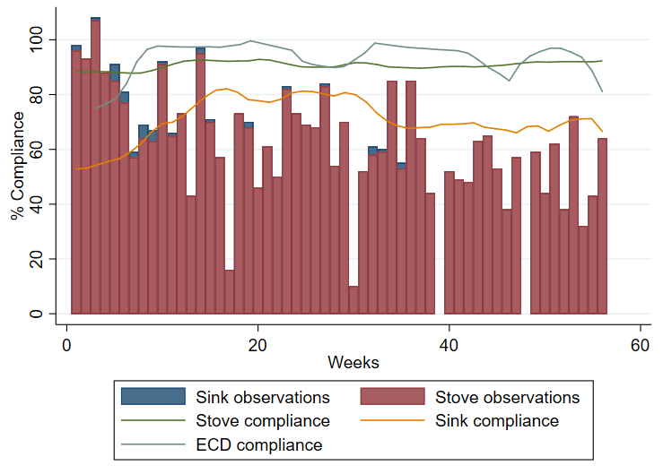

Figure S4.2 represents sink compliance from the arm using the home-hygiene intervention and rainfall levels (litres/m²) in three study districts (D1–D3) during trial´s follow-up. Information was extracted from the public records of the National Service of Meteorology and Hydrology of Peru. In the three districts analysed, levels of sink use followed the same pattern.
Figure S4.2. Association between rainfall and sink use during follow-up
