Impact of the national Hepatitis B immunization program in China: a modeling study
Appendix
Contents
- Terminology Definitions
  - Chronic hepatitis B virus infection (Chronic HBV infection)
  - Chronic hepatitis B (CHB)
- Model Description
2.1 Model Conceptions
    - Natural History of HBV Infection
  - Mathematical Model
    - Mathematical Model Framework
    - Parameter Settings and Initial States
    - Differential Equations
    - Parameter Estimation and Model Fitting
    - Derivation and Calculation of Reproductive Number (R_{e})
    - Sensitivity Analysis
  - Decision Tree-Markov Model
    - Decision Tree-Markov Model Framework
    - Force of Infection
- Results of Mathematical Model
  - Mathematical Model Fits
  - Calculation of Reproductive Number (R_{e})
  - Potential immunization strategies
  - Sensitivity Analysis
SUPPLEMENTARY TABLES
Table S1: Critical parameters of HBV mathematical model
Table S2: Parameters of decision tree-Markov model
Table S3: Time-varied data of birth, death and vaccination rates
SUPPLEMENTARY FIGURES
Fig S1: Transmission structure of the HBV mathematical model.
Fig S2: HBV infection and progression structure of Markov model
Fig S3: Process of acute HBV infection
Fig S4: Dynamic model fitting and prediction results. The blue points represent the observed incidence data, while the black cross represents the incidence data fitted by the model. Red triangles represent the predicted incidence data.
Fig S5: Exploration of feasible vaccination interventions on hepatitis B. A: the impact of varied coverage rates of antiviral treatment in childbearing-age patients with chronic HBV infection and non-infant vaccination rates on the total chronic HBV infections; B: the impact of varied coverage rates of antiviral treatment in childbearing-age patients with chronic HBV infection and non-infant vaccination rate on the MTCT cases; C: the impact of varied coverage rates of antiviral treatment in childbearing-age patients with chronic HBV infection and non-infant vaccination rates on the chronic HBV infections under five years old; D: the impact of varied coverage rates of antiviral treatment in childbearing-age patients with chronic HBV infection and non-infant vaccination rates on the number of people who avoided HBV infection. MTCT: mother-to-child transmission.
Fig S6: Sensitivity analysis of parameters and R_{e}. Estimated impacts of parameters on the R_{e}, with varied ranges based on sensitivity analysis. A, B, C, D show the parameters (β₂, β₃, D_{c}, e₂, θ, ω₂) range below to above of their setting values, respectively.
Fig S7: Sensitivity analysis results of parameters. Estimated impacts of parameters on the number of chronic HBV infections (I_{c}+I_{u}+I_{d}), with varied ranges based on sensitivity analysis. A, B, C, D show the four parameters (β₂, β₃, D_{c}, e₂) range below to above of their setting values, respectively.
Fig S8: Results of Probabilistic Sensitivity Analysis
Incremental Cost-Effectiveness among the PMTCT strategy vs. Infant vaccination strategy (conducted in “Status quo” scenario).

- Terminology Definitions
1.1 Chronic hepatitis B virus infection (Chronic HBV infection) is defined as a dynamic process with HBsAg and/or HBV DNA positivity for more than 6 months, reflecting the interaction between HBV replication and the host immune response.
1.2 Chronic hepatitis B (CHB) is defined as a chronic inflammatory disease of the liver caused by persistent HBV infection.
Noted, not all patients with chronic HBV infection can be defined as chronic hepatitis B (CHB), only the portion of chronic HBV infections who were accompanied with chronic inflammatory liver disease can be classified to this category. Thus, CHB cases are belong to a part of chronic HBV infections; and the total number of chronic HBV infections is defined as the sum of chronic HBV infections without chronic inflammatory liver disease and CHB cases.
- Model Description
As described in the main text, after completing the estimation of the epidemic burden of chronic HBV infections in China, this study further evaluated the achievement of the 2030 goal by predicting the real-time total number of chronic HBV infections and then completed the impact evaluation of immunization strategies. Finally, cost-benefit and cost-effectiveness analysis were used to evaluate the effectiveness of immunization strategies from the perspective of economics.
2.1 Mathematical Conceptions
2.1.1 Natural History of HBV Infection
The model framework is based on this natural historical course of HBV infection: once HBV infection is established in a host, the clinical illness may take one of two possible courses[1]: acute infection or chronic infection. The average duration of an acute HBV infection is usually 3 months. Therefore, if an acute HBV infectious individual doesn’t self-clear HBV or if the duration exceeds 6 months, they will enter the chronic infection stage. Not all chronic HBV infection can be diagnosed as chronic hepatitis B (CHB). Chronic HBV infection can be defined as being HBsAg and/or HBV DNA positive for at least 6 months, while CHB is a chronic inflammatory disease of the liver caused by persistent HBV infection[2]. In a person with chronic HBV infection, the liver is constantly exposed to virus, and the condition may progress to liver cirrhosis. If cirrhosis has not been treated in time, patients may develop complications of cirrhosis such as edema, jaundice and ascites (called decompensation). A few individuals with chronic HBV infection individual can gain immunity shifting to an immune state.
2.2 Mathematical Model
2.2.1 Mathematical Model Framework
In this study, the whole population was divided into nine compartments to represent each stage of hepatitis B based on the characteristics of transmission, natural history and literature. In addition, due to omitted report of HBV infections and lack of standardized diagnostic criteria in the 1990s, the number of reported infections is substantially smaller than the realistic infections. Therefore, it’s crucial to divided CHB compartment into ascertained CHB (the CHB cases were caught and reported by the National Notifiable Disease Report System (NNDRS) and unascertained CHB (the CHB cases that were omitted and failed to report by the NNDRS) compartment for interpreting transmission dynamics and epidemic of HBV infections. Specifically, we described the dynamic progress of hepatitis B by extending the susceptible-exposed-infectious-recovered (SEIR) model to include age-varied acute infectious (A_{i}) (Given to differences in the risk of progression to chronic disease among acute infectious individuals at different age ranges), chronic HBV infection (I^{c}), unascertained CHB (I^{u}) and ascertained CHB (I^{d}), generating a mathematical model to estimate the burden and epidemic trend of hepatitis B during the past 30 years. The model framework is shown in Fig S1.
2.2.2 Parameter Settings and Initial States
We obtained critical parameters for our model through research literature and government reports. Parameter settings for the analysis are summarized in S1 Table. Based on the sero-epidemiological survey
of hepatitis B conducted in 1992, the total number of chronic HBV infection Ic(0), unascertained CHB Iu(0) and ascertained CHB Id(0) were estimated as the prevalence data on hepatitis B surface antigen (HBsAg) multiplied by the total population size, the number of recovery cases R(0) was estimated as the prevalence data of hepatitis B core antibody (Anti-HBc) multiplied by the total population size. Further, the initial acute HBV infections A<1 years old (0), A1-5 years old (0) and A>5 years old (0) was estimated by use corresponding data from the institute for health metrics and evaluation (IHME). The detailed model is described by a set of differential equations showed in Appendix p5. Furthermore, the parameter “θ” was set to assume coverage rate of antiviral treatment among childbearing-age patients with chronic HBV infection (as a part of PMTCT strategies); the baseline of chronic HBV infection in women of gestational age in the general population (parameter b) was quantified by calculating the proportion of women of gestational age with chronic HBV infection in the general population of women in the same age group; then we obtained P_{A} = (1-θ)×b, which reflect the impact of antiviral treatment among childbearing-age patients with chronic HBV infection on the containment of mother-to-child transmission. Therefore, this parameter will decrease with the expansion of standard treatment for women of childbearing age and vice versa.
2.2.3 Differential equations
$$\frac{dS}{dt}=μω_{1}\left[N−P_{A}\left(I^{c}+I^{u}\right)\right]+μ{(1−e}_{1})\left(1−ω_{1}\right)\left[N−θ\left(I^{c}+I^{u}\right)\right]−\frac{\left[β_{1}\left(A_{1}+A_{2}+A_{3}\right)+{β_{2}I}^{c}+β_{3}I^{u}\right]S}{N}−e_{3}p(t)S+φS−kS$$
$$\frac{dE}{dt}=\frac{\left[β_{1}\left(A_{1}+A_{2}+A_{3}\right)+{β_{2}I}^{c}+β_{3}I^{u}\right]S}{N}−D_{e}E$$
$$\frac{dA_{<1 years old}}{dt}=ρ_{1}D_{e}E−{D_{a}A}_{1}$$
$$\frac{dA_{1−5 years old}}{dt}=ρ_{2}D_{e}E−{D_{a}A}_{2}$$
$$\frac{dA_{>5 years old}}{dt}=\left(1−ρ_{1}−ρ_{2}\right)D_{e}E−{D_{a}A}_{3}$$
$$\frac{dI^{c}}{dt}=q_{i}D_{a}A_{i}+μω_{2}P_{A}I^{c}+μ\left({1−e}_{2}\right)\left(1−ω_{2}\right)P_{A}I^{c}+γ_{1}\left(I^{u}+I^{d}\right)−{D_{c}I}^{c}−kI^{c}−γ_{c}I^{c},(i=1,2,3)$$
$$\frac{dI^{u}}{dt}=\left(1−r_{\left(t\right)}\right)D_{c}I^{c}+μω_{2}P_{A}I^{u}+μ\left({1−e}_{2}\right)\left(1−ω_{2}\right)P_{A}I^{u}−{γ_{1}I^{u}−γ}_{2}I^{u}−kI^{u}−γ_{d}I^{u}−γ_{u}I^{u}$$
$$\frac{dI^{d}}{dt}=r_{\left(t\right)}D_{c}I^{c}−γ_{1}I^{d}−γ_{2}I^{d}−kI^{d}$$
$$\frac{dR}{dt}=μe_{1}\left(1−ω_{1}\right)\left[N−P_{A}\left(I^{c}+I^{u}\right)\right]+μe_{2}\left(1−ω_{2}\right)P_{A}\left(I^{c}+I^{u}\right)+e_{3}p(t)S+\left(1−q_{i}\right)D_{a}A_{i}+γ_{2}(I^{d}+I^{u})−φS−kR$$
2.2.4 Parameter Estimation and Model Fitting
The yearly reported CHB data (a portion of the total number of HBV cases) from 1990 to 2018 are used to estimate β₁, β₂, and β₃, among which represent the transmission rates for age varied acute infectious individuals, chronic infectious individuals, unascertained and ascertained CHB individuals, respectively. These parameters were estimated by minimizing the sum of squares (MSS); the whole fitting process was completed within the Fminsearch function package of the MATLAB R2019a tool, which is used to perform unconstrained nonlinear minimization to obtain all optimal parameters when the results of Fminsearch converged.
$MSS=sqrt(\sum{\left[I^{d}(i)−x(i)\right]}$²
Where I^{d}(i) indicates the fitted CHB data in year i; x(i) indicates the observed CHB data in year i. In addition, i represents the year i corresponding to the observed data of CHB. Furthermore, in order to test the goodness of fit between the estimated incidence data and the reported incidence data, a two-sample t-test was performed on the two groups of data. Null hypothesis (H₀): The modeled incidence data (I^{d}) is equal to the observed incidence data. Alternative hypothesis (H₁): The modeled incidence data (I^{d}) is not equal to the observed incidence data.
2.2.5 Derivation and Calculation of Reproductive Number (R_{e})
Effective Reproductive number (R_{e}) is defined as the number of second-generation infectious cases caused by an infected individual in a susceptible population. It’s also a threshold indicator to measure the ability of HBV to invade a population and to determine the disease-free equilibrium (DFE). Based on the differential equations of the Hepatitis B dynamics model, the matrix expression of R_{e} was derived. If R_{e} < 1, it means that an infected individual has produced less than one new infection during his or her infection period, and the hepatitis B epidemic cannot increase. On the contrary, if R_{e} >1, each infected individual will produce more than one newly infected individual on average, and the disease will continue to exist and develop into a endemic epidemic or even an outbreak. Therefore, the calculation of this index plays an important role in judging the effect of the immunization strategy on the control of hepatitis B epidemic.
Considering that the dynamics model of hepatitis B is not a simple linear chain model in this study, the Next Generation Matrix method is adopted. The method was established in 1990 by Diekmann et al.[3], and it’s a general method for calculating reproductive number in any complex compartment model[4]. The method consists of the following steps:
(1) Based on the differential equations of hepatitis B dynamics model, identify all infectious compartments M;
(2) An M×1 matrix f was constructed based on the differential equations of all infectious compartments, including the expression of new infections caused by each infectious compartment and entering it. This matrix represents the occurrence rate of new infections in susceptible population.
(3) An M×1 matrix ν⁺ was constructed based on the differential equations of all infectious compartments, including the incremental expression of non-newly infectious cases entering each infectious compartment;
(4) An M×1 matrix ν⁻ was constructed based on the differential equations of all infectious compartments, including the expression of the loss amount of non-newly infectious cases entering each infectious compartment;
(5) By combining steps (3) and (4), an M×1 matrix ν was constructed, ν = ν⁻- ν⁺, which represented the progression rates of non-newly infected quantities in the corresponding infectious compartments.
(6) Calculate the Jacobian matrix for the matrix f and ν in step (2) and step (5) respectively, and get two m×m new matrix F and V, which represent the partial derivatives of matrix f and matrix ν with respect to m infectious state variables respectively;
(7) To obtain the inverse matrix V⁻¹ of the matrix V;
(8) Solve the maximum eigenvalue of the spectral radius of the product of matrix F and V⁻¹ to get the value of R_{e}.
The calculation process was completed by Wolfram Mathematica (version 12.0) and MATLAB software (version R2019a).
2.2.6 Sensitivity Analysis
Sensitivity analysis was performed by changing the main parameters. According to the formula of basic reproductive number, we found out the relevant parameters that will affect R_{e}. In order to further explore the relationship between R_{e} and these parameters, we conducted sensitivity analysis to measured and quantified the impact of these parameters (p, θ, β₂, β₃, D_{c} and e₂) on the number of chronic HBV infections and R_{e}. In the analysis, the transmission rate of chronic HBV infections (β₂) is set as 0.031-0.60; the transmission rate of CHB cases (β₃) of 0.41-0.021. The rate of chronic HBV infections becoming CHB (D_{c}) was 0.1-0.0025. The efficacy of timely birth-dose HBV vaccine (e₂) on mother-to-child transmission of 70–99% (the second value is the default value used in the model). The vaccination coverage of non-newborn (p) varied from 30-80% since 2018 (the first value is the default value used in the model). The theta (θ) value varied from 18%-72% since 2018 (the second value is the default value used in the model. The ranges of these parameters were set to quantify the capacity of immunization strategies that could be improved in the future. All the above analyses were performed by MATLAB software (version number: R2019a).
2.3 Decision Tree-Markov Model
2.3.1 Decision Tree-Markov Model Framework
The Markov part of the model was used to simulate HBV infection and progression. It was mainly constructed based on "China's Diagnostic criteria for hepatitis B virus (ws299-2008)", "Diagnostic criteria for chronic hepatitis B (2015)" and relevant literature at home and abroad. This section includes a total of eight Markov states: susceptible to HBV; recovery due to infection or vaccination; chronic HBV infection; chronic hepatitis (CHB); compensated cirrhosis; decompensated cirrhosis; hepatocellular carcinoma; and death. The relationships between them are shown in Fig S2. In addition, "acute infection" was not a Markov state in this model, which was a short process in the " susceptible to HBV " state. The process of acute HBV infection was shown in Fig S3.
2.3.2 Force of Infection
Formula 1:$P\left(a\right)=k(1−e^{(\frac{b_{2}}{b_{3}}\left(1−e^{b_{3}a}−b_{1}a\right))}$
Formula 2:$λ\left(a\right)=b_{1}+b_{2}×e^{（b_{3}a）} (b_{1 }>0,b_{2}>0,b_{3}<0)$
Formula 3:$λ\left(a\right)=0.034435+0.49448×e^{（−0.729443×age）}$
Because the incomplete data on the incidence of acute hepatitis B reported in China, this study estimated the annual incidence of HBV infection in susceptible populations of different age groups based on the data from the national sero-epidemiological. As the sero-epidemiological survey in 1992 was performed just before the recommendation of routine hepatitis B vaccination for newborns was announced, its data could characterize natural HBV infections without vaccination. The catalytic model was used to fit the national data, and the best fitting was the age-dependent exponential equation as shown above. Formula 1 and 2 are the original catalytic models used to fit the national data. Formula 3 is the fitting result. P(a) is the prevalence of HBV infection in the population at age a. A person with a positive test result for HBV surface antigen (HBsAg), core antibody (anti-HBc) or surface antibody (anti-HBs) was defined as one who had been infected by HBV. λ(a), as a function of age, denotes the age-dependent force of HBV infection.
3. Results of Mathematical Model
3.1 Mathematical Model Fits
The fitting result of estimated incidence data through modeling is basically consistent with the observed data reported by the NNDRS, as shown in Fig S4. The result of two-sample t-test shows the p value is 0.985 which is greater than 0.05; therefore, we can’t reject the null hypothesis (H₀) at the 5% significant level. The modeled result is a good estimate of the observed data.
3.2 Calculation of Reproductive Number (R_{e})
- It can be seen from the model equations that there are 6 infectious compartments in this model, which are E, A_{<1 years old}, A_{1-5 years old}, A_{>5 years old}, I^{c} and I^{u} respectively. Thus, two 6×1 matrices f, ν⁺ and ν⁻ are obtained, as shown below:
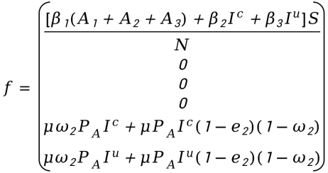
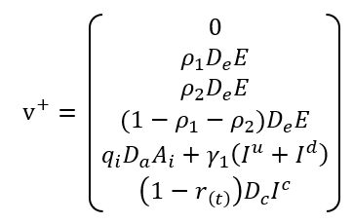
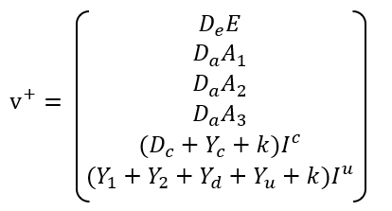
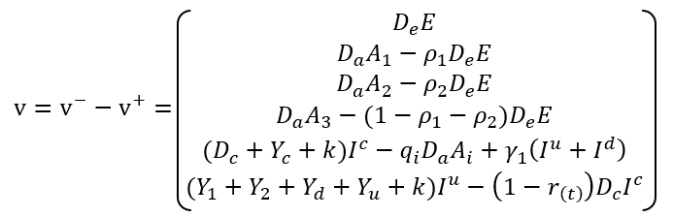
- Matrix f represents the rate of new infections resulting from horizontal transmission and mother-to-child transmission. In addition, the matrix ν is calculated from the matrix ν⁺ which represents the increment rate of entering each infectious compartment and the matrix ν⁻ which represents the loss rate of moving out of each infectious compartment. The detailed process is shown as follows:
- Calculate the Jacobian matrix of matrix f and ν respectively, that is, calculate the partial derivatives of matrix f and matrix ν with respect to the above six infectious state variables respectively, and get two new matrices F and V of 6×6, the results are as follows:
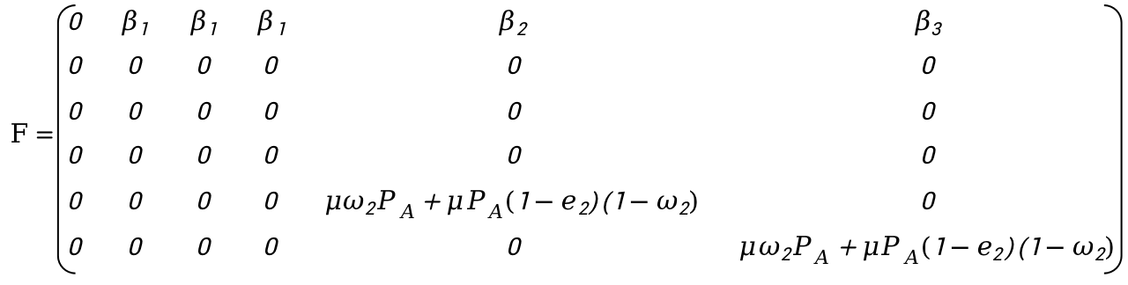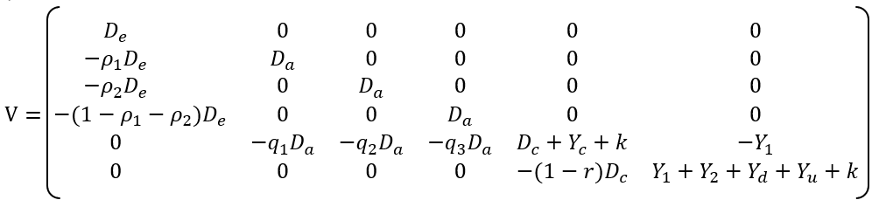
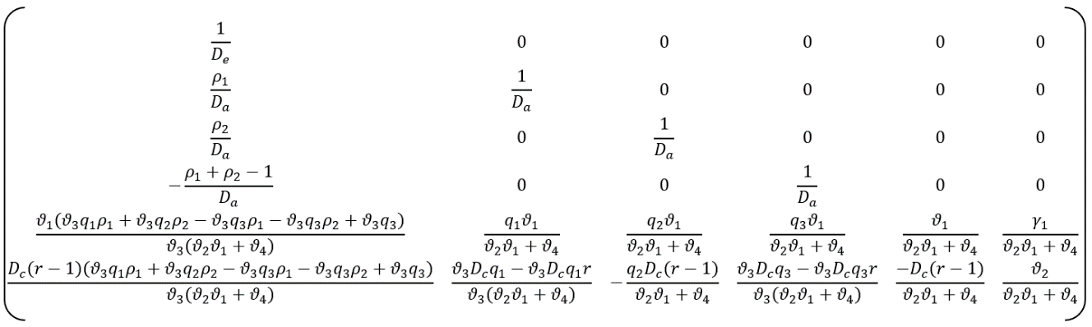
- We obtained its inverse matrix V⁻¹ base on the matrix V. To simplify the expression of result, let $ϑ_{1}=Y_{1}+Y_{2}+Y_{d}+Y_{u}+k,ϑ_{2}=D_{c}+Y_{c}+k, ϑ_{3}= D_{a}^{3}D_{e}, ϑ_{4}=D_{c}\left(r−1\right)Y_{1}$, the matrix V-1 of be as follows:
In conclusion, $R_{e}=ρ\left(FV^{−1}\right)=max\left|λ_{i}\right|, when\left|λ_{i}\left(FV^{−1}\right)−E\right|=0.353.$
3.3 Potential immunization strategies
At present, both the infant coverage rate and the timely birth-dose vaccination rate in China have nearly reached the level of 100%. However, due to the high burden of chronic HBV infection in China, feasible immunization strategies should be further explored on the basis of maintaining the high coverage rates. In China, hepatitis B vaccine is recommended, but not mandatory, for non-infants. In our model, we simulated that in the range of coverage rate for non-infants (40%-80%), the total number of chronic HBV infections only declined with 12,967-1,444 (Fig S5-A); the results exhibited that the greater input in non-infant vaccination, the lower the decrease in chronic HBV infections. It’s shown that the strategy has no significant effect on any of the four outcome indicators in Fig S5. With each 18% increase in the parameter θ (representing an increase of magnitude of enhancing PMTCT strategy), it will decline with 17,1648 chronic HBV infections; the number of chronic HBV infections that less than 5 years old only has extra decrease of 23,952 chronic HBV infections. The average increase in the number of individuals who could avoid infection with HBV was as high as 2.08 million (Fig S5). In addition, the results of sensitivity analysis are shown in Fig S6-S7.
3.4 Sensitivity Analysis
This study was more intuitively understood the impact of the parameters on R_{e} and the uncertainty of the model through sensitivity analysis. Based on the derivation process and results of R_{e}, it is found that the main parameters affecting R_{e} are β₂, β₃, D_{C}, E₂, θ and ω₂, respectively. As can be seen from Fig S6, ω₂ is the most sensitive parameter to R_{e}, followed by D_{c}, E₂ and θ, while β₂ and β₃ are less sensitive. On the basis of maintaining the PMTCT efficiency (e₂) as high as 99%, R_{e} decreases with the increase of the timely birth-dose vaccination rate (1-ω₂). When the timely birth-dose vaccination rate is continuously stable at 96% or above (the current situation), R_{e} can be stable at less than 0.5. However, if the timely birth-dose vaccination rate is lower than 70%, R_{e} will exceed 1 (disease-free equilibrium threshold), leading to the outbreak of hepatitis B (Fig S6-C).
In addition, even if on the basis of the timely birth-dose vaccination rate is close to 100% and e₂ is 99%, if the antiviral treatment are not implemented for women of childbearing age, the coverage rate of antiviral treatment among childbearing-age patients with chronic HBV infection in the population (θ) reaches the level of the scenario “Without the NIP”, and the R_{e} increases to 1.5 ~ 2.5. The timely birth-dose vaccination rate can be appropriately reduced only under the premise that the infectious proportion of childbearing-age women in the infectious population is reduced to the same as that of childbearing-age women in the general population and the PMTCT strategy (timely birth-dose vaccination + immunoglobulin vaccination + antiviral treatment of among childbearing-age patients with chronic HBV infection) is fully implemented (Fig S6-A).
Compared with the effect of immunization strategy, if the progression rate from chronic HBV infections to CHB stage can be slowed down (e.g., developing more effective antiviral drugs) to prolong the carrying status of chronic HBV infectious (reduced D_{c}), it will play a great role in prevent and control the hepatitis B epidemic, despite of there is a large number of chronic HBV infections in the population (Fig S6-B). As can be seen from Fig S6-D, β₂ and β₃ have little effect on R_{e}.
The dynamic model was then used to explore the effects of the changes of β₂, β₃, D_{c} and e₂ on the number of real-time chronic HBV infections (I^{c} + I^{u} + I^{d}) in a certain interval above and below the set baseline values(Fig S7). Note: sensitivity analysis of these parameters is not considered because natural birth and death rates vary relatively steady in reality, and the progression rates of the natural course are more closely related to the disease itself. The effect of parameter θ variation on the total number of real-time chronic HBV infections within a defined interval has been described in Results of manuscript.
The analysis results showed that the progression rate (D_{c}) from chronic HBV carriers to CHB infection was the most sensitive. When the baseline level increased to 0.05 and 0.1, chronic HBV infections decreased by 13.76 million and 27.38 million cases, respectively. When baseline levels dropped to 0.0025, chronic HBV infections increased by a maximum of 25.96 million, respectively. Second sensitive parameter is maternal and child block the efficient (e₂), sensitivity analysis shows that if only the implementation of timely birth-dose vaccination strategies and without timely vaccination immunoglobulin (the effective rate of PMTCT strategy was 87.8%), it will achieve maximum growth of 4.86 million cases of chronic HBV infections; and continue to reduce to 70% of efficiency, it will cause a much more cases, about 11.7 million cases.
In addition, it’s known from the calculation principle that the influence factors of β₂ and β₃ may be the population contact matrix and the infectivity of HBV itself, so these parameters generally don’t fluctuate over a wide range of areas. Sensitivity analysis found that β₂ had a greater effect on the number of chronic HBV infections than β₃, with an average increase of 3.81 million and 770 million chronic HBV infections when the baseline levels of the two parameters were increased by 10 times, respectively.
Sensitivity analysis of the two parts has drawn relatively consistent conclusions.

Table S1. Critical parameters of HBV mathematical model
Parameter | Description | Value | Source
μ(t) | Birth rate in year t | See Table S3 | National Bureau of Statistics
k(t) | Death rate in year t | See Table S3 | National Bureau of Statistics
ω₁ | 1- (infant vaccination coverage in year t) | See Table S3 | [5, 6]
ω₂ | 1- (timely birth-dose vaccination coverage in year t) | See Table S3 | [5, 6]
b | The proportion of women HBV infections (15-49 years) in chronic HBV infections/the proportion of women individuals (15-49 years) in general population | 2.2  (Calculated based on survey data in 1992) | [7]
θ | The coverage rate of antiviral treatment among childbearing-age patients with chronic HBV infection | 0%-72% | Assumed
β₁ | Transmission coefficient of the total acute infections | 0.026 | Least square method
β₂ | Transmission coefficient of chronic HBV infections | 0.030 | Least square method
β₃ | Transmission coefficient of chronic hepatitis B | 0.021 | Least square method
h | Latent period | 6 | [8]
s | Duration of acute infectious period | 4 | [8]
p | Vaccination coverage rate of non-infant individuals | 0-0.3 | Assumed
$$ρ_{1}$$ | The proportion of acute infections under 1 year of age | 0.005 | GBD[9]
$$ρ_{2}$$ | The proportion of acute infections under 1-5 year of age | 0.02 | GBD[9]
q₁ | Proportion of acute HBV infections (< 1 years) become chronic infectiousness | 0.9 | [10]
q₂ | Proportion of acute HBV infections (1-5 years) become chronic infectiousness | 0.275 | [10]
q₃ | Proportion of acute HBV infections (>5 years) become chronic infectiousness | 0.075 | [10]
$$φ$$ | Loss rate of HBV vaccine effectiveness | 0.05 | Guidelines for the prevention and treatment of chronic hepatitis B (2015 edition)
D_{c} | Rate of chronic HBV infections becoming CHB | 0.025 | Assumed
γ₁ | Rate of CHB becoming chronic HBV infections | 0.00608 | [11]
γ₂ | Recovery rate of CHB | 0.025 | [8]
γ₃ | Rate of CC becoming HCC | 0.03 | Guidelines for the prevention and treatment of chronic hepatitis B (2015 edition)
γ_{c} | Rate of chronic HBV infections becoming HCC | 0.005 | [12]
γ_{u} | Rate of transition from CHB becoming HCC | 0.004 | Guidelines for the prevention and treatment of chronic hepatitis B (2015 edition)
e₁ | Efficacy of infant vaccination | 0.90 | [13]
e₂ | Efficacy of timely birth-dose vaccination | 0.878-0.990 | [13]
e₃ | Efficacy of HBV vaccination in non-infant | 0.70 | [13]

Table S2. Parameters of decision tree-Markov model
Parameter | Value | Range
Outcome probabilities of acute infection
Symptomatic[11, 14]
<1 year | 0.01 | ±50%
1-10 years | 0.1
≥11 years | 0.3
Symptomatic infections that require hospitalization[15] | 0.12 | 0.01-0.5
Hospitalized cases that are fulminant[16] | 0.04 | 0.01-0.1
Fulminant cases that result in death[15] | 0.65 | 0.4-0.8
Acute infections that become chronic[17]
<1 year | 0.3 | ±50%
1-5 years | 0.25
6-19 years | 0.06
≥20 years | 0.04
Annual transition probabilities related to chronic infection
Asymptomatic carrier
To immune[18] | 0.012 | ±50%
To chronic hepatitis[19]
0-19 years | 0.0012
20-39 years | 0.0023
≥40 years | 0.0054
To hepatocellular carcinoma[19]
0-19 years | 0.0005 | ±50%
20-39 years | 0.002
≥40 years | 0.0061
Chronic hepatitis
To Asymptomatic carrier[20] | 0.00608 | 0-0.05
To compensated cirrhosis[17]
0-19 years | 0.0081 | ±50%
20-39 years | 0.02
≥40 years | 0.027
To hepatocellular carcinoma[21]
0-19 years | 0.003 | ±50%
20-39 years | 0.005
≥40 years | 0.0064
Compensated cirrhosis
To Decompensated cirrhosis[22] | 0.07 | 0.03-0.1
To hepatocellular carcinoma[22] | 0.034 | 0.01-0.1
Decompensated cirrhosis
To hepatocellular carcinoma[22] | 0.034 | 0.01-0.1
To death[22] | 0.144 | 0.1-0.25
Hepatocellular carcinoma
To death[22] | 0.5 | 0.3-0.7
HBsAg screening | 0.965 | 0.8-0.974
HBsAg positive women | 0.069 | 0.061-0.077
HBIG coverage | 0.888 | 0.85-0.974
Costs[23]
Acute infection in hospital | 2438.84 | ±50%
Acute infection not in hospital | 118.51
Chronic infection | 3395.14
Compensated cirrhosis | 5359.84
Decompensated cirrhosis | 6956.43
Hepatocellular carcinoma | 11128.66
HBV vaccine | 3.18 | 16-25
HBIG | 22.99 | 145-176
Screening | 1.21 | 6-10
Utility scores[22, 24]
Acute symptomatic infection
Not fulminant | 0.9 | 0.8-1
Fulminant | 0.73 | 0.5-0.8
Chronic hepatitis | 0.789 | 0.7-1
Compensated cirrhosis | 0.763 | 0.7-0.9
Decompensated cirrhosis | 0.661 | 0.5-0.8
Hepatocellular carcinoma | 0.699 | 0.5-0.8
Discount rate | 0.03 | 0-0.05

Note: All costs were adjusted with respect to the cost of dollar according to the exchange rate in 2018.

Table S3. Time-varied data of birth, death and vaccination rates
Year | Infant vaccination rate | Timely birth-dose vaccination rate | Birth rate | Death rate
1990 | 0 | 0 | 0.02106 | 0.00667
1991 | 0 | 0 | 0.01968 | 0.00670
1992 | 0.300 | 0.222 | 0.01824 | 0.00664
1993 | 0.343 | 0.237 | 0.01809 | 0.00664
1994 | 0.381 | 0.225 | 0.01770 | 0.00649
1995 | 0.397 | 0.271 | 0.01712 | 0.00657
1996 | 0.452 | 0.282 | 0.01698 | 0.00656
1997 | 0.559 | 0.394 | 0.01657 | 0.00651
1998 | 0.568 | 0.391 | 0.01603 | 0.00650
1999 | 0.612 | 0.437 | 0.01464 | 0.00646
2000 | 0.766 | 0.541 | 0.01403 | 0.00645
2001 | 0.830 | 0.644 | 0.01338 | 0.00643
2002 | 0.843 | 0.661 | 0.01286 | 0.00641
2003 | 0.877 | 0.689 | 0.01241 | 0.00640
2004 | 0.900 | 0.760 | 0.01229 | 0.00642
2005 | 0.840 | 0.860 | 0.01240 | 0.00651
2006 | 0.910 | 0.880 | 0.01209 | 0.00681
2007 | 0.920 | 0.860 | 0.01210 | 0.00693
2008 | 0.950 | 0.910 | 0.01214 | 0.00706
2009 | 0.991 | 0.930 | 0.01195 | 0.00708
2010 | 0.995 | 0.920 | 0.01190 | 0.00711
2011 | 0.996 | 0.950 | 0.01193 | 0.00714
2012 | 0.997 | 0.960 | 0.01210 | 0.00715
2013 | 0.996 | 0.990 | 0.01208 | 0.00716
2014 | 0.994 | 0.940 | 0.01237 | 0.00716
2015 | 0.996 | 0.960 | 0.01207 | 0.00711
2016 | 0.995 | 0.960 | 0.01295 | 0.00709
2017 | 0.995 | 0.960 | 0.01243 | 0.00711
2018 | 0.995 | 0.960 | 0.01094 | 0.00713

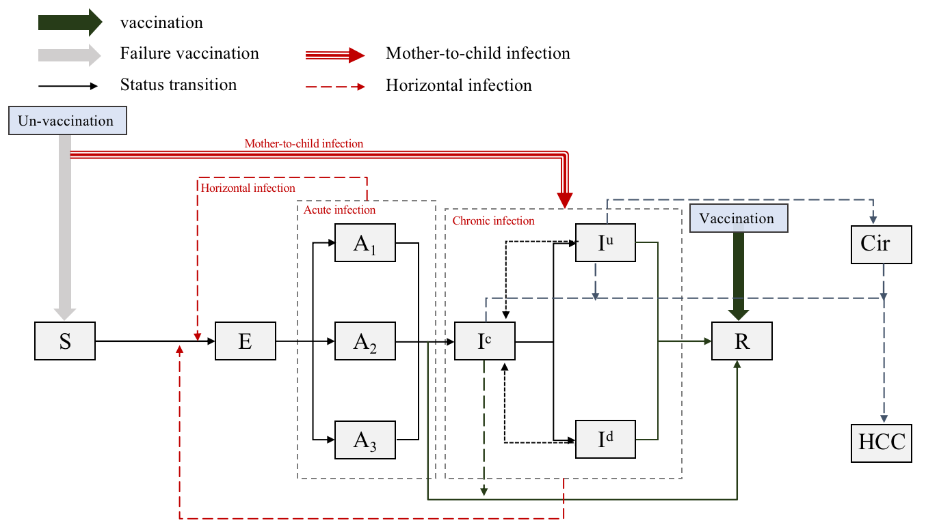
Fig S1. Transmission structure of the HBV mathematical model

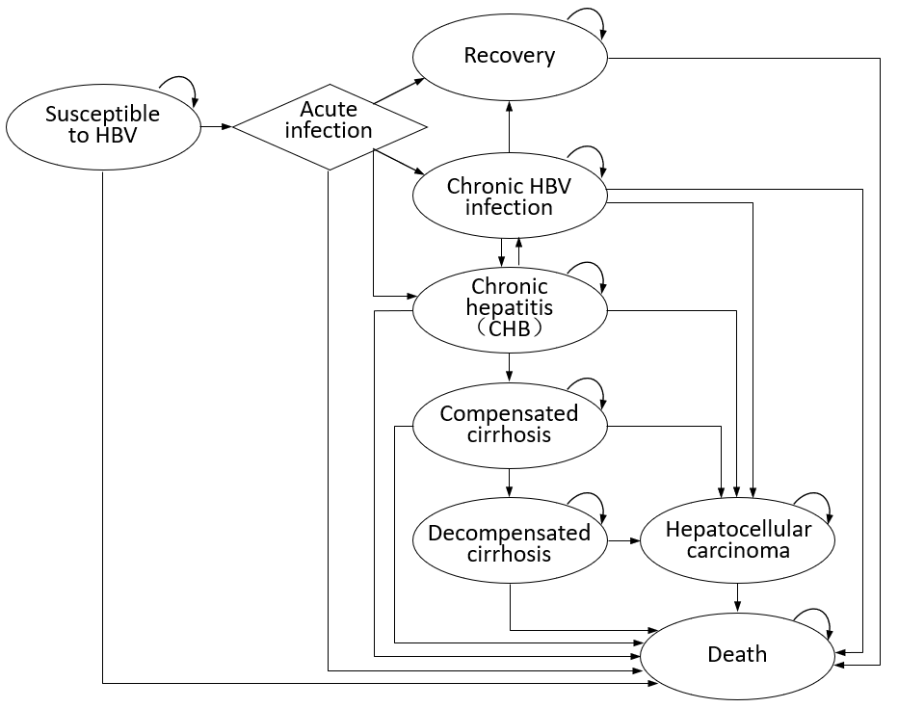
Fig S2. HBV infection and progression structure of Markov model

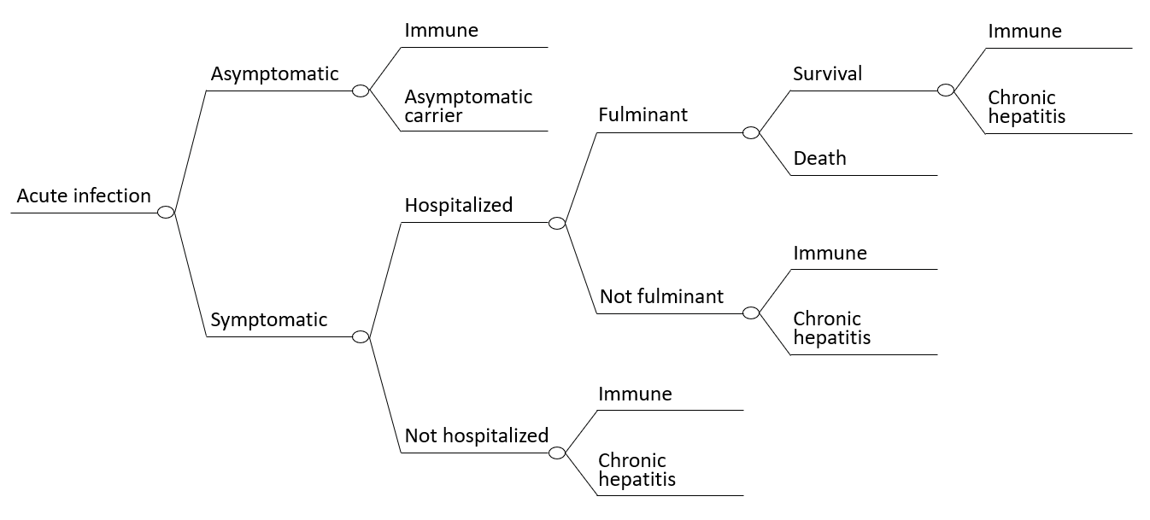
Fig S3. Process of acute HBV infection

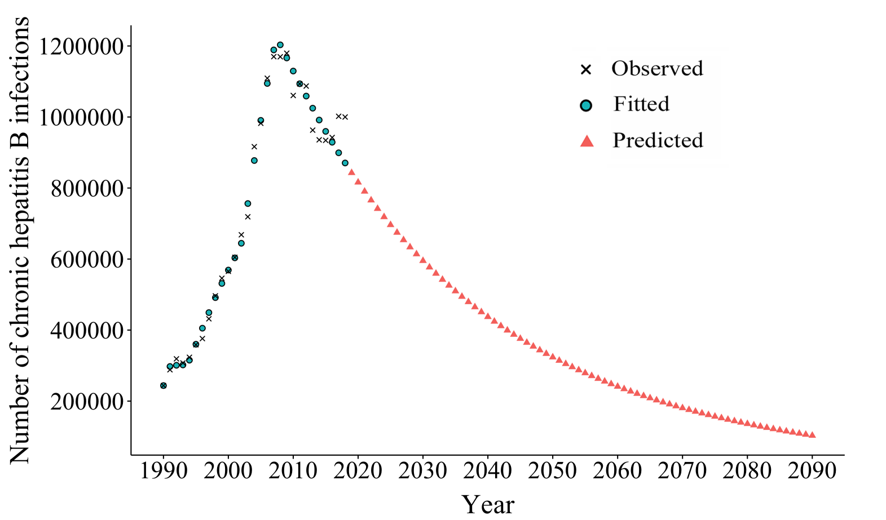
Fig S4. Dynamic model fitting and prediction results
The blue points represent the observed incidence data, while the black cross represents the incidence data fitted by the model. Red triangles represent the predicted incidence data.
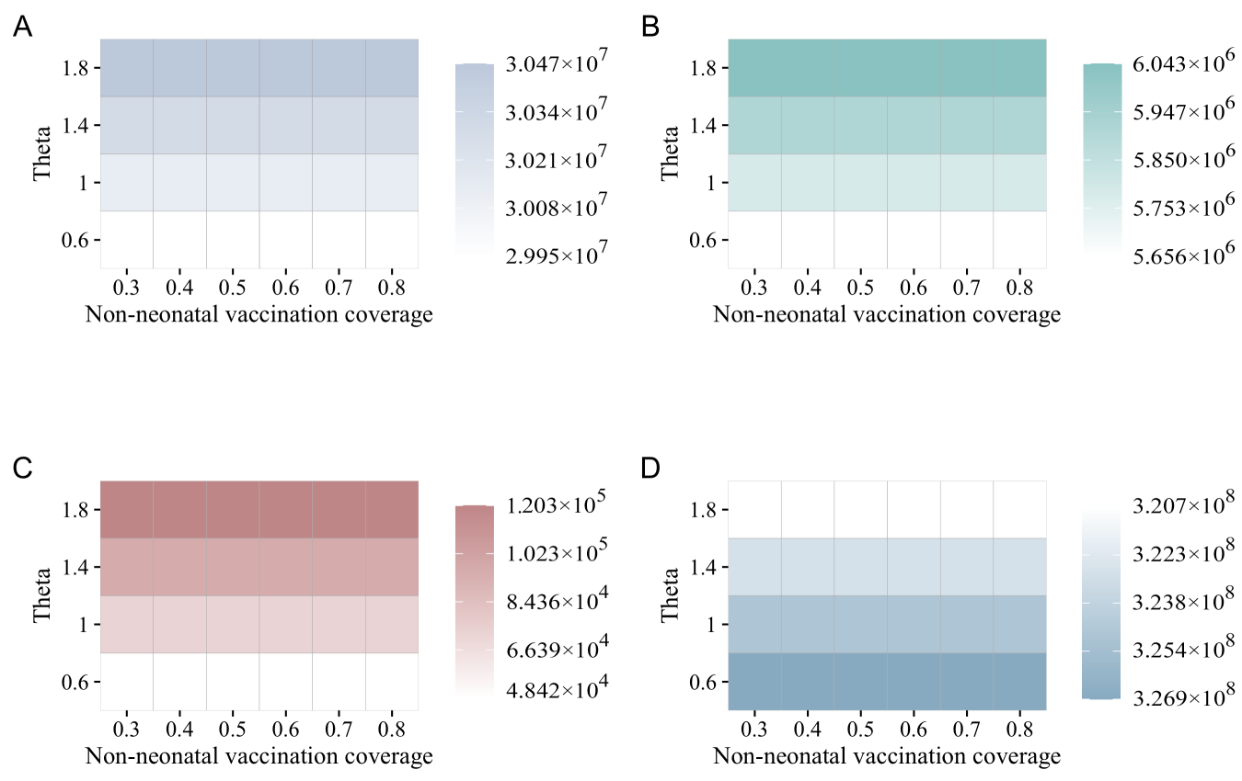
The total number of chronic
infectious cases
The number of MTCT cases
The number of chronic
infectious cases (≤5 years old)
The number of
averted infectious cases

Fig S5. Exploration of feasible vaccination interventions on hepatitis B.
A: the impact of varied coverage rates of antiviral treatment in childbearing-age patients with chronic HBV infection and non-infant vaccination rates on the total chronic HBV infections; B: the impact of varied coverage rates of antiviral treatment in childbearing-age patients with chronic HBV infection and non-infant vaccination rate on the MTCT cases; C: the impact of varied coverage rates of antiviral treatment in childbearing-age patients with chronic HBV infection and non-infant vaccination rates on the chronic HBV infections under five years old; D: the impact of varied coverage rates of antiviral treatment in childbearing-age patients with chronic HBV infection and non-infant vaccination rates on the number of people who avoided HBV infection. MTCT: mother-to-child transmission.

Fig S6. Sensitivity analysis of parameters and R_{e}
Estimated impacts of parameters on the R_{e}, with varied ranges based on sensitivity analysis. A, B, C, D show the parameters (β₂, β₃, D_{c}, e₂, $θ, ω_{2}$) range below to above of their setting values, respectively.

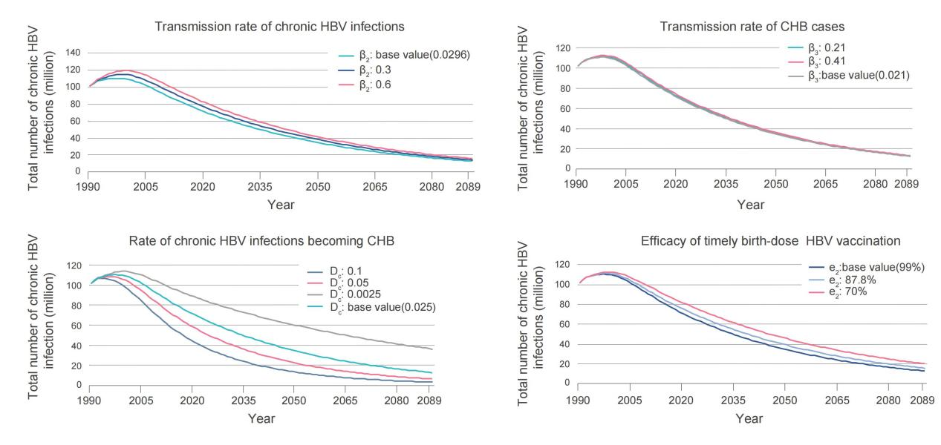
Fig S7. Sensitivity analysis results of parameters
Estimated impacts of parameters on the number of chronic HBV infections (I^{c}+I^{u}+I^{d}), with varied ranges based on sensitivity analysis. A, B, C, D show the four parameters (β₂, β₃, D_{c}, e₂) range below to above of their setting values, respectively.

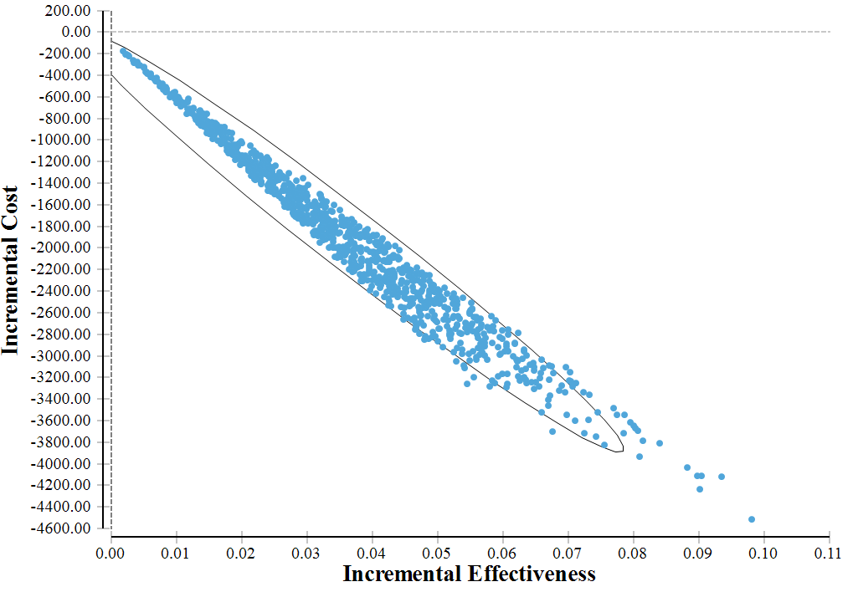
Fig S8. Results of Probabilistic Sensitivity Analysis
Incremental Cost-Effectiveness among the PMTCT vs. Infant vaccination strategy (conducted in “Status quo” scenario).

Reference
1. Edmunds WJ, Medley GF, Nokes DJ, Hall AJ, Whittle HC. The influence of age on the development of the hepatitis B carrier state. Proc Biol Sci. 1993;253(1337):197-201.
2. Trepo C, Chan HLY, Lok A. Hepatitis B virus infection. Lancet (London, England). 2014;384(9959):2053-63.
3. Diekmann O, Heesterbeek JA, Metz JA. On the definition and the computation of the basic reproduction ratio R0 in models for infectious diseases in heterogeneous populations. J Math Biol. 1990;28(4):365-82.
4. van den Driessche P, Watmough J. Reproduction numbers and sub-threshold endemic equilibria for compartmental models of disease transmission. Math Biosci. 2002;180:29-48.
5. WHO. Hepatitis B immunization coverage among 1-year-olds. World Health Organization. 2021.
6. Liang X, Bi S, Yang W, Wang L, Cui G, Cui F, et al. Evaluation of the Impact of Hepatitis B Vaccination among Children Born during 1992–2005 in China. The Journal of Infectious Diseases. 2009;200(1):39-47.
7. Xia G-L, Liu C-B, Cao H-L, Bi S-L, Zhan M-Y, Su C-A, et al. Prevalence of hepatitis B and C virus infections in the general Chinese population. Results from a nationwide cross-sectional seroepidemiologic study of hepatitis A, B, C, D, and E virus infections in China, 1992. International Hepatology Communications. 1996;5(1):62-73.
8. Shepard CW, Simard EP, Finelli L, Fiore AE, Bell BP. Hepatitis B virus infection: epidemiology and vaccination. Epidemiol Rev. 2006;28:112-25.
9. GBD. GBD Results Tool. Global Burden of Disease. 2021.
10. Lai CL, Ratziu V, Yuen MF, Poynard T. Viral hepatitis B. Lancet (London, England). 2003;362(9401):2089-94.
11. Yin J, Ji Z, Liang P, Wu Q, Cui F, Wang F, et al. The doses of 10 μg should replace the doses of 5 μg in newborn hepatitis B vaccination in China: A cost-effectiveness analysis. Vaccine. 2015;33(31):3731-8.
12. Lin X, Robinson NJ, Thursz M, Rosenberg DM, Weild A, Pimenta JM, et al. Chronic hepatitis B virus infection in the Asia-Pacific region and Africa: review of disease progression. J Gastroenterol Hepatol. 2005;20(6):833-43.
13. Xia GL GJ, Wang JJ, Meng ZD, Jia ZY, Cao HL, Liu CB. Efficacy of recombinant hepatitis B vaccine and low—dose hepatitis B immune globulin in preventing mother-infant transmission of hepatitis B virus infection. Chinese Journal of Epidemiology. 2003(05):32-5.
14. Fabrizi F, Martin P. Hepatitis B virus infection in dialysis patients. American journal of nephrology. 2000;20(1):1-11.
15. Trépo C, Chan HL, Lok A. Hepatitis B virus infection. (1474-547X (Electronic)).
16. Gibson E, Begum N, Sigmundsson B, Sackeyfio A, Hackett J, Rajaram S. Economic evaluation of pediatric influenza immunization program compared with other pediatric immunization programs: A systematic review. Human vaccines & immunotherapeutics. 2016;12(5):1202-16.
17. Busch K, Thimme R. Natural history of chronic hepatitis B virus infection. (1432-1831 (Electronic)).
18. Chu CM, Liaw YF. HBsAg seroclearance in asymptomatic carriers of high endemic areas: appreciably high rates during a long-term follow-up. (0270-9139 (Print)).
19. Hung HF, Chen TH. Probabilistic cost-effectiveness analysis of the long-term effect of universal hepatitis B vaccination: an experience from Taiwan with high hepatitis B virus infection and Hepatitis B e Antigen positive prevalence. (1873-2518 (Electronic)).
20. Zheng H, Wang FZ, Zhang GM, Cui FQ, Wu ZH, Miao N, et al. An economic analysis of adult hepatitis B vaccination in China. Vaccine. 2015;33(48):6831-9.
21. Chen YS, Zheng H, Liu YM, Wang FZ, Wu ZH, Miao N, et al. Economic evaluation on infant hepatitis B vaccination combined with immunoglobulin in China, 2013. Human vaccines & immunotherapeutics. 2016;12(7):1838-46.
22. Jia Y, Li L, Cui F, Zhang D, Zhang G, Wang F, et al. Cost-effectiveness analysis of a hepatitis B vaccination catch-up program among children in Shandong Province, China. Human vaccines & immunotherapeutics. 2014;10(10):2983-91.
23. Zhang S, Ma Q, Liang S, Xiao H, Zhuang G, Zou Y, et al. Annual economic burden of hepatitis B virus-related diseases among hospitalized patients in twelve cities in China. (1365-2893 (Electronic)).
24. La Torre G, Mannocci A, Saulle R, Colamesta V, Meggiolaro A, Mipatrini D, et al. Economic evaluation of HBV vaccination: A systematic review of recent publications (2000-2013). Human vaccines & immunotherapeutics. 2016;12(9):2299-311.

