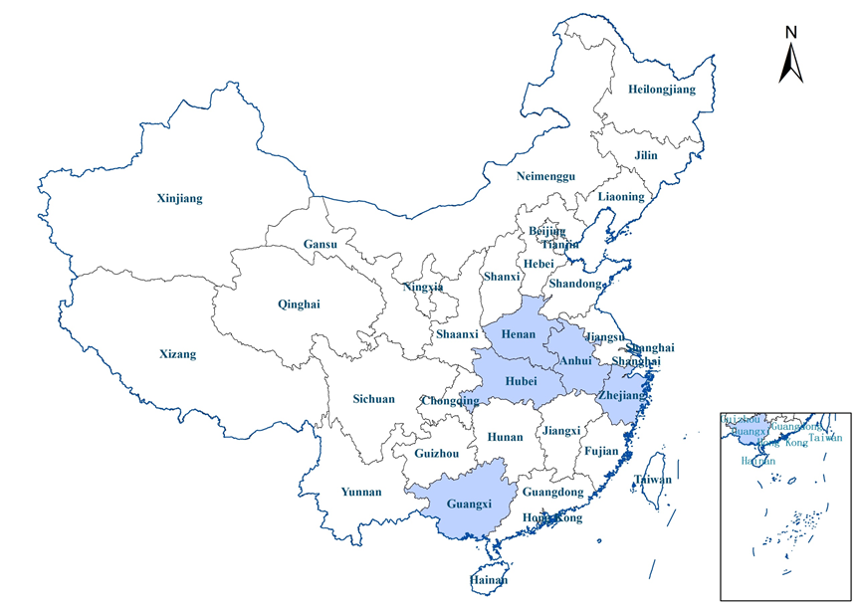
Location of the study area in China.
The thematic map of geographic distribution was compiled using MapInfo 15.0 (Pitney Bowes Inc., Troy, NY, USA).

