Additional 3. OHGI Rankings

3. 1 The mean score distribution of OHGI in 19 indicators

Fig. 3 The mean score distribution of OHGI in 19 indicators

3.2 Global score Map of One Health Governance inedex

Among the 146 countries scored in our index system, the country with the first score is Australia, with a score of 70.28. The average score for all countries was 34.11. The countries with higher overall regional scores are those in Europe and Central Asia, East Asia and the Pacific and North America. Sub Saharan Africa has the lowest overall regional score.
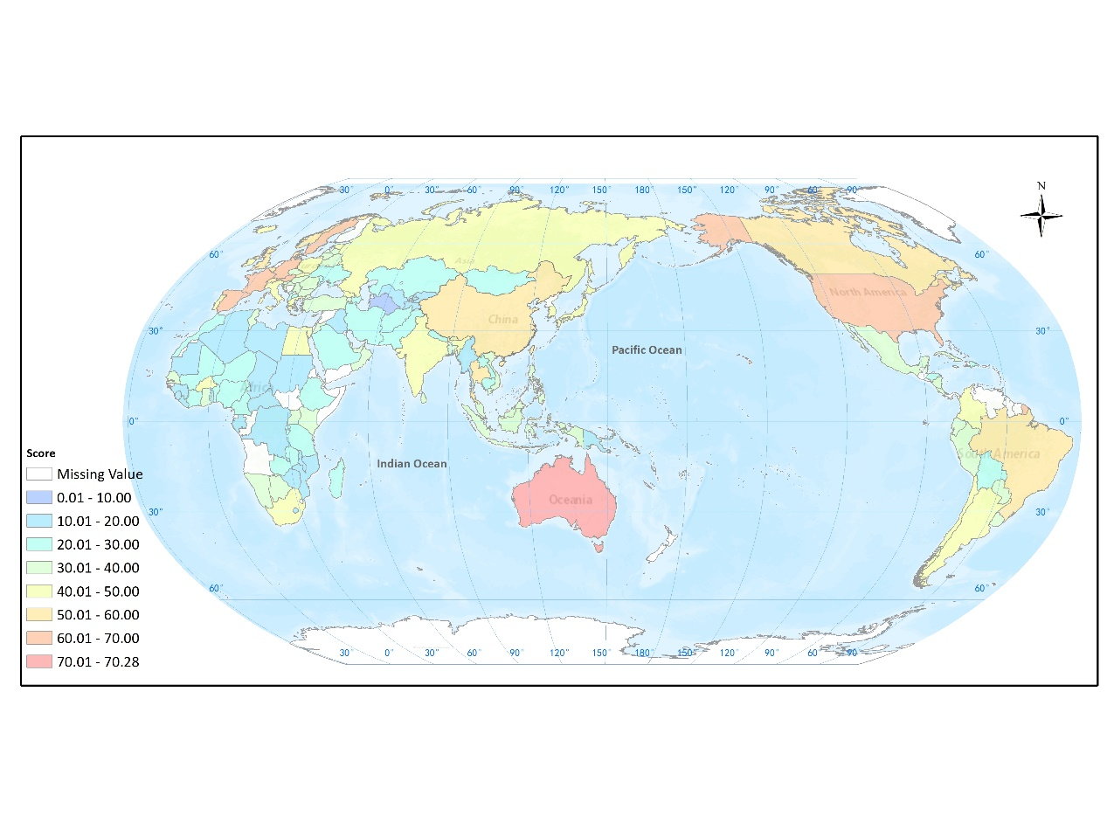
Fig. 4 Global score Map of One Health Governance index

