National prevalence and risk factors for tungiasis in Kenya

Additional file 1: Materials

9 counties
First survey
randomly selected
99 schools
Second survey
randomly selected
97 schools
School pupils aged 8–14 years
Randomly selected, n = 10,865
School pupils aged 8–14 years
Randomly selected, n = 10,600
Infected
n = 147
Uninfected
n = 10,718
Infected
n = 95
Uninfected
n = 10,505
Infected
n = 77
Selected for risk factor interview
Uninfected
n = 566
Infected
n = 242
Population-wide risk factor analysis
Uninfected
n = 21,223
Infection intensity & morbidity assessment n = 242
Infected
n = 82
Rapid assessment n = 221
Uninfected
n =139

S1 Flow diagram describing selection of participant groups. Orange boxes represent pupils infected with tungiasis; green boxes represent uninfected pupils. Blue arrows depict flow in the first survey, Orange arrows depict flow in the second survey.
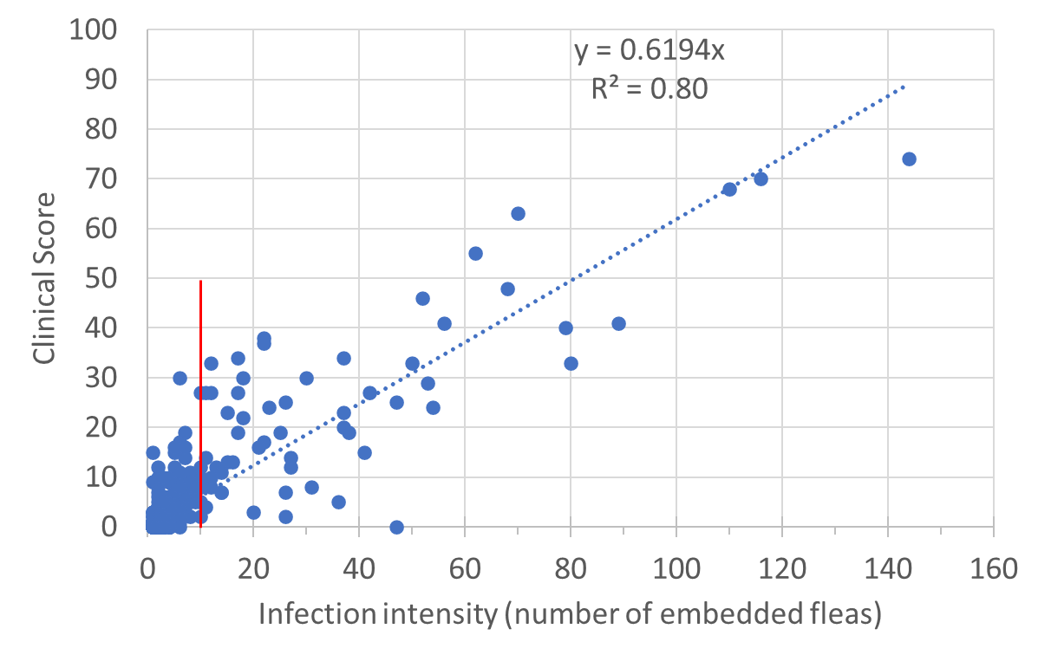

S2 Correlation of infection intensity with clinical score for all pupils with tungiasis in their feet (n = 242) with a fitted linear regression line (dotted blue line). The red line indicates the 10 flea threshold for mild and severe disease.

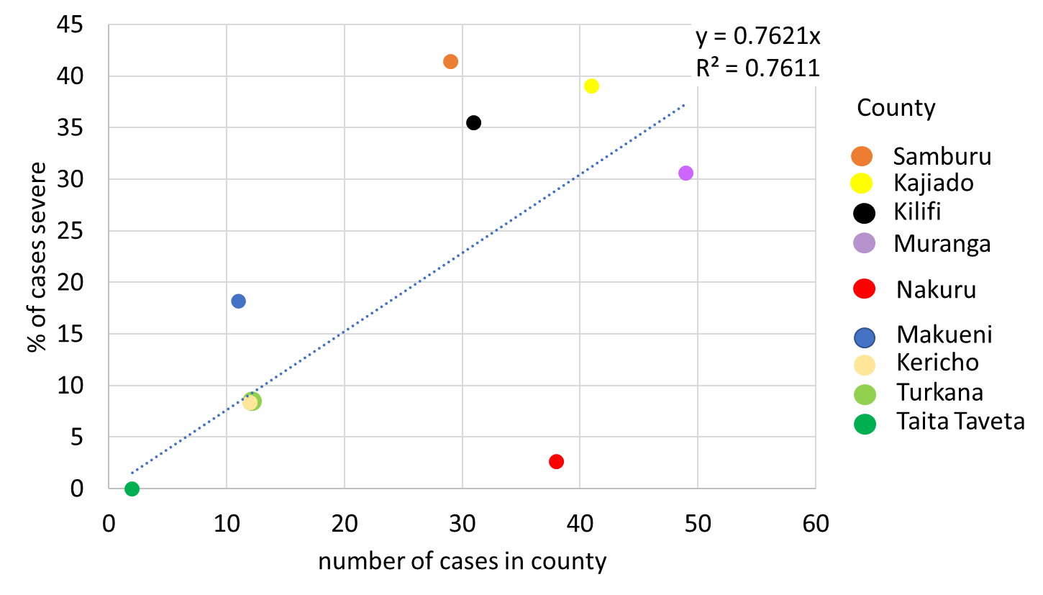
S3 Correlation of county percent infected with percent of cases with severe disease (n = 225)

S4 Demographics of pupils selected for risk factor interviews

Months of survey | Oct 2021–Oct 2022
Number of schools | 95
Number of pupils selected | 643
% boys | 51.3
Mean age | 11.1
Number with disability (%)ª | 9 (1.4)
Number with other skin abnormality (%) ª | 38 (5.9)
Number with tungiasis (%) | 77 (11.9)
ª not assessed by a clinician

S5 Polychoric Principal Component Analysis for a Socio-Economic Variable
To construct the socio-economic status (SES) variable, polychoric principal component analysis was conducted with variables on ownership of household and individual assets/items such as wall materials, family income source and water source (Table S4 in supplementary materials. This was conducted by adding and removing potential variables ensuring all had an item-rest correlation in Cronbach’s alpha > 0.1 to obtain a factor with an overall Cronbach’s alpha >0.7 (See S5 in supplementary materials). The floor materials variable was excluded from the SES variable as it could be biologically associated to the dependent variable (disease status) in risk factor analysis. To confirm the SES factor correlated with national indicators a scatterplot and regression were conducted of county mean SES versus the county % of population living under the national poverty level which had an R² of 0.576 ([8], S6 supplementary material).

Variables included in the final Socio-Economic Factor generated through Principal Component Analysis
Variable
Pupil wearing a uniform (none/partial/full)
Condition of the clothes (poor/medium/ good)
Type of shoes (none/open sandals/ closed/closed with socks)
Family income from a job (yes/no)
House wall materials (mud with sticks and or stones, palm leaves, grass, wood/iron sheets/compressed mud bricks/stone bricks with cement)
Water source (open/ shared tap/own tap)
Family owns tv (yes/no)
Family owns mobile phone (yes/no)
Family owns sofa (yes/no)
Family owns cupboard (yes/no)
Own no animals (yes/no)

Cronbach’s alpha for Socio-Economic Factor
Item | Obs | Sign | Item-test correlation | Item-rest correlation | Interitem correlation | Alpha
Wearing uniform | 637 | + | 0.6030 | 0.4820 | 0.2436 | 0.7631
Condition of clothes | 616 | + | 0.5920 | 0.4685 | 0.2453 | 0.7647
Type of shoes | 632 | + | 0.7010 | 0.6028 | 0.2305 | 0.7497
Family income from job | 643 | + | 0.4801 | 0.3402 | 0.2609 | 0.7793
Wall materials | 642 | + | 0.6412 | 0.5297 | 0.2385 | 0.7580
Water source | 642 | + | 0.4911 | 0.3536 | 0.2590 | 0.7776
Family own tv | 643 | + | 0.7084 | 0.6123 | 0.2292 | 0.7484
Family own mobile phone | 643 | + | 0.4277 | 0.2812 | 0.2682 | 0.7856
Family own sofa | 643 | + | 0.6811 | 0.5785 | 0.2331 | 0.7524
Family own cupboard | 643 | + | 0.6335 | 0.5206 | 0.2397 | 0.7592
 | 643 | + | 0.2456 | 0.0853 | 0.2930 | 0.8056
Test scale |  |  |  |  | 0.2492 | 0.7850
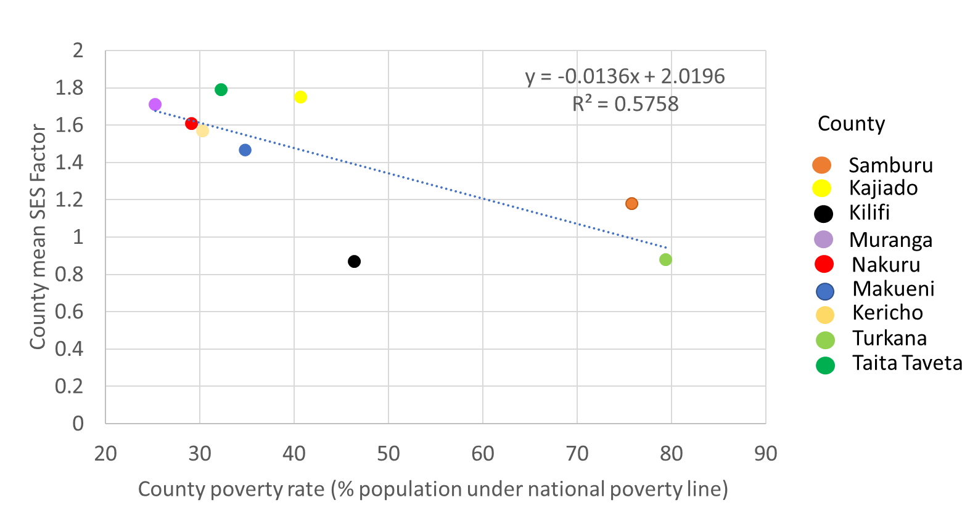
Correlation of SES factor with county poverty rate

