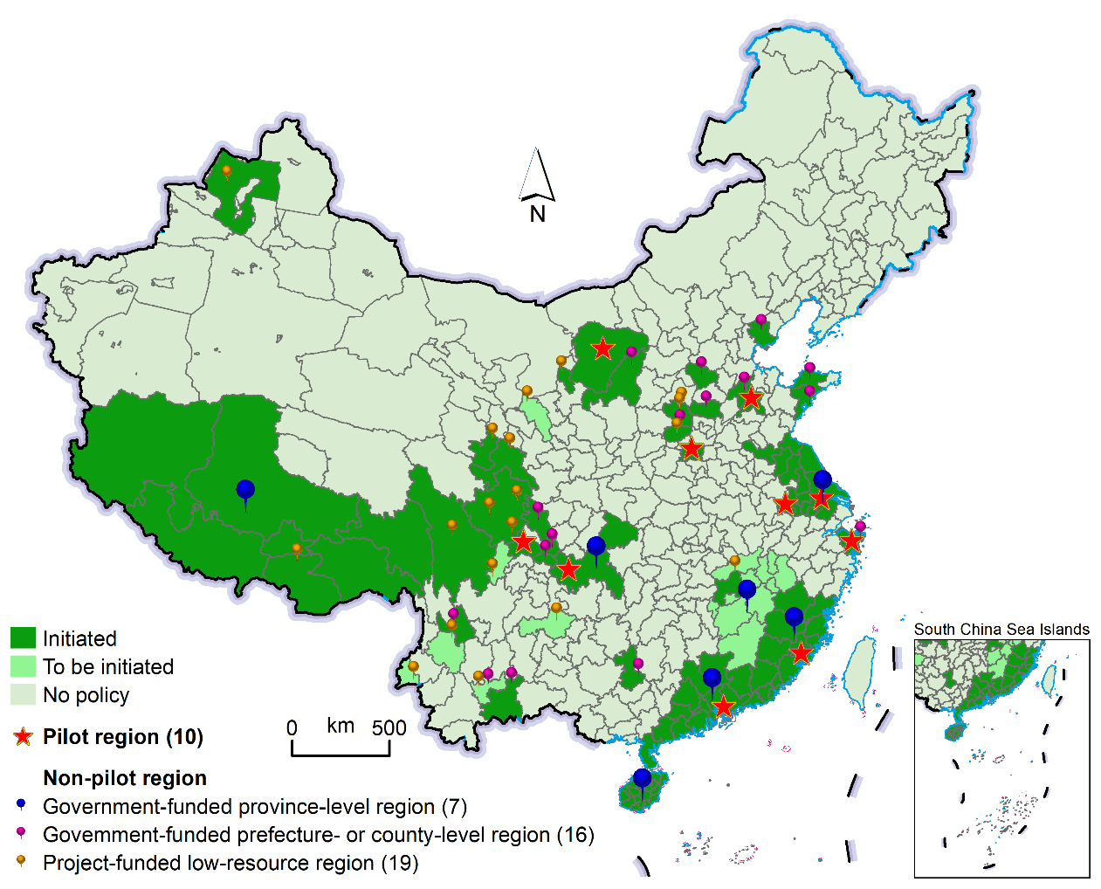
Figure S1. Free or subsidised human papillomavirus vaccination regions in China by April 2023

* The base map with an approval number of GS(2022)4299 was downloaded from the designated website (http://bzdt.ch.mnr.gov.cn/) without any modification of the boundaries.

