Tables
Table S1. Number of households and individuals screened for active case detection
District | Total population | Palika (municipality) | Households screened | People screened
Rautahat | 813,573 | Dewahi-Gonahi | 400 | 2744
 | 813,573 | Rajpur | 497 | 3238
 | 813,573 | Ishnath | 300 | 1958
 | 813,573 | Rajdevi | 787 | 5480
Banke | 603,194 | Nepalgunj | 891 | 5532
 | 603,194 | Narainapur | 418 | 2229
 | 603,194 | Janaki | 585 | 3612
 | 603,194 | Baijnath | 355 | 1676
Total |  |  | 4233 | 26,469

Table S2. Age and sex description of leprosy cases identified during active case detection
Years | Total cases | Number of female
0 to 4 | 1 | 1
5 to 9 | 2 | 1
10 to 14 | 5 | 4
15 to19 | 6 | 4
20 to 24 | 4 | 1
25 to 29 | 5 | 3
30 to 34 | 4 | 3
35 to 39 | 1 | 1
40 to 44 | 2 | 2
45 to 49 | 2 | 1
50 to 54 | 2 | 1
55 to 59 | 4 | 1
60 to 64 | 4 | 2
60 and above | 6 | 2
Overall | 48 | 27

Table S3: Attack rate in contacts of leprosy. See also Figure S1.
Type of Contact | Cases/number of contacts | Attack rate (%, 95% confidence intervals)
Household contact of MB cases | 3/926 | - (0.07 - 0.94)
Household contact of PB cases | 1/757 | 0.13 (0.03 - 0.73)
Neighbouring contact of MB cases | 8/3455 | 0.23 (0.1 - 0.46)
Neighbouring contact of PB cases | 7/1470 | 0.48 (0.19 - 0.98)

Table S4. Odds ratios for associations using Fisher's exact test. See also Figure S2.
Association | Odds ratio (95% CI) | P-value
MB cases: Household vs neighbour | 1.4 (0.24 - 5.85) | 0.71
PB cases: Household vs neighbour | 0.28 (0.01 - 2.17) | 0.28
All cases: Household vs neighbour | 0.78 (0.19 - 2.45) | 0.8
Household cases: MB vs PB | 2.5 (0.2 - 129.1) | 0.63
Neighbour cases: MB vs PB | 0.49 (0.15 - 1.57) | 0.16
All cases: MB vs PB | 0.7 (0.26 - 2.0) | 0.47

Table S5. Impact of BCG on leprosy transmission
BCG scar | Leprosy | No Leprosy
Present | 18 | 323
Absent | 27 | 201

Figures
Figure S1. Attack rates from case-contact surveys. Ninety-five percent confidence intervals (95% CI) are shown.
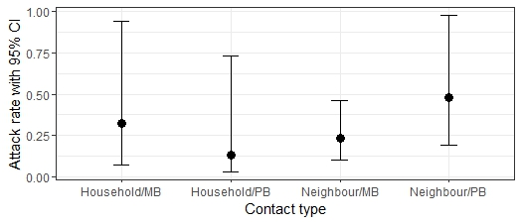
MB – multibacillary; PB – paucibacillary; Household – household contact; Neighbour – neighbouring house contact.

Figure S2. Odds ratios (OR) for associations among cases and contacts. Estimates are shown with 95% confidence intervals (CI). Intervals overlapping OR=1 are not significantly different. Note the log10 y-axis because of wide confidence intervals.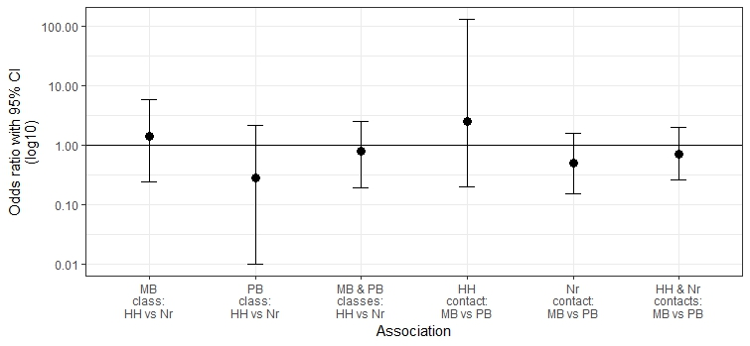
MB – multibacillary; PB – paucibacillary; Household – household contact; Neighbour – neighbouring house contact.

