Supplementary Table S1 – Search strategy

Searching
Liver flukes | "opisthorchis viverrini"[All Fields] OR "liver fluke" OR "opisthorchiasis" OR "clonorchis sinensis" OR "clonorchiasis"
Prevalence | "prevalence"[Title/Abstract] OR "incidence" OR "Survey" OR "infection rate" OR "percent" OR "percentage" OR "case report" OR "cross sectional" OR "epidemiology"
Greater Mekong Subregion | "gms"[Title/Abstract] OR "Greater Mekong subregion" OR "Cambodia" OR "Lao" OR "Lao PDR" OR "Myanmar" OR "Burma" OR "Thailand" OR "Vietnam" OR "China" OR "Yunnan" OR "Guangxi" OR "Guangxi Zhuang”
Population | (human[MeSH Terms]) OR (adult[MeSH Terms]) OR (children[MeSH Terms])) OR ("school children"[All Fields])
Overall | ((("opisthorchis viverrini"[All Fields] OR "liver fluke" OR "opisthorchiasis" OR "clonorchis sinensis" OR "clonorchiasis") ) AND ("prevalence"[Title/Abstract] OR "incidence" OR "Survey" OR "infection rate" OR "percent" OR "percentage" OR "case report" OR "cross sectional" OR "epidemiology")) AND ("gms"[Title/Abstract] OR "Greater Mekong subregion" OR "Cambodia" OR "Lao" OR "Lao PDR" OR "Myanmar" OR "Burma" OR "Thailand" OR "Vietnam" OR "China" OR "Yunnan" OR "Guangxi" OR "Guangxi Zhuang") AND (human[MeSH Terms]) OR (adult[MeSH Terms]) OR (children[MeSH Terms])) OR ("school children"[All Fields])

Supplementary Figure S1 – Risk of Bias of Opisthorchis viverrini
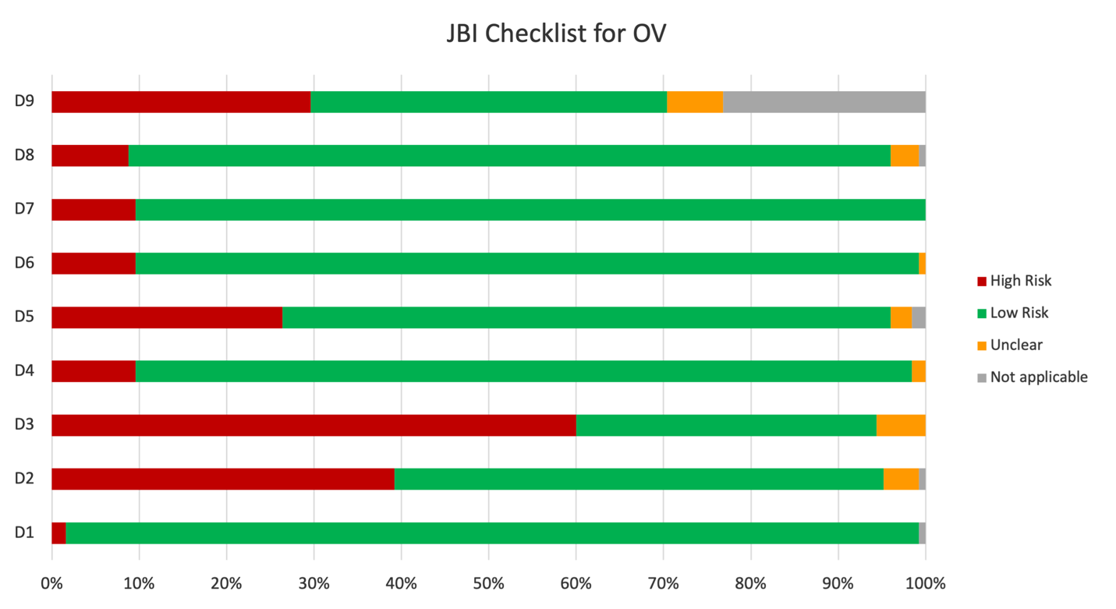

Questions:
D1: Was the sample frame appropriate to address the target population?
D2: Were study participants sampled in an appropriate way?
D3: Was the sample size adequate?
D4: Were the study subjects and the setting described in detail?
D5: Was the data analysis conducted with sufficient coverage of the identified sample?
D6: Were valid methods used for the identification of the condition?
D7: Was the condition measured in a standard, reliable way for all participants?
D8: Was there appropriate statistical analysis?
D9: Was the response rate adequate, and if not, was the low response rate managed appropriately?

Categorical labels:
0= No= High risk,
1= Yes= Low risk,
2= Un= Unclear
3=NA= Not applicable

Supplementary Table: S2 Risk of bias assessment of included studies for Opisthorchis viverrini by JBI critical appraisal checklist for studies reporting prevalence data.

Article | First Author, Publication Year | D1 | D2 | D3 | D4 | D5 | D6 | D7 | D8 | D9 | Total | QA grade
1 | Sornmani , 1973 | 1 | 0 | 1 | 1 | 1 | 0 | 0 | 1 | 1 | 6 | Medium
2 | Bunnag, 1980 | 1 | 0 | 0 | 1 | 1 | 0 | 0 | 0 | 3 | 3 | High
3 | Sornmani, 1981 | 1 | 1 | 1 | 1 | 1 | 0 | 0 | 1 | 2 | 6 | Medium
4 | Upatham, 1982 | 1 | 0 | 1 | 1 | 1 | 1 | 1 | 1 | 1 | 8 | Low
5 | Upatham, 1984 | 1 | 0 | 1 | 1 | 1 | 0 | 0 | 1 | 3 | 5 | Medium
6 | Upatham, 1985 | 1 | 1 | 1 | 1 | 1 | 0 | 0 | 1 | 1 | 7 | Low
7 | Maleewong, 1992 | 1 | 0 | 1 | 1 | 1 | 1 | 1 | 0 | 0 | 6 | Medium
8 | Radomyos, 1994 | 1 | 1 | 0 | 1 | 1 | 2 | 1 | 1 | 3 | 6 | Medium
9 | Kobayashi, 1996 | 1 | 0 | 0 | 1 | 1 | 1 | 1 | 1 | 1 | 7 | Low
10 | Pungpak, 1997 | 1 | 0 | 0 | 1 | 0 | 0 | 0 | 1 | 1 | 4 | Medium
11 | Vannachone, 1998 | 1 | 0 | 0 | 1 | 0 | 1 | 1 | 1 | 0 | 5 | Medium
12 | Radomyos, 1998 | 1 | 0 | 0 | 0 | 0 | 0 | 0 | 1 | 0 | 2 | High
13 | Kobayashi, 1999 | 1 | 1 | 0 | 2 | 2 | 1 | 1 | 0 | 0 | 4 | Medium
14 | Kobayashi, 2000 | 1 | 0 | 2 | 1 | 1 | 1 | 1 | 1 | 3 | 6 | Medium
15 | Waree, 2001 | 1 | 0 | 0 | 1 | 1 | 1 | 1 | 0 | 3 | 5 | Medium
16 | Sinuon, 2003 | 1 | 0 | 0 | 1 | 1 | 1 | 1 | 1 | 0 | 6 | Medium
17 | Sithithaworn, 2003 | 1 | 0 | 1 | 1 | 1 | 1 | 1 | 0 | 3 | 6 | Medium
18 | Piangjai, 2003 | 1 | 0 | 1 | 1 | 1 | 1 | 1 | 0 | 3 | 6 | Medium
19 | Sriamporn, 2004 | 1 | 0 | 1 | 1 | 1 | 1 | 1 | 1 | 3 | 7 | Low
20 | Sriamporn, 2005 | 1 | 0 | 0 | 1 | 0 | 0 | 0 | 0 | 3 | 2 | High
21 | Nontasut, 2005 | 0 | 0 | 0 | 0 | 0 | 1 | 1 | 1 | 0 | 3 | High
22 | Sithithaworn, 2006 | 1 | 0 | 0 | 1 | 1 | 1 | 1 | 1 | 0 | 6 | Medium
23 | Sayasone, 2007 | 1 | 0 | 0 | 1 | 1 | 1 | 1 | 1 | 3 | 6 | Medium
24 | Phathammavong, 2007 | 1 | 1 | 0 | 1 | 1 | 0 | 0 | 1 | 0 | 5 | Medium
25 | Tungtrongchitr, 2007 | 1 | 0 | 0 | 2 | 2 | 1 | 1 | 1 | 3 | 4 | Medium
26 | Erlanger, 2008 | 1 | 1 | 0 | 1 | 1 | 1 | 1 | 1 | 3 | 7 | Low
27 | Nithikathkul, 2009 | 1 | 0 | 0 | 1 | 1 | 1 | 1 | 1 | 3 | 6 | Medium
28 | Wattanayingcharoenchai, 2011 | 1 | 1 | 0 | 1 | 3 | 1 | 1 | 1 | 3 | 6 | Medium
29 | Sayasone, 2011 | 1 | 2 | 0 | 1 | 1 | 1 | 1 | 1 | 0 | 6 | Medium
30 | Wongsawad, 2012 | 0 | 0 | 0 | 0 | 0 | 1 | 1 | 0 | 3 | 2 | High
31 | Kaewpitoon(a), 2012 | 1 | 1 | 0 | 1 | 0 | 1 | 1 | 1 | 1 | 7 | Low
32 | Kaewpitoon(b), 2012 | 1 | 1 | 0 | 1 | 1 | 1 | 1 | 1 | 1 | 8 | Low
33 | Sohn, 2012 | 1 | 2 | 0 | 0 | 0 | 1 | 1 | 1 | 3 | 4 | Medium
34 | Yong, 2012 | 1 | 0 | 0 | 1 | 1 | 1 | 1 | 2 | 3 | 5 | Medium
35 | Saengsawang, 2012 | 1 | 0 | 0 | 1 | 1 | 1 | 1 | 1 | 1 | 7 | Low
36 | Forrer, 2012 | 1 | 1 | 0 | 1 | 1 | 1 | 1 | 1 | 1 | 8 | Low
37 | Songserm, 2012 | 1 | 1 | 0 | 1 | 1 | 1 | 1 | 1 | 3 | 7 | Low
38 | Boonjaraspinyo, 2013 | 1 | 0 | 0 | 1 | 1 | 1 | 1 | 1 | 1 | 7 | Low
39 | Suwannahitatorn, 2013 | 1 | 0 | 0 | 1 | 1 | 1 | 1 | 1 | 1 | 7 | Low
40 | Saengsawang, 2013 | 1 | 0 | 0 | 1 | 0 | 1 | 1 | 1 | 3 | 5 | Medium
41 | Phongluxa, 2013 | 1 | 1 | 0 | 1 | 1 | 1 | 1 | 1 | 1 | 8 | Low
42 | Puttaruk, 2013 | 3 | 0 | 0 | 1 | 0 | 1 | 1 | 1 | 3 | 4 | Medium
43 | Wongsaroj, 2014 | 1 | 3 | 1 | 1 | 0 | 1 | 1 | 1 | 1 | 7 | Low
44 | Miyamoto, 2014 | 1 | 0 | 0 | 1 | 1 | 1 | 1 | 1 | 3 | 6 | Medium
45 | Thaewnongiew, 2014 | 1 | 1 | 0 | 1 | 1 | 1 | 1 | 1 | 1 | 8 | Low
46 | Wiriyakijja, 2014 | 1 | 1 | 1 | 1 | 1 | 1 | 1 | 1 | 1 | 9 | Low
47 | Chaiputcha, 2015 | 1 | 1 | 1 | 1 | 1 | 1 | 1 | 1 | 1 | 9 | Low
48 | Vonghachack, 2015 | 1 | 1 | 0 | 1 | 1 | 1 | 1 | 1 | 3 | 7 | Low
49 | Kaewpitoon, 2015 | 1 | 1 | 1 | 1 | 1 | 1 | 1 | 1 | 1 | 9 | Low
50 | Sato, 2015 | 1 | 0 | 0 | 1 | 1 | 1 | 1 | 1 | 0 | 6 | Medium
51 | Sayasone, 2015 | 1 | 1 | 0 | 1 | 0 | 1 | 1 | 1 | 0 | 6 | Medium
52 | Rujirakul, 2015 | 1 | 0 | 0 | 0 | 0 | 1 | 1 | 1 | 0 | 4 | Medium
53 | Moore, 2015 | 1 | 0 | 0 | 1 | 1 | 1 | 1 | 1 | 0 | 6 | Medium
54 | Bless, 2015 | 1 | 0 | 0 | 1 | 1 | 1 | 1 | 1 | 1 | 7 | Low
55 | Yospanya, 2015 | 1 | 1 | 1 | 1 | 1 | 1 | 1 | 1 | 1 | 9 | Low
56 | Kaewpitoon(a), 2016 | 1 | 1 | 0 | 1 | 1 | 1 | 1 | 1 | 1 | 8 | Low
57 | Saiyachak, 2016 | 1 | 1 | 1 | 1 | 1 | 1 | 1 | 1 | 1 | 9 | Low
58 | Kaewpitoon(b), 2016 | 1 | 1 | 1 | 1 | 1 | 1 | 1 | 1 | 1 | 9 | Low
59 | Kaewpitoon(c), 2016 | 1 | 1 | 2 | 1 | 1 | 1 | 1 | 1 | 2 | 7 | Low
60 | Saengsawang, 2016 | 1 | 1 | 2 | 1 | 0 | 1 | 1 | 1 | 0 | 6 | Medium
61 | Kaewpitoon(d), 2016 | 1 | 1 | 2 | 1 | 0 | 1 | 1 | 1 | 1 | 7 | Low
62 | Kaewpitoon(e), 2016 | 1 | 1 | 0 | 1 | 1 | 1 | 1 | 1 | 0 | 7 | Low
63 | Doi, 2016 | 1 | 1 | 0 | 0 | 0 | 1 | 1 | 1 | 0 | 5 | Medium
64 | Chuangchaiya, 2016 | 1 | 2 | 2 | 1 | 1 | 0 | 0 | 1 | 2 | 4 | Medium
65 | Jamjane, 2016 | 1 | 1 | 0 | 1 | 1 | 1 | 1 | 1 | 3 | 7 | Low
66 | Taepongsorat, 2016 | 1 | 1 | 0 | 1 | 1 | 1 | 1 | 1 | 3 | 7 | Low
67 | Prakobwong, 2017 | 1 | 2 | 1 | 1 | 1 | 1 | 1 | 1 | 1 | 8 | Low
68 | Evdokimov, 2017 | 1 | 1 | 1 | 1 | 1 | 1 | 1 | 1 | 1 | 9 | Low
69 | Kitvatanachai, 2017 | 1 | 1 | 1 | 2 | 2 | 1 | 1 | 1 | 1 | 7 | Low
70 | Aung, 2017 | 1 | 1 | 1 | 1 | 1 | 1 | 1 | 1 | 1 | 9 | Low
71 | Vonghachack(a), 2017 | 1 | 1 | 1 | 1 | 1 | 1 | 1 | 1 | 1 | 9 | Low
72 | Saenna, 2017 | 1 | 2 | 0 | 1 | 1 | 1 | 1 | 1 | 1 | 7 | Low
73 | Vonghachack(b), 2017 | 1 | 1 | 1 | 1 | 1 | 1 | 1 | 1 | 1 | 9 | Low
74 | Wanpinyocheep, 2017 | 1 | 1 | 0 | 1 | 3 | 1 | 1 | 1 | 1 | 7 | Low
75 | Kaewpitoon(a), 2018 | 1 | 0 | 0 | 1 | 1 | 1 | 1 | 1 | 0 | 6 | Medium
76 | Nakbun, 2018 | 1 | 1 | 1 | 1 | 1 | 1 | 1 | 1 | 1 | 9 | Low
77 | Kaewpitoon(b), 2018 | 1 | 0 | 0 | 1 | 1 | 1 | 1 | 1 | 3 | 6 | Medium
78 | Assavapongpaiboon, 2018 | 1 | 1 | 0 | 1 | 1 | 1 | 1 | 1 | 0 | 7 | Low
79 | Kaewpitoon(c), 2018 | 1 | 0 | 0 | 1 | 1 | 1 | 1 | 1 | 0 | 6 | Medium
80 | Laoraksawong, 2018 | 1 | 1 | 1 | 1 | 1 | 1 | 1 | 1 | 0 | 8 | Low
81 | Panithanang, 2018 | 1 | 0 | 0 | 1 | 1 | 1 | 1 | 2 | 0 | 5 | Medium
82 | Thaewnongiew, 2018 | 1 | 1 | 0 | 1 | 0 | 1 | 1 | 1 | 0 | 6 | Medium
83 | Sornlorm, 2019 | 1 | 1 | 0 | 1 | 1 | 1 | 1 | 1 | 0 | 7 | Low
84 | Khieu, 2019 | 1 | 0 | 0 | 0 | 0 | 0 | 0 | 1 | 0 | 2 | High
85 | Sohn, 2019 | 1 | 0 | 0 | 1 | 0 | 1 | 1 | 0 | 0 | 4 | Medium
86 | Thinkhamrop, 2019 | 1 | 1 | 0 | 1 | 1 | 1 | 1 | 1 | 1 | 8 | Low
87 | Chuangchaiya, 2019 | 1 | 1 | 1 | 1 | 1 | 1 | 1 | 1 | 1 | 9 | Low
88 | Sayasone, 2019 | 1 | 1 | 0 | 1 | 1 | 1 | 1 | 1 | 0 | 7 | Low
89 | Rangsin, 2019 | 1 | 0 | 0 | 1 | 1 | 1 | 1 | 1 | 3 | 6 | Medium
90 | Kaewpitoon, 2019 | 1 | 0 | 0 | 1 | 1 | 1 | 1 | 1 | 3 | 6 | Medium
91 | Yoshida, 2019 | 1 | 1 | 1 | 1 | 1 | 1 | 1 | 1 | 1 | 9 | Low
92 | Namwong, 2019 | 1 | 1 | 0 | 0 | 0 | 1 | 1 | 1 | 0 | 5 | Medium
93 | Nak-ai, 2019 | 1 | 1 | 1 | 1 | 1 | 1 | 1 | 1 | 1 | 9 | Low
94 | Boondit, 2020 | 1 | 1 | 0 | 1 | 1 | 1 | 1 | 1 | 1 | 8 | Low
95 | Chuangchaiya, 2020 | 1 | 1 | 1 | 1 | 0 | 1 | 1 | 1 | 1 | 8 | Low
96 | Rattanapitoon, 2020 | 1 | 0 | 0 | 1 | 1 | 1 | 1 | 1 | 1 | 7 | Low
97 | Homsana, 2020 | 1 | 0 | 0 | 1 | 1 | 1 | 1 | 1 | 3 | 6 | Medium
98 | Buathong, 2020 | 1 | 0 | 0 | 0 | 0 | 1 | 1 | 1 | 0 | 4 | Medium
99 | Prakobwong,2020 | 1 | 1 | 0 | 1 | 1 | 1 | 1 | 1 | 1 | 8 | Low
100 | Nak-ai, 2020 | 1 | 1 | 1 | 1 | 1 | 1 | 1 | 1 | 1 | 9 | Low
101 | Wattanawong, 2021 | 1 | 1 | 1 | 1 | 1 | 1 | 1 | 1 | 1 | 9 | Low
102 | Soncharoen, 2021 | 1 | 1 | 1 | 1 | 1 | 1 | 1 | 1 | 1 | 9 | Low
103 | Srithai, 2021 | 1 | 1 | 1 | 1 | 0 | 1 | 1 | 1 | 1 | 8 | Low
104 | Kitphati, 2021 | 1 | 1 | 1 | 1 | 0 | 1 | 1 | 1 | 1 | 8 | Low
105 | Sungkhabut, 2021 | 1 | 1 | 1 | 1 | 0 | 1 | 1 | 1 | 3 | 7 | Low
106 | Kopolrat, 2021 | 1 | 1 | 1 | 1 | 1 | 1 | 1 | 1 | 1 | 9 | Low
107 | Soncharoen, 2022 | 1 | 1 | 1 | 1 | 1 | 1 | 1 | 1 | 1 | 9 | Low
108 | La, 2022 | 1 | 1 | 1 | 1 | 1 | 1 | 1 | 1 | 1 | 9 | Low
109 | Sangkaeo, 2022 | 1 | 1 | 2 | 0 | 0 | 1 | 1 | 1 | 2 | 5 | Medium
110 | Nantapulsab, 2022 | 1 | 1 | 1 | 1 | 1 | 1 | 1 | 1 | 0 | 8 | Low
111 | Boonkasem, 2022 | 1 | 0 | 0 | 1 | 0 | 1 | 1 | 1 | 0 | 5 | Medium
112 | Boonjaraspinyo, 2023 | 1 | 1 | 1 | 1 | 0 | 1 | 1 | 1 | 1 | 8 | Low
113 | Sato, 2010 | 1 | 0 | 0 | 0 | 0 | 1 | 1 | 1 | 0 | 4 | Medium
114 | Laymanivong, 2016 | 1 | 1 | 0 | 1 | 0 | 1 | 1 | 0 | 0 | 5 | Medium
115 | Nakamura, 2017 | 1 | 1 | 0 | 1 | 1 | 1 | 1 | 2 | 2 | 6 | Medium
116 | Chai, 1998 | 1 | 0 | 0 | 0 | 0 | 1 | 1 | 2 | 0 | 3 | High
117 | Htun, 2018 | 1 | 1 | 1 | 1 | 1 | 1 | 1 | 1 | 2 | 8 | Low
118 | Niamnuy, 2016 | 1 | 1 | 0 | 1 | 1 | 0 | 1 | 1 | 0 | 6 | Medium
119 | Ayé, 2015 | 1 | 1 | 2 | 1 | 1 | 1 | 1 | 1 | 2 | 7 | Low
120 | Giboda, 1991 | 1 | 0 | 0 | 1 | 0 | 1 | 1 | 3 | 0 | 4 | Medium
121 | Rim, 2003 | 1 | 1 | 1 | 1 | 1 | 1 | 1 | 1 | 2 | 8 | Low
122 | Dao, 2016 | 1 | 1 | 1 | 1 | 1 | 1 | 1 | 1 | 1 | 9 | Low
123 | De, 2003 | 1 | 0 | 0 | 0 | 0 | 1 | 0 | 0 | 0 | 2 | High
124 | Songserm, 2021 | 1 | 1 | 1 | 1 | 1 | 1 | 1 | 1 | 1 | 9 | Low
125 | Kaewpitoon(a), 2015 | 1 | 1 | 0 | 1 | 1 | 1 | 1 | 1 | 0 | 7 | Low

Supplementary Figure S2 – Risk of Bias of Clonorchis sinensis

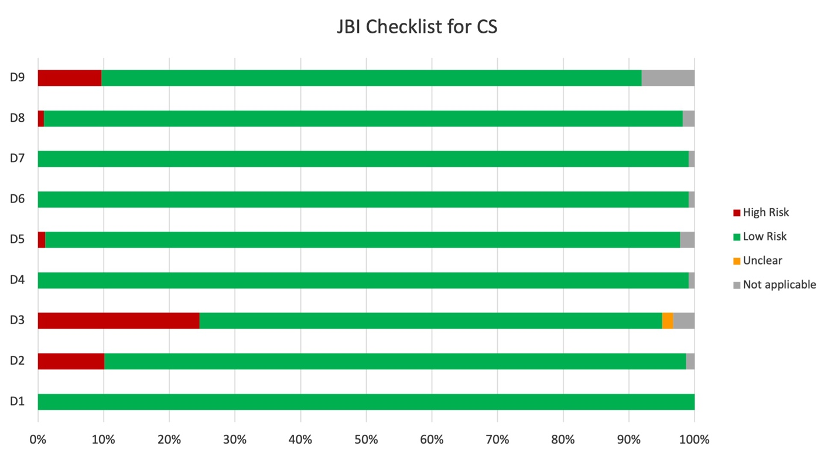
Questions:
D1: Was the sample frame appropriate to address the target population?
D2: Were study participants sampled in an appropriate way?
D3: Was the sample size adequate?
D4: Were the study subjects and the setting described in detail?
D5: Was the data analysis conducted with sufficient coverage of the identified sample?
D6: Were valid methods used for the identification of the condition?
D7: Was the condition measured in a standard, reliable way for all participants?
D8: Was there appropriate statistical analysis?
D9: Was the response rate adequate, and if not, was the low response rate managed appropriately?

Categorical labels:
0= No= High risk,
1= Yes= Low risk,
2= Un= Unclear
3=NA= Not applicable

Table S3: Risk of bias assessment of included studies for Clonorchis sinensis by JBI critical appraisal checklist for studies reporting prevalence data.

Article | First Author, Publication Year | D1 | D2 | D3 | D4 | D5 | D6 | D7 | D8 | D9 | Total | QA grade
1 | Kino, 1998 | 1 | 1 | 0 | 1 | 1 | 1 | 1 | 1 | 0 | 7 | Low
2 | Hong, 2001 | 1 | 1 | 0 | 1 | 1 | 1 | 1 | 0 | 3 | 6 | Medium
3 | Yu, 2003 | 1 | 1 | 3 | 1 | 3 | 1 | 1 | 3 | 3 | 5 | Medium
4 | Nontasut, 2003 | 1 | 0 | 0 | 1 | 1 | 1 | 1 | 1 | 0 | 6 | Medium
5 | Verle, 2003 | 1 | 1 | 0 | 1 | 1 | 1 | 1 | 1 | 0 | 7 | Low
6 | Dung, 2007 | 1 | 1 | 0 | 1 | 1 | 1 | 1 | 1 | 0 | 7 | Low
7 | Cam, 2008 | 1 | 1 | 0 | 1 | 1 | 1 | 1 | 1 | 0 | 7 | Low
8 | Yajima, 2009 | 1 | 1 | 0 | 1 | 0 | 1 | 1 | 1 | 0 | 6 | Medium
9 | Li, 2011 | 1 | 1 | 1 | 1 | 1 | 1 | 1 | 1 | 1 | 9 | Low
10 | Dan, 2012 | 1 | 1 | 1 | 1 | 1 | 1 | 1 | 1 | 1 | 9 | Low
11 | Jeon, 2012 | 1 | 0 | 0 | 3 | 3 | 3 | 3 | 1 | 3 | 2 | High
12 | Qian, 2014 | 1 | 0 | 0 | 1 | 1 | 1 | 1 | 1 | 1 | 7 | Low
13 | Lai, 2016 | 1 | 0 | 0 | 1 | 1 | 1 | 1 | 3 | 3 | 5 | Medium
14 | Vinh, 2017 | 1 | 1 | 0 | 1 | 1 | 1 | 1 | 1 | 1 | 8 | Low
15 | Zhu, 2020 | 1 | 1 | 1 | 1 | 1 | 1 | 1 | 1 | 1 | 9 | Low
16 | Sun, 2020 | 1 | 1 | 2 | 1 | 1 | 1 | 1 | 1 | 1 | 8 | Low
17 | Nguyen, 2020 | 1 | 1 | 1 | 1 | 1 | 1 | 1 | 1 | 1 | 9 | Low
18 | Xin,2021 | 1 | 1 | 0 | 1 | 1 | 1 | 1 | 1 | 3 | 7 | Low
19 | Jiang, 2021 | 1 | 1 | 0 | 1 | 1 | 1 | 1 | 1 | 1 | 8 | Low
20 | Qian, 2021 | 1 | 3 | 3 | 1 | 1 | 1 | 1 | 1 | 1 | 7 | Low
21 | Xu, 2021 | 1 | 0 | 1 | 1 | 1 | 1 | 1 | 1 | 1 | 8 | Low
22 | Qian, 2022 | 1 | 0 | 0 | 1 | 1 | 1 | 1 | 1 | 1 | 7 | Low
23 | Liu, 2015 | 1 | 0 | 0 | 1 | 1 | 1 | 1 | 1 | 1 | 7 | Low
24 | Fang, 2008 | 1 | 0 | 1 | 1 | 1 | 1 | 1 | 1 | 1 | 8 | Low
25 | LÜ, 2021 | 1 | 1 | 1 | 1 | 1 | 1 | 1 | 1 | 1 | 9 | Low
26 | Li, 2022 | 1 | 1 | 1 | 1 | 1 | 1 | 1 | 1 | 1 | 9 | Low

Supplementary Figure S3 Funnel plot of Opisthorchis viverrini

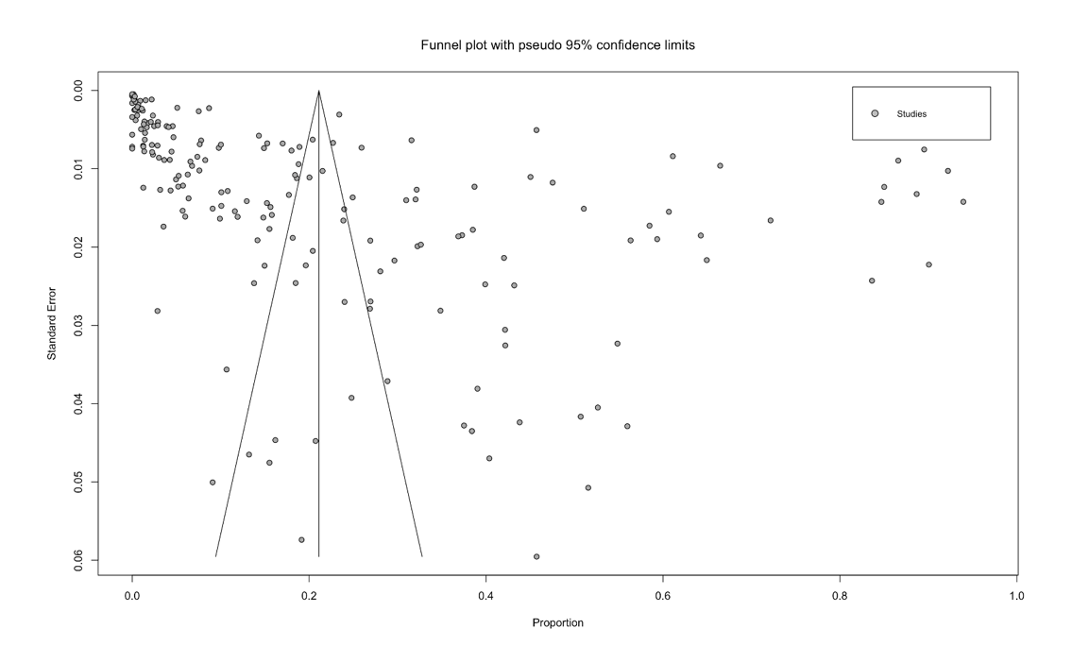

Figure S3 Opisthorchis viverrini studies funnel plot with pseudo 95% confidence intervals. To assess publication bias, the Opisthorchis viverrini data set was used. The P-value of 0.001 determined by Egger's test indicates publication bias.

Supplementary Figure S4 Funnel plot of Clonorchis sinensis
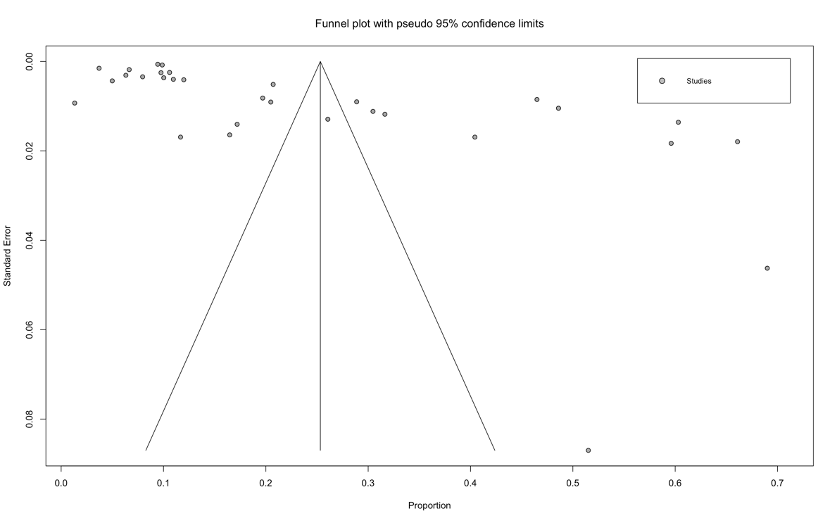

Figure S4 Clonorchis sinensis studies funnel plot with pseudo 95% confidence intervals. To assess publication bias, the Clonorchis sinensis data set was used. The P-value of 0.006 determined by Egger's test indicates publication bias.

Supplementary Figures S5, S6, S7, S8 and S9 – Random-effects meta-regression analyses
Opisthorchis viverrini

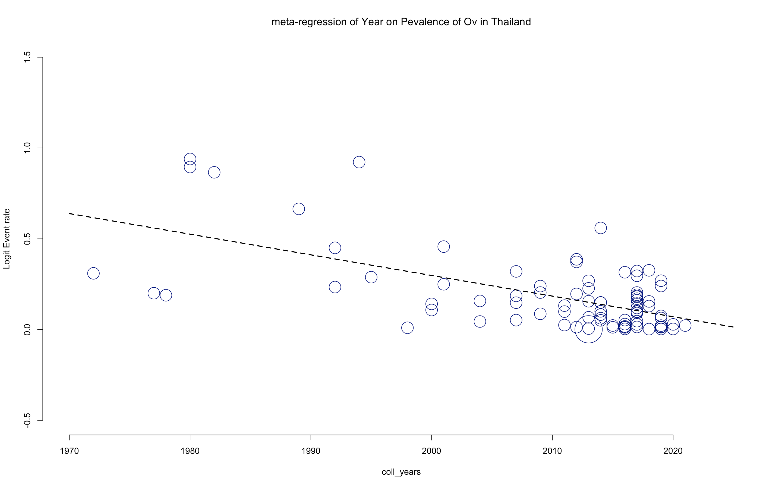
Figure S5 Random-effects meta-regression analyses of the prevalence of Opisthorchis viverrini infection in Thailand by collection year demonstrate a statistically significant downward trend in prevalence.

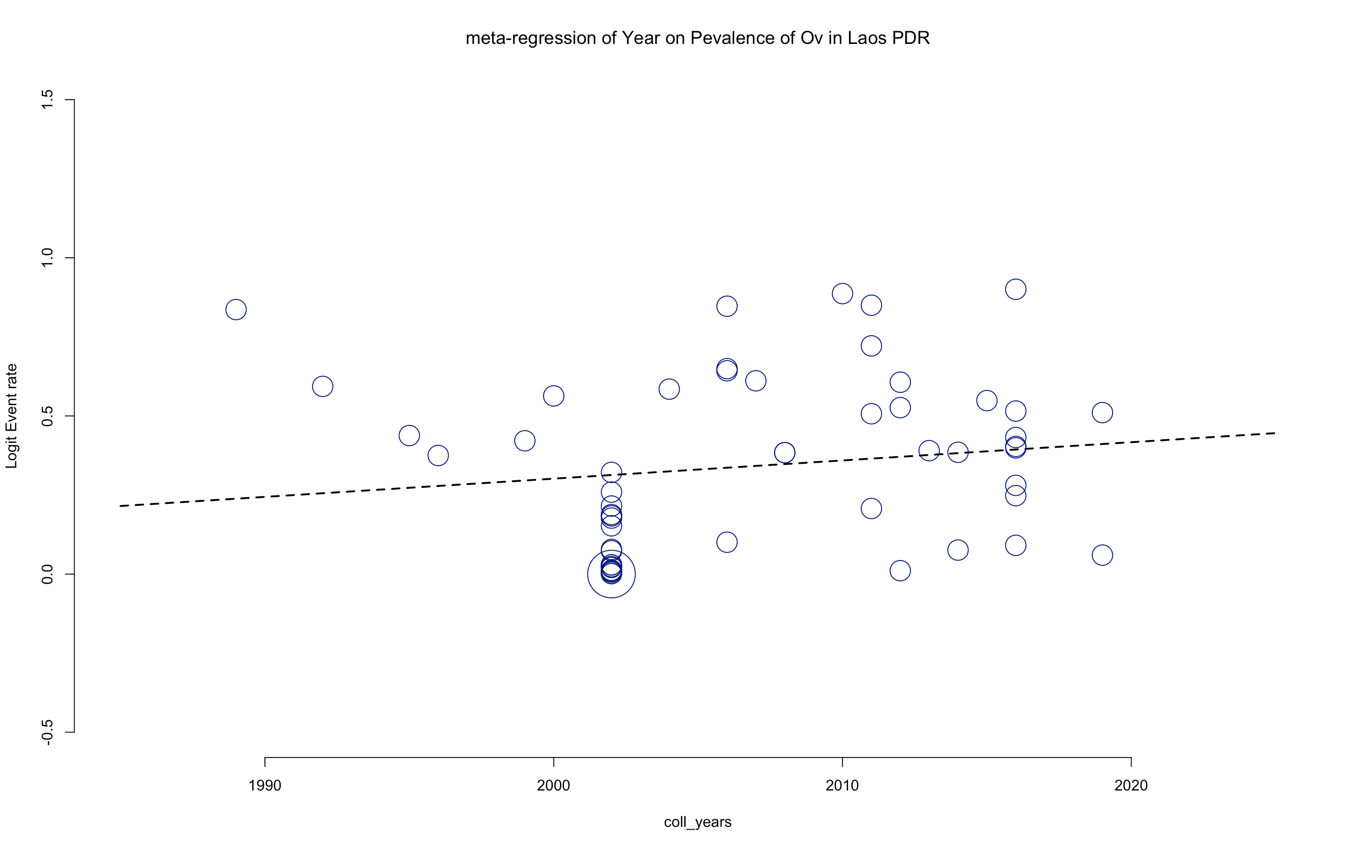
Figure S6 Random-effects meta-regression analyses of the prevalence of Opisthorchis viverrini infection in Laos PDR by collection year demonstrate a statistically non- significant upward trend in prevalence.

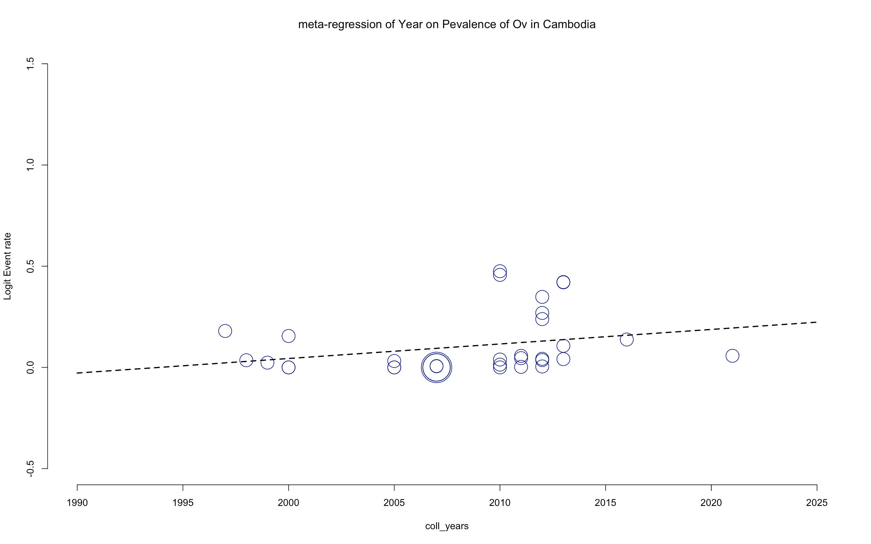
Figure S7 Random-effects meta-regression analyses of the prevalence of Opisthorchis viverrini infection in Cambodia by collection year demonstrate a statistically non- significant upward trend in prevalence.

Clonorchis sinensis

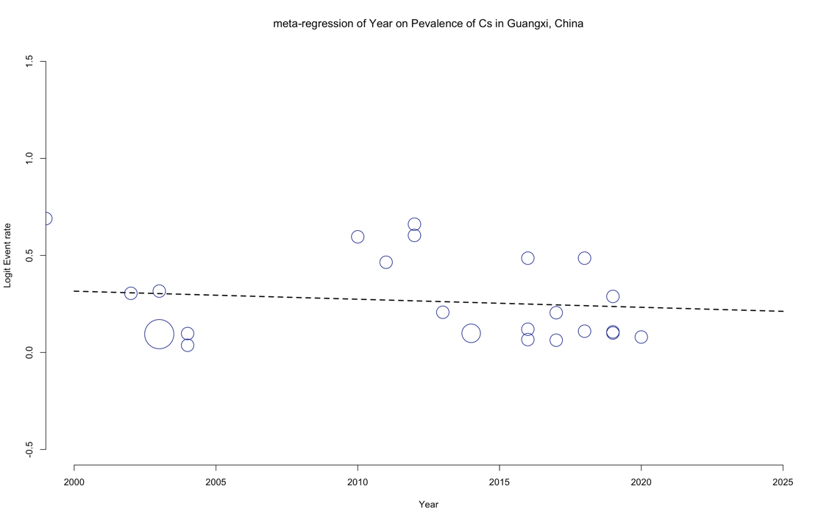
Figure S8 Random-effects meta-regression analysis of the prevalence of Clonorchis sinensis infection in Guangxi, China by collecting year show a statistically non-significant slightly downward trend in prevalence.

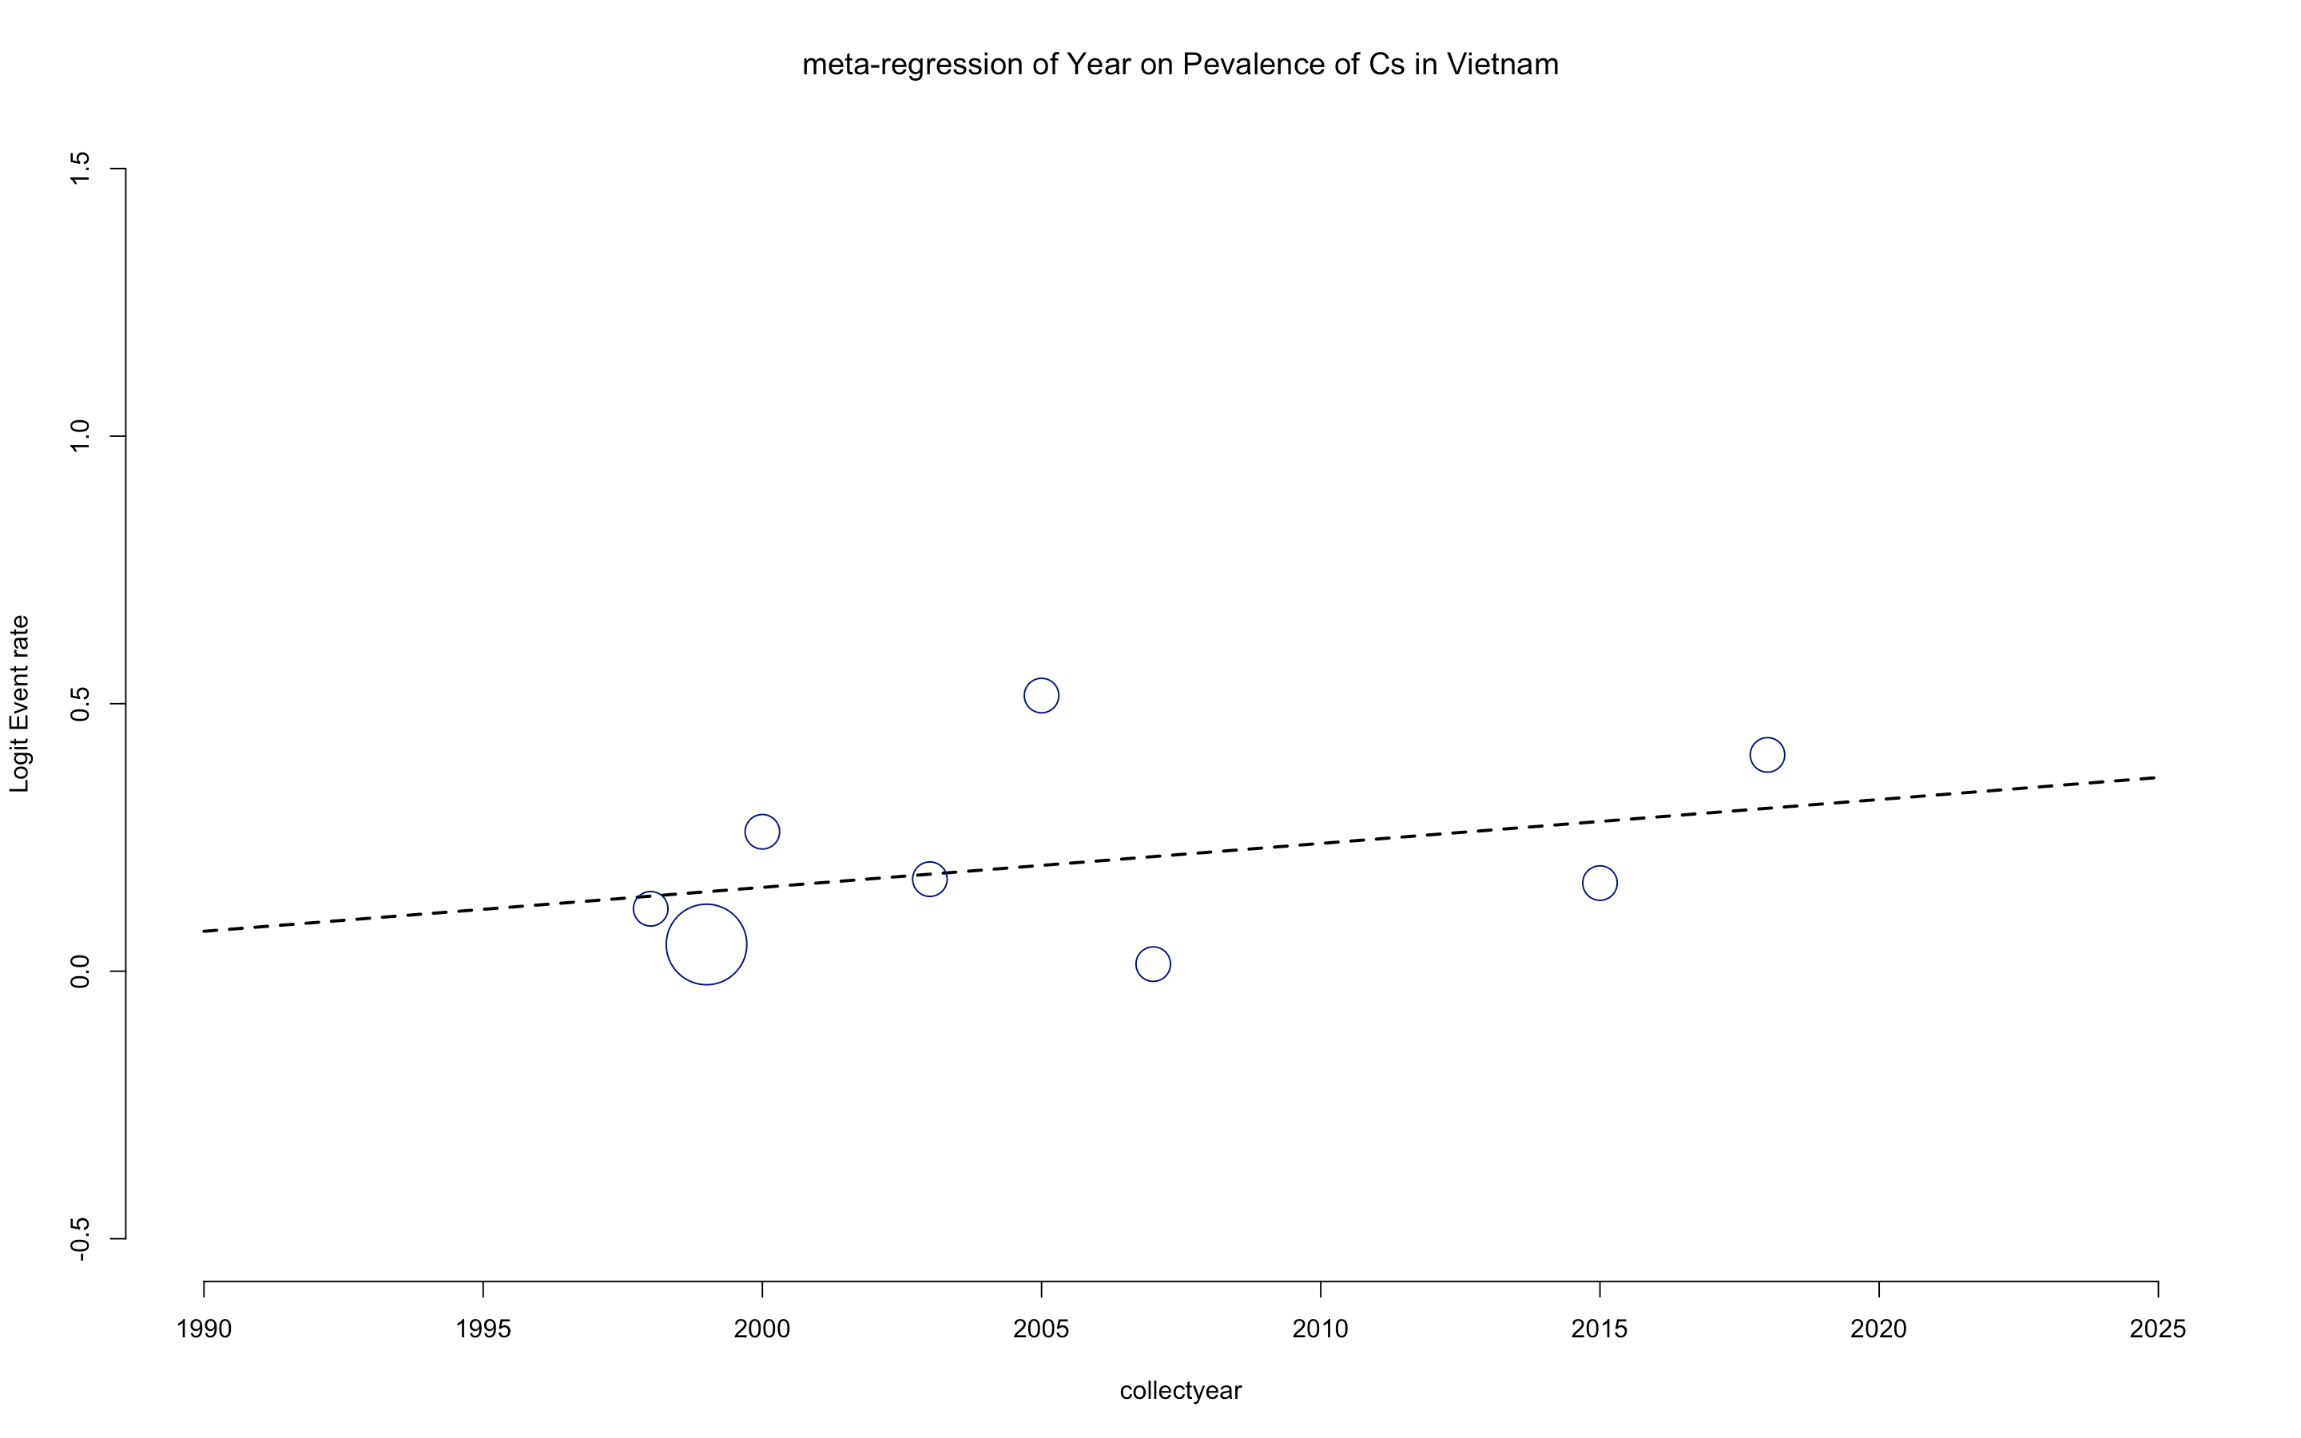
Figure S9 Random-effects meta-regression analysis of the prevalence of Clonorchis sinensis infection in Vietnam by collecting year show a statistically non-significant increase trend in prevalence.

