Table S1. Primers used for multigene testing
Specimens | Target gene | Primer name | Primer sequence (5’→3’)
Rattus species | COI | BatL5310 | CCTACTCRGCCATTTTACCTATG
Rattus species | COI | R6036R | ACTTCTGGGTGTCCAAAGAATCA
Tick species | COI | T-COIF | GAGTCGGTAAAATGGCGCTAC
Tick species | COI | T-COIR | GCTATCTTTAAGAGGGTAATA
Candidatus Rickettsia longicornii | 16S rRNA | Eh-out1 | TTGAGAGTTTGATCCTGGCTCAGAACG
Candidatus Rickettsia longicornii | 16S rRNA | Eh-out2U | CACCTCTACACTAGGAATTCCACTATC
Candidatus Rickettsia longicornii | 16S rRNA | 3-17U | WAAGGWGGTAATCCAGC
Candidatus Rickettsia longicornii | 16S rRNA | Eh-out2fU | GATAGTGGAATTCCTAGTGTAGAGGTG
Candidatus Rickettsia longicornii | gltA | CS2d | ATGACCAATGAAAATAATAAT
Candidatus Rickettsia longicornii | gltA | CSEndr | CTTATACTCTCTATGTACA
Candidatus Rickettsia longicornii | gltA | RpCS877f | GGGGACCTGCTCACGGCGG
Candidatus Rickettsia longicornii | gltA | RpCS1258r | ATTGCAAAAAGTACAGTGAACA
Candidatus Rickettsia longicornii | ompA | Rr190.70 | ATGGCGAATATTTCTCCAAAA
Candidatus Rickettsia longicornii | ompA | Rr190.602n | AGTGCAGCATTCGCTCCCCCT
Candidatus Rickettsia longicornii | ompA | Tara38s1 | AAAACCGCTTTATTACC
Candidatus Rickettsia longicornii | ompA | Tara384r1 | GGCAACAAGTTACCTCCT
Candidatus Rickettsia longicornii | ompB | rompB OF | GTAACCGGAAGTAATCGTTTCGTAA
Candidatus Rickettsia longicornii | ompB | rompB OR | GCTTTATAACCAGCTAAACCACC
Candidatus Rickettsia longicornii | ompB | rompB SFG IF | GTTTAATACGTGCTGCTAACCAA
Candidatus Rickettsia longicornii | ompB | rompB SFG/TG IR | GGTTTGGCCCATATACCATAAG
Candidatus Rickettsia longicornii | 17kDa | 17k3 | GCTTTACAAAATTCTAAAAACCATATA
Candidatus Rickettsia longicornii | 17kDa | 17k5 | TGTCTATCAATTCACAACTTGCC
Candidatus Rickettsia longicornii | 17kDa | Tara17KD 13s1 | ATTGTCCGTCAGGTTGGC
Candidatus Rickettsia longicornii | 17kDa | Tara17KD 408r1 | CGGGCGGTATGAATAAGC
Candidatus Rickettsia longicornii | sca1 | sca159 | CCCGTCTCGTGACTTACC
Candidatus Rickettsia longicornii | sca1 | sca936 | AGCATTAGGCGATGGTAG
Candidatus Rickettsia longicornii | sca1 | sca183 | TAAGCCGATATTTGGAGT
Candidatus Rickettsia longicornii | sca1 | sca612 | TTTATGGATGCGTGGTAT
Candidatus Rickettsia longicornii | sca4 | sc4-1 | ATGTCTCTGAATTAAGCAATGC
Candidatus Rickettsia longicornii | sca4 | Rj2837r | CCTGATACTACCCTTACATC
Candidatus Rickettsia longicornii | sca4 | sc4-3 | AATTATTAGGCTCTGTATTAAAGA
Candidatus Rickettsia longicornii | sca4 | sc4-4 | GAAAGGATAGCACGAAAAGTA
Candidatus Neoehrlichia mikurensis | 16S rRNA | Eh-out1 | TTGAGAGTTTGATCCTGGCTCAGAACG
Candidatus Neoehrlichia mikurensis | 16S rRNA | Eh-out2U | CACCTCTACACTAGGAATTCCACTATC
Candidatus Neoehrlichia mikurensis | 16S rRNA | 3-17U | WAAGGWGGTAATCCAGC
Candidatus Neoehrlichia mikurensis | 16S rRNA | Eh-out2fU | GATAGTGGAATTCCTAGTGTAGAG GTG
Candidatus Neoehrlichia mikurensis | groEL | CNM-out1 | TGGCAAATGTAGTTGTAACAGG
Candidatus Neoehrlichia mikurensis | groEL | CNM-out2 | TCTACTTCACTTGAACCGCCA
Candidatus Neoehrlichia mikurensis | groEL | CNM-in1 | GCTATTAGTAAGCCTTATGGTAC
Candidatus Neoehrlichia mikurensis | groEL | CNM-in2 | GAAGAATTACTATCTACGCTACC
Anaplasma capra | groEL | groe1F | ATGGCGAATGTTGTTGTT
Anaplasma capra | groEL | groe1472r | TTAGCGTAGTTCATGGTGTC
Anaplasma capra | groEL | groe3F | GGCGAATGTTGTTGTTACGG
Anaplasma capra | groEL | groe1011r | SACRCTTCCTATGATTGTGGT
Anaplasma capra | msp4 | Acm41f | CAGTCTGCGCCTGCTCCCTAC
Anaplasma capra | msp4 | Acm4799r | AGGAATCTTGCTCCAAGGTTA
Anaplasma capra | msp4 | Acm480f | CGGAGTCATGGGAGGTAG
Anaplasma capra | msp4 | Acm4693r | AGGATTCGTCAAAGAGCC
Anaplasma capra | gltA | AcgA122f | GCGTTGCTCATCTCCTGT
Anaplasma capra | gltA | ACgA790r | GATCGTAATTCTTGTAGACCCT
Anaplasma capra | gltA | ACgA122f | GCGTTGCTCATCTCCTGT
Anaplasma capra | gltA | ACgA758r | CCCATAAGCCTCACTCCAT
A. ovis | 16S rRNA | rp2 | ACGGCTACCTTGTTACGACTT
A. ovis | 16S rRNA | HER16SD | GGTACCYACAGAAGAAGTCC
A. ovis | 16S rRNA | fD1 | AGAGTTTGATCCTGGCTCAG
A. ovis | 16S rRNA | HER16SR | TAGCACTCATCGTTTACAGC
A. ovis | groEL | ovisge37f | AAATCTATAAGGGAGGTAGTGC
A. ovis | groEL | ovisg1048r | GGCTAGTCCTGCTGGTAAT
A. ovis | groEL | ovisgr419f | AGGACGAAATTGCACAGG
A. ovis | groEL | ovisg1474r | CGTTAGCGTAGTTCATGGTG
A. ovis | msp4 | Aomp4-63f | CCTGCTCCCTACTTGTTA
A. ovis | msp4 | Aomp4-769r | GTTATGTGCGGGTATGTC
A. ovis | msp4 | Aomp4-168f | CTTACAGCCCAGCGTTTC
A. ovis | msp4 | Aomp4-765r | TGTGCGGGTATGTCCTTG
A. ovis | gltA | 23F | GCGATTTTAGAGTGYGGAGATTG
A. ovis | gltA | 1104R | TACAATACCGGAGTAAAAGTCAA
A. ovis | gltA | 148F | GGGTTCMTGTCYACTGCTGCGTG
A. ovis | gltA | 940R | TTGGATCGTARTTCTTGTAGACC
A. phagocytophilum | groEL | ANA-GroF | TCATTACTCAGAGTGCTTCTCAGTG
A. phagocytophilum | groEL | ANA-GroR | CGATCAAACTGCATACCATCAGTC
Ehrlichia cains | groEL | gro607F | GAAGATGCWGTWGGWTGTACKGC
Ehrlichia cains | groEL | gro1294R | AGMGCTTCWCCTTCWACRTCYTC
Ehrlichia cains | groEL | gro677F | ATTACTCAGAGTGCTTCTCARTG
Ehrlichia cains | groEL | gro1121R | TGCATACCRTCAGTYTTTTCAAC
Ehrlichia cains | gltA | CAN-M61F | TTATCTGTTTATGTTATATAAGC
Ehrlichia cains | gltA | CAN1317R | CAGTACCTATGCATATCAATCC
Ehrlichia cains | Dsb | Dsb-330 | GATGATGTCTGAAGATATGAAACA AAT
Ehrlichia cains | Dsb | Dsb-728 | CTGCTCGTCTATTTTACTTCTTAAA GT
Ehrlichia cains | TRP36 | TRP36-F2 | TTTAAAACAAAATTAACACACTA
Ehrlichia cains | TRP36 | TRP36-R1 | AAGATTAACTTAATACTCAATATT ACT
Ehrlichia cains | TRP36 | TRP36-R1 | AAGATTAACTTAATACTCAATATT ACT
Ehrlichia cains | TRP36 | TRP36-DF | CACACTAAAATGTATAATAAAGC

Table S2. Overall prevalence of animals and vectors from different species with emerging Rickettsiales in Yunnan province
Species | No. of test | No. of positive | Prevalence (%) | Species | No. of test | No. of positive | Prevalence (%)
Small mammals |  |  |  | Leopoldamys edwardsi | 13 | 0 | 0.00%
Rattus tanezumi | 720 | 22 | 3.06 | Apodemus agrarius | 12 | 0 | 0.00
Apodemus draco | 452 | 14 | 3.10 | Berylmys bowersi | 11 | 0 | 0.00
Apodemus chevrieri | 429 | 2 | 0.47 | Niviventer excelsior | 11 | 0 | 0.00
Rattus andamanensis | 272 | 21 | 7.72 | Vernaya fulva | 9 | 0 | 0.00
Niviventer confucianus | 187 | 4 | 2.14 | Eothenomys proditor | 7 | 0 | 0.00
Eothenomys miletus | 172 | 2 | 1.16 | Rattus pyctoris | 7 | 0 | 0.00
Unknow species | 165 | 0 | 0.00 | Eothenomys melanogaster | 5 | 0 | 0.00
Suncus murinus | 124 | 2 | 1.61 | Ochotona forresti | 5 | 0 | 0.00
Mus pahari | 123 | 1 | 0.81 | Sorex unguiculatus | 5 | 0 | 0.00
Apodemus latronum | 121 | 4 | 3.31 | Suncus etruscus | 5 | 0 | 0.00
Niviventer fulvescens | 100 | 0 | 0.00 | Tamiops swinhoei | 5 | 0 | 0.00
Rattus norvegicus | 97 | 5 | 5.15 | Scaptonyx fusicaudus | 3 | 1 | 33.33
Anourosorex squamipes | 84 | 0 | 0.00 | Bandicota indica | 2 | 0 | 0.00
Episoriculus caudatus | 83 | 6 | 7.23 | Eozapus setchuanus | 2 | 0 | 0.00
Mus caroli | 77 | 0 | 0.00 | Crocidura lasiura | 1 | 0 | 0.00
Crocidura dracula | 73 | 1 | 1.37 | Dremomys rufigenis | 1 | 0 | 0.00
Eothenomys eleusis | 73 | 4 | 5.48 | Niviventer brahma | 1 | 0 | 0.00
Tupaia belangeri | 71 | 0 | 0.00 | Typhlomys cinereus | 1 | 0 | 0.00
Crocidura attenuata | 69 | 0 | 0.00 | Livestock
Rattus nitidus | 69 | 3 | 4.35 | Sheep | 1107 | 446 | 40.29
Eothenomys custos | 68 | 4 | 5.88 | Cow | 704 | 317 | 45.03
Ochotona thibetana | 65 | 3 | 4.62 | Dog | 559 | 37 | 6.62
Episoriculus leucops | 62 | 0 | 0.00 | Cat | 5 | 0 | 0.00
Sorex cylindricauda | 48 | 2 | 4.17 | Ticks
Neodon leucurus | 47 | 2 | 4.26 | Rhipicephalus microplus | 457 | 167 | 36.54
Crocidura vorax | 39 | 0 | 0.00 | Ixodes ovatus | 302 | 8 | 2.65
Micromys minutus | 33 | 0 | 0.00 | Haemaphysalis montgomeryi | 201 | 58 | 28.86
Uropsilus aequodonenia | 33 | 0 | 0.00 | Haemaphysalis Kolonini | 163 | 2 | 1.23
Eothenomys cachinus | 32 | 0 | 0.00 | Ixodes granulatus | 51 |  | 0.00
Neotetracus sinensis | 30 | 0 | 0.00 | Rhipicephalus haemaphysaloides | 15 | 8 | 53.33
Niviventer eha | 30 | 0 | 0.00 | Hae. spp. | 14 |  | 0.00
Sorex asper | 30 | 1 | 3.33 | Haemaphysalis yeni | 14 | 12 | 85.71
Neodon clarkei | 28 | 0 | 0.00 | Haemaphysalis menglaensis | 10 |  | 0.00
Hylomys suillus | 27 | 0 | 0.00 | Ixodes acutitarsus | 10 | 3 | 30.00
Niviventer andersoni | 24 | 1 | 4.17 | Haemaphysalis nepalensis | 9 |  | 0.00
Eothenomys olitor | 19 | 1 | 5.26 | Dermacentor auratus | 7 |  | 0.00
Mus musculus | 18 | 0 | 0.00 | Haemaphysalis longicornis | 5 | 2 | 40.00
Dremomys pernyi | 16 | 1 | 6.25 | Amblyomma testudinarium | 1 |  | 0.00
Crocidura indochinensis | 14 | 0 | 0.00

Table S3. The diversity of BLAST-based sequence analysis of tick-associated Rickettsiales in animals and vectors
Sample number | BLAST result | Accession | Query coverage（%） | Percent identity （%）
SP-030 | Candidatus Neoehrlichia mikurensis | HM439431.3 | 99.00 | 99.84
YM-159 | Candidatus Neoehrlichia mikurensis | HM439431.3 | 99.00 | 99.84
NE-038 | Candidatus Neoehrlichia mikurensis | HM439431.3 | 99.00 | 99.84
JG-061 | Candidatus Neoehrlichia mikurensis | HM439431.3 | 99.00 | 99.84
LC-146 | Candidatus Neoehrlichia mikurensis | HM439431.3 | 99.00 | 99.68
MLian-033 | Candidatus Neoehrlichia mikurensis | HM439431.3 | 100.00 | 99.68
TC-024 | Candidatus Neoehrlichia mikurensis | HM439431.3 | 100.00 | 99.68
YJ-014 | Candidatus Neoehrlichia mikurensis | OK560170.1 | 100.00 | 99.48
DQ-179 | Candidatus Neoehrlichia mikurensis | AB196304.1 | 100.00 | 99.65
WX-183 | Candidatus Neoehrlichia mikurensis | GU227699.1 | 100.00 | 99.39
YunL-065 | Candidatus Neoehrlichia mikurensis | AB196304.1 | 100.00 | 99.29
MLian-240 | Ehrlichia sp. YN04 | KY433582.1 | 96.00 | 99.38
YJ-005 | Ehrlichia sp. YN04 | KY433582.1 | 100.00 | 100.00
YM-090 | Anaplasma ovis | KX579073.1 | 100.00 | 100.00
YM-249 | Anaplasma ovis | KX579073.1 | 100.00 | 99.04
MLian-036 | Anaplasma ovis | OQ909500.1 | 100.00 | 98.23
DQ-098 | Anaplasma sp. strain DQ098 | KU189193.1 | 100.00 | 97.48
DQ-292 | Anaplasma sp. strain DQ098 | KU189193.1 | 100.00 | 97.48
SP-036 | A. phagocytophilum | CP015376.1 | 91.00 | 99.09
TC-013 | A. phagocytophilum | OL690565.1 | 100.00 | 99.43
YJ-316 | A. phagocytophilum | FJ788512.1 | 99.00 | 99.81
YM-063 | A. phagocytophilum | KC470064.1 | 100.00 | 99.50
YM-103 | A. phagocytophilum | KC470064.1 | 100.00 | 99.50
YL-020 | Wolbachia sp. strain YL020 | OX366385.1 | 100.00 | 99.68
XX-329 | Wolbachia sp. strain YM011 | DQ115537.1 | 100.00 | 98.83
MLian-056 | Wolbachia sp. strain YM011 | DQ115537.1 | 100.00 | 98.99
YM-011 | Wolbachia sp. strain YM011 | CP116767.1 | 100.00 | 98.72
LC-126 | Wolbachia sp. strain YM011 | DQ115537.1 | 100.00 | 99.66
MZ-112 | Wolbachia sp. strain YM011 | DQ115537.1 | 100.00 | 99.50
YS-016 | Wolbachia sp. strain YM011 | DQ115537.1 | 100.00 | 99.50
JG-008 | Wolbachia sp. strain YM011 | DQ115537.1 | 100.00 | 99.50
JG-013 | Wolbachia sp. strain YM011 | DQ115537.1 | 100.00 | 99.50
YM-174 | Rickettsia typhi | NR_074394.1 | 100.00 | 99.52
LC-024 | Candidatus R. longicornii | MT747412.1 | 100.00 | 99.38
TC-B-06 | A. marginale | MN187218.1 | 100.00 | 99.16
TC-B-357 | A. marginale | OL660546.1 | 100.00 | 98.99
YunL-B-115 | A. phagocytophilum | CP035303.1 | 100.00 | 97.65
TC-B-580 | A. phagocytophilum | OL690558.1 | 93.00 | 98.39
DQ-B-210 | A. phagocytophilum | MK814412.1 | 100.00 | 99.65
TC-B-613 | A. phagocytophilum | OL690562.1 | 99.00 | 98.31
TC-B-476 | A. phagocytophilum | CP015376.1 | 99.00 | 97.82
GM-B-35 | A. phagocytophilum | OL690562.1 | 99.00 | 98.98
TC-B-241 | A. phagocytophilum | OL690562.1 | 100.00 | 99.06
TC-B-174 | A. phagocytophilum | OL690562.1 | 100.00 | 99.46
Wsh-B-06 | A. phagocytophilum | OL690562.1 | 100.00 | 100.00
TC-B-614 | A. phagocytophilum | OL690562.1 | 99.00 | 100.00
YB-B-36 | A. platys | MF289478.1 | 100.00 | 99.29
TC-B-567 | A. platys | MF289478.1 | 100.00 | 99.83
TC-B-482 | A. platys | MF289478.1 | 100.00 | 99.16
TC-B-721 | A.platys | OK560282.1 | 99.00 | 98.31
TC-B-729 | A. platys | OK560282.1 | 99.00 | 98.48
TC-B-737 | A. platys | OK560281.1 | 99.00 | 98.65
TC-B-598 | A. platys | MK506833.1 | 100.00 | 98.49
TC-B-727 | A. marginale | MK804764.1 | 100.00 | 100.00
YJ-B-5 | A. marginale | MK804764.1 | 100.00 | 98.51
DQ-B-19 | A. marginale | MK804764.1 | 100.00 | 99.60
XX-B-37 | A. marginale | MK804764.1 | 100.00 | 99.80
DY-B-5 | A. marginale | MK804764.1 | 100.00 | 99.80
TC-B-479 | A. capra | MG869594.1 | 100.00 | 100.00
TC-B-240 | A. bovis | MH255940.1 | 100.00 | 98.56
DQ-B-3 | A. bovis | MH255940.1 | 100.00 | 99.46
TC-B-243 | A. bovis | MH255940.1 | 100.00 | 100.00
GM-B-38 | A. ovis | MG869525.1 | 100.00 | 100.00
HP-B-8 | A. ovis | MG869525.1 | 100.00 | 100.00
JC-B-47 | A. ovis | MG869525.1 | 100.00 | 100.00
LP-B-10 | A. ovis | MG869525.1 | 100.00 | 100.00
TC-B-182 | A. ovis | MG869525.1 | 100.00 | 100.00
Wsh-B-09 | A. ovis | MG869525.1 | 100.00 | 100.00
YunL-B-10 | A. ovis | KJ410244.1 | 100.00 | 99.83
YunL-B-122 | Ehrlichia cains | MK507008.1 | 100.00 | 99.50
YunL-B-120 | Ehrlichia cains | MK507008.1 | 100.00 | 99.43
TC-B-635 | Ehrlichia cains | MK507008.1 | 100.00 | 99.33
LP-B-2 | Ehrlichia cains | MK507008.1 | 100.00 | 99.29
DY-B-13 | Ehrlichia cains | MK507008.1 | 100.00 | 98.86
MLa-B-22 | Wolbachia pipientis | CP037426.1 | 100.00 | 99.83
TC-T-49 | A. phagocytophilum | OL690565.1 | 100.00 | 99.47
TC-T-157 | A. platys | MK736884.1 | 99.00 | 99.23
LS-T-35 | A. platys | MF289478.1 | 100.00 | 99.30
HQ-T-1 | Anaplasma sp. strain HQT1 | MK814441.1 | 100.00 | 98.49
JC-T-222 | Anaplasma sp. strain JCT222 | KY924886.1 | 100.00 | 100.00
DQ-T-52 | A. bovis | MH255939.1 | 100.00 | 99.73
TC-T-400 | Anaplasma sp. Strain TCT400 | OL690561.1 | 99.00 | 97.80
JH-T-19 | A. marginale | MK804764.1 | 100.00 | 100.00
TC-T-398 | A. ovis | OR214930.1 | 100.00 | 99.83
YunL-T-18 | A. ovis | KJ410245.1 | 99.00 | 100.00
YuL-T-53 | A. ovis | MG869525.1 | 100.00 | 100.00
JC-T-88 | A. ovis | MG869525.1 | 100.00 | 100.00
HQ-T-7 | A. ovis | MG869525.1 | 100.00 | 100.00
DQ-T-56 | A. ovis | MG869525.1 | 100.00 | 100.00
JC-T-246 | Ehrlichia cains | MK507008.1 | 100.00 | 99.00
TC-T-403 | Ehrlichia cains | MK507008.1 | 100.00 | 98.67
TC-T-393 | Ehrlichia cains | MK507008.1 | 100.00 | 98.84
LS-T-33 | Ehrlichia cains | MK507008.1 | 100.00 | 99.00
JC-T-251 | Ehrlichia cains | MK507008.1 | 100.00 | 99.34
YunL-T-26 | Candidatus Neoehrlichia mikurensis | AB196304.1 | 100.00 | 99.64
YunL-T-13 | Candidatus Neoehrlichia mikurensis | AB196304.1 | 100.00 | 99.46
HQ-T-2 | R. hoogstraalii | NR_104877.1 | 100.00 | 99.83
EY-T-6 | R. hoogstraalii | NR_104877.1 | 100.00 | 99.83
YunL-T-70 | R. hoogstraalii | NR_104877.1 | 100.00 | 99.83
JC-T-62 | Rickettsia massiliae | CP003319.1 | 100.00 | 100.00
EY-T-16 | Rickettsia massiliae | CP003319.1 | 100.00 | 100.00
JH-T-15 | Rickettsia massiliae | CP003319.1 | 100.00 | 100.00
YunL-T-67 | Candidatus R. longicornii | MT747412.1 | 100.00 | 99.83
YunL-T-49 | Candidatus R. longicornii | MT747412.1 | 100.00 | 99.83
YunL-T-30 | Candidatus R. longicornii | MT747412.1 | 100.00 | 100.00
WX-T-85 | Candidatus R. longicornii | MG906672.1 | 100.00 | 100.00
TC-T-155 | Candidatus R. longicornii | MG906672.1 | 100.00 | 99.30
LS-T-38 | Candidatus R. longicornii | MG906672.1 | 100.00 | 99.30
JC-T-135 | Candidatus R. longicornii | MG906672.1 | 100.00 | 100.00
GM-T-167 | Candidatus R. longicornii | MT747412.1 | 100.00 | 100.00
EY-T-3 | Candidatus R. longicornii | MG906672.1 | 100.00 | 100.00
DQ-T-40 | Candidatus R. longicornii | MT747412.1 | 100.00 | 99.82
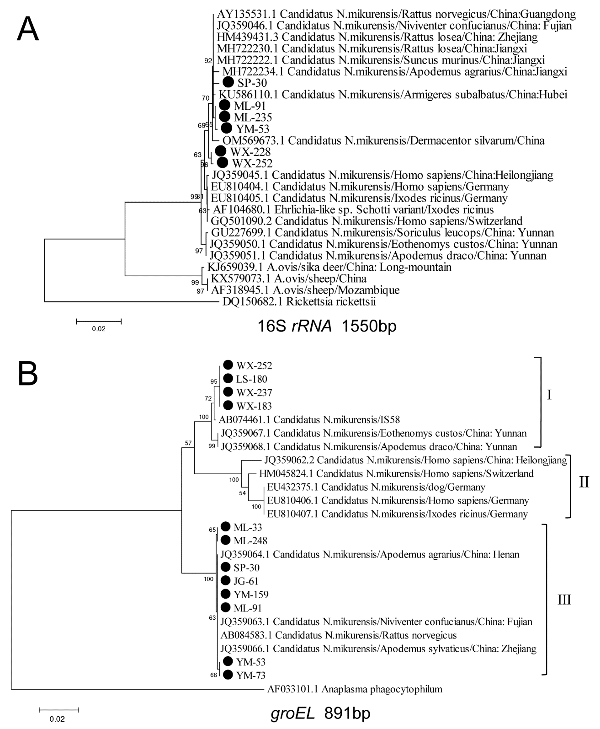Figure S1. Phylogenetic trees constructed by the MEGA v.6.0 software based on the neighbor-joining method of multigene detected in small mammals infected by Candidatus Neoehrlichia mikurensis. A: 16S rRNA gene (1550 bp); B: groEL gene (891 bp).
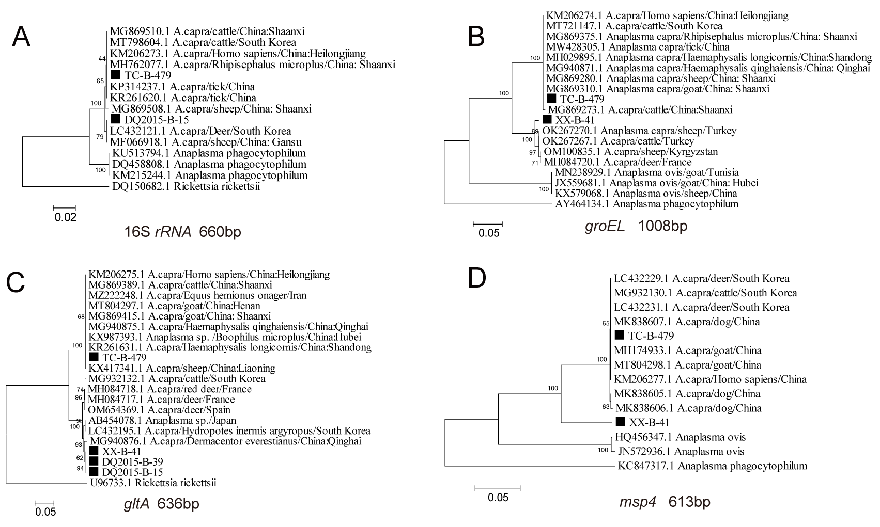Figure S2. Phylogenetic trees constructed by the MEGA v.6.0 software based on the neighbor-joining method of multigene detected in livestock infected by Anaplasma capra. A: 16S rRNA gene (660 bp); B: groEL gene (1008 bp); C: gltA gene (636 bp); D: msp4 gene (613 bp)/
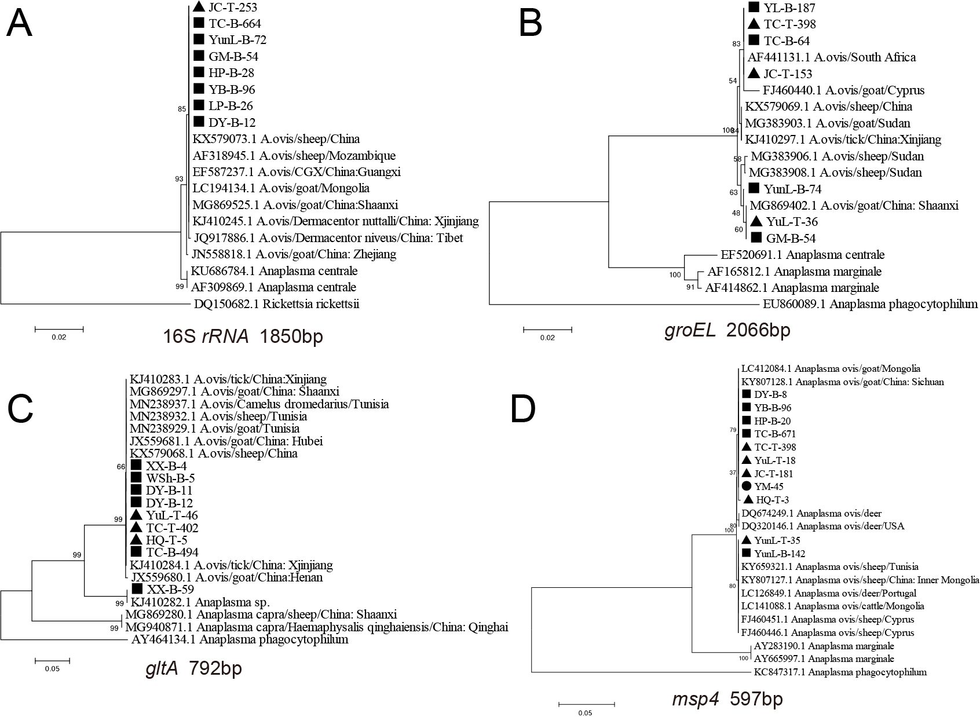
Figure S3. Phylogenetic trees constructed by the MEGA v.6.0 software based on the Neighbor-Joining method of multigene detected in different samples infected Anaplasma ovis. Triangles, circles and rectangles represent livestock, small mammals, and ticks in this study respectively. A: 16S rRNA gene (1850 bp); B: groEL gene (2066 bp); C: gltA gene (792 bp); D: msp4 gene (597 bp).
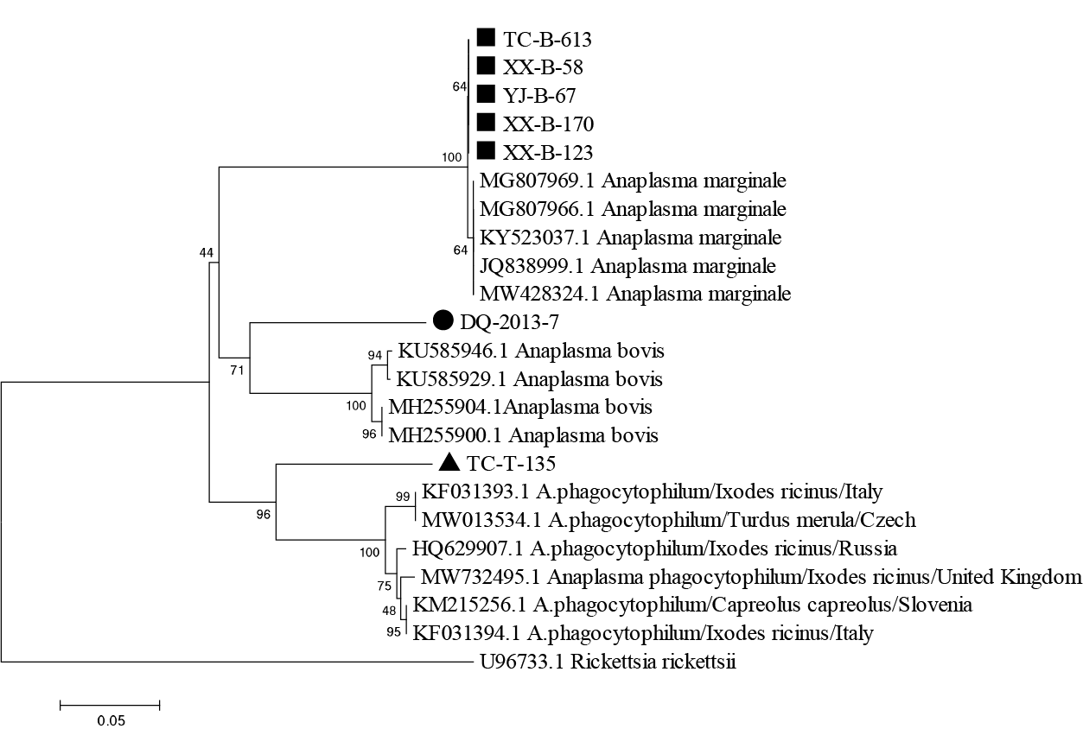
Figure S4. Phylogenetic trees constructed by the MEGA v.6.0 software based on the neighbor-joining method of groEL gene (372 bp) detected in different samples. Triangles, circles and rectangles represent livestock, small mammals, and ticks in this study respectively.

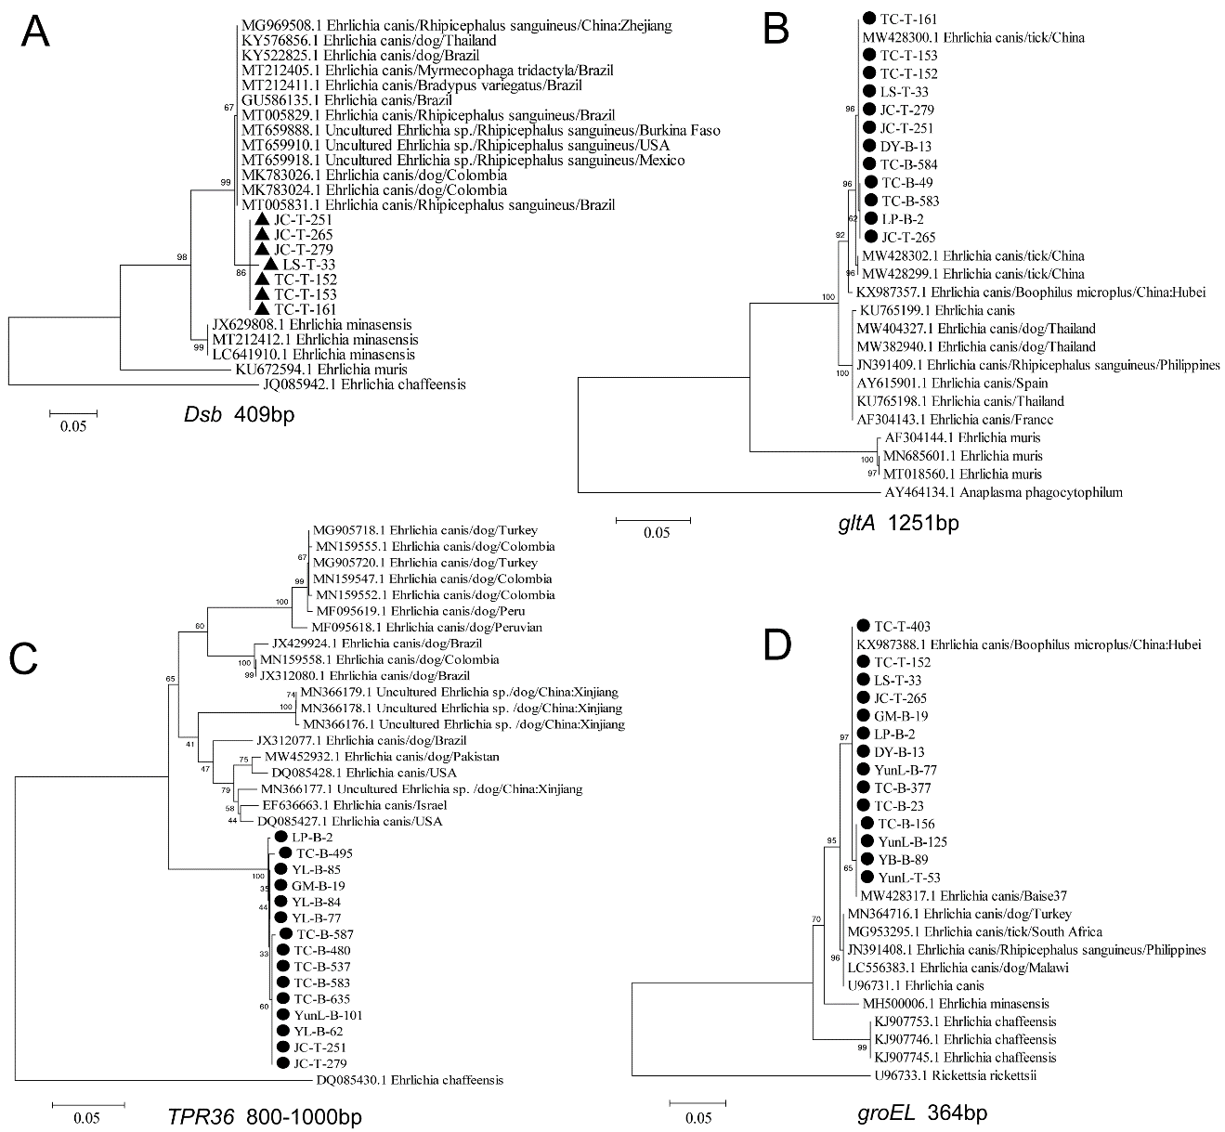Figure S5. Phylogenetic trees constructed by the MEGA v.6.0 software based on the neighbor-joining method of multigene detected in different samples infected Ehrlichia canis. Circles and rectangles represent small mammals and ticks in this study respectively. A: Dsb gene (409 bp); B: gltA gene (125 bp); C: TRP36 gene (800–1000 bp); D: groEL gene (364 bp).

