Additional file 7: Forest Plots of Socioeconomic Variables Associated with Human Visceral Leishmaniasis in the Americas
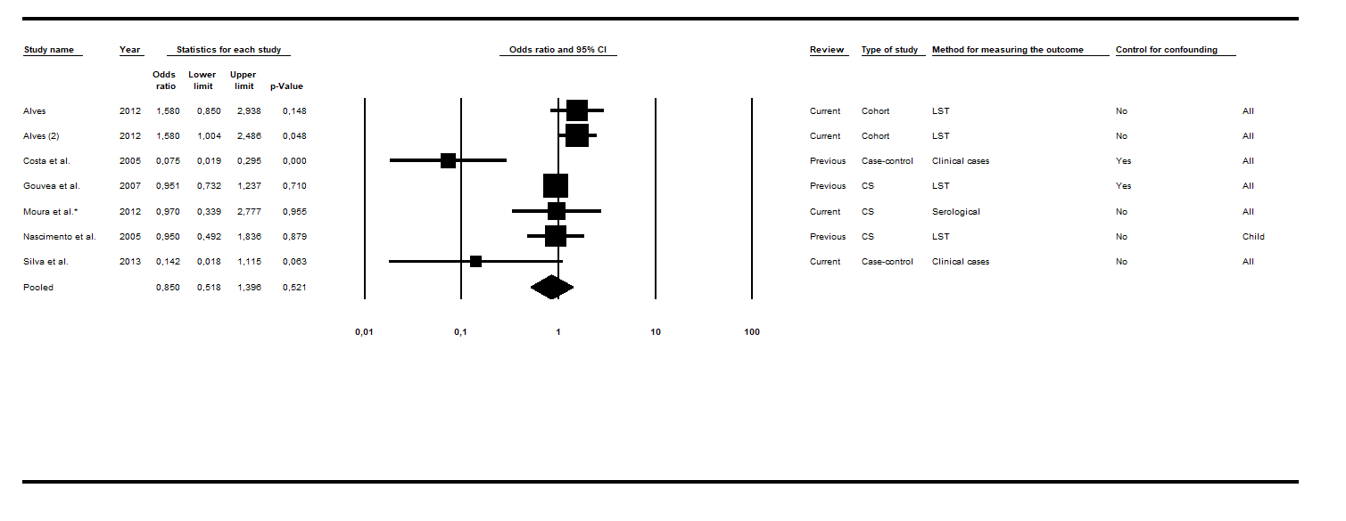
Fig. S1 Forest plot for the water supply variable. Abbreviations: CS cross-sectional; LST Leishmania skin test. Superscripts: (*) result of serological test in a study involving two diagnostic tests; (#) results in adults; (2) second result in a single article. The squares represent the weight of each study, whereas the diamonds represent the summary measurement of each subgroup. Reference: Non-piped water, Odds Ratio = 1. [40, 43, 48, 60, 63, 65]

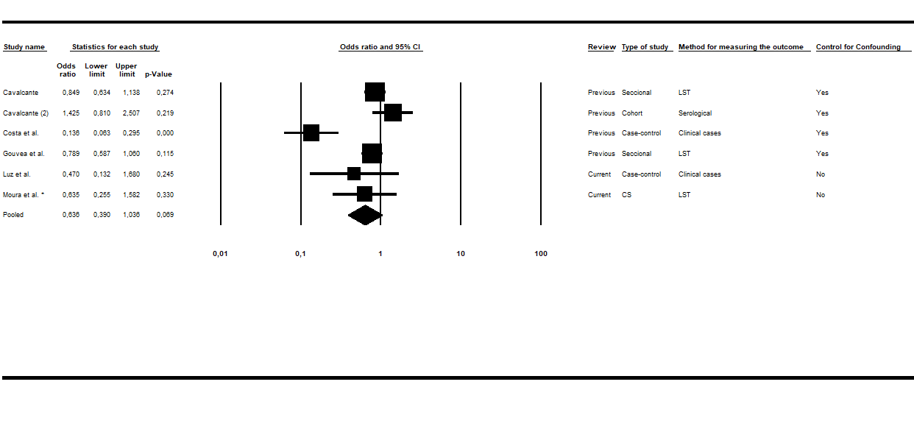 Fig. S2 Forest plot for the sewage system variable. Abbreviations: CS cross-sectional; LST Leishmania skin test. Superscripts: (*) result of serological test in a study involving two diagnostic tests; (#) results in adults; (2) second result in a single article. The squares represent the weight of each study, whereas the diamonds represent the summary measurement of each subgroup. Reference: Absence of sewage system, Odds Ratio = 1. [40, 48, 53, 63, 69]

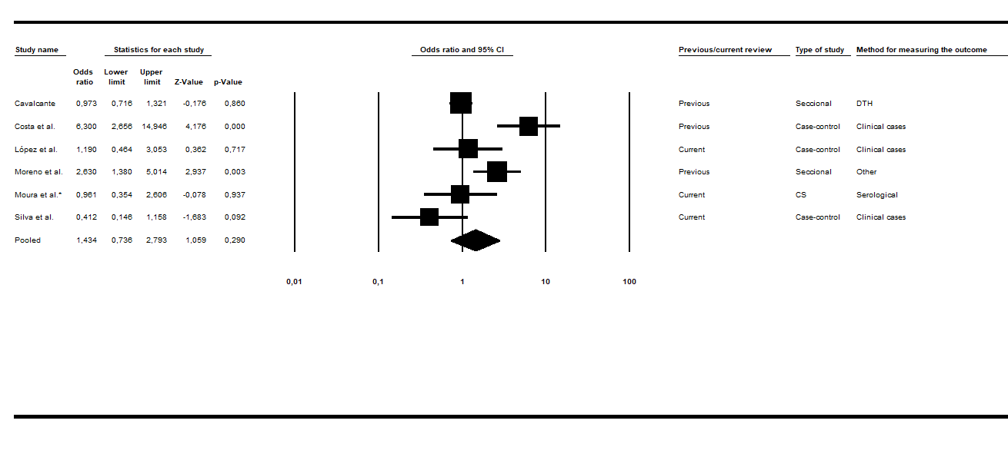
Fig. S3 Forest plot for the garbage collection variable. Abbreviations: CS cross-sectional; LST Leishmania skin test. Superscripts: (*) result of serological test in a study involving two diagnostic tests; (#) results in adults; (2) second result in a single article. The squares represent the weight of each study, whereas the diamonds represent the summary measurement of each subgroup. Reference: Public garbage collection, Odds Ratio = 1. [40, 42, 53, 63, 65, 67]

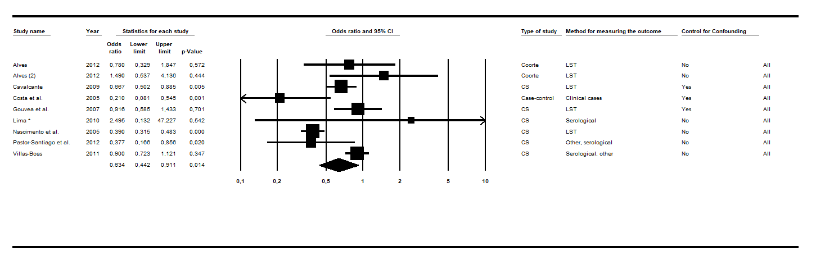
Fig. S4 Forest plot for the floor variable. Abbreviations: CS cross-sectional; LST Leishmania skin test. Superscripts: (*) result of serological test in a study involving two diagnostic tests; (#) results in adults; (2) second result in a single article. The squares represent the weight of each study, whereas the diamonds represent the summary measurement of each subgroup. Reference: Inadequate, Odds Ratio = 1. [14, 40, 43, 48, 53, 57, 59, 60]

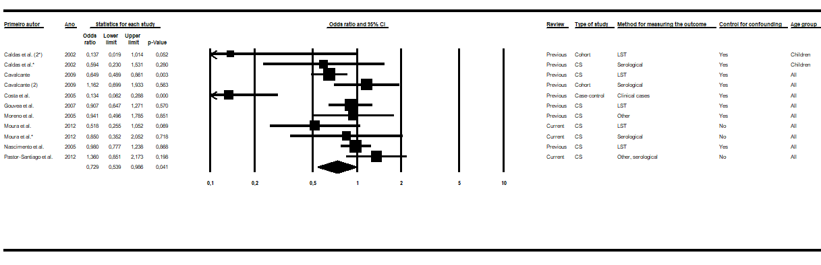
Fig. S5 Forest plot for the house finishing variable. Abbreviations: CS cross-sectional; LST Leishmania skin test. Superscripts: (*) result of serological test in a study involving two diagnostic tests; (#) results in adults; (2) second result in a single article. The squares represent the weight of each study, whereas the diamonds represent the summary measurement of each subgroup. Reference: Inadequate, Odds Ratio = 1. [14, 37, 40, 42, 43, 48, 53, 63]

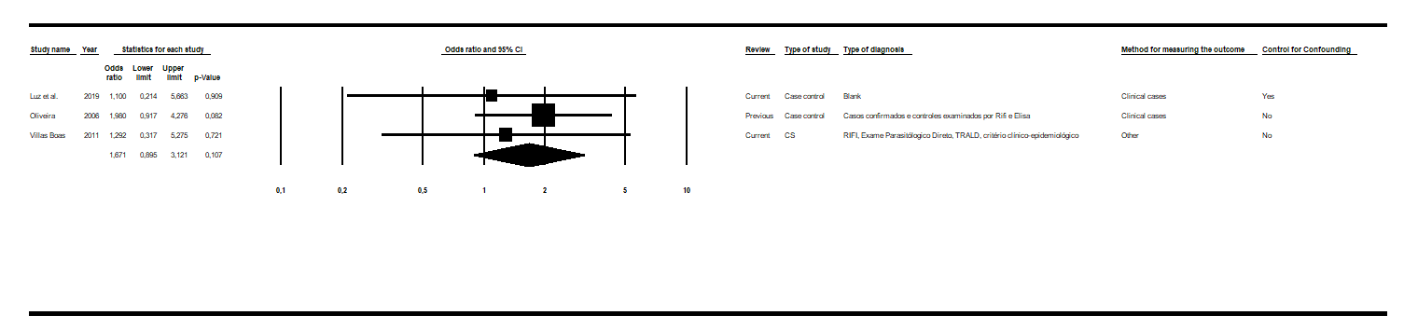
Fig. S6 Forest plot for the income variable. Abbreviations: CS cross-sectional; LST Leishmania skin test. Superscripts: (*) result of serological test in a study involving two diagnostic tests; (#) results in adults; (2) second result in a single article. The squares represent the weight of each study, whereas the diamonds represent the summary measurement of each subgroup. Reference: More than 01 minimum wage, Odds Ratio = 1. [45, 59, 69]

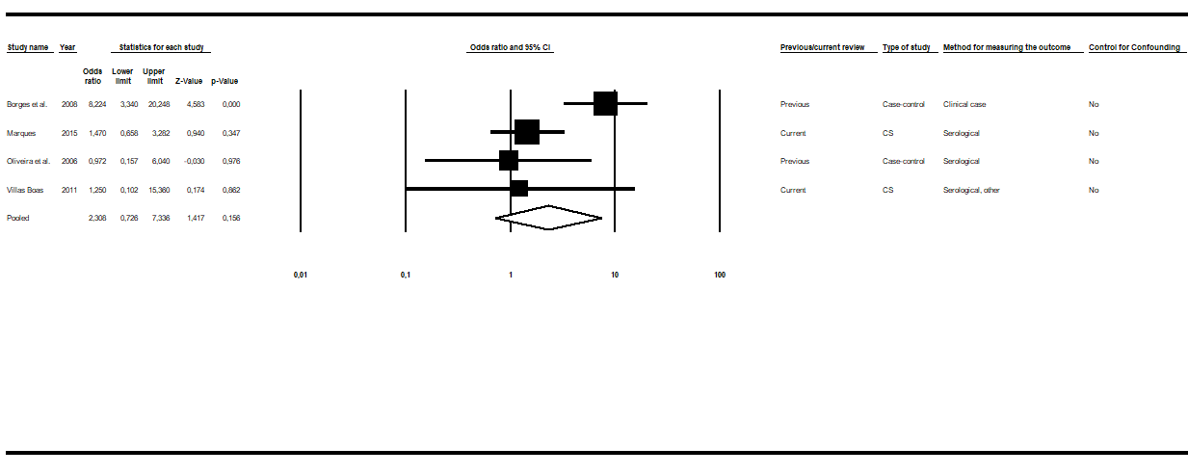 Fig. S7 Forest plot for the variable education. Abbreviations: CS cross-sectional; LST Leishmania skin test. Superscripts: (*) result of serological test in a study involving two diagnostic tests; (#) results in adults; (2) second result in a single article. The squares represent the weight of each study, whereas the diamonds represent the summary measurement of each subgroup. Reference: Some education, Odds Ratio = 1. [45, 49, 59, 66]

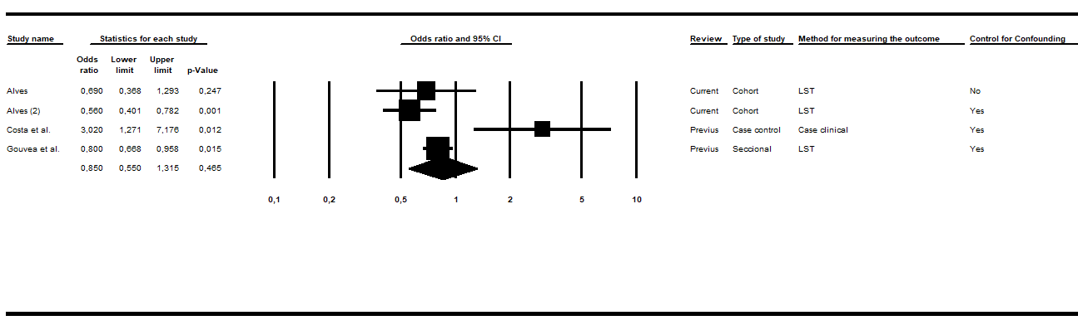
Fig. S8Forest plot for the variable education. Abbreviations: CS cross-sectional; LST Leishmania skin test. Superscripts: (*) result of serological test in a study involving two diagnostic tests; (#) results in adults; (2) second result in a single article. The squares represent the weight of each study, whereas the diamonds represent the summary measurement of each subgroup. Reference: Non-elementary, Odds Ratio = 1. [40, 48, 60]
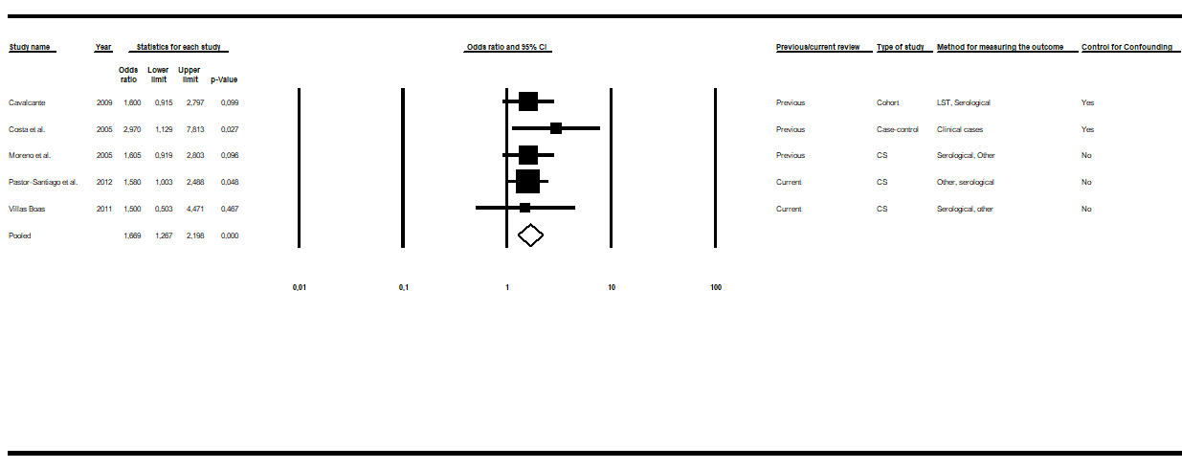
Fig. 9 Forest plot for the variable number of residents per household. Abbreviations: CS cross-sectional; LST Leishmania skin test. Superscripts: (*) result of serological test in a study involving two diagnostic tests; (#) results in adults; (2) second result in a single article. The squares represent the weight of each study, whereas the diamonds represent the summary measurement of each subgroup. Reference: < 4 people, Odds Ratio = 1. [14, 40, 42, 53, 59]

