Supplementary Information

Wildlife hunting and the increased risk of leprosy transmission in the tropical Americas: a pathogeographical study

Table of Contents
Table S1. Predictor variables considered in the Armadillo Hunting Model, Armadillo Leprosy Model and Risk of Leprosy in Humans Model.
Table S2. Armadillo Hunting Model outputs.
Table S3. Evaluation of the Armadillo Hunting Model and the distribution models used to build it based on discrimination and classification capabilities.
Table S4. Armadillo Leprosy Model outputs.
Fig. S1. Maps showing the occurrence records of Dasypus spp. and Euphractus sexcinctus in Brazil.
Fig. S2. Distribution models and hunting models of E. sexcinctus y Dasypus spp.

Table S1. Predictor variables considered for modelling. Some variables were used only in specific models: Armadillo-Hunting Model*, Leprosy Armadillo Model** and Human Leprosy Risk Model***
Factor | Code | Variable | Source
Climate | Bio1 | Annual Mean Temperature | Chelsa (http://chelsa-climate.org)
Climate | Bio5 | Max Temperature of Warmest Month | Chelsa (http://chelsa-climate.org)
Climate | Bio6 | Min Temperature of Coldest Month | Chelsa (http://chelsa-climate.org)
Climate | Bio7 | Temperature Annual Range (Bio5-Bio6) | Chelsa (http://chelsa-climate.org)
Climate | Bio12 | Annual Precipitation | Chelsa (http://chelsa-climate.org)
Climate | Bio15 | Precipitation Seasonality (Coefficient of Variation) | Chelsa (http://chelsa-climate.org)
Infrastructures | Roads_km2 | Density of roads | Extension of state and federal roads (km; dated from 2021 and sourced from Departamento Nacional de Infraestrutura de Transportes: https://www.gov.br/dnit/pt-br), divided by the municipality area.
Socioeconomic | Log_hpd_2021*** | Human population density (log) | Brazilian Institute of Geography and Statistics (IBGE, 2021)  IBGE. (2021). Estimativas populacionais para os municípios e para as Unidades da Federação brasileiros 2021. Available at: https://www.ibge.gov.br/.
Socioeconomic | Malnutrition*** | Malnutrition rate | Reports on the nutritional status of individuals monitored by period, life cycle stage, and index in the year 2021 (ages 0 to 5 years). Available at: https://sisaps.saude.gov.br/sisvan/relatoriopublico/index#)
Socioeconomic | IDHM_2010*** | Índice de Desenvolvimento Humano Municipal (Municipality Human Development Index) | Brazilian Human Development Atlas (PNUD, 2013),  PNUD - Brazilian Atlas of Human Development. 2013. Ranking IDH Municípios. Available at: http://www.atlasbrasil.org.br/2013/en.
Socioeconomic | Phone_cover** | Phone cover in Brazil | Sourced from Agência Nacional de Telecomunicações https://www.gov.br/anatel/pt-br/dados/qualidade/qualidade-dos-servicos/cobertura-da-telefonia-movel )
Socioeconomic | Log_PIB_per_capita*** | GDP per capita | Brazilian Institute of Geography and Statistics (IBGE, 2021). Produto Interno Bruto dos Municípios - 2021.
Socioeconomic | POV_2010*** | Poverty rate | Brazilian Human Development Atlas (PNUD, 2013),SOURCE  PNUD - Brazilian Atlas of Human Development. 2013. Ranking IDH Municípios. Available at: http://www.atlasbrasil.org.br/2013/en
Socioeconomic | B_votes*** | Percentage of people voting for Bolsonaro in 2022 | Percentage of votes for defeated and former president Jair Bolsonaro in the 2nd round of presidential elections in 2022 (sourced from Tribunal Superior Eleitoral, available at https://www.tse.jus.br/eleicoes/eleicoes-2022),
Socioeconomic | Gun_ind* | Proportion of guns per civilian | Obtained through direct request from the Brazilian Federal Police (Number of guns in the municipality divided by the total population of the municipality)
Hydrography | HydricAvai** | Hydric availability | https://metadados.snirh.gov.br/geonetwork/srv/por/catalog.search#/metadata/7ac42372-3605-44a4-bae4-4dee7af1a2f8
Hydrography | Rivers_km2** | Density of navigable rivers | Length of navigable rivers (km; 2017) sourced from the River and Groundwater Basins of the World, BGR/UNESCO (https://www.whymap.org/whymap/EN/Maps_Data/Rgwb/rgwb_node_en.html);
Ecosystem Types | Class 30 | Mosaic Vegetation (grassland, shrubland, forest) (50-70%) / Cropland (20-50%) | GlobCover (GC) Land Cover version 2.3 database for 2009 [1]
Ecosystem Types | Class 40 | Closed to open (>15%) broadleaved evergreen and/or semi-deciduous forest (>5m) | GlobCover (GC) Land Cover version 2.3 database for 2009 [1]
Ecosystem Types | Class 50 | Closed (>40%) broadleaved deciduous forest (>5m) | GlobCover (GC) Land Cover version 2.3 database for 2009 [1]
Ecosystem Types | Class 60 | Open (15-40%) broadleaved deciduous forest (>5m) | GlobCover (GC) Land Cover version 2.3 database for 2009 [1]
Ecosystem Types | Class 70 | Closed (>40%) needleleaved evergreen forest (>5m) | GlobCover (GC) Land Cover version 2.3 database for 2009 [1]
Ecosystem Types | Class 90 | Open (15-40%) needleleaved deciduous or evergreen forest (>5m) | GlobCover (GC) Land Cover version 2.3 database for 2009 [1]
Ecosystem Types | Class 100 | Closed to open (>15%) mixed broadleaved and needleleaved forest (>5m) | GlobCover (GC) Land Cover version 2.3 database for 2009 [1]
Ecosystem Types | Class 110 | Mosaic Forest/Shrubland (50-70%) / Grassland (20-50%) | GlobCover (GC) Land Cover version 2.3 database for 2009 [1]
Ecosystem Types | Class 120 | Mosaic Grassland (50-70%) / Forest/Shrubland (20-50%) | GlobCover (GC) Land Cover version 2.3 database for 2009 [1]
Ecosystem Types | Class 130 | Closed to open (>15%) shrubland (<5m) | GlobCover (GC) Land Cover version 2.3 database for 2009 [1]
Ecosystem Types | Class 140 | Closed to open (>15%) grassland | GlobCover (GC) Land Cover version 2.3 database for 2009 [1]
Ecosystem Types | Class 150 | Sparse (>15%) vegetation (woody vegetation, shrubs, grassland) | GlobCover (GC) Land Cover version 2.3 database for 2009 [1]
Ecosystem Types | Class 160 | Closed (>40%) broadleaved semi-deciduous and/or evergreen forest regularly flooded - Saline water | GlobCover (GC) Land Cover version 2.3 database for 2009 [1]
Ecosystem Types | Class 170 | Closed (>40%) broadleaved semi-deciduous and/or evergreen forest regularly flooded - Saline water | GlobCover (GC) Land Cover version 2.3 database for 2009 [1]
Ecosystem Types | Class 180 | Closed to open (>15%) vegetation (grassland, shrubland, woody vegetation) on regularly flooded or waterlogged soil - Fresh, brackish or saline water | GlobCover (GC) Land Cover version 2.3 database for 2009 [1]
Ecosystem Types | Class 200 | Bare areas | GlobCover (GC) Land Cover version 2.3 database for 2009 [1]
Ecosystem Types | Class 220 | Permanent snow and ice | GlobCover (GC) Land Cover version 2.3 database for 2009 [1]
Habitat | Forest loss | Non intact forest | High-Resolution Global Maps of 21st-Century Forest Cover Change [2]
Habitat | Natural_habitat (2019) | Native habitat coverage | Remaining native habitat cover in 2019 (%; MapBiomas 2019)
Habitat | Veg_height | Vegetation height | GEDI-Landsat data [3].
Habitat | Biomass_AG | Biomass Above Ground. | https://daac.ornl.gov/GEDI/guides/GEDI_L4B_Gridded_Biomass.html
Spatial descriptors | Yesp3 | Spatial trend | Linear combination of spatial variables derived from continental-scale trend surface analyses [4]
References:
[1] Bontemps S. GLOBCOVER 2009 Products Description and Validation Report. 2011.
[2] Hansen MC. High-resolution global maps of 21st-century forest cover change. Science. 2013;342: 850–853
[3] Potapov, P.; Hansen, M.C.; Kommareddy, I.; Kommareddy, A.; Turubanova, S.; Pickens, A.; Adusei, B.; Tyukavina, A.; Ying, Q. 2020. Landsat Analysis Ready Data for Global Land Cover and Land Cover Change Mapping. Remote Sens. 12, 426. https://doi.org/10.3390/rs12030426
[4] Legendre P. Spatial autocorrelation: Trouble or New Paradigm? Ecology. 1993;74: 1659–1673

Table S2. Armadillo Hunting Model outputs.
Dasypus spp.
Variable | Estimate | Std. Error | Wald | p-value
Constant | -22.937 | 7.821 | 8.601 | 0.003
Favourability of species distribution | 1.072 | 0.661 | 2.629 | 0.105
Min Temperature of Coldest Month | 0.007 | 0.003 | 7.072 | 0.008
Closed to open (>15%) broadleaved evergreen or semi-deciduous forest | 1.238 | 0.329 | 14.136 | <0.001
Slope (average) | -0.264 | 0.094 | 7.806 | 0.005
Density of roads | -1.406 | 0.555 | 6.423 | 0.011
Proportion of guns per civilian | 0.950 | 0.217 | 19.076 | <0.001
Human population density (log) | 1.175 | 0.112 | 109.910 | <0.001
Spatial trend of hunting | 0.790 | 0.131 | 36.273 | <0.001

Euphractus sexcinctus
Variable | Estimate | Std. Error | Wald | p-value
Constant | -0.867 | 1.262 | 0.473 | 0.492
Favourability of species distribution | 1.311 | 1.283 | 1.044 | 0.307
Proportion of guns per civilian | 1.350 | .481 | 7.874 | 0.005
Human population density (log) | 1.207 | .222 | 29.608 | <0.001
Spatial trend of hunting | 1.496 | .225 | 44.093 | <0.001

Table S3. Evaluation of the Armadillo Hunting Model and the distribution models used to build it based on discrimination and classification capabilities.
Sens.: sensitivity; Spec.: specificity; TSS true skill statistic; CCR: correct classification rate; Underp.: underprediction rate; Overp.: overprediction rate and AUC: area under the receiver operator characteristic curve.
 | Sen. | Spec. | TSS | CCR | Underp. | Overp. | AUC
Dasypus spp. Distribution Model | 0.588 | 0.653 | 0.241 | 0.637 | 0.171 | 0.643 | 0.674
Euphractus sexcinctus Distribution Model | 0.665 | 0.601 | 0.266 | 0.613 | 0.108 | 0.735 | 0.685
Euphractus sexcinctus Hunting Model | 0.721 | 0.721 | 0.442 | 0.721 | 0.003 | 0.980 | 0.798
Dasypus spp. Hunting Model | 0.677 | 0.762 | 0.439 | 0.758 | 0.020 | 0.882 | 0,783
Hunting Model | 0.745 | 0.587 | 0.332 | 0.595 | 0.022 | 0.913 | 0.744

Table S4. Armadillo Leprosy Model outputs.
Variable | Estimate | Std. Error | t value | Pr(>|t|) | Wald
Intercept | -116 | 4.59E-03 | -25273 | <0.001 | 6.39E+08
Mosaic Forest/Shrubland (50-70%) / Grassland (20-50%) | -2.633 | 9.46E-05 | -27849 | <0.001 | 7.75E+08
Hydric availability | -0.328 | 2.75E-06 | -119199 | <0.001 | 1.43E+10
Native habitat coverage | -2.278 | 2.05E-05 | -111310 | <0.001 | 1.24E+10
Density of navigable rivers | -18.2 | 1.33E-04 | -137027 | <0.001 | 1.88E+10
Closed to open (>15%) broadleaved evergreen or semi-deciduous forest | -2.619 | 2.74E-05 | -95449 | <0.001 | 9.11E+09
Slope (average) | -0.794 | 6.75E-06 | -117622 | <0.001 | 1.38E+10
Max Temperature of Warmest Month (log) | 34.24 | 1.32E-03 | 26002 | <0.001 | 6.76E+08
Temperature Annual Range (log) | 0.667 | 3.44E-05 | 19376 | <0.001 | 3.76E+08
Closed (>40%) broadleaved deciduous forest | -5.495 | 6.25E-05 | -87976 | <0.001 | 7.74E+09
Density of roads | -0.833 | 4.83E-05 | -17244 | <0.001 | 2.98E+08
Mosaic Vegetation (50-70%) / Cropland (20-50%) | -1.433 | 2.10E-05 | -68208 | <0.001 | 4.65E+09

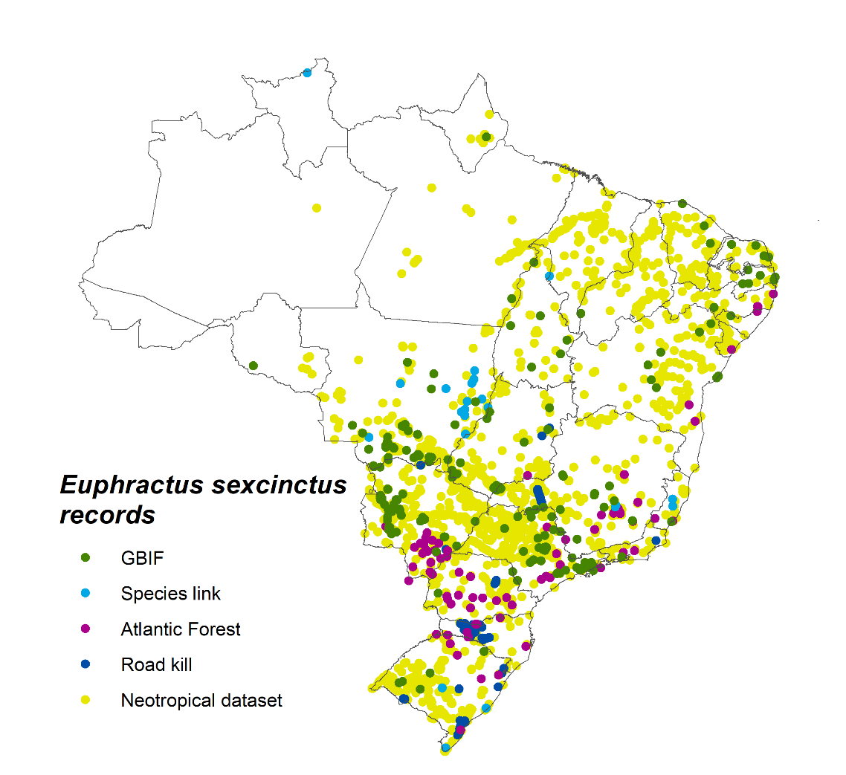
Fig. S1. Maps showing the occurrence records of Euphractus sexcinctus and Dasypus spp. in Brazil.

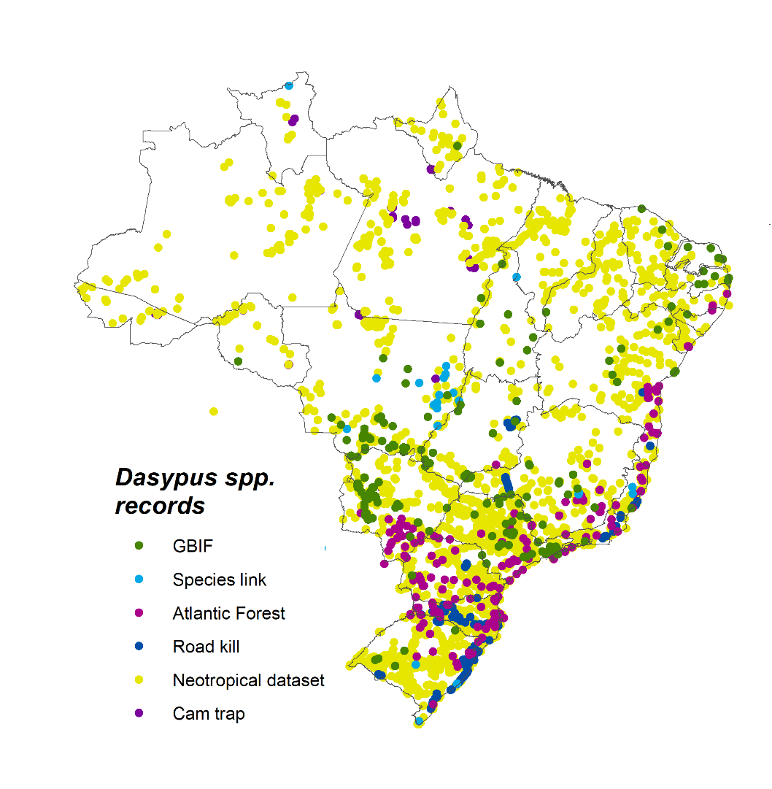

Fig. S2. Distribution models and hunting models of E. sexcinctus y Dasypus spp.
