Supplementary materials
Contrasting patterns of trematode and host snail dispersal across clusters of tropical crater lakes
Cyril Hammoud^{1,2}, Bert Van Bocxlaer^{3,1}, Julius Tumusiime⁴, Dirk Verschuren¹, Christian Albrecht^{4,5}, Casim Umba Tolo⁴, Tine Huyse^{2,6}
1. Ghent University, Limnology Unit, Department of Biology, 9000 Gent, Belgium
2. Royal Museum for Central Africa, Department of Biology, 3080 Tervuren, Belgium
3. French National Centre for Scientific Research, University of Lille, Mixed research unit 8198 Evolution-Ecology-Paleontology, F-59000 Lille, France
4. Mbarara University of Science and Technology, Department of Biology, 40006 Mbarara, Uganda
5. Justus Liebig University, Systematics and Biodiversity Laboratory, Department of Animal Ecology and Systematics, D-35392 Giessen, Germany
6. University of Leuven, Laboratory of Biodiversity and Evolutionary Genomics, B-3000 Leuven, Belgium
Corresponding author: Cyril Hammoud (cyril.hammoud@nioz.nl)
Clinical trial number: Not applicable.

 |  | Latitude | Longitude | Petasiger sp. | Echinoparyphium sp. | Plagiorchioidea sp.
Bunyaruguru | Nyungu n=115 | -0.25772 | 30.0943 | 0.9 | 4.3 | 7
Bunyaruguru | Maturo n=208 | -0.26555 | 30.10468 | 0 | 26.9 | 91.3
Bunyaruguru | Kigezi n=85 | -0.28746 | 30.109867 | 0 | 0 | 2.4
Bunyaruguru | Mirambi n=87 | -0.22515 | 30.10787 | 0 | 0 | 20.7
Ndali-Kasenda | Nyabikere n=200 | 0.49675 | 30.3311 | 1.5 | 22 | 0
Ndali-Kasenda | Kitere n=200 | 0.3973 | 30.2734 | 6.5 | 0 | 0
Ndali-Kasenda | Wandakara n=89 | 0.41565 | 30.2705 | 2.2 | 0 | 0
Ndali-Kasenda | Kasenda n=419 | 0.433017 | 30.29143 | 5 | 3.3 | 0.2
Ndali-Kasenda | Njarayabana n=73 | 0.429017 | 30.25103 | 1.4 | 0 | 0
Ndali-Kasenda | Mahuhura n=200 | 0.43925 | 30.26577 | 16.5 | 0 | 0
Ndali-Kasenda | Nyamirima n=111 | 0.519967 | 30.32038 | 4.5 | 2.7 | 0
Ndali-Kasenda | Rukwanzi n=201 | 0.473983 | 30.27928 | 8.5 | 0 | 0
Ndali-Kasenda | Nyinambuga n=71 | 0.481133 | 30.28778 | 0 | 0 | 0
Ndali-Kasenda | Katanda n=200 | 0.47795 | 30.26145 | 31.5 | 0 | 0
Ndali-Kasenda | Kanyamansira n=57 | 0.414683 | 30.3046 | 35.1 | 14 | 0
Table S1: Infection prevalence (in %) of the three parasites in the Bulinus tropicus populations analysed. Sample sizes (n) represent the number of host snails screened for infection per lake.
Table S2: GenBank accession numbers of the sequences used in the study.
Organism | Marker | GenBank accession numbers
Bulinus tropicus | cox1 I | OQ541006-OQ541828
Bulinus tropicus | cox1 II | OQ541851-OQ542662
Bulinus tropicus | NAD1 | OQ558014-OQ558829
Petasiger sp. | cox1 I | OQ543471-OQ543551
Petasiger sp. | cox1 II | OQ606526- OQ606696
Petasiger sp. | NAD1 | OQ574003-OQ574300
Petasiger sp. | cytb | OQ574934-OQ575061
Echinoparyphium sp. | cox1 I | -
Echinoparyphium sp. | cox1 II | OQ606482- OQ606490
Echinoparyphium sp. | NAD1 | OQ573822-OQ573932
Echinoparyphium sp. | cytb | OQ574693-OQ574808
Plagiorchioidea sp. | cox1 I | -
Plagiorchioidea sp. | cox1 II | -
Plagiorchioidea sp. | NAD1 | OQ574304-OQ574520
Plagiorchioidea sp. | cytb | OQ575062-OQ575271

Table S3: Sample size (n), number of unique haplotypes (Nh), number of polymorphic sites (Np), haplotype diversity (h) and nucleotide diversity (π) with standard deviation in the various populations of Bulinus tropicus, Petasiger sp., Echinoparyphium sp. and Plagiorchioidea sp.
Taxon | Marker | Cluster | Lake | n | Nh | Np | h | π
Bulinus tropicus | Multi-markers | Bunyaruguru | Nyungu | 14 | 2 | 20 | 0.1429 ± 0.1188 | 0.002199 ± 0.001382
Bulinus tropicus | Multi-markers | Bunyaruguru | Maturo | 191 | 14 | 32 | 0.6569 ± 0.0282 | 0.006949 ± 0.003556
Bulinus tropicus | Multi-markers | Bunyaruguru | Kigezi | 47 | 1 | 0 | 0.0000 ± 0.0000 | 0.000000 ± 0.000000
Bulinus tropicus | Multi-markers | Bunyaruguru | Mirambi | 34 | 3 | 21 | 0.6827 ± 0.0236 | 0.006934 ± 0.003640
Bulinus tropicus | Multi-markers | Ndali-Kasenda | Nyabikere | 44 | 5 | 4 | 0.6607 ± 0.0287 | 0.000631 ± 0.000508
Bulinus tropicus | Multi-markers | Ndali-Kasenda | Kitere | 33 | 9 | 13 | 0.8826 ± 0.0238 | 0.002312 ± 0.001377
Bulinus tropicus | Multi-markers | Ndali-Kasenda | Wandakara | 18 | 5 | 6 | 0.6928 ± 0.0864 | 0.001263 ± 0.000873
Bulinus tropicus | Multi-markers | Ndali-Kasenda | Kasenda | 133 | 7 | 8 | 0.5324 ± 0.0260 | 0.000478 ± 0.000419
Bulinus tropicus | Multi-markers | Ndali-Kasenda | Njarayabana | 64 | 25 | 28 | 0.9444 ± 0.0127 | 0.003349 ± 0.001860
Bulinus tropicus | Multi-markers | Ndali-Kasenda | Mahuhura | 54 | 24 | 34 | 0.8728 ± 0.0354 | 0.001968 ± 0.001191
Bulinus tropicus | Multi-markers | Ndali-Kasenda | Nyamirima | 7 | 4 | 5 | 0.7143 ± 0.1809 | 0.001246 ± 0.000955
Bulinus tropicus | Multi-markers | Ndali-Kasenda | Rukwanzi | 19 | 2 | 8 | 0.4561 ± 0.0852 | 0.002809 ± 0.001663
Bulinus tropicus | Multi-markers | Ndali-Kasenda | Nyinambuga | 12 | 2 | 8 | 0.4848 ± 0.1059 | 0.002986 ± 0.001814
Bulinus tropicus | Multi-markers | Ndali-Kasenda | Katanda | 80 | 3 | 9 | 0.0972 ± 0.0448 | 0.000469 ± 0.000417
Bulinus tropicus | Multi-markers | Ndali-Kasenda | Kanyamansira | 33 | 3 | 3 | 0.2254 ± 0.0916 | 0.000309 ± 0.000327
Bulinus tropicus | COI1 | Bunyaruguru | Nyungu | 15 | 2 | 7 | 0.1333 ± 0.1123 | 0.001973 ± 0.001609
Bulinus tropicus | COI1 | Bunyaruguru | Maturo | 191 | 8 | 13 | 0.6233 ± 0.0283 | 0.006907 ± 0.003954
Bulinus tropicus | COI1 | Bunyaruguru | Kigezi | 47 | 1 | 0 | 0.0000 ± 0.0000 | 0.000000 ± 0.000000
Bulinus tropicus | COI1 | Bunyaruguru | Mirambi | 34 | 2 | 7 | 0.4278 ± 0.0667 | 0.006331 ± 0.003769
Bulinus tropicus | COI1 | Ndali-Kasenda | Nyabikere | 69 | 3 | 2 | 0.6338 ± 0.0283 | 0.001610 ± 0.001327
Bulinus tropicus | COI1 | Ndali-Kasenda | Kitere | 33 | 5 | 5 | 0.7367 ± 0.0400 | 0.002867 ± 0.002023
Bulinus tropicus | COI1 | Ndali-Kasenda | Wandakara | 18 | 3 | 2 | 0.3072 ± 0.1316 | 0.000677 ± 0.000805
Bulinus tropicus | COI1 | Ndali-Kasenda | Kasenda | 141 | 6 | 5 | 0.5370 ± 0.0227 | 0.001245 ± 0.001113
Bulinus tropicus | COI1 | Ndali-Kasenda | Njarayabana | 64 | 12 | 13 | 0.8398 ± 0.0245 | 0.005696 ± 0.003404
Bulinus tropicus | COI1 | Ndali-Kasenda | Mahuhura | 57 | 9 | 10 | 0.5345 ± 0.0729 | 0.003828 ± 0.002484
Bulinus tropicus | COI1 | Ndali-Kasenda | Nyamirima | 7 | 3 | 3 | 0.5238 ± 0.2086 | 0.001812 ± 0.001652
Bulinus tropicus | COI1 | Ndali-Kasenda | Rukwanzi | 20 | 3 | 3 | 0.5105 ± 0.0907 | 0.002237 ± 0.001726
Bulinus tropicus | COI1 | Ndali-Kasenda | Nyinambuga | 12 | 2 | 2 | 0.4848 ± 0.1059 | 0.002050 ± 0.001683
Bulinus tropicus | COI1 | Ndali-Kasenda | Katanda | 81 | 2 | 3 | 0.0722 ± 0.0389 | 0.000458 ± 0.000615
Bulinus tropicus | COI1 | Ndali-Kasenda | Kanyamansira | 34 | 2 | 1 | 0.1658 ± 0.0804 | 0.000350 ± 0.000539
Bulinus tropicus | COI2 | Bunyaruguru | Nyungu | 15 | 2 | 6 | 0.1333 ± 0.1123 | 0.002410 ± 0.002063
Bulinus tropicus | COI2 | Bunyaruguru | Maturo | 191 | 6 | 10 | 0.5238 ± 0.0306 | 0.008251 ± 0.004864
Bulinus tropicus | COI2 | Bunyaruguru | Kigezi | 47 | 1 | 0 | 0.0000 ± 0.0000 | 0.000000 ± 0.000000
Bulinus tropicus | COI2 | Bunyaruguru | Mirambi | 34 | 3 | 6 | 0.6827 ± 0.0236 | 0.007801 ± 0.004763
Bulinus tropicus | COI2 | Ndali-Kasenda | Nyabikere | 69 | 2 | 1 | 0.0290 ± 0.0279 | 0.000087 ± 0.000303
Bulinus tropicus | COI2 | Ndali-Kasenda | Kitere | 33 | 3 | 2 | 0.3561 ± 0.0907 | 0.001107 ± 0.001213
Bulinus tropicus | COI2 | Ndali-Kasenda | Wandakara | 18 | 4 | 3 | 0.6601 ± 0.0781 | 0.002559 ± 0.002124
Bulinus tropicus | COI2 | Ndali-Kasenda | Kasenda | 135 | 3 | 2 | 0.0295 ± 0.0203 | 0.000089 ± 0.000305
Bulinus tropicus | COI2 | Ndali-Kasenda | Njarayabana | 64 | 7 | 6 | 0.6855 ± 0.0463 | 0.003030 ± 0.002290
Bulinus tropicus | COI2 | Ndali-Kasenda | Mahuhura | 54 | 11 | 10 | 0.4500 ± 0.0842 | 0.001718 ± 0.001572
Bulinus tropicus | COI2 | Ndali-Kasenda | Nyamirima | 7 | 3 | 2 | 0.6667 ± 0.1598 | 0.002295 ± 0.002172
Bulinus tropicus | COI2 | Ndali-Kasenda | Rukwanzi | 19 | 2 | 2 | 0.4561 ± 0.0852 | 0.002748 ± 0.002224
Bulinus tropicus | COI2 | Ndali-Kasenda | Nyinambuga | 12 | 2 | 2 | 0.4848 ± 0.1059 | 0.002921 ± 0.002398
Bulinus tropicus | COI2 | Ndali-Kasenda | Katanda | 81 | 2 | 1 | 0.0722 ± 0.0389 | 0.000218 ± 0.000484
Bulinus tropicus | COI2 | Ndali-Kasenda | Kanyamansira | 33 | 2 | 1 | 0.1705 ± 0.0822 | 0.000513 ± 0.000781
Bulinus tropicus | NAD1 | Bunyaruguru | Nyungu | 14 | 2 | 7 | 0.1429 ± 0.1188 | 0.002024 ± 0.001625
Bulinus tropicus | NAD1 | Bunyaruguru | Maturo | 191 | 4 | 9 | 0.5218 ± 0.0290 | 0.006114 ± 0.003545
Bulinus tropicus | NAD1 | Bunyaruguru | Kigezi | 47 | 1 | 0 | 0.0000 ± 0.0000 | 0.000000 ± 0.000000
Bulinus tropicus | NAD1 | Bunyaruguru | Mirambi | 34 | 2 | 8 | 0.4278 ± 0.0667 | 0.006928 ± 0.004037
Bulinus tropicus | NAD1 | Ndali-Kasenda | Nyabikere | 69 | 2 | 1 | 0.0290 ± 0.0279 | 0.000059 ± 0.000204
Bulinus tropicus | NAD1 | Ndali-Kasenda | Kitere | 33 | 6 | 6 | 0.7216 ± 0.0498 | 0.002592 ± 0.001857
Bulinus tropicus | NAD1 | Ndali-Kasenda | Wandakara | 18 | 2 | 1 | 0.4706 ± 0.0823 | 0.000953 ± 0.000973
Bulinus tropicus | NAD1 | Ndali-Kasenda | Kasenda | 137 | 2 | 1 | 0.0146 ± 0.0143 | 0.000030 ± 0.000143
Bulinus tropicus | NAD1 | Ndali-Kasenda | Njarayabana | 64 | 12 | 12 | 0.8204 ± 0.0370 | 0.003201 ± 0.002140
Bulinus tropicus | NAD1 | Ndali-Kasenda | Mahuhura | 57 | 15 | 19 | 0.6347 ± 0.0716 | 0.002209 ± 0.001634
Bulinus tropicus | NAD1 | Ndali-Kasenda | Nyamirima | 7 | 1 | 0 | 0.0000 ± 0.0000 | 0.000000 ± 0.000000
Bulinus tropicus | NAD1 | Ndali-Kasenda | Rukwanzi | 20 | 2 | 4 | 0.4789 ± 0.0720 | 0.003878 ± 0.002572
Bulinus tropicus | NAD1 | Ndali-Kasenda | Nyinambuga | 12 | 2 | 4 | 0.4848 ± 0.1059 | 0.003926 ± 0.002694
Bulinus tropicus | NAD1 | Ndali-Kasenda | Katanda | 80 | 3 | 5 | 0.0972 ± 0.0448 | 0.000643 ± 0.000734
Bulinus tropicus | NAD1 | Ndali-Kasenda | Kanyamansira | 33 | 2 | 1 | 0.0606 ± 0.0561 | 0.000123 ± 0.000303
Petasiger sp. | COI1 | Ndali-Kasenda | Nyabikere | 1 | 1 | 0 | 0.0000 ± 0.0000 | 0.000000 ± 0.000000
Petasiger sp. | COI1 | Ndali-Kasenda | Kitere | 5 | 4 | 6 | 0.9000 ± 0.1610 | 0.006931 ± 0.005118
Petasiger sp. | COI1 | Ndali-Kasenda | Wandakara | 1 | 1 | 0 | 0.0000 ± 0.0000 | 0.000000 ± 0.000000
Petasiger sp. | COI1 | Ndali-Kasenda | Kasenda | 18 | 9 | 9 | 0.8758 ± 0.0515 | 0.005501 ± 0.003557
Petasiger sp. | COI1 | Ndali-Kasenda | Mahuhura | 4 | 3 | 5 | 0.8333 ± 0.2224 | 0.006188 ± 0.004982
Petasiger sp. | COI1 | Ndali-Kasenda | Nyamirima | 2 | 2 | 1 | 1.0000 ± 0.5000 | 0.002475 ± 0.003501
Petasiger sp. | COI1 | Ndali-Kasenda | Rukwanzi | 9 | 5 | 8 | 0.7222 ± 0.1592 | 0.004400 ± 0.003178
Petasiger sp. | COI1 | Ndali-Kasenda | Katanda | 28 | 10 | 12 | 0.8042 ± 0.0590 | 0.004564 ± 0.003006
Petasiger sp. | COI1 | Ndali-Kasenda | Kanyamansira | 3 | 3 | 4 | 1.0000 ± 0.2722 | 0.006601 ± 0.005924
Petasiger sp. | COI2 | Ndali-Kasenda | Nyabikere | 1 | 1 | 0 | 0.0000 ± 0.0000 | 0.000000 ± 0.000000
Petasiger sp. | COI2 | Ndali-Kasenda | Kitere | 14 | 9 | 21 | 0.9121 ± 0.0593 | 0.005 ± 0.0593
Petasiger sp. | COI2 | Ndali-Kasenda | Wandakara | 1 | 1 | 0 | 0.0000 ± 0.0000 | 0.000000 ± 0.000000
Petasiger sp. | COI2 | Ndali-Kasenda | Kasenda | 20 | 12 | 14 | 0.9000 ± 0.0532 | 0.006899 ± 0.004385
Petasiger sp. | COI2 | Ndali-Kasenda | Mahuhura | 29 | 10 | 9 | 0.7660 ± 0.0613 | 0.005937 ± 0.003826
Petasiger sp. | COI2 | Ndali-Kasenda | Nyamirima | 5 | 4 | 6 | 0.9000 ± 0.1610 | 0.008798 ± 0.006425
Petasiger sp. | COI2 | Ndali-Kasenda | Rukwanzi | 15 | 7 | 7 | 0.7714 ± 0.1001 | 0.005977 ± 0.003983
Petasiger sp. | COI2 | Ndali-Kasenda | Katanda | 65 | 21 | 26 | 0.7534 ± 0.0467 | 0.008304 ± 0.004918
Petasiger sp. | COI2 | Ndali-Kasenda | Kanyamansira | 21 | 9 | 13 | 0.8238 ± 0.0600 | 0.007708 ± 0.004786
Petasiger sp. | NAD1 | Bunyaruguru | Nyungu | 1 | 1 | 0 | 0.0000 ± 0.0000 | 0.000000 ± 0.000000
Petasiger sp. | NAD1 | Ndali-Kasenda | Nyabikere | 6 | 6 | 9 | 1.0000 ± 0.0962 | 0.007660 ± 0.005212
Petasiger sp. | NAD1 | Ndali-Kasenda | Kitere | 14 | 5 | 11 | 0.7253 ± 0.1040 | 0.005004 ± 0.003257
Petasiger sp. | NAD1 | Ndali-Kasenda | Wandakara | 2 | 2 | 3 | 1.0000 ± 0.5000 | 0.006383 ± 0.007370
Petasiger sp. | NAD1 | Ndali-Kasenda | Kasenda | 26 | 11 | 17 | 0.8062 ± 0.0706 | 0.005617 ± 0.003451
Petasiger sp. | NAD1 | Ndali-Kasenda | Njarayabana | 1 | 1 | 0 | 0.0000 ± 0.0000 | 0.000000 ± 0.000000
Petasiger sp. | NAD1 | Ndali-Kasenda | Mahuhura | 53 | 25 | 28 | 0.9035 ± 0.0312 | 0.006330 ± 0.003731
Petasiger sp. | NAD1 | Ndali-Kasenda | Nyamirima | 17 | 15 | 13 | 0.9853 ± 0.0252 | 0.007541 ± 0.004513
Petasiger sp. | NAD1 | Ndali-Kasenda | Rukwanzi | 33 | 23 | 19 | 0.9527 ± 0.0271 | 0.008075 ± 0.004639
Petasiger sp. | NAD1 | Ndali-Kasenda | Katanda | 107 | 39 | 39 | 0.8919 ± 0.0210 | 0.006934 ± 0.003987
Petasiger sp. | NAD1 | Ndali-Kasenda | Kanyamansira | 38 | 21 | 21 | 0.9403 ± 0.0232 | 0.007966 ± 0.004566
Petasiger sp. | cytb | Ndali-Kasenda | Nyabikere | 1 | 1 | 0 | 0.0000 ± 0.0000 | 0.000000 ± 0.000000
Petasiger sp. | cytb | Ndali-Kasenda | Kitere | 10 | 4 | 6 | 0.7333 ± 0.1199 | 0.006332 ± 0.004242
Petasiger sp. | cytb | Ndali-Kasenda | Wandakara | 1 | 1 | 0 | 0.0000 ± 0.0000 | 0.000000 ± 0.000000
Petasiger sp. | cytb | Ndali-Kasenda | Kasenda | 8 | 4 | 5 | 0.7857 ± 0.1127 | 0.006502 ± 0.004465
Petasiger sp. | cytb | Ndali-Kasenda | Mahuhura | 20 | 11 | 14 | 0.8684 ± 0.0570 | 0.008235 ± 0.004978
Petasiger sp. | cytb | Ndali-Kasenda | Nyamirima | 5 | 3 | 4 | 0.8000 ± 0.1640 | 0.005805 ± 0.004474
Petasiger sp. | cytb | Ndali-Kasenda | Rukwanzi | 13 | 6 | 7 | 0.7821 ± 0.1045 | 0.005751 ± 0.003823
Petasiger sp. | cytb | Ndali-Kasenda | Katanda | 55 | 15 | 17 | 0.8222 ± 0.0338 | 0.006528 ± 0.003973
Petasiger sp. | cytb | Ndali-Kasenda | Kanyamansira | 15 | 9 | 12 | 0.8857 ± 0.0686 | 0.007790 ± 0.004841
Echinoparyphium sp. | COI2 | Bunyaruguru | Nyungu | 2 | 1 | 0 | 0.0000 ± 0.0000 | 0.000000 ± 0.000000
Echinoparyphium sp. | COI2 | Ndali-Kasenda | Nyabikere | 4 | 2 | 4 | 0.6667 ± 0.2041 | 0.007890 ± 0.006283
Echinoparyphium sp. | COI2 | Ndali-Kasenda | Kasenda | 1 | 1 | 0 | 0.0000 ± 0.0000 | 0.000000 ± 0.000000
Echinoparyphium sp. | COI2 | Ndali-Kasenda | Kanyamansira | 2 | 2 | 1 | 1.0000 ± 0.5000 | 0.002959 ± 0.004184
Echinoparyphium sp. | NAD1 | Bunyaruguru | Nyungu | 4 | 2 | 9 | 0.5000 ± 0.2652 | 0.009574 ± 0.007097
Echinoparyphium sp. | NAD1 | Bunyaruguru | Maturo | 38 | 6 | 6 | 0.5861 ± 0.0746 | 0.002609 ± 0.001884
Echinoparyphium sp. | NAD1 | Ndali-Kasenda | Nyabikere | 44 | 9 | 12 | 0.7008 ± 0.0671 | 0.007759 ± 0.004448
Echinoparyphium sp. | NAD1 | Ndali-Kasenda | Nyamirima | 3 | 3 | 10 | 1.0000 ± 0.2722 | 0.014184 ± 0.011485
Echinoparyphium sp. | NAD1 | Ndali-Kasenda | Kasenda | 13 | 5 | 11 | 0.6282 ± 0.1431 | 0.009547 ± 0.005650
Echinoparyphium sp. | NAD1 | Ndali-Kasenda | Kanyamansira | 7 | 4 | 9 | 0.8095 ± 0.1298 | 0.010132 ± 0.006452
Echinoparyphium sp. | cytb | Bunyaruguru | Nyungu | 4 | 1 | 0 | 0.0000 ± 0.0000 | 0.000000 ± 0.000000
Echinoparyphium sp. | cytb | Bunyaruguru | Maturo | 50 | 2 | 1 | 0.0400 ± 0.0380 | 0.000106 ± 0.000315
Echinoparyphium sp. | cytb | Ndali-Kasenda | Nyabikere | 39 | 1 | 0 | 0.0000 ± 0.0000 | 0.000000 ± 0.000000
Echinoparyphium sp. | cytb | Ndali-Kasenda | Nyamirima | 3 | 2 | 1 | 0.6667 ± 0.3143 | 0.001759 ± 0.002194
Echinoparyphium sp. | cytb | Ndali-Kasenda | Kasenda | 13 | 2 | 2 | 0.1538 ± 0.1261 | 0.000812 ± 0.001003
Echinoparyphium sp. | cytb | Ndali-Kasenda | Kanyamansira | 7 | 2 | 1 | 0.2857 ± 0.1964 | 0.000754 ± 0.001030
Plagiorchioidea sp. | NAD1 | Bunyaruguru | Nyungu | 7 | 1 | 0 | 0.0000 ± 0.0000 | 0.000000 ± 0.000000
Plagiorchioidea sp. | NAD1 | Bunyaruguru | Kigezi | 1 | 1 | 0 | 0.0000 ± 0.0000 | 0.000000 ± 0.000000
Plagiorchioidea sp. | NAD1 | Bunyaruguru | Mirambi | 18 | 1 | 0 | 0.0000 ± 0.0000 | 0.000000 ± 0.000000
Plagiorchioidea sp. | NAD1 | Bunyaruguru | Maturo | 190 | 1 | 0 | 0.0000 ± 0.0000 | 0.000000 ± 0.000000
Plagiorchioidea sp. |  | Ndali-Kasenda | Kasenda | 1 | 1 | 0 | 0.0000 ± 0.0000 | 0.000000 ± 0.000000
Plagiorchioidea sp. | cytb | Bunyaruguru | Nyungu | 4 | 1 | 0 | 0.0000 ± 0.0000 | 0.000000 ± 0.000000
Plagiorchioidea sp. | cytb | Bunyaruguru | Kigezi | 2 | 1 | 0 | 0.0000 ± 0.0000 | 0.000000 ± 0.000000
Plagiorchioidea sp. | cytb | Bunyaruguru | Mirambi | 15 | 1 | 0 | 0.0000 ± 0.0000 | 0.000000 ± 0.000000
Plagiorchioidea sp. | cytb | Bunyaruguru | Maturo | 189 | 1 | 0 | 0.0000 ± 0.0000 | 0.000000 ± 0.000000

Table S4: P-values obtained from the pairwise Wilcoxon tests with Hommel’s corrections to compare haplotype and nucleotide diversity between analysed markers for each species. Populations of Plagiorchioidea sp. were not included as no genetic polymorphism was observed within or among these populations. Populations with sample size <5 are excluded from these analyses. Values in bold indicate significant differences. Cells containing – indicate that no comparison was performed because the markers could not be amplified.
 |  | Haplotype diversity |  |  | Nucleotide diversity
 |  | COI1 | COI2 | NAD1 | COI1 | COI2 | NAD1
Bulinus tropicus | COI2 | 0.65 |  |  | 0.88
Bulinus tropicus | NAD1 | 0.59 | 0.59 |  | 0.88 | 0.88
Petasiger sp. | COI2 | 0.77 |  |  | 0.43
Petasiger sp. | NAD1 | 0.43 | 0.59 |  | 0.25 | 0.95
Petasiger sp. | cytb | 0.77 | 0.77 | 0.28 | 0.43 | 0.95 | 0.95
Echinoparyphium sp. | cytb | – | – | 0.03 | – | – | 0.03

Table S5: P-values obtained from the pairwise Wilcoxon tests with Hommel’s corrections to compare haplotype and nucleotide diversity between the species analysed for each marker sequenced. Populations of Plagiorchioidea sp. were not included as no genetic polymorphism was observed within or among these populations. Populations with sample size <5 are excluded from these analyses. Values in bold indicate significant differences.
 |  | Haplotype diversity |  |  | Nucleotide diversity
 |  | Petasiger sp. | Echinoparyphium sp. | Petasiger sp. |  | Echinoparyphium sp.
COI1 | Bulinus tropicus | < 0.01 |  | 0.05
COI2 | Bulinus tropicus | < 0.01 |  | < 0.01
NAD1 | Bulinus tropicus | < 0.01 | 0.04 | < 0.01 |  | 0.02
NAD1 | Echinoparyphium sp. | 0.04 |  | 0.5522
cytb | Echinoparyphium sp. | 0.01 |  | 0.01

Table S6: Tajima’s D and Fu’s Fs tests of neutral evolution. Lakes with low sample size (<5 are excluded) and lakes with only 1 haplotype are indicated with –. Significance of p-value is signalled by * if < 0.05 for Tajima’s D or < 0.02 for Fu’s Fs and ** if < 0.001 (both tests).
Species | Lake | COI1 |  | COI2 |  | NAD1 |  |  | cytb
Species | Lake | Tajima's D | Fu's Fs | Tajima's D | Fu's Fs | Tajima's D | Fu's Fs | Tajima's D |  | Fu's Fs
Bulinus tropicus | Nyungu | -2.040* | 2.471 | -1.983* | 2.119 | -2.014* | 2.565 | - |  | -
Bulinus tropicus | Maturo | 1.155 | 4.137 | 1.399 | 4.988 | 2.184 | 8.950 | - |  | -
Bulinus tropicus | Kigezi | - | - | - | - | - | - | - |  | -
Bulinus tropicus | Mirambi | 2.150 | 8.861 | 2.118 | 5.437 | 2.212 | 9.841 | - |  | -
Bulinus tropicus | Nyabikere | 1.373 | 1.577 | -1069 | -1.906 | -1.069 | -1.906 | - |  | -
Bulinus tropicus | Kitere | 0.268 | 0.296 | -0.507 | -0.470 | -0.374 | -0.791 | - |  | -
Bulinus tropicus | Wandakara | -1.096 | -1.096 | -0.072 | -0.491 | 1.166 | 1.215 | - |  | -
Bulinus tropicus | Kasenda | -0.705 | -1.749 | -1.338* | -4.487** | -0.993 | -2.485* | - |  | -
Bulinus tropicus | Njarayabana | -0.058 | -1.602 | -0.503 | -1.657 | -1.070 | -4.424 | - |  | -
Bulinus tropicus | Mahuhura | -0.461 | -1.331 | -2.087* | -10.732** | -2.283** | -12.148** | - |  | -
Bulinus tropicus | Nyamirima | -1.358 | -0.237 | -0.275 | -0.438 | - | - | - |  | -
Bulinus tropicus | Rukwanzi | 0.671 | 1.357 | 1.420 | 2.650 | 2.024 | 5.160 | - |  | -
Bulinus tropicus | Nyinambuga | 1.356 | 2.328 | 1.356 | 2.328 | 1.633 | 4.240 | - |  | -
Bulinus tropicus | Katanda | -1.197 | 0.606 | -0.769 | -0.855 | -1.517* | -0.297 | - |  | -
Bulinus tropicus | Kanyamansira | -0.483 | -0.073 | -0.466 | -0.047 | -1.140 | -1.290 | - |  | -
Petasiger sp. | Nyabikere | - | - | - | - | -0.516 | -2.855 | - |  | -
Petasiger sp. | Kitere | -0.191 | -0.445 | -0.991 | -1.381 | -1.262 | 0.482 | 0.544 |  | 1.007
Petasiger sp. | Kasenda | -0.534 | -3.253 | -1.478 | -6.694** | -1.436 | -3.369 | 1.260 |  | 0.583
Petasiger sp. | Mahuhura | - | - | -0.365 | -3.201 | -1.698* | -17.584** | -0.765 |  | -3.702
Petasiger sp. | Nyamirima | - | - | 0.286 | -0.332 | -0.297 | -11.630** | 0.957 |  | 0.804
Petasiger sp. | Rukwanzi | -1.798* | -1.113 | -0.192 | -1.825 | -0.644 | -17.133** | -0.128 |  | -0.912
Petasiger sp. | Katanda | -1.332 | -3.752* | -1.529* | -10.073** | -1.739* | -26.260** | -1.028 |  | -5.058
Petasiger sp. | Kanyamansira | - | - | -0.976 | -2.080 | -0.842 | -11.522** | -0.779 |  | -2.878
Echinopariphium sp. | Maturo | - | - | - | - | -0.382 | -0.741 | -1.103 |  | -1.636
Echinopariphium sp. | Nyabikere | - | - | - | - | 0.974 | 0.862 | - |  | -
Echinopariphium sp. | Kasenda | - | - | - | - | 1.075 | 2.112 | -1.468 |  | 0.362
Echinopariphium sp. | Kanyamansira | - | - | - | - | 1.575 | 1.621 | -1.006 |  | -0.095
Plagiorchioidea sp. | Rukwanzi | - | - | - | - | - | - | - |  | -
Plagiorchioidea sp. | Katanda | - | - | - | - | - | - | - |  | -
Plagiorchioidea sp. | Kanyamansira | - | - | - | - | - | - | - |  | -
Table S7: Results of Mantel tests to examine correlations between Slatkin’s genetic distance among populations and the Euclidian geographic distance between the lakes where these populations were sampled.
Organism | Marker | Correlation coefficient | Variation explained | p-value
Bulinus tropicus | Multi-locus (n = 15) | 0.199 | 4.0 % | 0.052
Bulinus tropicus | COI1 (n = 15) | 0.230 | 5.3 % | <0.050
Bulinus tropicus | COI2 (n = 15) | 0.199 | 3.9 % | <0.050
Bulinus tropicus | NAD1 (n = 15) | 0.065 | 0.4 % | >0.100
Petasiger sp. | COI1 (n = 4) | 0.491 | 24.1 % | >0.100
Petasiger sp. | COI2 (n = 7) | -0.602 | 36.2 % | >0.100
Petasiger sp. | cytb (n = 7) | -0.195 | 3.8 % | >0.100
Petasiger sp. | NAD1 (n = 8) | 0.161 | 2.6 % | >0.100
Echinoparyphium sp. | cytb (n = 4) | -244 | 5.9 % | >0.100
Echinoparyphium sp. | NAD1 (n = 4) | 0.731 | 53.5 % | >0.100

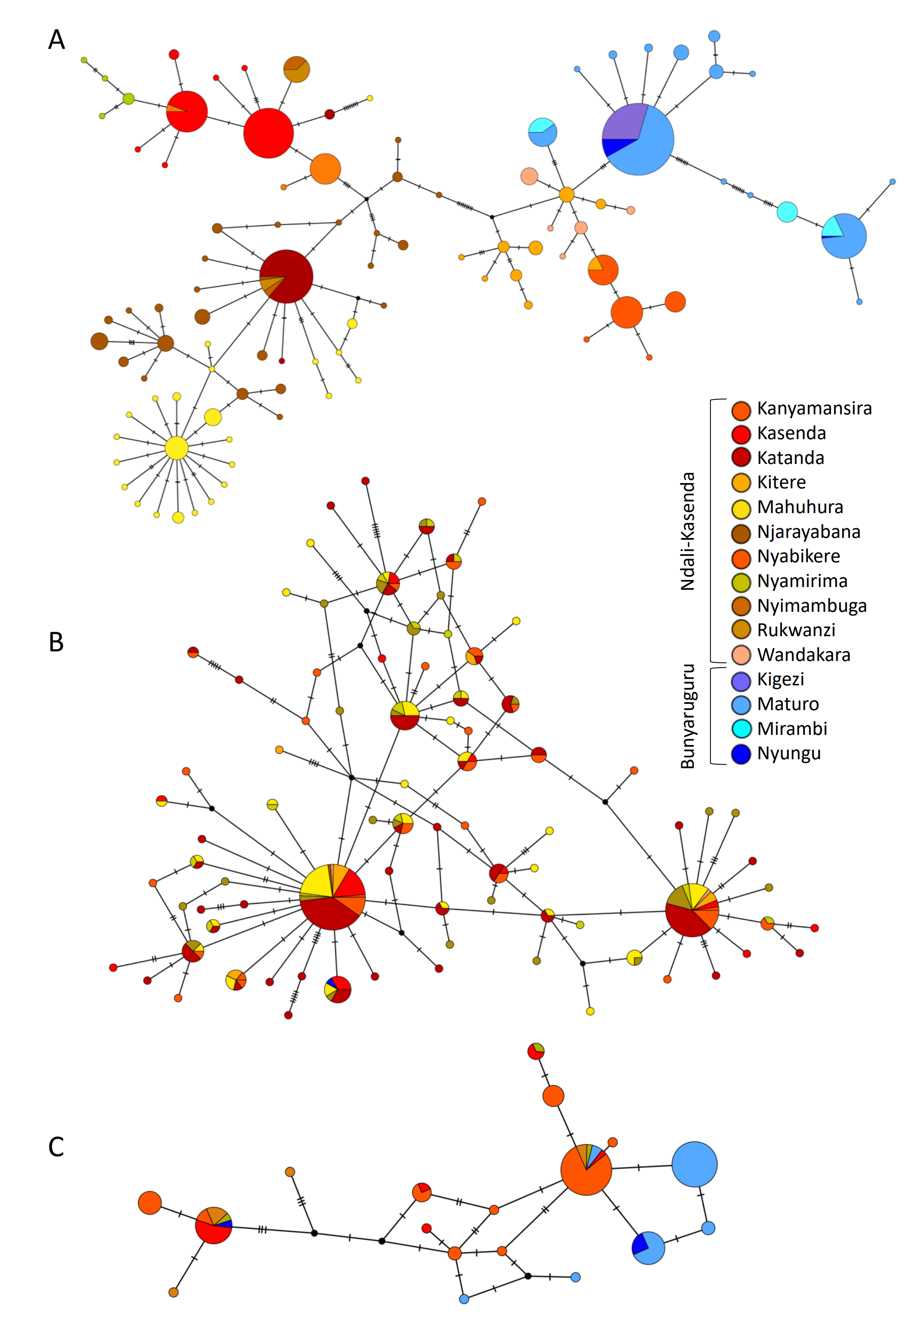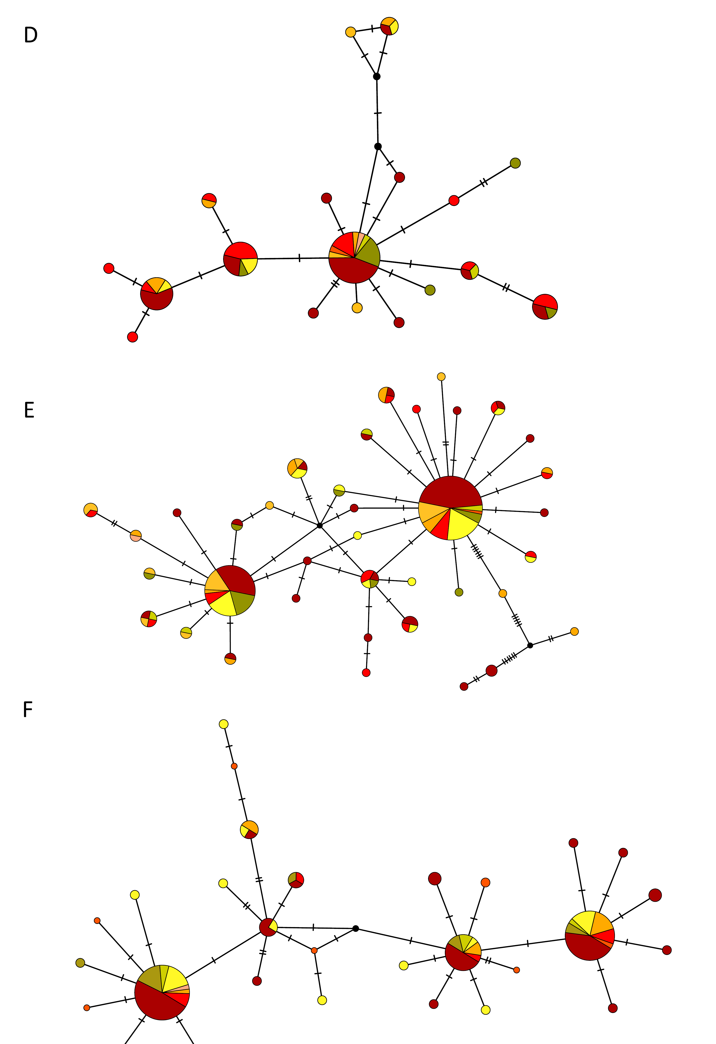
Figure S1: TCS haplotype networks of: A. COI1 marker of Bulinus tropicus (n = 823); B. COI2 marker of Bulinus tropicus (n = 812); C. NAD1 marker of B. tropicus (n = 816); D. COI1 of Petasiger sp. (n = 71); ); E. COI2 of Petasiger sp. (n = 171); ); F. cytb of Petasiger sp. (n = 128); G. cytb of Echinoparyphium sp. (n = 116). Each circle represents a unique haplotype, circle size being proportional to the number of specimens with the haplotype/ Colors proportions in the circles provides information on the population of the specimens for each population (blue colors = populations from the Bunyaruguru cluster, red to yellow colors = populations from the Ndali-Kasenda cluster). Dashes on segments connecting haplotype circles represent the number of inferred mutation steps between haplotypes.

Figure S2 Relationships between Slatkin’s genetic distance among populations and the geographic distance between the lakes where the populations were sampled for Bulinus tropicus (multi-locus dataset, 15 lakes), Petasiger sp. (NAD1 marker, eight lakes) and Echinoparyphium sp. (NAD1 marker, four lakes). A linear regression line is fitted for illustration in the plot of Bulinus tropicus as a near-significant isolation-by-distance pattern was observed using a Mantel test (p-value = 0.052). Geographic distances were log10-transformed in the B. tropicus plot to increase visual clarity.

