Supplementary Figure S1.

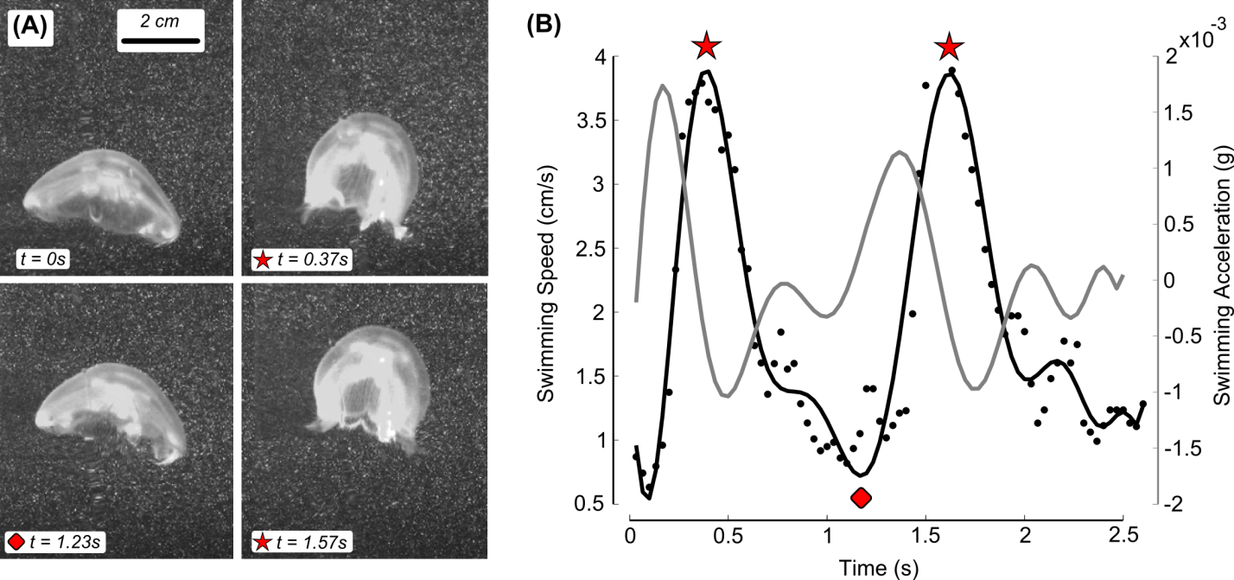
Figure S1. Motion details of captive Aurelia aurita. (A) Consecutive still images of a 4.5 cm diameter Aurelia aurita swimming through a laser sheet in the laboratory used to identify the body centroid location over two swimming cycles. Stars and diamonds indicate frames that capture peak contraction and relaxation of the bell during swimming, respectively. The body centroid position was then used to determine the swimming speed (B, black line) and the swimming acceleration (B, gray line) during consecutive swimming cycles. These methods are described in more detail in Katija and Jiang (2013).

