Supplementary boxplots of net depth measurements

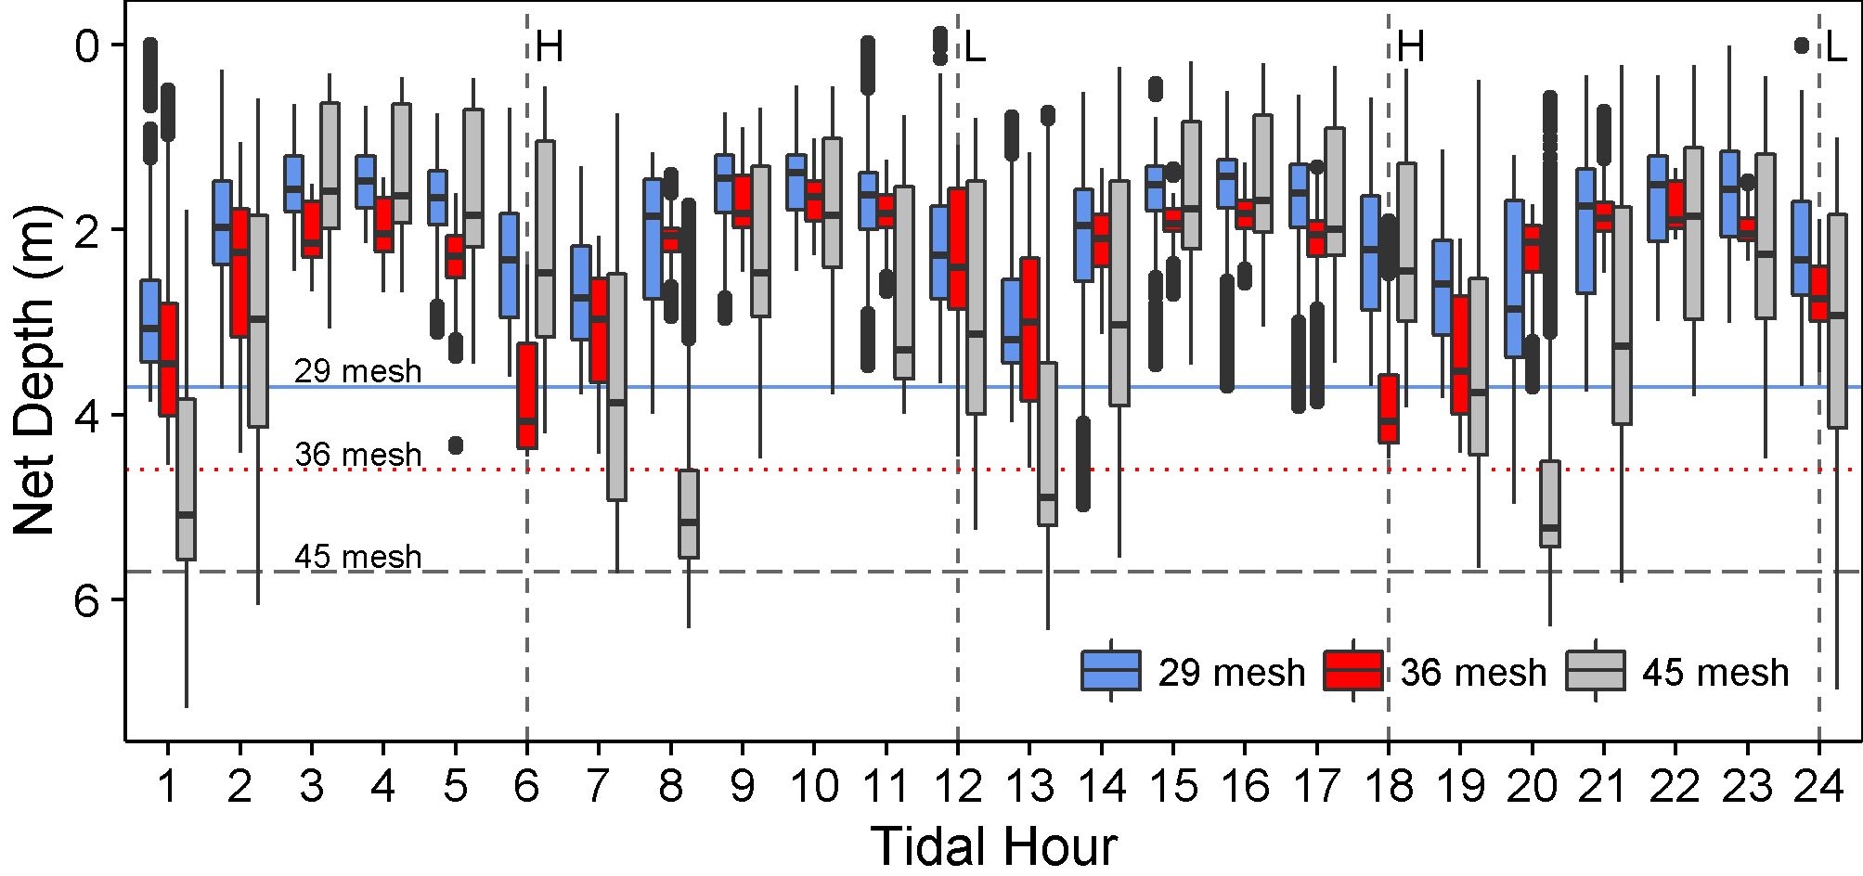
Figure 1. All nets combined. Boxplots of the distribution of the leadline depth (m) of fishing nets instrumented with depth recorders in Cook Inlet, 2015 relative to the tidal cycle. The solid line in the middle of each box shows the median depth of the leadline. The top and bottom of each box are the 25th and 75th percentiles, and the whiskers extend to the minimum and maximum values exclusive of outliers which are shown as dots. The times of high (H) and low (L) tides are centered in the tidal hours indicated with vertical dotted lines. The three horizontal lines show the potential maximum net depths assuming 5 inch mesh. This and subsequent figures in the SI report the same information as in the main text, but broken down and presented as boxplots to allow assessment of the intrinsic variability between nets, and demonstrate the consistency of the overall pattern.

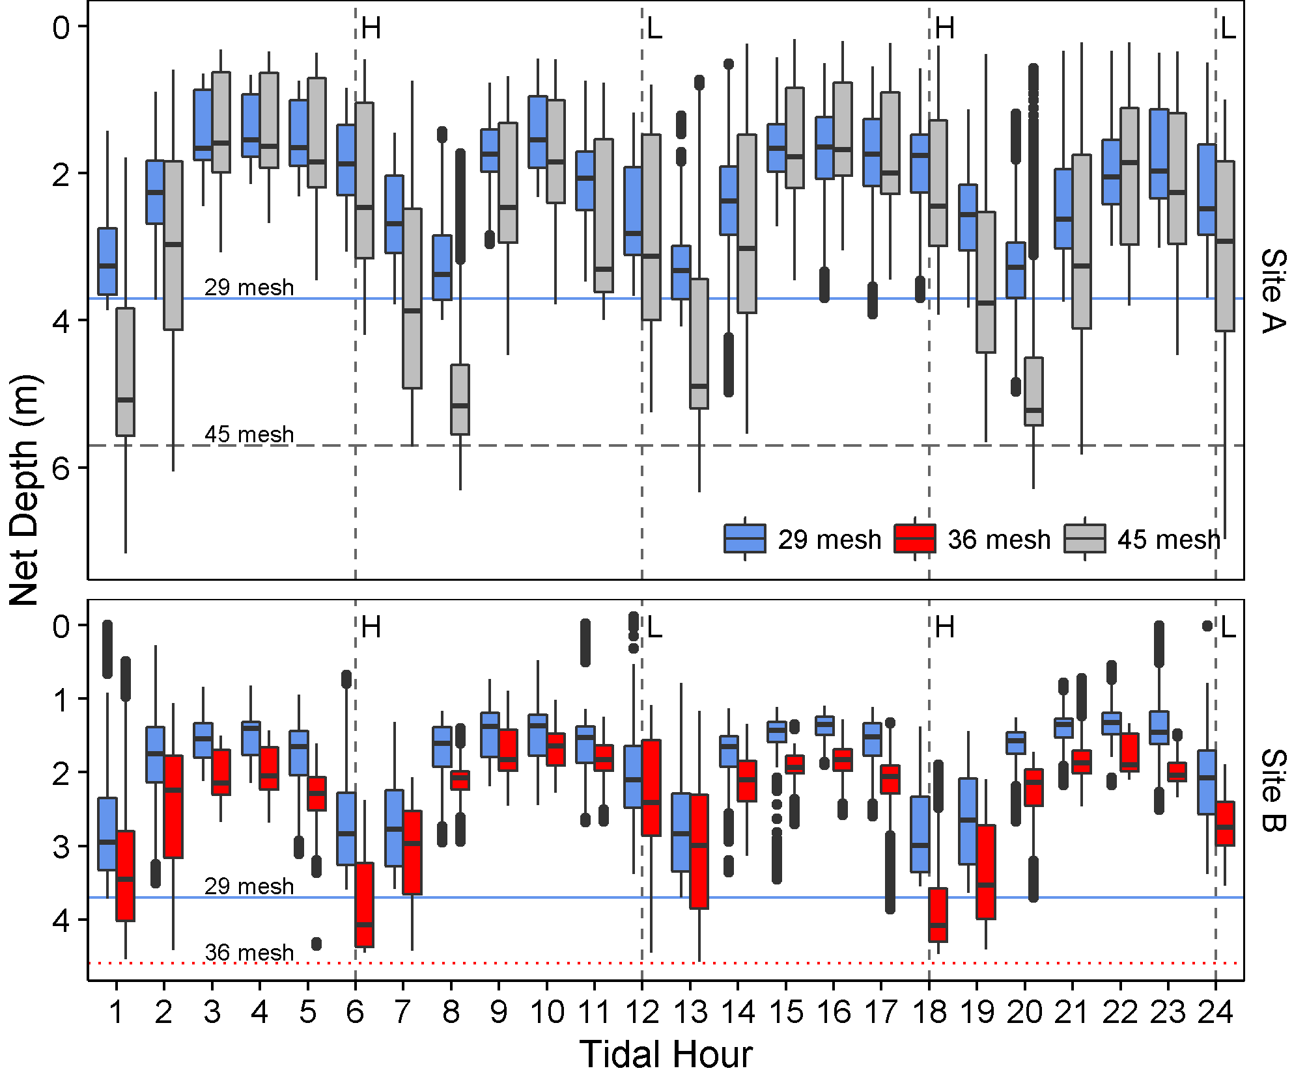
Figure 2. Sites A and B separated. Boxplots of the distribution of the leadline depth (m) of fishing nets instrumented with depth recorders in Cook Inlet, 2015 relative to the tidal cycle.

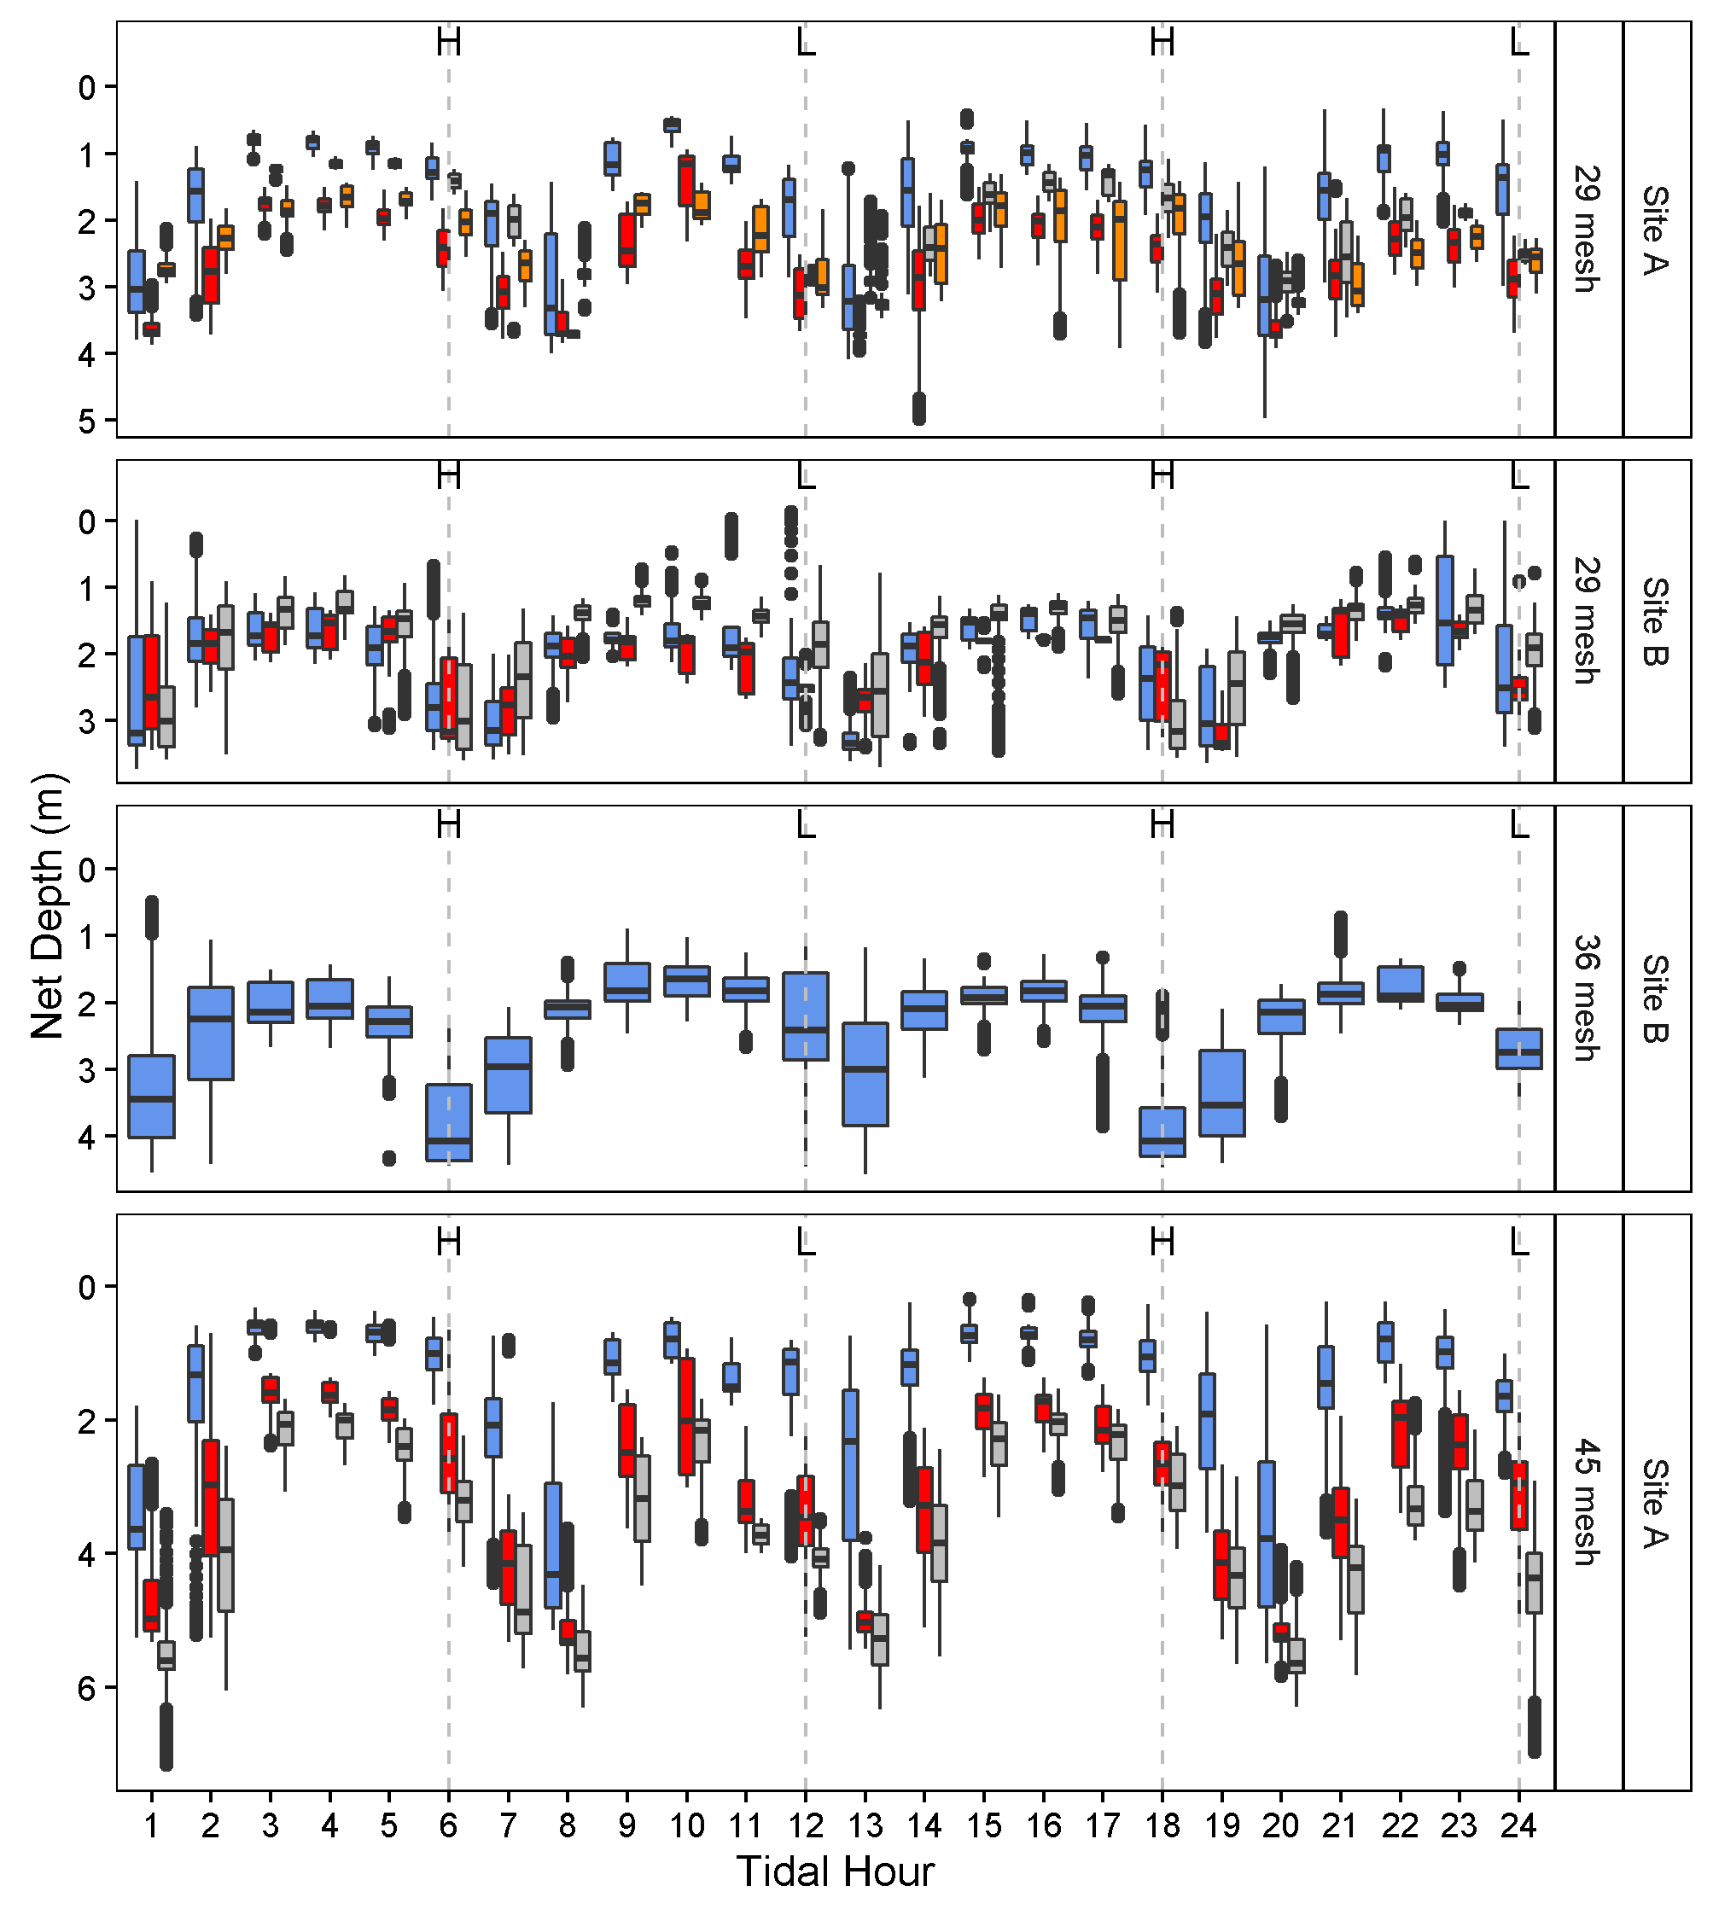
Figure 3. All nets separate. Boxplots of the distribution of the leadline depth (m) of the 11 fishing nets instrumented with depth recorders in Cook Inlet, 2015 relative to the tidal cycle.
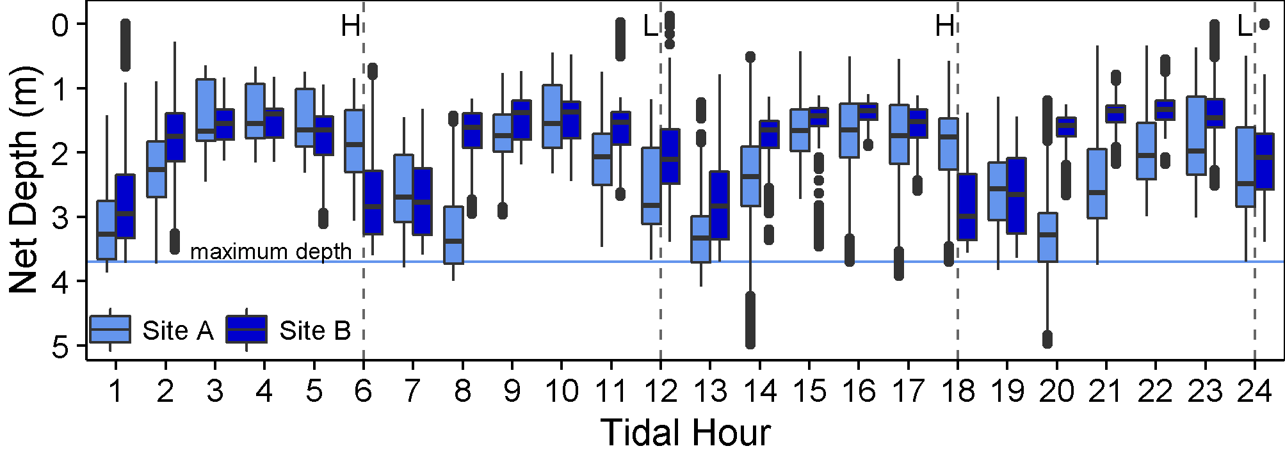
Figure 4. Comparison of the depth of 29 mesh leadlines relative to the tidal cycle for Sites A and B, showing the similar changes in leadline depth with tidal hour.
A similar comparison for 45 mesh nets is not possible, as 45 mesh nets were only instrumented in Site A.

