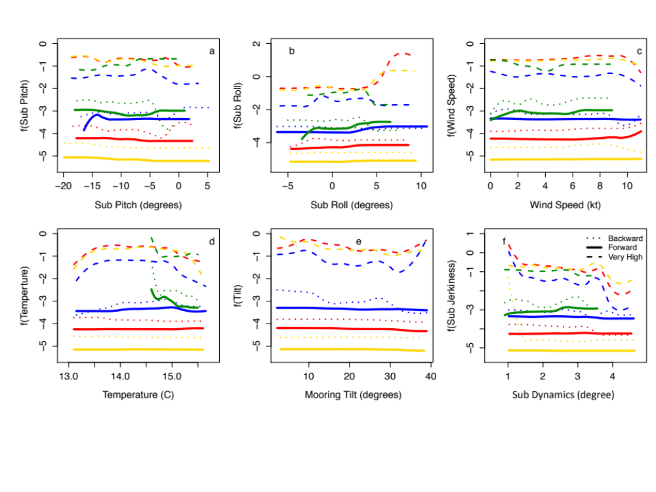
Partial dependence plots of boosted regression trees (BRTs) relating acoustics detections (yes/no) to environmental and vehicle predictors. The predictors include a) sub pitch, b) sub roll, c) wind speed, d) water temperature, e) mooring tilt and f) sub dynamics. Each line corresponds to a model in Table 2. Green lines represent the north mooring (V13 tag or receiver), and blue, red and yellow lines are the three transceivers (high, medium, low) on the mooring line. Backward and forward represents models that investigated drivers of acoustic detections on the Wave Glider (WG) transceiver/receiver. Very high represents models that investigated drivers of detections on the mooring lines from of the very high transceiver mounted on the WG. These plots show the effect of a variable on the response after accounting for the average effects of other model variables.

