Additional file 2: Geomagnetic tag measurement artifacts
Magnetic field measurements recorded by geomagnetic archival tags do not always represent the actual value of the Earth’s magnetic field at a given location and time because they can be influenced by tag conditions such as orientation or temperature. These issues related to sensor and tag technology can produce artifacts in archived data sets that mask actual changes in the magnetic field or produce misleading patterns that seem like horizontal displacement when they are really not. In this appendix, we discuss two common tag measurement artifacts in the context of the temporal patterns observed for the five archival tags that were deployed on the long-term stationary mooring (main manuscript Figure 7). As stated in the caveats section of the chapter, the tag data presented here were obtained from the earliest versions of geomagnetic tags (2012 – 2013) supplied from Desert Star (Marina, California, USA) and Star Oddi (Garōabӕr, Iceland). Improvements have likely been made since then, but researchers should ask the manufacturers how they have addressed the following tag issues and confirm that they have been addressed prior to deployment on fish.

Orientation
Magnetic sensors onboard archival tags are subject to an array of effects that can influence the values that they measure when held in different orientations (Yang et al., 2017). These effects include hard and soft iron effects caused by other nearby tag components such as batteries. Hard iron effects result from constant distortion of the magnetic field in the vicinity of the sensor from materials such as iron that have their own magnetic field. Soft iron effects are caused by materials that are susceptible to magnetization when exposed to a magnetic field; therefore, the distortion caused by these materials increases when aligned with external fields (such as the Earth’s magnetic field). In addition, rotational errors can be caused by non-orthogonal sensors and mis-alignment of sensors with the instrument.
Such errors can be demonstrated simply by placing the tag in different orientations and examining the total magnetic field readings measured by the tags at each orientation (Figure 2-1). In the example shown, the tag has a standard deviation of 43 nT around the mean measured value (range ± 100 nT) when orientation, temperature, and light intensity are constant. However, the measured value of the magnetic field varies from the true value at the tag location by more than 2000 nT depending solely upon the tag orientation.
The measurement issues related to change in tag orientation produces patterns in the total magnetic field measured by stationary tags attached to mooring lines over long time periods. We first observed these patterns from a Desert Star SeaTagMOD attached to a long-term stationary mooring near Kodiak, Alaska, USA, previous to conducting the current study (Figure 2-2). The tag was mounted loosely to the mooring line so that in the case that the mooring line could not be recovered, the tag could still pop off and provide summarized data. Therefore, the motion of the tag was constrained, but it was not fixed tightly to the mooring line. The range in detailed data was 3400 nT over the course of the deployment, and the range of daily means fluctuated within a range of 1630 nT. When magnetic field observations were restricted to only one tag orientation, the range in detailed measurements was reduced to 1280 nT and the range in daily means was reduced to 819 nT.
In contrast to the Desert Star SeaTagMOD on the Kodiak mooring, the stationary tags in the current Glacier Bay study were tightly affixed to the line, so that changes in tag orientation were related to change in orientation of the mooring line itself. When we restricted tag magnetic field measurements from the Glacier Bay stationary tags to only one tag orientation based on acceleration measurements (Table 2-1), the range in detailed magnetic field measurements was not reduced to the degree observed for the Kodiak tags (Figure 2-3). In addition, restricting the tag orientation did nothing to reduce the “wandering” pattern, where measurements fluctuated between positive and negative values relative to the known value at the mooring location. Therefore, either very small changes in orientation cause large effects on magnetic field measurement, or some other aspect of tag movement on the mooring line or internal architecture may be causing the “wandering pattern” observed in the magnetic field data. However, because the magnetic field sensors and archival tags are complicated, we leave further discussion of possible explanations for the temporal patterns observed on mooring lines to engineers and others more familiar with the details of their operation.

Temperature
All geomagnetic archival tags are sensitive to temperature change due to the nature of the sensors employed. In general, as temperature increased, the reported value of the magnetic field decreased for both tag models that were deployed (Figure 2-4). However, differences in change in measured magnetic field per unit of temperature change may vary by tag.
Literature cited
Yang, D., You, Z., Li, B., Duan, W., Yuan, B., 2017. Complete tri-axis magnetometer calibration with a gyro auxiliary. Sensors (Basel, Switzerland) 17, 1223.

Acknowledgements
We thank Katy Echave (NOAA, Ted Stevens Marine Institute) for providing the Desert Star SeaTagMOD deployed on the Kodiak mooring buoy. We thank the International Pacific Halibut Commission and the F/V Kema Sue for deploying and recovering the Kodiak mooring assembly.

Table 2-1. To reduce effects of rotational distortion on magnetic field measurement, archival tag data were restricted to only one orientation to determine whether magnetic field values from the subset data still exhibited temporal patterns unrelated to known temporal fluctuations in the field. To restrict measurements to one orientation, accelerometer X, Y, and Z axes were each constrained to a specific range of values. These are measured in units of gravity (g) for Desert Star (Marina, California, USA) SeaTagMOD (DS) tags and degrees (d) for Star Oddi (Garōabӕr, Iceland) DSTmagnetic (SO) tags. The number of records comprising the subset data and percent of the full data set are also shown. Subset data are shown in Figure 2-3.
TagID | X-axis range | Y-axis range | Z-axis range | # records | % original
DS-1 | > -0.175, < -0.17 g | > 0.034, < 0.036 g | > 0.965, < 0.97 g | 4767 | 5.0
DS-2 | > 0.083, < 0.09 g | > -0.09, < -0.08 g | > 1.0, < 1.03 g | 17482 | 18.3
DS-3 | > 0.08, < 0.09 g | > -0.09, < -0.08 g | >1.005, < 1.013 g | 17642 | 18.5
SO-1 | > -11.2, < -10.8 d | > 10.4, < 10.8 d | > 68.3, < 68.6 d | 3264 | 19.3
SO-2 | > -4.9, < -4.5 d | > 0.25, < 0.6 d | > 84.8, < 85.2 d | 1986 | 11.8

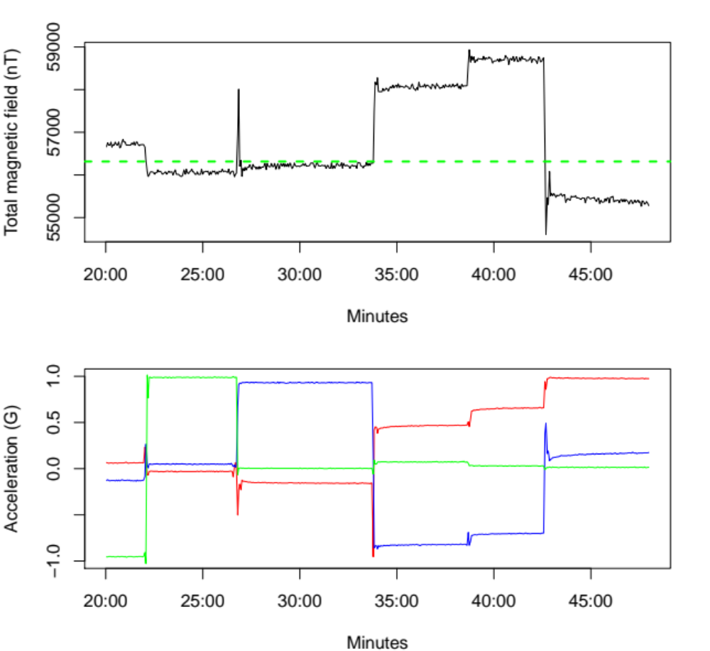

Figure 2-1. Effect of tag rotation on total magnetic field values measured by a Desert Star (Marina, California, USA) SeaTagMOD in Juneau, Alaska, USA. Top: Magnetic field values collected during a 30-minute period of low light, when temperatures were 2 – 2.5°C. Dashed line indicates known value at tag location determined with a G-857 proton precession magnetometer (Geometrics, San Jose, CA, USA). Bottom: Acceleration values indicate different tag orientations during the same time period (when a tag is not in motion accelerometers measure sensor angle relative to the direction of gravity). Acceleration X axis is shown in red, the Y axis in blue, and the Z axis in green.

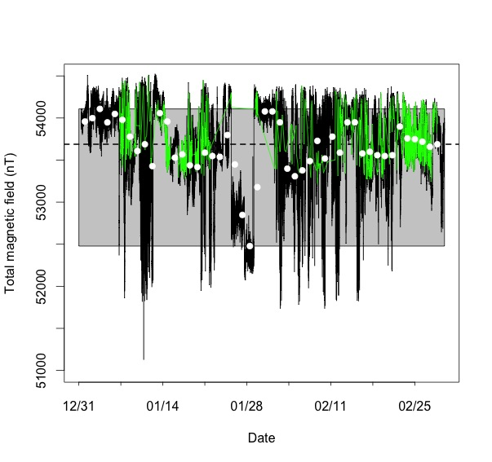

Figure 2-2. Total magnetic field values from a 3-month deployment of a SeaTagMOD geomagnetic archival tag (Desert Star, Marina, California, USA) loosely affixed to a mooring line near Kodiak, Alaska, USA. Detailed (4-minute resolution) magnetic field measurements are shown in black, and daily means are indicated by white circles. The dashed line indicates the mapped value at the mooring location and the gray box indicates the range in daily averages. A subset of detailed measurements where the tag is restricted to only one tag orientation is indicated by green lines.

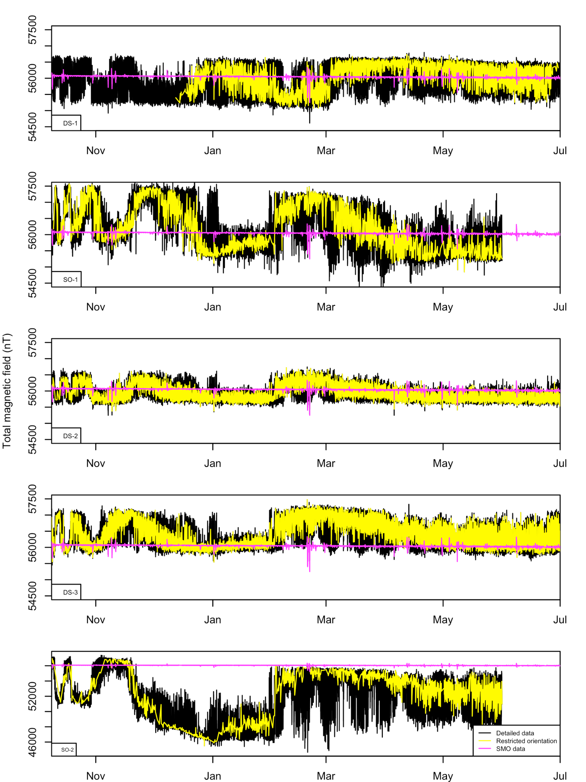
Figure 2-3. Detailed total magnetic field strength measurements from the five stationary archival tags deployed in Glacier Bay, USA, on the long-term mooring (also shown in Figure 7 of the main text; black lines). Measurements when tag was restricted to only one orientation (Table 2-1) are indicated by yellow lines. The change in magnetic field values recorded by the near-by Sitka Magnetic Observatory (SMO) is indicated by pink lines.
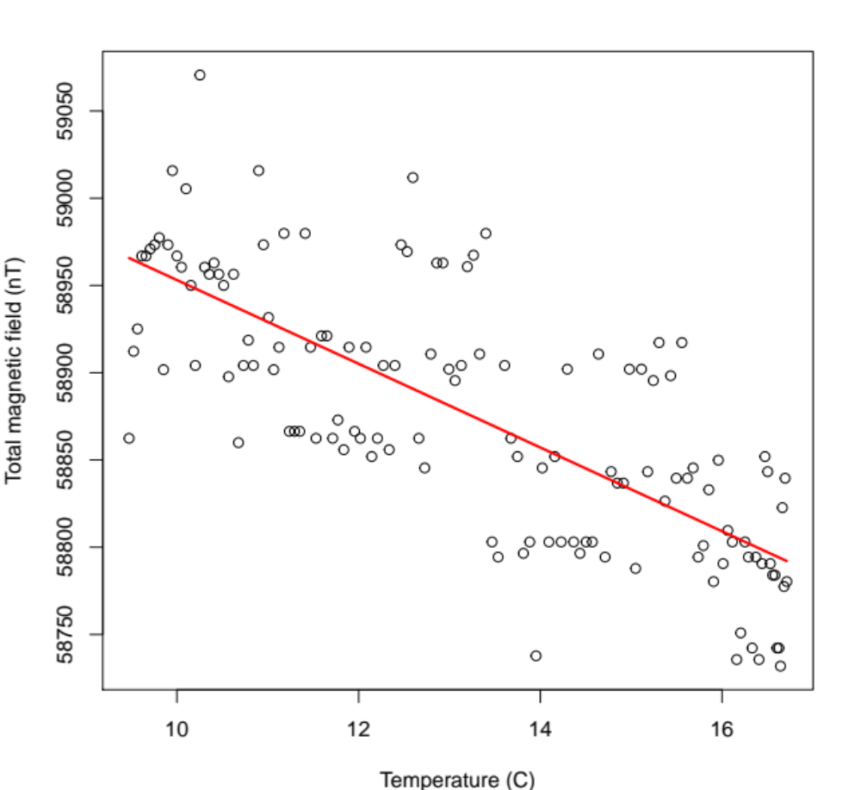

Figure 2-4. Relationship between change in temperature and change in measured magnetic field values for a Desert Star (Marina, California, USA) SeaTagMOD in stationary and low light conditions in Juneau, Alaska. Red line indicates linear model fitted slope of -24.0 nT per °C (p<2e16).

