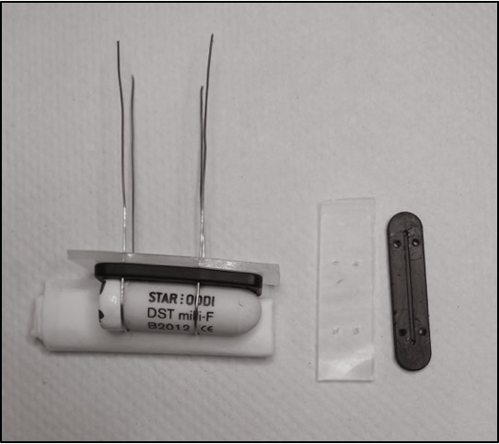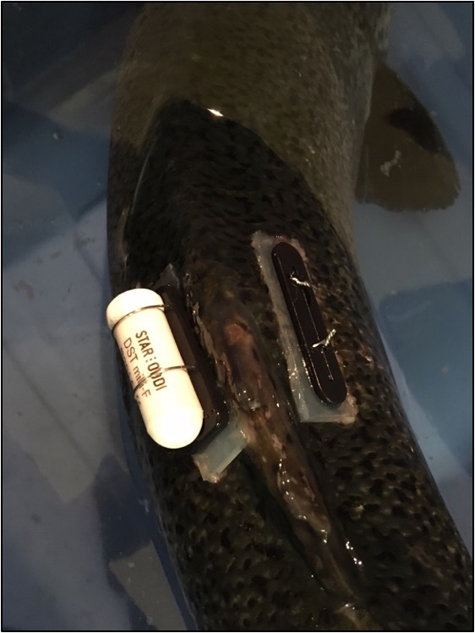

Fig. S1. Milli-TD DSTs (that record depth and temperature) were attached to the fish externally using a “plate holder kit” provided by Star-Oddi and stainless steel wire (0.02” diameter). Tags were prepared for attachment by looping pre-sterilized stainless steel wire over the tag and passing the ends of the wire through one of the kit’s silicone pads and the pre-drilled holes in the kit’s plastic mold. Four pre-sterilized stainless steel hypodermic needles (15 gauge, 3.5” long) were then passed through the skin and muscle below the dorsal fin to allow the stainless-steel wire to be guided through. Then, the hypodermic needles were removed and the 4 wires exiting the muscle were passed through the kit’s other silicone pad and plastic mold, and the wires were twisted together to secure the DST to the fish.

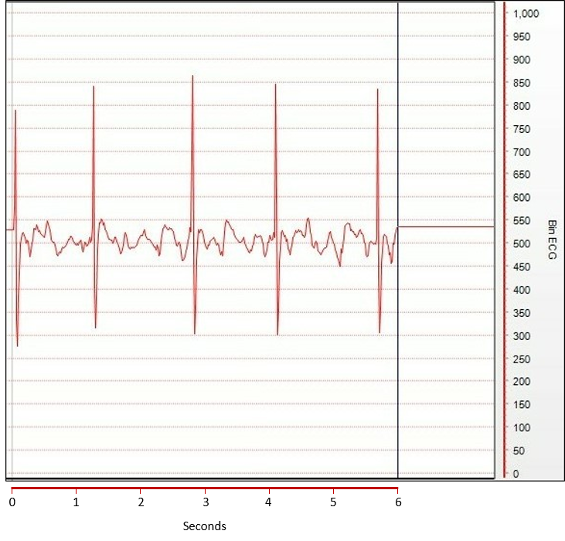

Fig. S2. An electrocardiogram (ECG) recorded in a salmon during one week of recovery. The ECG was randomly chosen to represent the typical recording from a salmon, where Bin ECG represents the amplitude of the PQRS waveform and ranges from 0 to 1000 mV. Heart rate (f_{H}) was calculated from the ECGs as the time between R wave peaks (measured in seconds). These values were then averaged, and 60 was divided by the average to obtain the fish’s f_{H} in bpm. Heart rate variability (HRV) was calculated as the standard deviation of the time between successive R wave peaks (in msec).

Table S1. Photographs of the Star-Oddi data storage tags used in this paper. Further information on these products can be found at https://www.star-oddi.com.

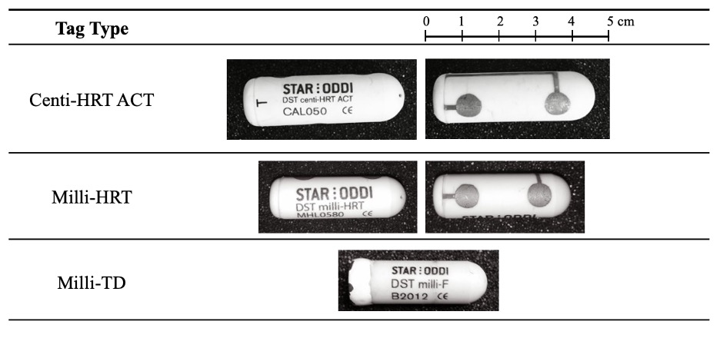

Table S2. Linear mixed-effects models were used to determine the relationships between external acceleration (EA, mg) and swimming speed (BL sec⁻¹) and tail beat frequency (tail beats min⁻¹), and between the latter two parameters and variation in EA (VAR, mg²), with fish as a random factor. The lowest Akaike information criterion (AIC) value was used to select between the two models (linear regression and log transformed data).

Model |  | P | AIC | Equation
lme(EA ~ BL, random=~1|Fish) | (Intercept)  BLS | 0.933  <0.001 | 1118.3 | EA = 9.8*BL – 0.1
lme(log(EA) ~ BL, random=~1|Fish) | (Intercept)  BLS | <0.001  <0.001 | -155.9 | EA = 3.6e^{0.9*BL}
lme(EA ~ TBF, random=~1|Fish) | (Intercept)  BLS | 0.0024  <0.001 | 1196.2 | EA = 0.1*TBF + 3.6
lme(log(EA) ~ TBF, random=~1|Fish) | (Intercept)  BLS | <0.001  <0.001 | 10.7 | EA = 4.9e^{0.006*TBF}
lme(VAR ~ BL, random=~1|Fish) | (Intercept)  BLS | <0.001  <0.001 | 3225.5 | VAR = 282.8*BL – 209.4
lme(log(VAR) ~ BL, random=~1|Fish) | (Intercept)  BLS | <0.001  <0.001 | 397.7 | VAR = 5.0e^{2.1*BL}
lme(VAR ~ TBF, random=~1|Fish) | Intercept  BLS | 0.022  <0.001 | 2903.2 | VAR = 1.3*TBF – 56.5
lme(log(VAR) ~ TBF, random=~1|Fish) | Intercept  BLS | <0.001  <0.001 | 479.0 | VAR = 11.4e^{0.01*TBF}

Table S3. Summary of the statistical outputs from linear mixed-effects models that were used to examine the effects of swimming speed on heart rate parameters in Atlantic salmon. Linear mixed-effects models were used to assess the effects of swimming speed (body lengths sec⁻¹) on heart rate, heart rate variability and the percentage of quality index values equal to zero (QI₀). Significant differences are shown in bold font.

Independent Factor | Dependent Factor | NumDF | DenDF | F | P
Heart Rate | (Intercept) | 1 | 230 | 1915.2032 | <0.0001
 | Body Lengths Sec⁻¹ | 6 | 230 | 45.8207 | <0.0001
Heart Rate Variability | (Intercept) | 1 | 228 | 49.84475 | <0.0001
 | Body Lengths Sec⁻¹ | 6 | 228 | 4.45037 | 3e-04
Percentage of Quality Index Values = 0 | (Intercept) | 1 | 35 | 49.96008 | <0.0001
 | Body Lengths Sec⁻¹ | 6 | 35 | 1.69760 | 0.1508
NumDF and DenDF are the degrees of freedom of the numerator and denominator of the F distribution ratio.

Table S4. Summary of the statistical outputs from the linear mixed-effects models that examined the effects of night / day (photoperiod), days post-implantation, and their interaction, on f_{H} parameters [f_{H} and percentage of quality index values equal to zero (QI₀)] and external acceleration (EA) in salmon for 7 days post-surgery. Significant differences are shown in bold.

Independent Factor | Dependent Factor | NumDF | DenDF | F | P
Heart Rate | (Intercept) | 1 | 8560 | 510.753 | <0.0001
 | Photoperiod | 1 | 8560 | 3712.111 | <0.0001
 | Day | 5 | 8560 | 805.027 | <0.0001
 | Interaction | 5 | 8560 | 23.073 | <0.0001
Percentage of Quality Index Values = 0 | (Intercept) | 1 | 98 | 923.827 | <0.0001
 | Photoperiod | 1 | 98 | 1.944 | 0.1664
 | Day | 5 | 98 | 5.476 | 0.0002
 | Interaction | 5 | 98 | 0.631 | 0.6762
External Acceleration | (Intercept) | 1 | 8586 | 95.752 | <0.0001
 | Photoperiod | 1 | 8586 | 860.051 | <0.0001
 | Day | 5 | 8586 | 131.749 | <0.0001
 | Interaction | 5 | 8586 | 3.500 | 0.0018
NumDF and DenDF are the degrees of freedom of the numerator and denominator of the F distribution ratio.
Table S5. Summary of the statistical output from the linear mixed-effects models that examined the effects of night / day (photoperiod), at every 10 days or for all days post-implantation, on f_{H} parameters [f_{H} and percentage of quality index values equal to zero (QI₀)] and external acceleration (EA) in Atlantic salmon for 6 weeks post-implantation, and their interaction. Due to issues with facility temperature control, the data is separated into two trials with a tank temperature of 8°C in trial 1 (a 10 days; b all data) and 8-12°C in trial 2 (c).

Independent Factor | Dependent Factor | NumDF | DenDF | F | P
(a) Trial 1 – every 10th day
Heart Rate | (Intercept) | 1 | 252 | 116.8220 | <0.0001
 | Photoperiod | 1 | 252 | 121.1120 | <0.0001
 | Day | 4 | 252 | 79.46901 | <0.0001
 | Interaction | 4 | 252 | 3.89345 | 0.0044
Percentage of Quality Index Values = 0 | (Intercept) | 1 | 35 | 67.76189 | <0.0001
 | Photoperiod | 1 | 35 | 1.54935 | 0.2215
 | Day | 4 | 35 | 1.34151 | 0.2741
 | Interaction | 4 | 35 | 0.09792 | 0.9824
External Acceleration | (Intercept) | 1 | 225 | 57.24601 | <0.0001
 | Photoperiod | 1 | 225 | 0.70989 | 0.4004
 | Day | 4 | 225 | 7.70921 | <0.0001
 | Interaction | 4 | 225 | 0.65493 | 0.6240
(b) Trial 1 – all data
Heart Rate | (Intercept) | 1 | 2123 | 130.792 | <0.0001
 | Photoperiod | 1 | 2123 | 806.2189 | <0.0001
 | Day | 34 | 2123 | 21.922 | <0.0001
 | Interaction | 34 | 2123 | 1.5527 | 0.0221
(c) Trial 2 – every 10th day
Heart Rate | (Intercept) | 1 | 282 | 393.0201 | <0.0001
 | Photoperiod | 1 | 282 | 53.4608 | <0.0001
 | Day | 4 | 282 | 44.5078 | <0.0001
 | Interaction | 4 | 282 | 3.4822 | 0.0085
 | Temperature | 1 | 282 | 1.5987 | 0.2071
Percentage of Quality Index Values = 0 | (Intercept) | 1 | 35 | 3731.347 | <0.0001
 | Photoperiod | 1 | 35 | 0.317 | 0.5767
 | Day | 4 | 35 | 1.210 | 0.3241
 | Interaction | 4 | 1 | 1.654 | 0.1826
External Acceleration | (Intercept) | 1 | 224 | 56.30882 | <0.0001
 | Photoperiod | 1 | 224 | 0.71487 | 0.3987
 | Day | 4 | 224 | 7.76377 | <0.0001
 | Interaction | 4 | 224 | 0.79094 | 0.5321
 | Temperature | 1 | 224 | 2.01856 | 0.1568
NumDF and DenDF are the degrees of freedom of the numerator and denominator of the F distribution ratio.

