Tag Predation Supplemental Materials
Diagnosing predated tags in telemetry survival studies of migratory fishes in river systems

Supplemental Methods

2016 Chinook Tagging Study
Juvenile fall-run Chinook Salmon used for tagging were obtained from the Merced River Fish Hatchery (MRFH). Study fish from Week 1 averaged 6.6 g (standard deviation (SD)=0.53 g, range = 6.0–8.5 g) in weight and 83.4 mm (SD=2.3 mm, range = 73–90 mm) fork length; study fish from Week 2 averaged 8.3 g (SD=1.3 g, range = 6.0–12.9 g) and 87.8 mm (SD=4.2 mm, range = 77–103 mm). Fish were taken off feed 24 hours prior to surgery. Juvenile salmon were surgically implanted (“tagged”) with Vemco V4-180 kHz microacoustic transmitters (“tags”; 11 mm length, 3.6 mm height, 5.7 mm width). Transmitter weight in air averaged 0.416 g (SD=0.002 g). Tag burden (tag weight in air divided by fish weight) averaged 6.3% (SD=0.5%, range = 4.9%–7.0%) in Week 1 and averaged 5.2% (SD=0.8%, range = 3.3%–7.0%) in Week 2.
Tags were soaked in saline water ≥ 24 hr prior to tag activation. Dry tags were activated using a Vemco Tag Activator-180k-200 approximately 24 hr prior to tag implantation. Chinook salmon were tagged at the MRFH over two 4-day periods: 12–15 April 2016 (Week 1), and 19–22 April 2016 (Week 2), by a team of three surgeons, three surgical assistants, and two to three additional support staff. The surgical and tagging standard operating procedure was developed based on Adams et al., Martinelli et al., and Liedtke et al. [1–3]. Anesthesia was a 33.8 mg/L or 39.4 mg/L concentration of Aqui-S 20E. Fish were allowed to recover at least 10 minutes after surgery before being transferred to a 19 L perforated bucket, loaded on transport truck, and transported to a holding site at Durham Ferry (approximately 90 minutes by road). At the holding sites, fish were transferred to 120 L plastic garbage cans (“holding cans”) held in the river where they were held for approximately 24 hr prior to transport approximately 200 m downstream and released to the river. Fish found dead in the holding cans were not released. Releases were made every 6 hours after the 24 hr holding period.
The U.S. Geological Survey (USGS; Sacramento, California office) oversaw installation, operation, maintenance, and removal of an array of Vemco 180-kHz acoustic receivers in the lower San Joaquin River and Delta, downloaded data from the receivers, and performed initial processing of the data (funding from U.S. Bureau of Reclamation). The USGS Great Lakes Science Center further processed the data to define detection events, where unique detection events at a telemetry station were separated either by detection at different station or by a time gap of ≥ 12 hr. USGS then transferred the processed data to the University of Washington for additional processing and analysis.

Complex Rule-based Predator Filter
A total of 24 metrics were defined for the complex rule-based predator filter, derived from the detection event data (Table S1). Residence time was categorized on three spatiotemporal scales: near field, mid field, and far field. The near field scale measured the duration of each station-specific detection event; because sequential tag observations at a given station that were separated by a time gap of < 12 hours were assigned to the same detection event, the near field scale represented the maximum time spent in the near vicinity of the station without requiring continual detection. The mid field residence time measured the total time from the start to end of a series of consecutive detection events at a station without intervening detection elsewhere; this scale removed the temporal component of the near field residence time. The far field residence time measured the length of time a tag was known to be in various regions of the study area, defined by groups of telemetry stations (Table 1).
Travel time was measured as total time since release to the start of each detection event, and as the transition time from the end of the previous detection event to the start of the current event (reach travel time). Migration rate was measured both as a simple ratio of reach travel time to reach length (km/hr) and also adjusted by water velocity and scaled by fish length at tagging to measure body length per second (absolute value; body lengths per second [BLPS]).
Additional metrics measured a running count of detection events at a given station, the number and length of upstream-directed excursions, and the time that separated repeated detection events at a station. Several logical (true/false) metrics were calculated: whether the following transition (if any) was directed downstream, whether the tag had previously been detected in the interior delta after detection in the lower San Joaquin River, whether the tag had previously been detected as far downstream in the San Joaquin River as Garwood Bridge (A16), whether the tag had previously been detected in the northwestern region of the delta (i.e., downstream of Turner Cut/MacDonald Island or west of the San Joaquin River, head of Old River, or Turner Cut), and whether the barrier at the head of Old River had been completely installed at the time of the beginning of the detection event. Although there were telemetry receivers located in the western delta at or near the water export facilities, no tags were detected there before the final detections as far downstream as Turner Cut; additionally, no tags detected downstream of the Turner Cut Junction were later observed in the study area. Thus, the interior delta and northwestern region of the delta pertinent to the case study consisted only of receivers near the head of Middle River (B2, C1).
River data (water velocity, river stage, river discharge) were summarized for each detection event and transition between consecutive detection events. For each transition between detection events, the mean observed water velocity was compiled from observations at the gaging station closest to the telemetry station. Water velocity and river discharge values were also recorded at the start and end of each detection event using linear interpolation from 15-minute observation data at the closest gaging station. The 15-minute change in river stage at the beginning of each detection event was computed as an indication of slack tide.
Some metrics were used for all stations and transitions: residence time (near field, mid field, and far field), travel time, migration rate, time since release, and the running count of detection events at a given station. Other metrics, such as river flow and water velocity, were used for only a subset of stations or for particular transitions (e.g., upstream transitions to a station, or transitions across the barrier at the head of Old River) (Table S2). The filter consisted of values for each metric that were considered more representative of salmon than of likely predatory fishes; observed metrics beyond those intervals were considered indicative of predation or tag excretion (Table S2). Residence time criteria were developed based on literature review, consultation with salmon and bass experts, considerations of where the tag was coming from, whether the detection was a repeat detection, and the low flow conditions present during the 2016 study. We also examined the distribution of observed residence times for the population of salmon tags and for the known predator tags. The mid field and far field residence time criteria were determined partially based on the near field residence time and travel time criteria. For some transitions (e.g., A18/A19 to A20), less stringent criteria were used if the river condition metrics indicated that the tag arrived at the station during slack tide (low 15-minute change in river stage) or if water velocity was low during the transition from the previous station. The maximum and minimum water velocity and river discharge metrics were used to compare the imputed direction of movement of the tag with the direction of river flow.

Table S1. Categories of metrics used in complex rule-based predator filter for 2016 Chinook Salmon case study. Each metric was defined for each detection event at a given telemetry station.
Metric | Criteria category | Description
Near field residence time | Residence time: near | Duration of detection event at telemetry station (hr); includes detection gaps < 12 hours if no intervening detection elsewhere
Known presence duration | Residence time: near | Portion of near field residence time when tag was actively detected (hr)
Mid field residence time | Residence time: mid | Total time from start to end of series of consecutive detection events at telemetry station without intervening detections elsewhere (hr)
Far field residence time | Residence time: far (current event); movement patternsª (end of previous event) | Length of time a tag was known to be in region of the study area (hr); see Table 1 for region definitions; measured at start and end of detection event
Total residence time | Residence time: far | Sum of near field residence times at telemetry station (hr)
Time since release | Travel time since release | Running measure of time since fish release at Durham Ferry (hr)
Transition time | Migration rate | Time from end of previous detection event to start of current detection event (hr)
Migration rate | Migration rate | Transition time scaled by reach distance (km∙hr⁻¹)
Time since last here | Migration rate | Time since previous detection at same telemetry station
BLPS | BLPS | Body lengths per second; = migration rate adjusted by average water velocity during transition and scaled by fish length at tagging
Next transition downstream | Upstream transitions | Logical variable: is the next transition directed downstream?
Number of detection events | Movement patternsª | Running count of detection events at telemetry station
Number of upstream-directed forays | Movement patternsª | Running count of upstream-directed transitions in any part of the study area, pooled over consecutive upstream transitions without intervening route reversals
Length of upstream-directed transitions | Movement patternsª | Running sum of distance of consecutive upstream-directed transitions
Previous ID detection from lower SJR | Movement patterns | Logical variable: was the tag previously detected in the interior delta (B2, C1) after detection in San Joaquin River at sites ≥A14?
Previous detection in lower SJR | Movement patterns | Logical variable: was the tag previously detected in the lower San Joaquin River (≥A16)?
Previous detection in NW delta | Movement patterns | Logical variable: was the tag previously detected in the northwestern part of the delta (B2, C1)?
Barrier | Movement patterns | Logical variable: was the barrier at the head of Old River installed at the start of the detection event?
Mean water velocity | Movement patternsª; Residence time: near field^{b} | Mean water velocity during transition, measured at closest gaging station (m∙s⁻¹)
River discharge at arrival and departure | Movement against flow | River discharge (flow) at the time of the start (arrival) or end (departure) of detection event, interpolated from 15-minute event data; measured at closest gaging station (m³∙s⁻¹)
Water velocity at arrival and departure | Movement against flow; Residence time: near field^{b} | Water velocity at the time of the start (arrival) or end (departure) of detection event, interpolated from 15-minute event data; measured at closest gaging station (m∙s⁻¹)
Delta river stage | Residence time: near field^{b} | Change in 15-minute river stage value at beginning of detection event, measured at closest gaging station (m)
a = Falls under Upstream transitions category instead of Movement patterns if observed transition is directed upstream
b = Metric is used to identify conditions that trigger alternative criteria values in Residence time: near field

Table S2a. Cutoff values used in predator filter in 2016. Observed values past cutoff or unmet conditions indicated a predator. Time durations are in hours unless otherwise specified. DF = Durham Ferry release site. See Table S2b for Flow, Water Velocity, Extra Conditions, and Comment. Footnotes refer to both this table and Table S2b. Additional criteria: BLPS≤8; travel time <24 hr for consecutive detection events at same site unless otherwise noted. Unobserved transitions are omitted.
Telemetry station |  | Residence timeª (hr) |  |  |  | Migration rate^{b, c} (km/hr) |  | Time since last (hr) | No. of events | No. of upstream forays
 |  | Near field | Mid-field | Far-field | Total
Current | Previous | Maximum | Maximum | Maximum | Maximum | Minimum | Maximum | Maximum | Maximum | Maximum
A1 | DF, A2 | 1 | 2 | 15 | 15 | 0.2 (0.6^{f}) | 4 |  | 1 | 1
A2 | DF, A1 | 10 | 20 | 30 | 94 | 0.05 | 4 |  | 1 | 0
 | A2 | 2 | 47 | 94 | 94 |  |  |  | 2 | 0
A3 | DF, A2 | 4 | 8 | 30 | 70 | 0.1 | 4 |  | 1 | 0
 | A3 | 2 | 35 | 70 | 70 |  |  |  | 2 | 0
 | A4, A5 | 2 | 4 | 30 | 70 | 0.1 | 4 |  | 2 | 1
A4 | DF, A2, A3 | 4 | 8 | 30 | 70 | 0.1 | 4 |  | 1 | 0
 | A4 | 2 | 35 | 70 | 70 |  |  |  | 2 | 0
 | A5 | 2 | 4 | 30 | 70 | 0.1 | 4 |  | 2 | 1
A5 | DF, A2–A4 | 10 | 20 | 40 | 90 | 0.1 | 4 |  | 1 | 0
 | A5 | 0.1 | 45 | 90 | 90 |  |  |  | 2 | 0
A6 | DF, A2–A5 | 12 | 24 | 60 | 102 | 0.1 | 4 |  | 1 | 0
 | A6 | 2 | 51 | 102 | 102 |  |  |  | 2 | 1
A8 | A7 | 10 | 25 | 50 | 180 | 0.1 | 4 | 15 | 2 | 0
 | A8 | 1 | 51 | 121 (20e) | 180 |  |  |  | 2 | 1
 | B1 | 1 | 10 | 20 (20e) | 180 | 0.5 | 4 | 15 | 1 | 0
 | A9 | 1 | 10 | 180 (20e) | 180 | 0.1 | 4 | 15 | 3 | 1
A9 | A8 | 7 | 19 | 155 | 309 | 0.1 | 4 | 15 | 2 | 0
 | A9 | 1 | 45 | 220 | 309 |  |  |  | 2 | 1
 | A10 | 0.5 | 10 | 309 (20e) | 309 | 0.1 | 4 | 15 | 3 | 1
A10 | A8, A9 | 7 | 19 | 277 (261^{f}) | 360 | 0.1 | 4 | 15 | 2 | 0
 | A10 | 1 | 45 | 342 | 360 |  |  |  | 2 | 1
 | A11 | 1 | 10 | 360 (25e) | 360 | 0.1 | 4 | 15 | 3 | 1
A11 | A10 | 10 | 25 | 360 | 360 | 0.1 | 4 | 15 | 2 | 0
 | A11 | 1 | 51 | 360 | 360 |  |  |  | 2 | 1
 | A12 | 1 | 10 | 360 (30e) | 360 | 0.1 | 4 | 15 | 3 | 1
A12 | A11 | 10 | 25 | 360 | 360 | 0.1 | 4 | 15 | 2 | 0
 | A12 | 1 | 51 | 360 | 360 |  |  |  | 2 | 1
 | A13 | 1 | 10 | 360 (35e) | 360 | 0.1 | 4 | 15 | 3 | 1
A13 | A12 | 10 | 25 | 360 | 360 | 0.1 | 4 | 15 | 2 | 0
 | A13 | 1 | 51 | 360 | 360 |  |  |  | 2 | 1
 | A14 | 1 | 10 | 360 (40e) | 360 | 0.1 | 4 | 15 | 3 | 1
A14 | A13 | 5 | 15 | 360 | 360 | 0.1 | 4 | 15 | 2 | 0
 | A14 | 1 | 41 | 360 | 360 |  |  |  | 2 | 1
 | A15 | 1 | 10 | 360 (45e) | 360 | 0.1 | 4 | 15 | 3 | 2
A15 | A14 | 5 | 15 | 360 | 360 | 0.1 | 4 | 15 | 2 | 0
 | A16 | 1 | 10 | 360 (50e) | 360 | 0.1 | 4 | 15 | 3 | 2
A16 | A15 | 12 | 24 | 360 | 360 | 0.1 | 4 | 15 | 2 | 0
 | A16 | 1 | 50 | 360 | 360 |  |  |  | 2 | 1
 | A17 | 3 | 6 | 360 (55e) | 360 | 0.1 | 4 | 15 | 3 | 2
A17 | A16 | 15 (6^{f}) | 30 (12^{f}) | 360 | 360 | 0.1 | 4 | 15 | 2 | 0
 | A17 | 1 | 50 | 360 | 360 |  |  |  | 2 | 2
 | R1 | 1 | 2 | 360 | 360 | 0.5 | 1 | 15 | 2 | 0
R1 | A16 | 15 | 30 | 360 | 360 | 0.1 | 4 | 15 | 1 | 0
 | A17 | 2 | 4 | 360 | 360 | 0.5 | 1 | 15 | 2 | 0
A18 | A17, R1 | 30 (15^{f}) | 60 (30^{f}) | 360 | 360 | 0.1 | 4 | 15 | 2 | 0
 | A18 | 30 | 119 | 360 | 360 |  |  |  | 2 | 2
 | A19 | 10 | 20 | 40 | 360 | 0.1 | 4 | 15 | 2 | 2
A19 | A18 | 30 (15^{f}) | 60 (30^{f}) | 120 (60^{f}) | 60 | 0.1 | 4 | 24 | 3 | 0
 | A19 | 30 | 129 | 293 | 60 |  |  |  | 3 | 3
 | A20 | 30 | 60 | 360 (60e) | 60 | 0.1 | 4 | 24 | 3 | 3
A20 | A18 | 30 (25^{f}) | 60 (50^{f}) | 360 | 40 | 0.1 | 4 | 24 | 1 | 0
 | A19 | 30 (25^{f}) | 60 (50^{f}) | 360 | 40 | 0.1 | 4 | 24 | 2 | 0
 | A20 | 30 | 119 | 360 | 40 |  |  |  | 3 | 2
T1 | A19 | 12 | 24 | 333 | 40 | 0.1 | 4 | 24 | 1 | 0
 | T1 | 1 | 54 | 360 | 40 |  |  |  | 2 | 2
 | A20 | 5 | 10 | 360 | 40 | 0.1 | 4 | 24 | 2 | 2
A7 | DF, A6 | 12 | 24 | 80 | 102 | 0.1 | 4 |  | 1 (2^{f}) | 0
 | A7 | 2 | 51 | 102 | 102 |  |  |  | 2 | 1
 | A8 | 2 (3^{f}) | 4 (6^{f}) | 80 (10e) | 102 | 0.1 | 4 (5^{f}) | 15 | 2 | 1
B1 | A7 | 10 | 20 | 40 | 349 | 0.1 | 4 | 15 | 1 | 0
 | B1 | 1 | 46 | 106 | 349 |  |  |  | 2 | 1
 | A8 | 10 | 20 | 40 (20e) | 349 | 0.5 | 4 | 15 | 2 | 1
 | B2, C1 | 1 | 2 | 248 (349^{f}) | 349 | 0.6 | 4 | 24 | 1 | 1
B2 | B1 | 15 | 30 | 196 | 310 | 0.1 | 4 | 36 | 1 | 0
 | B2 | 5 | 64 | 284 | 310 |  |  |  | 2 | 1
 | C1 | 1 | 2 | 310 | 310 | 0.1 | 4 | 36 | 1 | 1
C1 | C1 | 1 | 32 | 56 | 297 |  |  |  | 2 | 1
 | B2 | 1 | 2 | 297 | 297 | 0.1 | 4 | 36 | 1 | 1
a = Near field residence time includes up to 12 hours missing between detections, while mid-field residence time includes entire time lag between first and last detections without intervening detections elsewhere; far-field residence time includes all time from entry in region to arrival at and departure from current site
b = Approximate migration rate was calculated on most direct pathway
c = Missing values for transitions to and from same site: travel times must be 12 to 24 hours, unless otherwise specified under “Extra conditions”
e = Condition at departure from previous site
f = See comments for alternative criteria

Table S2b. Cutoff values used in predator filter in 2016. Observed values past cutoff or unmet conditions indicate a predator. Time durations are in hours unless otherwise specified. DF = Durham Ferry release site. Footnotes, Extra Conditions and Comment refer to both this table and Table S2a. Additional criteria: tag should not have been previously detected in the northwestern region of the SJR and Delta before detection at SJR stations upstream of Turner Cut; tags detected in the lower SJR should not be subsequently detected in OR or MR or subsequently detected in the SJR after detections in the interior Delta west of Turner Cut. Unobserved transitions are omitted.
Detection site |  | Flow^{d} (m³∙s⁻¹) |  | Water velocity^{d} (m∙s⁻¹) |  |  | Extra conditions | Comment
Current | Previous | At arrival | At departure^{e} | At arrival | At departure^{e} | Average during transition
A1 | DF, A2 |  |  |  |  |  |  | Alternate value if coming from A2
A2 | DF, A1
 | A2 |  |  |  |  |  | Travel time < 20
A3 | DF, A2, A4, A5
 | A3 |  |  |  |  |  | Travel time < 20
A4 | DF, A2, A3, A5
 | A4 |  |  |  |  |  | Travel time < 20
A5 | DF, A2–A4
 | A5 |  |  |  |  |  | Travel time < 20
A6 | DF, A2–A5
 | A6 | <396 |  |  |  | <0.8 | Travel time < 20
 | A7 | <396 |  |  |  | <0.03
A8 | A7
 | A8 |  |  |  |  |  | Travel time < 20
 | B1 |  |  |  |  |  | No HOR barrier
 | A9 |  |  |  |  |  | Next transition must be directed downstream
A9 | A8
 | A9 |  |  |  |  |  | Travel time < 20
 | A10 |  |  | <0.5 | <0.5 |  | Next transition must be directed downstream
A10 | A8, A9 |  |  |  |  |  |  | Alternate value if coming from A9
 | A10 |  |  |  |  |  | Travel time < 20
 | A11 |  |  | <0.5 | <0.5 | <0.4 | Next transition must be directed downstream
A11 | A10
 | A11 |  |  |  |  |  | Travel time < 20
 | A12 |  |  | <0.5 | <0.5 | <0.4 | Next transition must be directed downstream
A12 | A11
 | A12 |  |  |  |  |  | Travel time < 20
 | A13 |  |  | <0.5 | <0.5 | <0.4 | Next transition must be directed downstream
A13 | A12
 | A13 |  |  |  |  |  | Travel time < 20
 | A14 |  |  | <0.5 | <0.5 | <0.4 | Next transition must be directed downstream
A14 | A13
 | A14 |  |  |  |  |  | Travel time < 20
 | A15 |  |  | <0.5 | <0.5 | <0.4 | Next transition must be directed downstream
A15 | A14
 | A16 |  |  | <0.5 | <0.5 | <0.4 | Next transition must be directed downstream
A16 | A15
 | A16 |  |  |  |  |  | Travel time < 20
 | A17 | <99 | <99 | <0.3 | <0.3 | <0.4
A17 | A16 |  |  |  |  |  |  | Alternate value if water velocity at arrival > 2 or change in river stage at arrival: < -0.1 or > 0.1
 | A17 | <23 (>-14)^{g} | >-14 (<23)^{g} | <0.06 (>-0.03)^{g} | >-0.03 (<0.06)^{g} | <0.5 | Travel time < 14
 | R1
R1 | A16, A17
A18 | A17, R1 |  |  |  |  | -0.03 to 0.1 (NA^{f}) |  | Alternate value if water velocity at arrival > 2 or change in river stage at arrival: < -0.1 or > 0.1
 | A18 | <113 (>-62)^{g} | >-62 (<113)^{g} | <0.06 (>-0.03)^{g} | >-0.03 (<0.06)^{g}
 | A19 | <113 | <170 | <0.06 | <0.1 | <0.4
A19 | A18 |  |  |  |  | -0.03 to 0.1 (NA^{f}) |  | Alternate value if water velocity at arrival > 0.3 or change in river stage at arrival: < -0.1 or > 0.1
 | A19 |  |  | <0.1 (>-0.1)^{g} | >-0.1 (<0.1)^{g}
 | A20 |  |  |  |  | <0.4
A20 | A18, A19 |  |  |  |  | -0.03 to 0.1 | Known presence in detection range < 10 hours | Alternate value if average water velocity during transition is out of range
 | A20 |  |  | <0.1 (>-0.1)^{g} | >-0.1 (<0.1)^{g}
T1 | A19 | <18.5 |  | <0.03
 | T1 | <18.5 (>18.5)^{g} | >18.5 (<18.5)^{g} | <0.03 (>0.03)^{g} | >0.03 (<0.03)^{g} | -0.06 to 0.06
 | A20 | <18.5 |  | <0.03 | <0.1 | <0.06
A7 | DF, A6 |  |  |  |  |  |  | Alternate value if coming from A6
 | A7 | <396 |  |  |  |  | Travel time < 20
 | A8 | <396 |  | <0.5 |  | <0.3 (0.4^{f}) |  | Alternate value if next transition is directed downstream
B1 | A7
 | B1 |  |  |  |  |  | Travel time < 20
 | A8 | >-6 |  | >-0.03
 | B2, C1 | <11 |  | <0.06 |  |  |  | Alternate value if coming from C1
B2 | B1 | >-31 |  | >-0.15
 | B2 | <34 (>-34)^{g} | >-34 (<34)^{g} | <0.15 (>-0.15)^{g} | >-0.15 (<0.15)^{g}
 | C1
C1 | C1 | <5 (>-1)^{g} | >-1 (<5)^{g} | <0.15 (>-0.15)^{g} | >-0.15 (<0.15)^{g}
 | B2
d = Classified as predator if flow or velocity condition, if any, is violated
e = Condition at departure from previous site
f = See comments for alternative criteria
g = High flow/velocity on departure requires low values on arrival (and vice versa)

Pattern Recognition Filters
Table S3. Description of metrics used in tag-level pattern recognition analysis: name and definition of event-level metrics, summary statistics used in aggregating the metric at the tag level, and rationale for inclusion. The “sum” and “proportion” labels in the “Summary statistics” column denote counts of events at the event level and the proportion of events in the detection history in which certain conditions were met, respectively. The words “down” and “up” in parenthesis describe measures associated downstream and upstream movement.
Metric | Definition | Summary statistics | Rationale | Data vector names
Distance | Distance between current array and location of previous detection | Max (up), sum | Exceptionally high or low distance traveled, contrast in mean vs max distance, or upstream movement may indicate tag predation. | up.km_MAX, km_SUM
Distance over days | Cumulative distance traveled / number of days in study area | Max | Exceptionally high or low cumulative distance traveled over a given period may indicate predation. | dist_over_days_MAX
Residence time | Time spent within detection range of array (including gaps in detection of up to 12 hours) | Mean, max, sum | Generally longer residence time may indicate resident behavior of a predator. | res.hr_MEAN, res.hr_MAX, res.hr.to.date_MAX
Time since release | Time elapsed between release and detection at an array | Max | Exceptionally long detection history may suggest residential behavior of a predator. | tt.rel_MAX
Migration rate | Estimated rate of travel between detections (distance / hours between detections). | Mean, SD | Exceptionally low, high, or variable migration rate may indicate tag predation. | mig.rate_MEAN, mig.rate_SD
Migration rate (downstream/ upstream) | Defined as above, but for only downstream or upstream movements. | Max (down)  Max (up) | Exceptionally high or low movement in particular direction or contrast between mean and max (or min) may indicate tag predation. | mig.rateUP_MAX, mig.rateDOWN_MAX
Migration rate  (flow- and length-adjusted) | Migration rate adjusted for direction of flow and tagged fish length (body length per second). | Max absolute value | Exceptionally high values may indicate movement beyond swimming capabilities of juvenile salmon and may indicate tag predation | blps_MAXABS
Visit | Record of detections at an array separated by >12 hour period in detections or detections at another array. Counts are cumulative. | Max, sum | Exceptionally long detection history or many visits to the same array may indicate tag predation. | visit_MAX, visit_LEN
Flow during residence | Absolute value of the flow experienced while the tag was residing near an array. | Max | Study subjects would less expected to reside at an array under high flow conditions than a predator. | abs_vel_none_tran_MAX
Upstream transitions | Detections at an array that is upstream of that which was previously visited. | Proportion, sum | Directed downstream movement is expected or study subjects | up.trans_PROP_VIS, up.trans_SUM
Against-flow transitions | Detections at an array which necessitated movement against flow either upstream or downstream against an incoming tide. | Proportion | Study subjects would be less expected to move in opposition to flow than a predator | any_agnst_PROP_VIS
Route reversals | Detections that represent reversal from upstream to downstream travel and vice versa. | Sum | Frequent shifts in movement direction may reflect those of a residential predator. | rte_rev_SUM
Detection in high risk zones | Either zone | Proportion, sum | Visits to any of the known predator concentration in the study area are likely to increase risk of tag predation. | ANY_DZ.res_PROP_VIS, ANY_DZ.res_SUM

Supplemental Results
Table S4. Number of tags detected at telemetry stations and classified as smolts (non-predated) under five filtering approaches: No filter, two rule-based (RB) filters, and two pattern recognition (PR) filters. Only detections in core area or preceding detections in core area are included. Core area = stations A2 - A20, B1, R1, and T1, omits stations A1, B2, and C1 (Figure 1 in main article).
Station | No filter | Simple RB filter | Complex RB filter | Smolt-only PR filter | Multispecies PR filter
A1 | 2 | 0 | 2 | 2 | 2
A2 | 525 | 521 | 521 | 524 | 521
A3 | 205 | 203 | 204 | 204 | 204
A4 | 178 | 176 | 176 | 177 | 176
A5 | 470 | 467 | 467 | 470 | 465
A6 | 416 | 415 | 415 | 416 | 415
A7 | 361 | 360 | 358 | 361 | 359
A8 | 250 | 249 | 246 | 249 | 247
A9 | 201 | 199 | 198 | 198 | 194
A10 | 176 | 174 | 171 | 172 | 167
A11 | 142 | 139 | 138 | 137 | 132
A12 | 108 | 106 | 105 | 104 | 99
A13 | 95 | 94 | 90 | 86 | 81
A14 | 89 | 88 | 85 | 80 | 74
A15 | 85 | 83 | 80 | 72 | 71
A16 | 79 | 78 | 77 | 63 | 63
A17 | 76 | 74 | 74 | 55 | 54
R1 | 5 | 5 | 5 | 4 | 4
A18 | 51 | 49 | 50 | 40 | 39
A19 | 29 | 27 | 27 | 23 | 22
A20 | 25 | 23 | 25 | 19 | 19
T1 | 3 | 3 | 3 | 2 | 2
B1 | 32 | 32 | 32 | 32 | 32
B2 | 1 | 1 | 1 | 1 | 1
C1 | 1 | 1 | 1 | 1 | 1

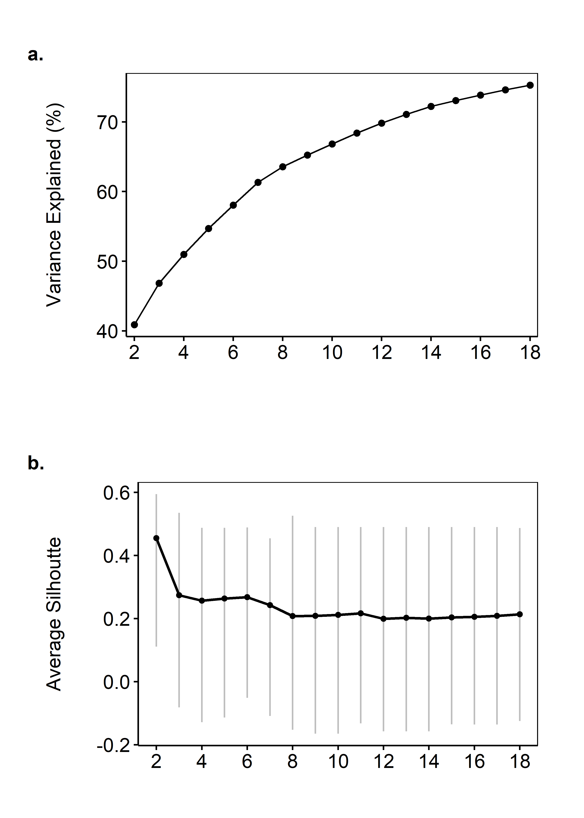
Figure S1. Visualizations used in determining optimal number of clusters in smolt-only pattern recognition analysis for case study of acoustic-tagged Chinook salmon smolts in the San Joaquin River, California, United States.

The cluster analysis for the multispecies pattern recognition data set partitioned the study tags into five clusters, the two largest of which were classified as smolts and the remainder as predators. Five clusters were selected in order to jointly minimize the total number of clusters and the number of mixed clusters containing large majorities of smolt tags. The dendrogram in Figure 5 (main article) shows the groupings at different levels of clustering; the great majority of known predator tags (35 of 37) are grouped at the top and bottom. The separation between groups of known predators reflected different patterns of behavior. Dividing the data set into two clusters would have produced a result similar to the smolt-only analysis but overlooked the large number (549) of smolt tags intermixed with the majority of predators (upper cluster). Three clusters were sufficient to isolate a smolt-tag-only grouping (labeled cluster 3 in Figure 5d) from those including known predator tags but left a large mixed cluster that was 93% smolt tags but which contained 62% (23) of the total known predator tags in the data set. Five clusters were necessary to separate the predator-rich grouping at the top of the dendrogram (cluster 1: 20 smolt tags, 21 predator tags) from the two majority-smolt-tag clusters in the middle of the dendrogram (clusters 2 and 3), both of which exhibited behavior patterns more expected from smolts. The fourth cluster included all 66 tags flagged as suspicious in the smolt-only procedure and 3 additional smolt tags. Admixture of 12 known predator tags with smolt tags in this cluster provided additional evidence of tag predation (Figure 5d, cluster 4). The smallest cluster of the five (cluster 5) contained only 2 tags, both of which were known predators (striped bass and white catfish) and deviated significantly from the norm based on their long detection sequences (> 35 events) and high frequency of upstream transitions. Examination of the PCA ordination plot (not shown) and correlations between principal component weights and behavioral metrics for the multispecies procedure (Table 6, main article) indicated that cluster 1 was characterized by abnormally long residence times at telemetry stations. Smolt tags in clusters 1, 4, and 5 were classified as predated. The remaining 529 smolt tags in clusters 2 and 3 were classified as non-predated by the end of the study (Figure 5d).

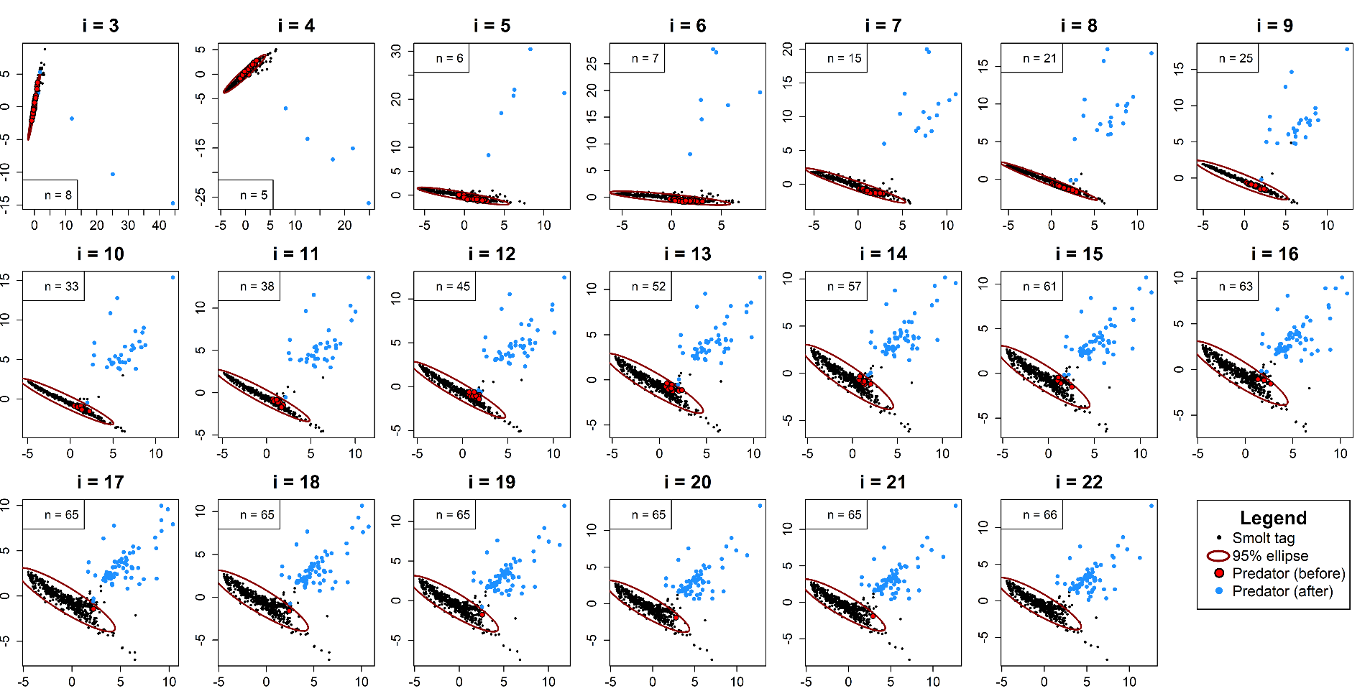
Figure S2a. Illustration of recursive ordination ellipse (ROE) procedure used in determining first detection event after predation for tags that were ultimately classified as predators in the smolt-only pattern recognition predator filter applied to detection data of Chinook salmon tags released in the San Joaquin River in 2016. Each plot depicts a principal component analysis based on behavioral metrics aggregated cumulatively from release to between $i=$ 3 and $i=$ 22 detection events. The value$n$ denotes the number of tags considered consumed by predators by that point ($n$ ≤ 66). The ellipse in each plot is defined as the 95% interval for the subset of tags ultimately classified as belonging to smolts by the filter. Individuals flagged by the tag-level analysis are considered smolts while inside the ellipse (red points) and transition to the predator state upon passing outside of the ellipse (blue points).

. 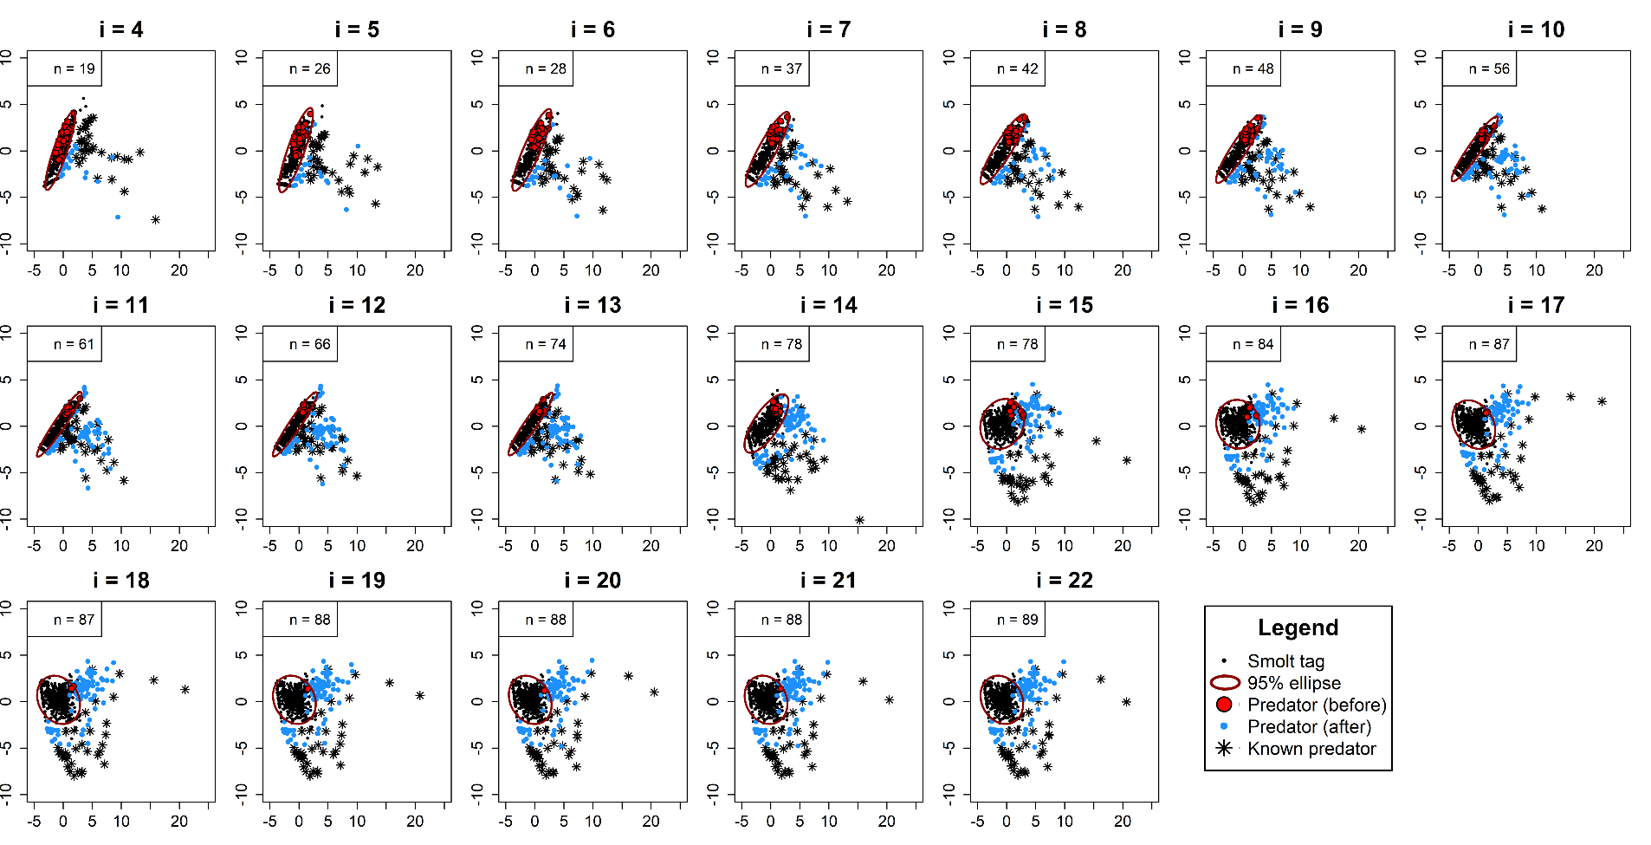
Figure S2b. Illustration of recursive ordination ellipse (ROE) procedure used in determining first detection event after predation for tags that were ultimately classified as predators in the multispecies pattern recognition predator filter applied to detection data of Chinook salmon tags released in the San Joaquin River in 2016. Each plot depicts a principal component analysis based on behavioral metrics aggregated cumulatively from release to between $i=$ 4 and $i=$ 22 detection events. The value $n$ denotes the number of tags considered consumed by predators by that point ($n$ ≤ 89). The ellipse in each plot is defined as the 95% interval for the subset of tags ultimately classified as belonging to smolts by the filter. Individuals flagged by the tag-level analysis are considered smolts while inside the ellipse (red points) and transition to the predated state upon passing outside of the ellipse (blue points). The subset of 37 known predator tags also included in the analysis are denoted by asterisks.

Table S5. Parameter estimates from release-recapture model (Figure 2 of main article) for alternative predator filtering approaches for 2016 San Joaquin River Chinook almon data processed using no filter, simple or complex rule-based (RB) filter, and smolt-only or multispecies pattern recognition (PR) filter. Standard errors are in parentheses.
Category | Model parameter |  | No filter | Simple RB | Complex RB | Smolt-only PR | Multispecies PR |  | CV (%)
Survival | S_{A1} |  | 0.967 (0.009) | 0.958 (0.009) | 0.957 (0.009) | 0.967 (0.009) | 0.967 (0.009) |  | 0.5
 | S_{A2} |  | 0.953 (0.017) | 0.950 (0.016) | 0.955 (0.016) | 0.953 (0.017) | 0.950 (0.016) |  | 0.2
 | S_{A3} |  | 0.976 (0.021) | 0.982 (0.019) | 0.973 (0.019) | 0.976 (0.021) | 0.981 (0.020) |  | 0.4
 | S_{A4} |  | 1.012 (0.020) | 1.016 (0.019) | 1.022 (0.018) | 1.012 (0.020) | 1.011 (0.020) |  | 0.5
 | S_{A5} |  | 0.707 (0.021) | 0.707 (0.021) | 0.707 (0.021) | 0.707 (0.021) | 0.707 (0.021) |  | 0
 | S_{A6} |  | 0.859 (0.017) | 0.865 (0.017) | 0.861 (0.017) | 0.859 (0.017) | 0.854 (0.017) |  | 0.5
 | S_{A7} |  | 0.774 (0.022) | 0.775 (0.022) | 0.765 (0.022) | 0.776 (0.022) | 0.769 (0.022) |  | 0.6
 | S_{A8} |  | 0.808 (0.025) | 0.799 (0.026) | 0.806 (0.025) | 0.808 (0.025) | 0.778 (0.027) |  | 1.6
 | S_{A9} |  | 0.871 (0.024) | 0.878 (0.023) | 0.861 (0.025) | 0.860 (0.024) | 0.865 (0.025) |  | 0.9
 | S_{A10} |  | 0.795 (0.031) | 0.793 (0.031) | 0.810 (0.030) | 0.787 (0.032) | 0.789 (0.032) |  | 1.1
 | S_{A11} |  | 0.756 (0.036) | 0.768 (0.036) | 0.743 (0.037) | 0.758 (0.037) | 0.708 (0.040) |  | 3.1
 | S_{A12} |  | 0.889 (0.031) | 0.877 (0.032) | 0.881 (0.032) | 0.818 (0.039) | 0.879 (0.034) |  | 3.3
 | S_{A13} |  | 0.919 (0.027) | 0.935 (0.025) | 0.933 (0.027) | 0.910 (0.030) | 0.900 (0.034) |  | 1.6
 | S_{A14} |  | 0.953 (0.023) | 0.920 (0.029) | 0.940 (0.026) | 0.947 (0.026) | 0.861 (0.041) |  | 4.1
 | S_{A15} |  | 0.951 (0.024) | 0.963 (0.021) | 0.987 (0.013) | 0.875 (0.039) | 0.919 (0.035) |  | 4.6
 | S_{A16} |  | 1.000 (0.000) | 0.974 (0.018) | 0.987 (0.013) | 0.921 (0.034) | 0.930 (0.034) |  | 3.7
 | S_{A17} |  | 0.665 (0.054) | 0.654 (0.055) | 0.658 (0.054) | 0.710 (0.060) | 0.739 (0.061) |  | 5.5
 | S_{A18} |  | 0.549 (0.070) | 0.530 (0.071) | 0.562 (0.071) | 0.559 (0.077) | 0.536 (0.079) |  | 2.5
 | S_{A19} |  | 0.906 (0.062) | 0.885 (0.063) | 0.889 (0.060) | 0.890 (0.072) | 0.976 (0.048) |  | 4.2
Detection | P_{A2} |  | 0.838 (0.015) | 0.839 (0.015) | 0.839 (0.015) | 0.838 (0.015) | 0.838 (0.015) |  | 0.1
 | P_{A3} |  | 0.343 (0.020) | 0.344 (0.020) | 0.345 (0.020) | 0.343 (0.020) | 0.343 (0.020) |  | 0.2
 | P_{A4} |  | 0.304 (0.020) | 0.304 (0.020) | 0.304 (0.020) | 0.304 (0.020) | 0.303 (0.020) |  | 0.1
 | P_{A5} |  | 0.793 (0.020) | 0.793 (0.020) | 0.793 (0.020) | 0.793 (0.020) | 0.794 (0.020) |  | 0
 | P_{A6} |  | 1.000 (0.000) | 1.000 (0.000) | 1.000 (0.000) | 1.000 (0.000) | 1.000 (0.000) |  | 0
 | P_{A7} |  | 1.000 (0.000) | 1.000 (0.000) | 1.000 (0.000) | 1.000 (0.000) | 1.000 (0.000) |  | 0
 | P_{A8} |  | 0.999 (0.001) | 0.999 (0.000) | 1.000 (0.000) | 0.999 (0.000) | 0.999 (0.000) |  | 0
 | P_{A9} |  | 0.994 (0.006) | 0.994 (0.006) | 0.994 (0.006) | 0.994 (0.006) | 0.994 (0.006) |  | 0
 | P_{A10} |  | 1.000 (0.000) | 1.000 (0.000) | 1.000 (0.000) | 1.000 (0.000) | 1.000 (0.000) |  | 0
 | P_{A11} |  | 1.000 (0.000) | 1.000 (0.000) | 1.000 (0.000) | 1.000 (0.000) | 1.000 (0.000) |  | 0
 | P_{A12} |  | 1.000 (0.000) | 1.000 (0.000) | 1.000 (0.000) | 1.000 (0.000) | 1.000 (0.000) |  | 0
 | P_{A13} |  | 1.000 (0.000) | 1.000 (0.000) | 1.000 (0.000) | 1.000 (0.000) | 1.000 (0.000) |  | 0
 | P_{A14} |  | 1.000 (0.000) | 1.000 (0.000) | 1.000 (0.000) | 1.000 (0.000) | 1.000 (0.000) |  | 0
 | P_{A15} |  | 1.000 (0.000) | 1.000 (0.000) | 1.000 (0.000) | 1.000 (0.000) | 1.000 (0.000) |  | 0
 | P_{A16} |  | 1.000 (0.000) | 1.000 (0.000) | 1.000 (0.000) | 1.000 (0.000) | 1.000 (0.000) |  | 0
 | P_{A17/R1} |  | 1.000 (0.000) | 1.000 (0.000) | 1.000 (0.000) | 1.000 (0.000) | 1.000 (0.000) |  | 0
 | P_{A18} |  | 0.999 (0.001) | 0.999 (0.001) | 0.999 (0.001) | 0.999 (0.001) | 1.000 (0.000) |  | 0
 | P_{A19} |  | 0.960 (0.039) | 1.000 (0.000) | 0.960 (0.039) | 1.000 (0.000) | 1.000 (0.000) |  | 2.2
 | P_{A20/T1} |  | 1.000 (0.000) | 1.000 (0.000) | 1.000 (0.000) | 1.000 (0.000) | 0.999 (0.003) |  | 0
 | P_{B1} |  | 1.000 (0.000) | 1.000 (0.000) | 1.000 (0.000) | 1.000 (0.000) | 1.000 (0.000) |  | 0

Supplemental References
- Adams NS, Rondorf DW, Evans SD, Kelly JE. Effects of surgically and gastrically implanted radio transmitters on growth and feeding behavior of juvenile Chinook Salmon. Trans Am Fish Soc. 1998;127(1):128–136.
- Martinelli TL, Hansel HC, Shively RS. Growth and physiological responses to surgical and gastric radio transmitter implantation techniques in subyearling Chinook salmon (Oncorhynchus tshawytscha). Hydrobiologia. 1998;371/372:79–87.
- Liedtke TL, Beeman JW, and Gee LP. A standard operating procedure for the surgical implantation of transmitters in juvenile salmonids. U.S. Geological Survey Open-File Report 2012-1267. 2012.

