Kurt C. Heim¹, William R. Ardren^{1**}, Theodore Castro-Santos²

¹ U.S. Fish and Wildlife Service, Lake Champlain Fish and Wildlife Conservation Office, Essex Junction, VT 05452, USA (Corresponding Author)

²U.S. Geological Survey, Eastern Ecological Science Center, S. O. Conte Anadromous Fish Research Center, One Migratory Way, Turners Falls, MA 01376, USA

**Current address: U.S. Fish and Wildlife Service, Midwest Fisheries Center, 555 Lester Avenue, Onalaska, WI 54650, USA.

Any use of trade, product, or firm names is for descriptive purposes only and does not imply endorsement by the U.S. Government.

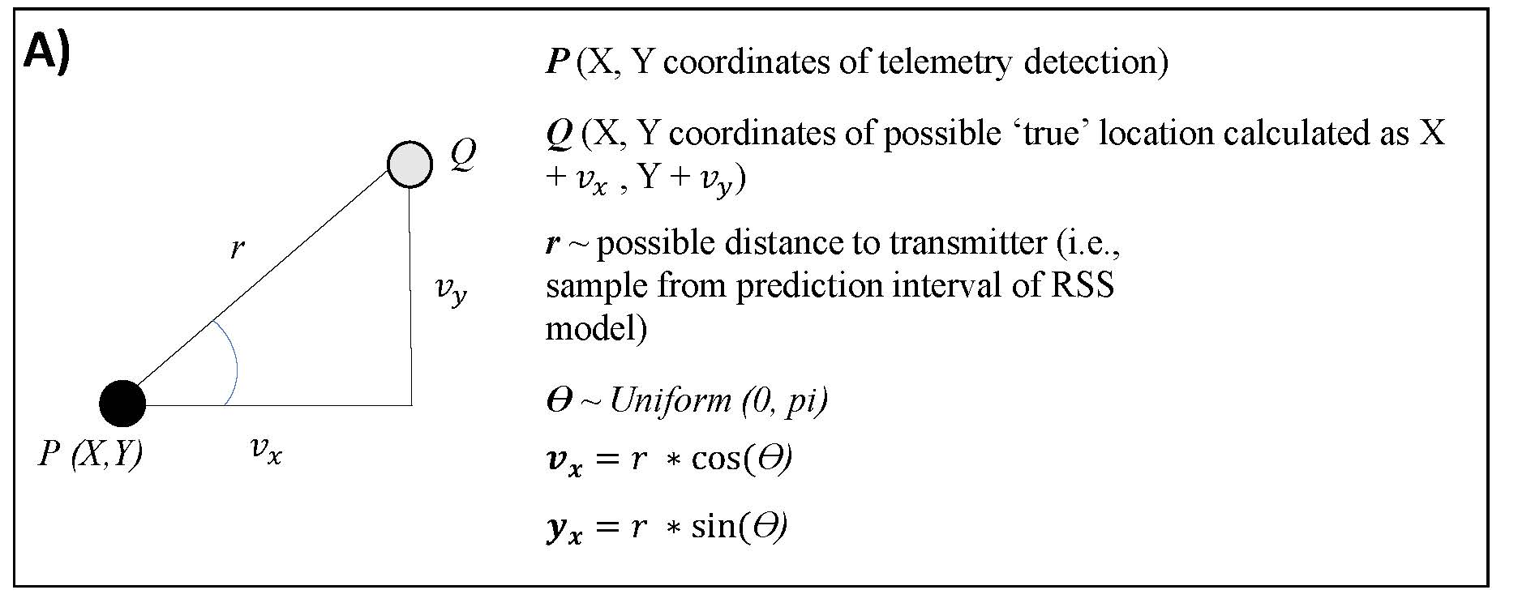
Figure S1. Trigonometry employed in determining range of ‘possible locations’ given (1) an estimated location made in the field (2) received signal strength (RSS) of the detection used to estimate location and (3) a fitted RSS model relating RSS to distance to transmitter. From an estimated point P (i.e., an X, Y coordinate) possible locations (Q) are estimated using the r (predicted distance-to-transmitter given the observed RSS and the RSS model) and a random angle.

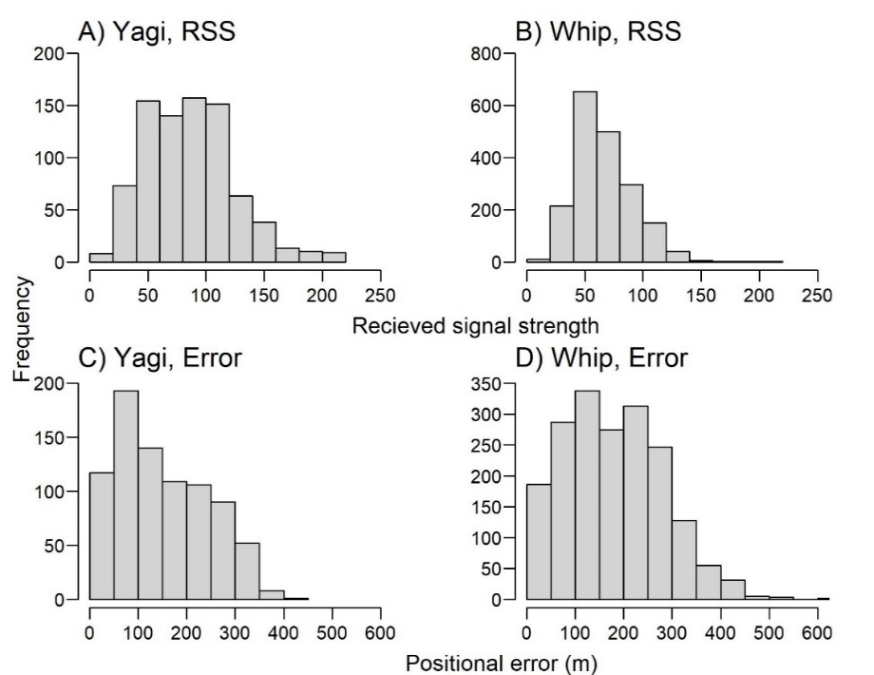
Figure S2. Distribution of recorded received signal strength (RSS) values for detections of transmitters at large (A, B) and the resulting positional error estimates for those detections based on the best fitting model (C, D).

