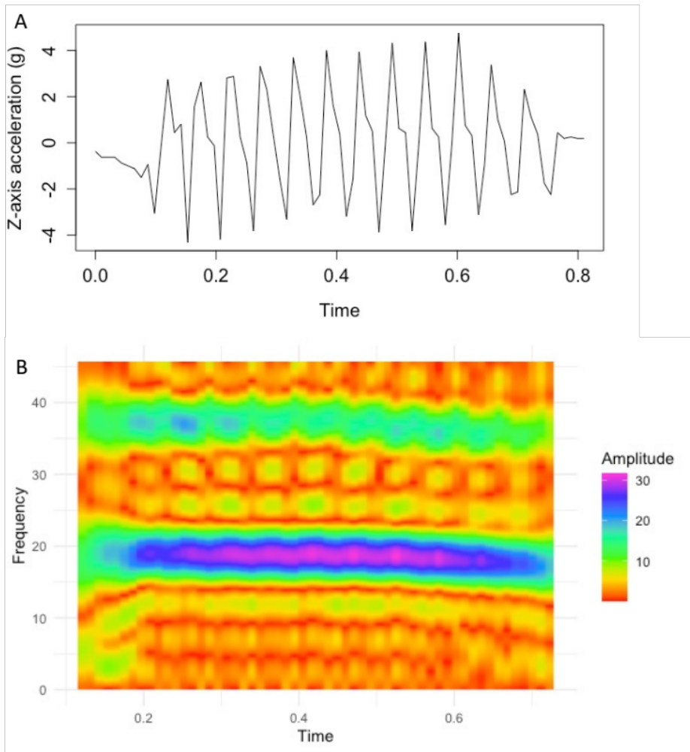
Figure S1. An example of z-axis flight accelerometer data (A) of one pied flycatcher, and the corresponding spectrogram (B). The spectral analysis was performed using ‘hht’ R package.

