Additional file material: Characterization of acoustic detection efficiency using an unmanned surface vessel as a mobile receiver platform.

Eric M. Gaskell¹, Tyler R. Funnell², Christopher M. Holbrook², Darryl W. Hondorp³, and Xiaobo Tan¹

¹Department of Electrical and Computer Engineering, Smart Microsystems Lab, Michigan State University, East Lansing, USA.
²U.S. Geological Survey, Great Lakes Science Center, Hammond Bay Biological Station, Millersburg, MI, USA.
³U.S. Geological Survey, Great Lakes Science Center, Ann Arbor, MI, USA.

Disclaimer: Any use of trade, product, or firm names is for descriptive purposes only and does not imply endorsement by the U.S. Government.

Figure S1. Unmanned surface vessel (USV) tracks (black line), stationary receivers (pink), and tag (green) location in the study area. Panels provide each run (1-8) with USV trials operated in station-keeping mode in the left column (trials 1, 4, and 7) and trials operated in drifting mode in the center and right columns (trials 2, 3, 5, 6, and 8).
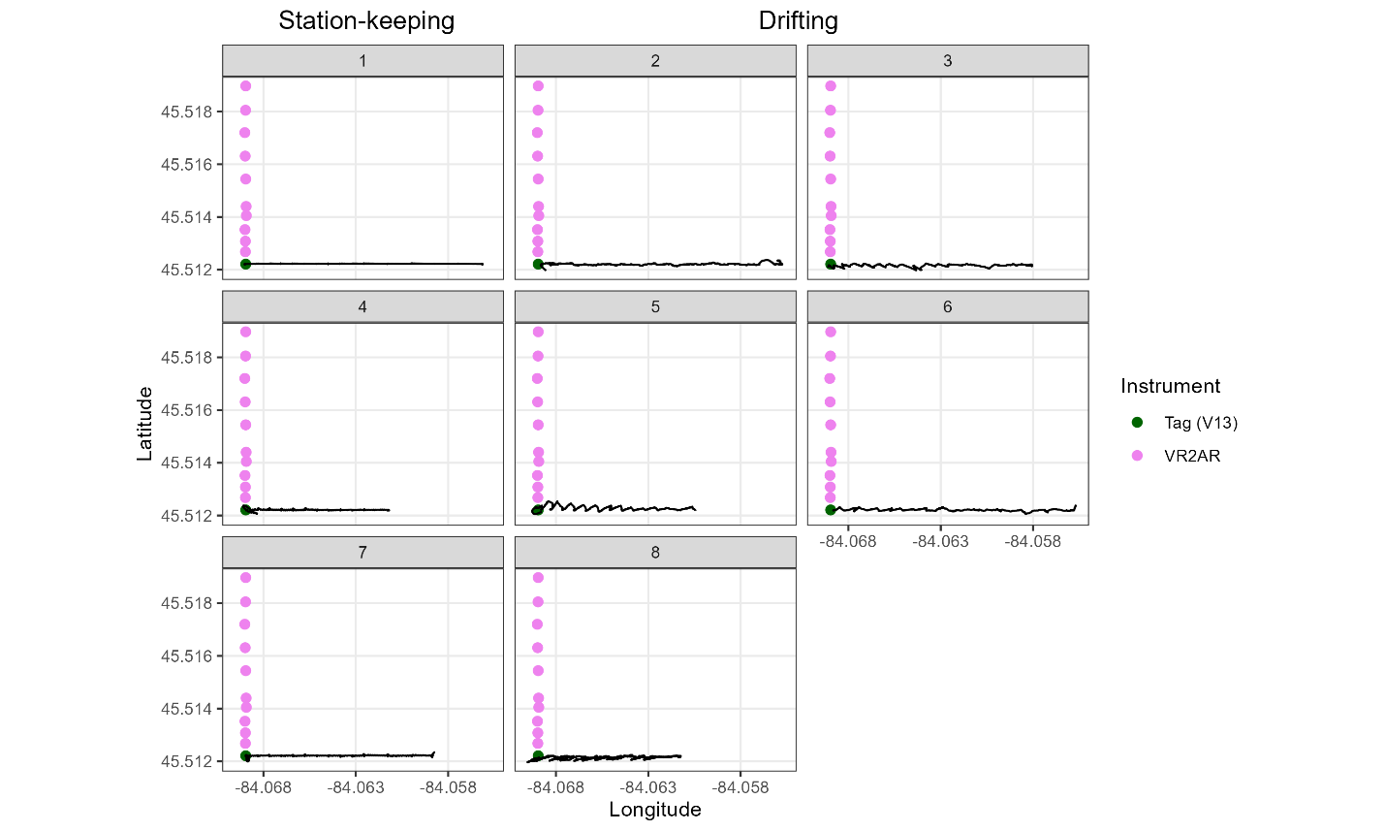
Figure S2. OPTION A. Temperature (°C) over time recorded at seven temperature loggers suspended within the water column near the line of stationary receivers in Hammond Bay, Lake Huron (45.5155, -84.06943). Each line represents temperature recorded by a single logger, colored by height off bottom (m). Shaded regions indicate unmanned surface vessel (USV) trials with trial number given at the top (see Table 1 for trial descriptions). Heights off bottom notable to the study include: transmitter nearest to 8.3 m off bottom, USV receiver nearest to 21.35 m off bottom, stationary receivers nearest to 1.65 m off bottom.
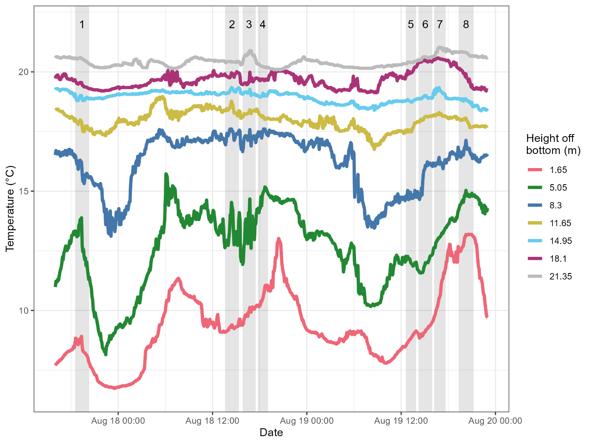

Figure S2. OPTION B. Temperature (°C) over time recorded at seven temperature loggers suspended within the water column near the line of stationary receivers in Hammond Bay, Lake Huron (45.5155, -84.06943). Each line represents temperature recorded by a single logger, shown at the depth of the logger within the water column and colored by temperature (°C). Shaded regions indicate unmanned surface vessel (USV) trials with trial number given at the top (see Table 1 for trial descriptions). Dashed lines are labeled with the height of receivers and the transmitter used in the study (see methods for details).
